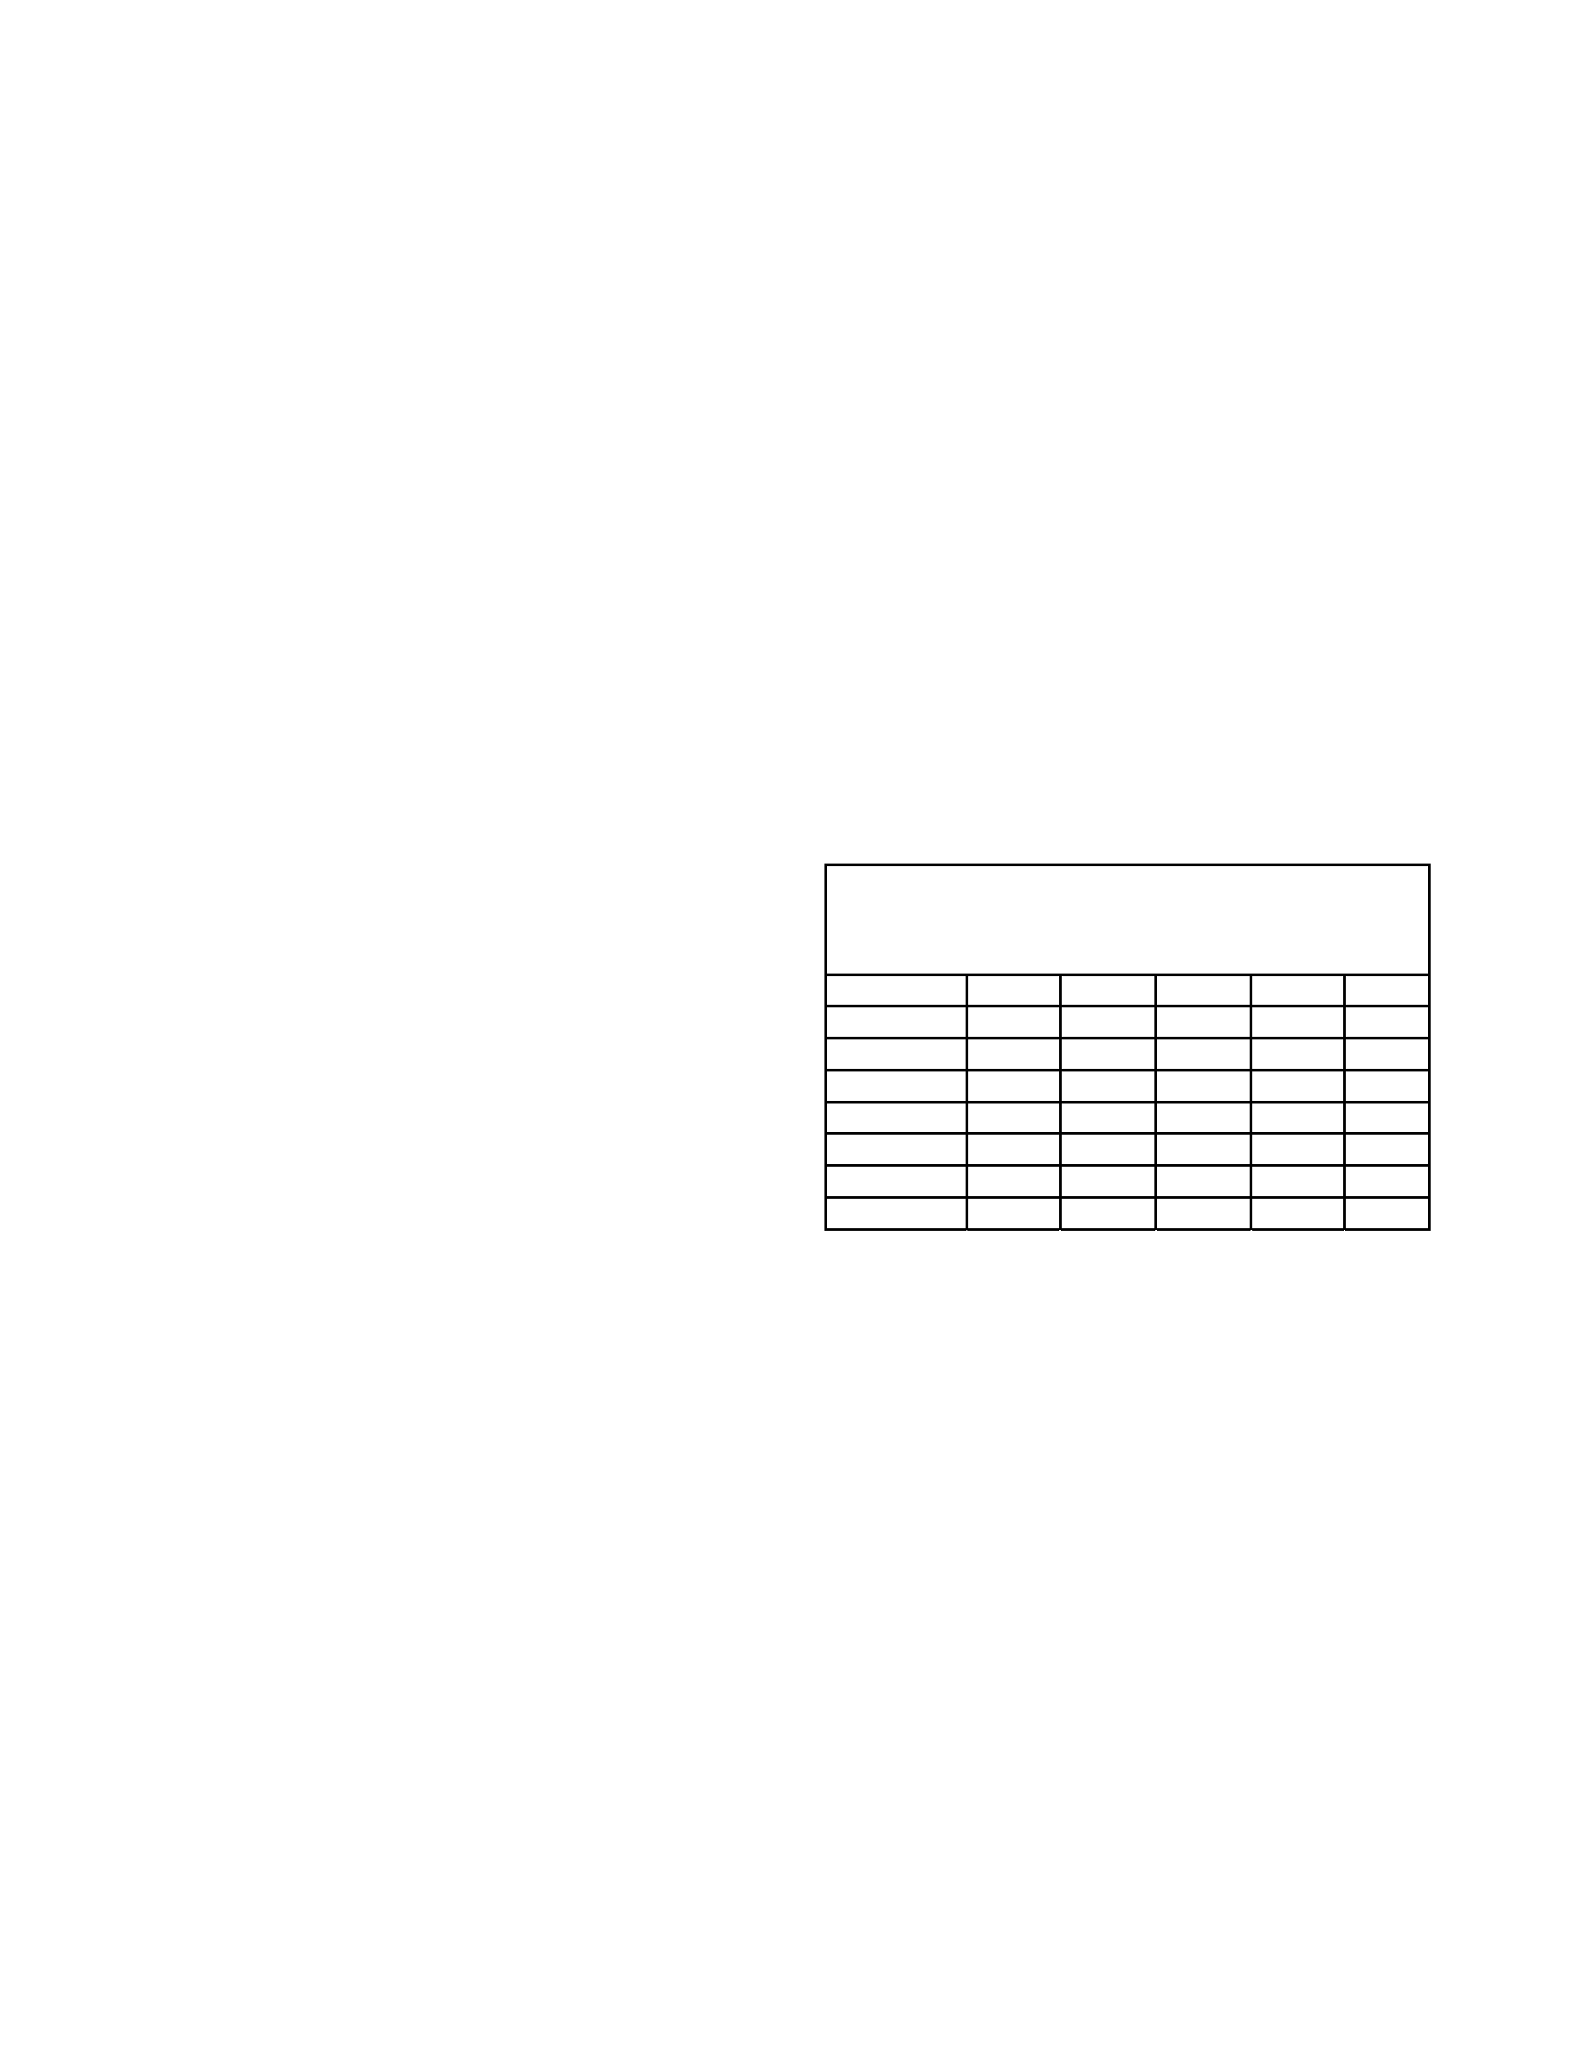
Fleet
race
boat
rotations
Taken
from
the
“
Race
Management
Handbook
”,
©
2001,
US
SAILING
Chapter
5;
5.2,
5.3
“Follow
the
leader”
rotations
“Follow
the
leader”
rotations
can
be
used
with
any
number
of
entries,
odd
or
even.
Their
advan-
tages
are
that
they
are
easy
for
crews
to
remember,
and
are
easily
adaptable
when
established
in
advance,
if
fewer
crews
than
expected
appear
for
the
regatta.
The
drawbacks
to
“follow-the-leader”
rotations
are
that:
(1)
each
crew
to
use
a
boat
always
fol-
lows
the
same
crew
which
has
previously
used
the
boat,
so
it
is
easy
for
one
crew
to
affect
another’s
standing;
and
(2)
they
require
a
larger
number
of
time-consuming
landings
and
exchanges,
either
on
the
exchange
boat
or
ashore.
Each
crew
draws
a
boat
number
for
the
first
race,
and
thereafter
sails
the
next
highest
(or
lowest)
number
each
succeeding
race
(there
is
no
magic
to
use
of
a
higher-numbered
or
lower
numbered
method,
only
personal
preference).
A
simple
“follow
the
leader”
rotation
(sailing
a
higher
numbered
boat)
is
shown
in
Table
5.1.
How
to
exchange
boats
To
exchange
boats
after
the
first
race
1.
The
crew
of
Boat
#1
(Crew
A)
gets
off
on
a
well
fendered
exchange
boat,
and
Boat
#1
is
sailed
away
by
a
non-competitor.
The
crew
of
Boat
#2
(Crew
B)
then
gets
off
on
the
exchange
boat,
and
the
former
crew
of
Boat
#1
takes
Boat
#2
for
the
next
race.
Similarly,
the
former
crew
of
Boat
#3
(Crew
C)
takes
Boat
#4,
etc.,
until
finally
Boat
#1
is
sailed
back
to
the
exchange
boat
for
the
last
crew
(Crew
E).
TABLE
5.1
“Follow
the
Leader”
Rotation
Fleet
Racing
Series
6
Crews,
6
Boats,
5
Races
Race
1
2
3
4
5
Crew
Boat
A
1
2
3
4
5
B
2
3
4
5
6
C
3
4
5
6
1
D
4
5
6
1
2
E
5
6
1
2
3
F
6
1
2
3
4
2.
To
prevent
Crew
A
from
having
a
big
time
advantage
in
preparing
for
subsequent
races,
Boat
#1
(rather
than
Crew
A)
should
always
be
called
first
to
the
exchange
boat
3.
Should
one
or
more
boats
not
sail
the
entire
series,
a
new
rotation
is
easy
to
make.
If
all
crew
listed
start
the
first
race,
the
rotation
should
not
be
changed.
“Direct
swap”
rotations
Whenever
entries
total
an
even
number,
the
“direct
swap”
system
lessens
the
time
for
boat
exchanges
by
having
pairs
of
crews
change
boats
simultaneously.
The
number
of
races
in
which
each
crew
follows
the
same
crew
is
also
markedly
reduced.
For
odd
numbers
of
entries,
use
the
“follow-the-leader”
method.
This
section
discusses
the
method
of
creating
“direct
swap”
boat
rotations.
The
tables
contained
here
are
designed
for
fleet-race
competition
(approximately
90%
of
all
intercollegiate
racing
is
cur-
rently
fleet
racing).’
While
they
are
adaptable
to
team
racing,
most
regatta
organizers
use
the
Hinman
Championship
style
rotations
which
have
been
developed
(see
Tables
in
”Team
racing
rotations
and
boat
pairings”).
Event: Enter event name

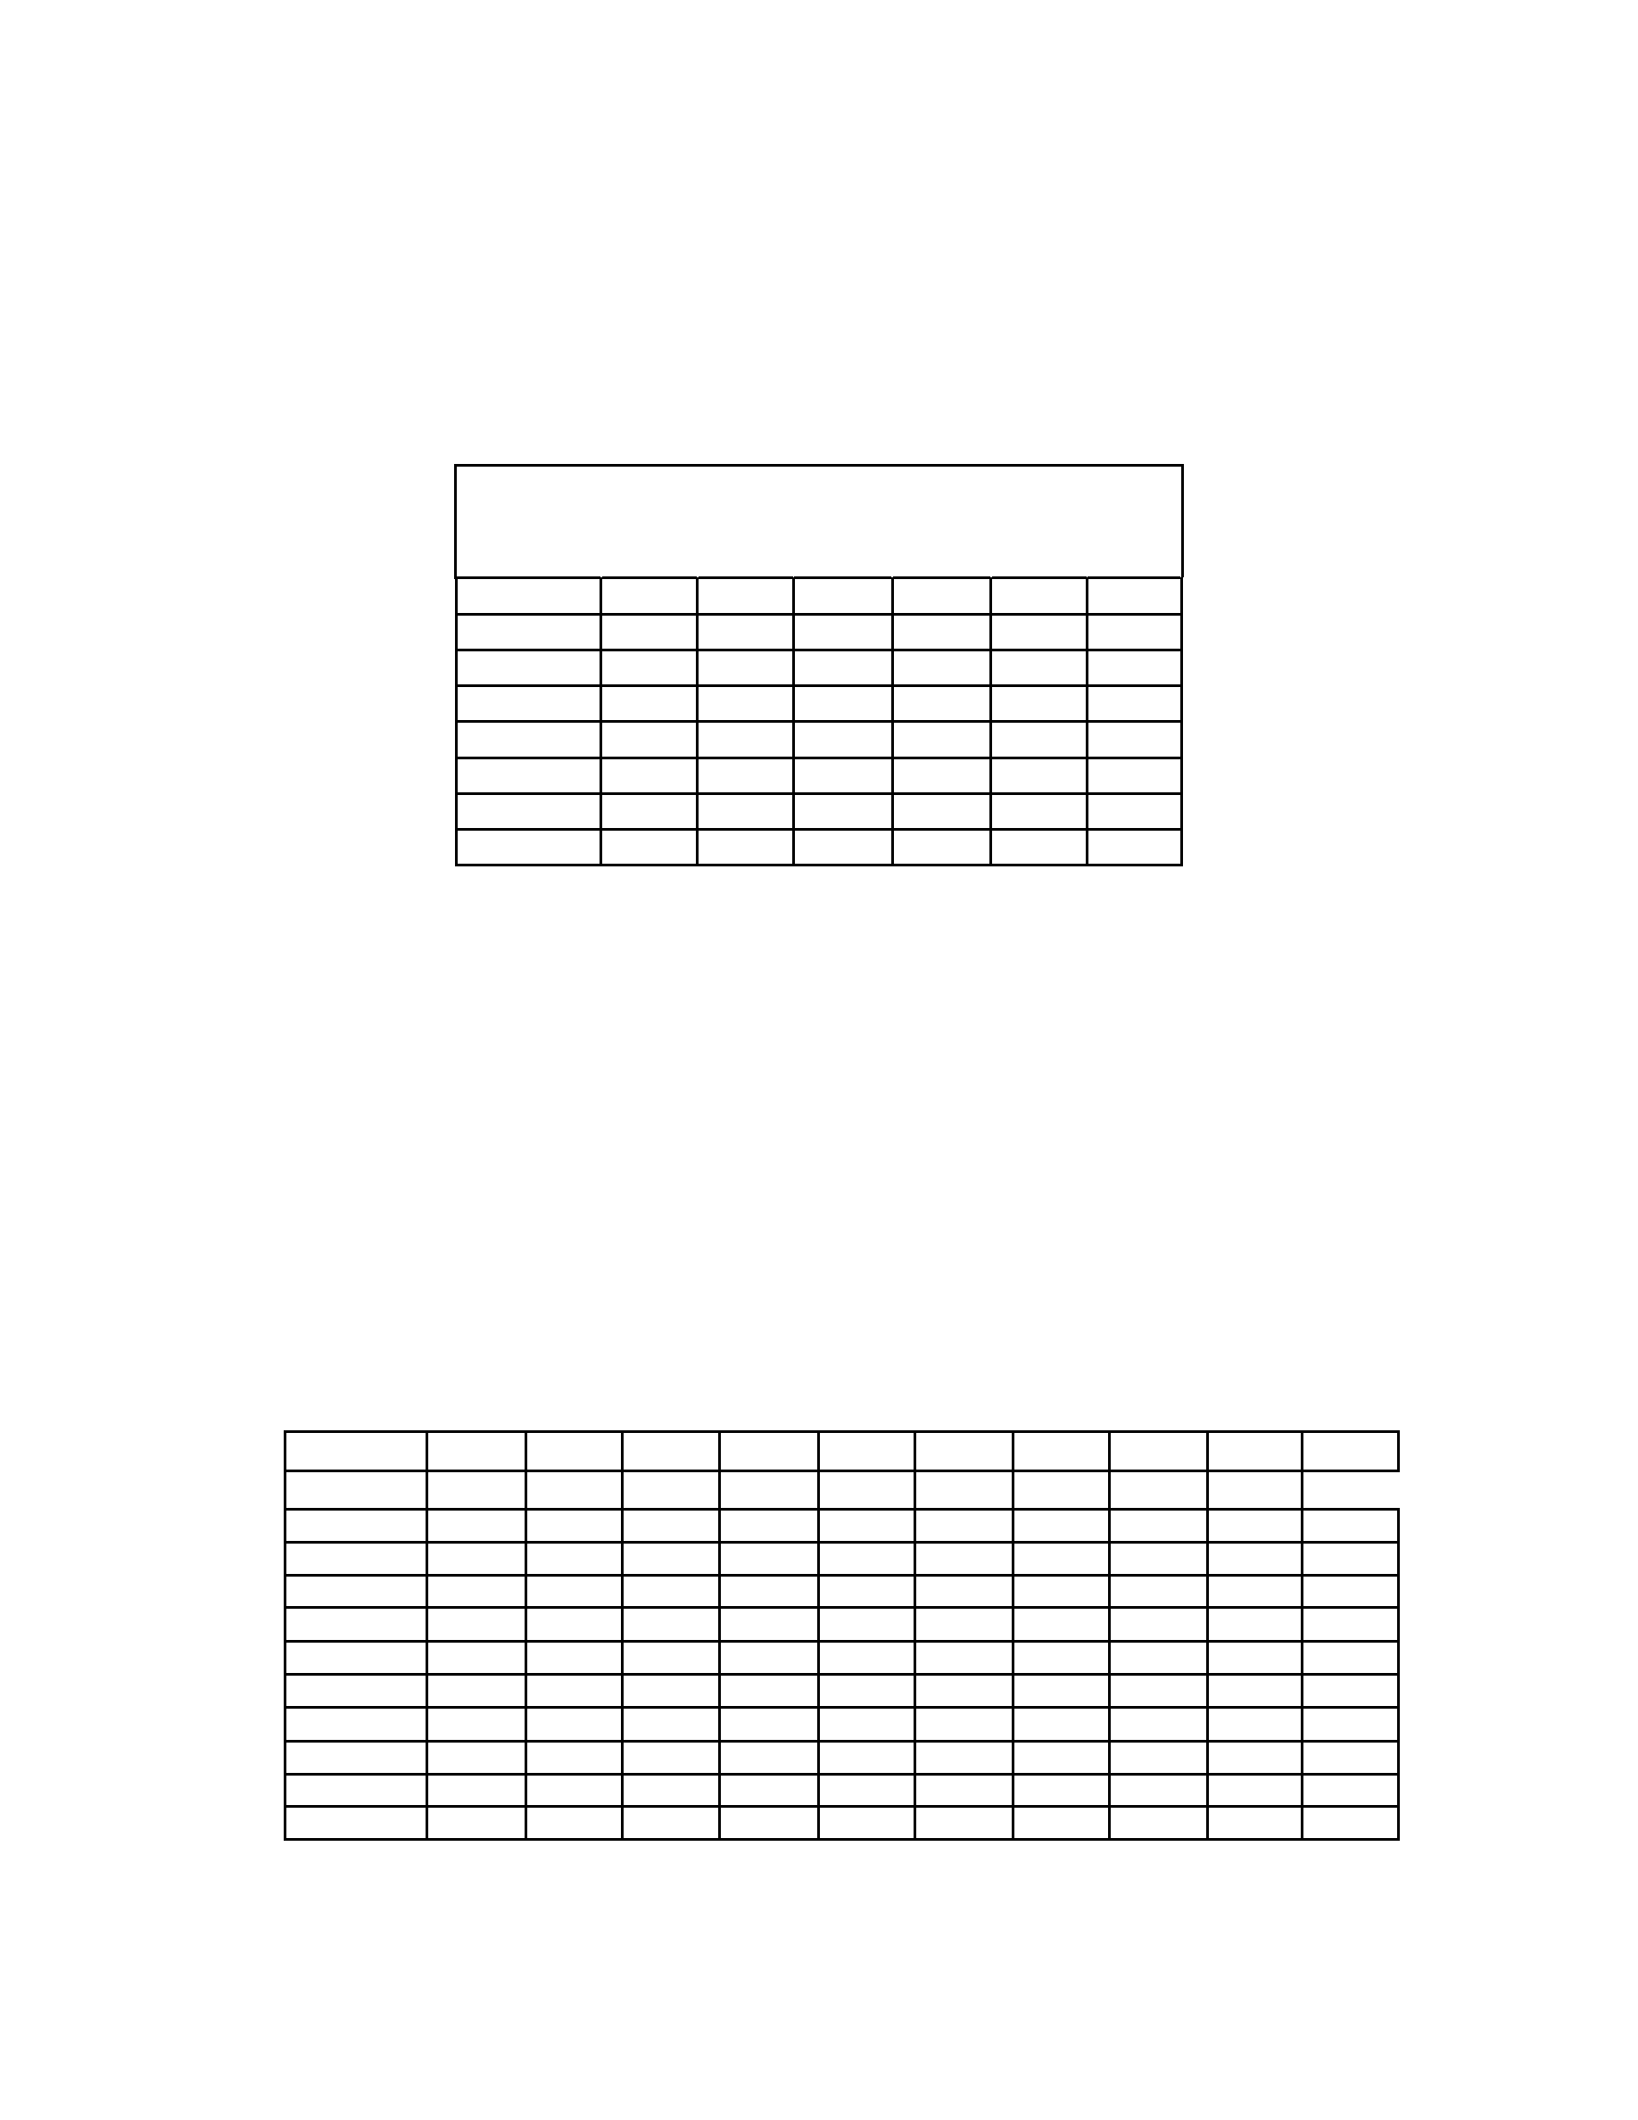
To
create
a
table
(5.2)
of
boat
rotation
for
an
even
number
of
crews:
1.
Down
the
vertical
column
for
the
first
race,
list
boat
numbers
in
ascending
order.
2.
For
the
first
horizontal
row,
list
boats
in
ascending
order.
3.
For
the
second
horizontal
row,
list
boats
in
descending
order.
4.
For
the
remaining
horizontal
rows,
list
boats
alternately
in
ascending
and
descending
order.
TABLE
5.2
Fleet
Race
Direct
Swap
Rotation
6
Crews,
6
Boats,
5
Races
Race
1
2
3
4
5
6
Crew
Boat
A
1
2
3
4
5
6
B
2
1
6
5
4
3
C
3
4
5
6
1
5
D
4
3
2
1
6
5
E
5
6
1
2
3
4
F
6
5
4
3
2
1
For
example,
Table
5.2
shows
a
direct
swap
rotation
for
six
entries.
If
you
have
one
fewer
boats
than
the
number
of
crews,
you
may
still
use
the
direct-swap
format.
Each
crew
sits
out
one
race.
An
example
is
shown
in
Table
5.3.
The
same
concept
applies
where
there
are
ten
crews,
but
only
8
boats.
Each
crew
sits
out
2
races.
Byes
can
be
used
in
either
direct
swap
or
follow-the-leader
rotations.
If
there
is
to
be
more
than
one
bye,
they
should
be
staggered
through
the
rotation
so
that
one
team
or
crew
does
not
have
consecutive
byes.
TABLE
5.3
Fleet
Race
Direct
Swap
Rotation
10
Crews,
9
Boats,
10
Races
Race:
1
2
3
4
5
6
7
8
9
10
Crew:
Boat
A
1
2
3
4
5
6
7
8
9
X
B
2
1
X
9
8
7
6
5
4
3
C
3
4
5
6
7
8
9
X
1
2
D
4
3
2
1
X
9
8
7
6
5
E
5
6
7
8
9
X
1
2
3
4
F
6
5
4
3
2
1
X
9
8
7
G
7
8
9
X
1
2
3
4
5
6
H
8
7
6
5
4
3
2
1
X
9
I
9
X
1
2
3
4
5
6
7
8
J
X
9
8
7
6
5
4
3
2
1
©
2001,
US
SAILING
Event: Enter event name

