Event: Enter event name
RACE ADMINISTRATION EVENT FORMS
Enter the Event name above once. It is shared throughout this packet.
Print the pages you need, then complete the working forms by hand. The four original form templates also retain their editable controls.
Forms and references
2 Notice to Competitors
3 Protest Time Limits
4 Race Committee Actions
5 Race Committee Log
6 Mark Rounding and Finishing Log
7 Race Committee Wind Log
8 Timer Worksheet RRS 26
9 Signal Boat Summary
10 Race Scoring Grid
11 Scoring Review Your Version
12 Scoring Review US Sailing Version
13 Scoring Penalty Form
14 Protest Worksheet
15 Windward Leeward Course Headings
16 Trapezoid Headings 60 Degree Reach
18 Trapezoid Headings 70 Degree Reach
20 Fleet Race Boat Rotations
22 Team Race Round Robin Rotations
Source forms and reference schedules are reproduced from the supplied library. Reference tables retain the supplied values and rules wording.
Event: Enter event name
NOTICE TO COMPETITORS

NOTICE #: Number | COURSE: Course | DATE: MM/DD/YYYY

BY: Enter name SIGNED: Enter signature

For the Race Committee DATE/TIME POSTED: Date and time

CONTENT:

Click here to enter the notice text

Event: Enter event name
PROTEST TIME LIMITS
Day Date Course
RC finish boat docked at:
Protest time limit:
Arbitration hearings begin at:
Day Date Course
RC finish boat docked at:
Protest time limit:
Arbitration hearings begin at:
Arbitration hearings will be held in the Regatta Room. Each party's designated representative (conforming to RRS 63.3(a)) should be available for the arbitration hearing. No witnesses are permitted.
Posted at:

Event: Enter event name
RACE COMMITTEE ACTIONS
Day __________ Date __________ Course __________ Recorder __________________
Class | Series Race # | Sail # | Action | Comments

Event: Enter event name
RACE COMMITTEE LOG
Date __________ Race Number ______ Recorder ______________ Page Number ______
 | TIME | COMMENTS
1
2
3
4
5
6
7
8
9
10
11
12
13
14
15
16
17
18
19
20
21
22
23
24
25

Event: Enter event name
MARK ROUNDING AND FINISHING LOG
Date __________ Boat ______________ Recorder ______________ Page Number ______
 | RACE___ MARK_____ |  |  |  |  |  | RACE___ MARK_____ |  |  |  |  |  | RACE___ MARK_____
 | TIME |  | SAIL # | FLAG |  |  | TIME |  | SAIL # | FLAG |  |  | TIME |  | SAIL # | FLAG
1 |  |  |  |  |  | 1 |  |  |  |  |  | 1
2 |  |  |  |  |  | 2 |  |  |  |  |  | 2
3 |  |  |  |  |  | 3 |  |  |  |  |  | 3
4 |  |  |  |  |  | 4 |  |  |  |  |  | 4
5 |  |  |  |  |  | 5 |  |  |  |  |  | 5
6 |  |  |  |  |  | 6 |  |  |  |  |  | 6
7 |  |  |  |  |  | 7 |  |  |  |  |  | 7
8 |  |  |  |  |  | 8 |  |  |  |  |  | 8
9 |  |  |  |  |  | 9 |  |  |  |  |  | 9
10 |  |  |  |  |  | 10 |  |  |  |  |  | 10
11 |  |  |  |  |  | 11 |  |  |  |  |  | 11
12 |  |  |  |  |  | 12 |  |  |  |  |  | 12
13 |  |  |  |  |  | 13 |  |  |  |  |  | 13
14 |  |  |  |  |  | 14 |  |  |  |  |  | 14
15 |  |  |  |  |  | 15 |  |  |  |  |  | 15
16 |  |  |  |  |  | 16 |  |  |  |  |  | 16
17 |  |  |  |  |  | 17 |  |  |  |  |  | 17
18 |  |  |  |  |  | 18 |  |  |  |  |  | 18
19 |  |  |  |  |  | 19 |  |  |  |  |  | 19
20 |  |  |  |  |  | 20 |  |  |  |  |  | 20
21 |  |  |  |  |  | 21 |  |  |  |  |  | 21
22 |  |  |  |  |  | 22 |  |  |  |  |  | 22
23 |  |  |  |  |  | 23 |  |  |  |  |  | 23
24 |  |  |  |  |  | 24 |  |  |  |  |  | 24
25 |  |  |  |  |  | 25 |  |  |  |  |  | 25

Event: Enter event name
RACE COMMITTEE WIND LOG
Date __________ Boat ______________ Recorder ______________ Page Number ______
 | VELO- | WIND DIRECTION |  |  |  |  |  |  |  |  |  |  |  | VELO- | WIND DIRECTION
TIME | CITY |  |  |  |  |  |  |  |  |  |  |  | TIME | CITY

Event: Enter event name
TIMER WORKSHEET RRS 26
CLASS |  | DATE | RACE # | # BOATS |  | TIMER'S NAME
TIME OFF DOCK |  | TIME | TIME | TIME | TIME | Call attention to scheduled Warning at 15, 10 & 5 min in advance
POSTPONE |  |  |  |  |  | AP up with 2 sounds
 |  |  |  |  |  | 1 min to AP down with 1 sound
 |  | +1 min | +1 min | +1 min | +1 min
END POSTPONEMENT |  |  |  |  |  | AP down with 1 sound; 1 min to WARNING
or END OF GENERAL RECALL |  |  |  |  |  | 1st SUB down with 1 sound
 |  | +1 min | +1 min | +1 min | +1 min
WARNING |  |  |  |  |  | CLASS FLAG up with 1 sound; 1 min to PREP
 |  | +1 min | +1 min | +1 min | +1 min
PREPARATORY |  |  |  |  |  | P, I, Z, I&Z, or BLACK up with 1 sound
 |  | +2 min | +2 min | +2 min | +2 min
 |  |  |  |  |  | 1 min to PREP down with 1 long sound
 |  | +1 min | +1 min | +1 min | +1 min
PREP DOWN |  |  |  |  |  | PREP down with 1 long sound; 1 min to START
 |  | +1 min | +1 min | +1 min | +1 min
START |  |  |  |  |  | CLASS FLAG down with 1 sound
INDIVIDUAL RECALL |  |  |  |  |  | X up with 1 sound
GENERAL RECALL |  |  |  |  |  | FIRST SUBSTITUTE up with 2 sounds
ABANDON |  |  |  |  |  | N (or N over H or over A) with 3 sounds
DOCKING TIME

Event: Enter event name
 | SIGNAL BOAT SUMMARY | DATE: MM/DD/YYYY | COURSE: Course

ACTION | Class | Race Number | Protesting Boat(s) | Protested Boat(s) | Comments
Action | Class | Race | Boat(s) | Boat(s) | Comments
Action | Class | Race | Boat(s) | Boat(s) | Comments
Action | Class | Race | Boat(s) | Boat(s) | Comments
Action | Class | Race | Boat(s) | Boat(s) | Comments
Action | Class | Race | Boat(s) | Boat(s) | Comments
Action | Class | Race | Boat(s) | Boat(s) | Comments
Action | Class | Race | Boat(s) | Boat(s) | Comments
Action | Class | Race | Boat(s) | Boat(s) | Comments
Action | Class | Race | Boat(s) | Boat(s) | Comments

DOCK TIME: HH:MM HRS | POSTED BY: Enter name AT HH:MM HRS | PAGE No. OF Total

Event: Enter event name
RACE SCORING GRID
Date __________________ Race cells: boat number above, race points left, cumulative points right, finish position below
Boat # | Race 1 | Race 2 | Race 3 | Race 4 | Race 5 | Race 6 | Race 7 | Race 8 | Race 9 | Race 10 | Finish Points | Finish Position

Event: Enter event name
REQUEST FOR SCORING REVIEW

DATE:  MM/DD/YYYY | SAIL/BOW #/BOAT:  Enter sail/bow number or boat name
DATE:  MM/DD/YYYY | RACE #:  Race number | POSTED SCORE:  Posted score

I BELIEVE THAT MY SCORE IN THE POSTED RESULTS IS INCORRECT FOR THE FOLLOWING REASON:
Click here to explain the scoring issue

PRINT NAME:  Enter name | SIGNED:  Enter signature

For the Race Committee

Received by:  Enter name | Time:  HH:MM | Request #:  Request number

RC Comments:
Click here to enter Race Committee comments

Corrected score:  Corrected score | By RC:  Enter name
Scoring completed:  Date and time | By:  Enter name

Event: Enter event name
REQUEST FOR SCORING REVIEW
Day __________ Date __________ Course ____________________
Class __________________________ Sail Number __________________
Boat Name ______________________ Bow Number __________________
Race Number ____________________ Posted Score _________________
I believe that my score in the posted results is incorrect for the following reason:
My Name please print __________________________________________________
Signature _____________________________________________________________
Received By ____________________ Time __________ Request Number ______
Race Committee Comments:
Corrected Score ____________________ Signature ______________________
Entered By Scoring date and time ________________________________________

Event: Enter event name
SCORING PENALTY FORM
Record scoring penalties taken under Racing Rule 44.3(a), or 720° penalties under Racing Rule 44.1
Organizing Club: ________________________________
Date: ________________ Race Number ____________________
PROTESTED YACHT: ________________________________
Class: ________________ Sail Number _____________________
Owner or Representative: ________________________________
Telephone: ________________ Signature _______________________
Address: ________________________________
Time of incident: ________________ Rule broken _____________________
Time Yellow Flag displayed or 720° penalty taken: ________________
Flag displayed continuously until protested yacht finished: ☐ Yes ☐ No
Flag called to Race Committee's attention at the finish: ☐ Yes ☐ No
PROTESTING YACHT: ________________________________
Class: ________________ Sail Number _____________________
Owner or Representative if known: ________________________________
Telephone if known: ________________________________
Address if known: ________________________________

Event: Enter event name
PROTEST WORKSHEET
Protest Number:  Protest number | Course:  Course | Worksheet Date:  MM/DD/YYYY
Class:  Class | Race Number:  Race number | Date and Day of Week:  Day and date

Time Protest Submitted (hrs):  HH:MM | End of Protest Time (hrs):  HH:MM

Protestor | Protestee
Boat Name:  Boat name  Sail/Bow No.:  Sail/bow number | Boat Name:  Boat name  Sail/Bow No.:  Sail/bow number
Boat Name 2:
Boat name
Sail/Bow No.:
Sail/bow number
Boat Name 3:
Boat name
Sail/Bow No.:
Sail/bow number

Disposition
☐ Withdrawn by protestor
☐ Invalid Protest
☐ No penalties
☐ Boat(s) to be scored
Boat(s): Enter boat(s) To be scored: Score / penalty

For the PC:  Enter name | Date:  MM/DD/YYYY | Time (hrs):  HH:MM
For the Scorer:  Enter name | Date:  MM/DD/YYYY | Time (hrs):  HH:MM

Event: Enter event name
WINDWARD LEEWARD COURSE HEADINGS
Windward | Leeward | Start / Finish Line
000 (180) | 180 (000) | 090 - 270
005 (185) | 185 (005) | 095 - 275
010 (190) | 190 (010) | 100 - 280
015 (195) | 195 (015) | 105 - 285
020 (200) | 200 (020) | 110 - 290
025 (205) | 205 (025) | 115 - 295
030 (210) | 210 (030) | 120 - 300
035 (215) | 215 (035) | 125 - 305
040 (220) | 220 (040) | 130 - 310
045 (225) | 225 (045) | 135 - 315
050 (230) | 230 (050) | 140 - 320
055 (235) | 235 (055) | 145 - 325
060 (240) | 240 (060) | 150 - 330
065 (245) | 245 (065) | 155 - 335
070 (250) | 250 (070) | 160 - 340
075 (255) | 255 (075) | 165 - 345
080 (260) | 260 (080) | 170 - 350
085 (265) | 265 (085) | 175 - 355
090 (270) | 270 (090) | 180 - 000
095 (275) | 275 (095) | 185 - 005
100 (280) | 280 (100) | 190 - 010
105 (285) | 285 (105) | 195 - 015
110 (290) | 290 (110) | 200 - 020
115 (295) | 295 (115) | 205 - 025
120 (300) | 300 (120) | 210 - 030
125 (305) | 305 (125) | 215 - 035
130 (310) | 310 (130) | 220 - 040
135 (315) | 315 (135) | 225 - 045
140 (320) | 320 (140) | 230 - 050
145 (325) | 325 (145) | 235 - 055
150 (330) | 330 (150) | 240 - 060
155 (335) | 335 (155) | 245 - 065
160 (340) | 340 (160) | 250 - 070
165 (345) | 345 (165) | 255 - 075
170 (350) | 350 (170) | 260 - 080
175 (355) | 355 (175) | 265 - 085
180 (000) | 000 (180) | 270 - 090
Reciprocals are shown in parentheses

Event: Enter event name
TRAPEZOID COURSE HEADINGS 60 DEGREE REACH
Wind | Recip. | 1st Reach | Recip. | Run | Recip. | Finish | Recip. | Mark 4 to 2 | Recip.
0 | 180 | 240 | 60 | 180 | 0 | 110 | 290 | 300 | 120
5 | 185 | 245 | 65 | 185 | 5 | 115 | 295 | 305 | 125
10 | 190 | 250 | 70 | 190 | 10 | 120 | 300 | 310 | 130
15 | 195 | 255 | 75 | 195 | 15 | 125 | 305 | 315 | 135
20 | 200 | 260 | 80 | 200 | 20 | 130 | 310 | 320 | 140
25 | 205 | 265 | 85 | 205 | 25 | 135 | 315 | 325 | 145
30 | 210 | 270 | 90 | 210 | 30 | 140 | 320 | 330 | 150
35 | 215 | 275 | 95 | 215 | 35 | 145 | 325 | 335 | 155
40 | 220 | 280 | 100 | 220 | 40 | 150 | 330 | 340 | 160
45 | 225 | 285 | 105 | 225 | 45 | 155 | 335 | 345 | 165
50 | 230 | 290 | 110 | 230 | 50 | 160 | 340 | 350 | 170
55 | 235 | 295 | 115 | 235 | 55 | 165 | 345 | 355 | 175
60 | 240 | 300 | 120 | 240 | 60 | 170 | 350 | 360 | 180
65 | 245 | 305 | 125 | 245 | 65 | 175 | 355 | 5 | 185
70 | 250 | 310 | 130 | 250 | 70 | 180 | 360 | 10 | 190
75 | 255 | 315 | 135 | 255 | 75 | 185 | 5 | 15 | 195
80 | 260 | 320 | 140 | 260 | 80 | 190 | 10 | 20 | 200
85 | 265 | 325 | 145 | 265 | 85 | 195 | 15 | 25 | 205
90 | 270 | 330 | 150 | 270 | 90 | 200 | 20 | 30 | 210
95 | 275 | 335 | 155 | 275 | 95 | 205 | 25 | 35 | 215
100 | 280 | 340 | 160 | 280 | 100 | 210 | 30 | 40 | 220
105 | 285 | 345 | 165 | 285 | 105 | 215 | 35 | 45 | 225
110 | 290 | 350 | 170 | 290 | 110 | 220 | 40 | 50 | 230
115 | 295 | 355 | 175 | 295 | 115 | 225 | 45 | 55 | 235
120 | 300 | 360 | 180 | 300 | 120 | 230 | 50 | 60 | 240
125 | 305 | 5 | 185 | 305 | 125 | 235 | 55 | 65 | 245
130 | 310 | 10 | 190 | 310 | 130 | 240 | 60 | 70 | 250
135 | 315 | 15 | 195 | 315 | 135 | 245 | 65 | 75 | 255
140 | 320 | 20 | 200 | 320 | 140 | 250 | 70 | 80 | 260
145 | 325 | 25 | 205 | 325 | 145 | 255 | 75 | 85 | 265
150 | 330 | 30 | 210 | 330 | 150 | 260 | 80 | 90 | 270
155 | 335 | 35 | 215 | 335 | 155 | 265 | 85 | 95 | 275
160 | 340 | 40 | 220 | 340 | 160 | 270 | 90 | 100 | 280
165 | 345 | 45 | 225 | 345 | 165 | 275 | 95 | 105 | 285
170 | 350 | 50 | 230 | 350 | 170 | 280 | 100 | 110 | 290
175 | 355 | 55 | 235 | 355 | 175 | 285 | 105 | 115 | 295
180 | 360 | 60 | 240 | 360 | 180 | 290 | 110 | 120 | 300

Event: Enter event name
TRAPEZOID COURSE HEADINGS 60 DEGREE REACH CONTINUED
Wind | Recip. | 1st Reach | Recip. | Run | Recip. | Finish | Recip. | Mark 4 to 2 | Recip.
180 | 0 | 60 | 240 | 0 | 180 | 290 | 110 | 120 | 300
185 | 5 | 65 | 245 | 5 | 185 | 295 | 115 | 125 | 305
190 | 10 | 70 | 250 | 10 | 190 | 300 | 120 | 130 | 310
195 | 15 | 75 | 255 | 15 | 195 | 305 | 125 | 135 | 315
200 | 20 | 80 | 260 | 20 | 200 | 310 | 130 | 140 | 320
205 | 25 | 85 | 265 | 25 | 205 | 315 | 135 | 145 | 325
210 | 30 | 90 | 270 | 30 | 210 | 320 | 140 | 150 | 330
215 | 35 | 95 | 275 | 35 | 215 | 325 | 145 | 155 | 335
220 | 40 | 100 | 280 | 40 | 220 | 330 | 150 | 160 | 340
225 | 45 | 105 | 285 | 45 | 225 | 335 | 155 | 165 | 345
230 | 50 | 110 | 290 | 50 | 230 | 340 | 160 | 170 | 350
235 | 55 | 115 | 295 | 55 | 235 | 345 | 165 | 175 | 355
240 | 60 | 120 | 300 | 60 | 240 | 350 | 170 | 180 | 360
245 | 65 | 125 | 305 | 65 | 245 | 355 | 175 | 185 | 5
250 | 70 | 130 | 310 | 70 | 250 | 360 | 180 | 190 | 10
255 | 75 | 135 | 315 | 75 | 255 | 5 | 185 | 195 | 15
260 | 80 | 140 | 320 | 80 | 260 | 10 | 190 | 200 | 20
265 | 85 | 145 | 325 | 85 | 265 | 15 | 195 | 205 | 25
270 | 90 | 150 | 330 | 90 | 270 | 20 | 200 | 210 | 30
275 | 95 | 155 | 335 | 95 | 275 | 25 | 205 | 215 | 35
280 | 100 | 160 | 340 | 100 | 280 | 30 | 210 | 220 | 40
285 | 105 | 165 | 345 | 105 | 285 | 35 | 215 | 225 | 45
290 | 110 | 170 | 350 | 110 | 290 | 40 | 220 | 230 | 50
295 | 115 | 175 | 355 | 115 | 295 | 45 | 225 | 235 | 55
300 | 120 | 180 | 360 | 120 | 300 | 50 | 230 | 240 | 60
305 | 125 | 185 | 5 | 125 | 305 | 55 | 235 | 245 | 65
310 | 130 | 190 | 10 | 130 | 310 | 60 | 240 | 250 | 70
315 | 135 | 195 | 15 | 135 | 315 | 65 | 245 | 255 | 75
320 | 140 | 200 | 20 | 140 | 320 | 70 | 250 | 260 | 80
325 | 145 | 205 | 25 | 145 | 325 | 75 | 255 | 265 | 85
330 | 150 | 210 | 30 | 150 | 330 | 80 | 260 | 270 | 90
335 | 155 | 215 | 35 | 155 | 335 | 85 | 265 | 275 | 95
340 | 160 | 220 | 40 | 160 | 340 | 90 | 270 | 280 | 100
345 | 165 | 225 | 45 | 165 | 345 | 95 | 275 | 285 | 105
350 | 170 | 230 | 50 | 170 | 350 | 100 | 280 | 290 | 110
355 | 175 | 235 | 55 | 175 | 355 | 105 | 285 | 295 | 115
360 | 180 | 240 | 60 | 180 | 360 | 110 | 290 | 300 | 120

Event: Enter event name
TRAPEZOID COURSE HEADINGS 70 DEGREE REACH
Wind | Recip. | 1st Reach | Recip. | Run | Recip. | Finish | Recip.
0 | 180 | 250 | 70 | 180 | 0 | 110 | 290
5 | 185 | 255 | 75 | 185 | 5 | 115 | 295
10 | 190 | 260 | 80 | 190 | 10 | 120 | 300
15 | 195 | 265 | 85 | 195 | 15 | 125 | 305
20 | 200 | 270 | 90 | 200 | 20 | 130 | 310
25 | 205 | 275 | 95 | 205 | 25 | 135 | 315
30 | 210 | 280 | 100 | 210 | 30 | 140 | 320
35 | 215 | 285 | 105 | 215 | 35 | 145 | 325
40 | 220 | 290 | 110 | 220 | 40 | 150 | 330
45 | 225 | 295 | 115 | 225 | 45 | 155 | 335
50 | 230 | 300 | 120 | 230 | 50 | 160 | 340
55 | 235 | 305 | 125 | 235 | 55 | 165 | 345
60 | 240 | 310 | 130 | 240 | 60 | 170 | 350
65 | 245 | 315 | 135 | 245 | 65 | 175 | 355
70 | 250 | 320 | 140 | 250 | 70 | 180 | 360
75 | 255 | 325 | 145 | 255 | 75 | 185 | 5
80 | 260 | 330 | 150 | 260 | 80 | 190 | 10
85 | 265 | 335 | 155 | 265 | 85 | 195 | 15
90 | 270 | 340 | 160 | 270 | 90 | 200 | 20
95 | 275 | 345 | 165 | 275 | 95 | 205 | 25
100 | 280 | 350 | 170 | 280 | 100 | 210 | 30
105 | 285 | 355 | 175 | 285 | 105 | 215 | 35
110 | 290 | 360 | 180 | 290 | 110 | 220 | 40
115 | 295 | 5 | 185 | 295 | 115 | 225 | 45
120 | 300 | 10 | 190 | 300 | 120 | 230 | 50
125 | 305 | 15 | 195 | 305 | 125 | 235 | 55
130 | 310 | 20 | 200 | 310 | 130 | 240 | 60
135 | 315 | 25 | 205 | 315 | 135 | 245 | 65
140 | 320 | 30 | 210 | 320 | 140 | 250 | 70
145 | 325 | 35 | 215 | 325 | 145 | 255 | 75
150 | 330 | 40 | 220 | 330 | 150 | 260 | 80
155 | 335 | 45 | 225 | 335 | 155 | 265 | 85
160 | 340 | 50 | 230 | 340 | 160 | 270 | 90
165 | 345 | 55 | 235 | 345 | 165 | 275 | 95
170 | 350 | 60 | 240 | 350 | 170 | 280 | 100
175 | 355 | 65 | 245 | 355 | 175 | 285 | 105
180 | 360 | 70 | 250 | 360 | 180 | 290 | 110

Event: Enter event name
TRAPEZOID COURSE HEADINGS 70 DEGREE REACH CONTINUED
Wind | Recip. | 1st Reach | Recip. | Run | Recip. | Finish | Recip.
180 | 0 | 70 | 250 | 0 | 180 | 290 | 110
185 | 5 | 75 | 255 | 5 | 185 | 295 | 115
190 | 10 | 80 | 260 | 10 | 190 | 300 | 120
195 | 15 | 85 | 265 | 15 | 195 | 305 | 125
200 | 20 | 90 | 270 | 20 | 200 | 310 | 130
205 | 25 | 95 | 275 | 25 | 205 | 315 | 135
210 | 30 | 100 | 280 | 30 | 210 | 320 | 140
215 | 35 | 105 | 285 | 35 | 215 | 325 | 145
220 | 40 | 110 | 290 | 40 | 220 | 330 | 150
225 | 45 | 115 | 295 | 45 | 225 | 335 | 155
230 | 50 | 120 | 300 | 50 | 230 | 340 | 160
235 | 55 | 125 | 305 | 55 | 235 | 345 | 165
240 | 60 | 130 | 310 | 60 | 240 | 350 | 170
245 | 65 | 135 | 315 | 65 | 245 | 355 | 175
250 | 70 | 140 | 320 | 70 | 250 | 360 | 180
255 | 75 | 145 | 325 | 75 | 255 | 5 | 185
260 | 80 | 150 | 330 | 80 | 260 | 10 | 190
265 | 85 | 155 | 335 | 85 | 265 | 15 | 195
270 | 90 | 160 | 340 | 90 | 270 | 20 | 200
275 | 95 | 165 | 345 | 95 | 275 | 25 | 205
280 | 100 | 170 | 350 | 100 | 280 | 30 | 210
285 | 105 | 175 | 355 | 105 | 285 | 35 | 215
290 | 110 | 180 | 360 | 110 | 290 | 40 | 220
295 | 115 | 185 | 5 | 115 | 295 | 45 | 225
300 | 120 | 190 | 10 | 120 | 300 | 50 | 230
305 | 125 | 195 | 15 | 125 | 305 | 55 | 235
310 | 130 | 200 | 20 | 130 | 310 | 60 | 240
315 | 135 | 205 | 25 | 135 | 315 | 65 | 245
320 | 140 | 210 | 30 | 140 | 320 | 70 | 250
325 | 145 | 215 | 35 | 145 | 325 | 75 | 255
330 | 150 | 220 | 40 | 150 | 330 | 80 | 260
335 | 155 | 225 | 45 | 155 | 335 | 85 | 265
340 | 160 | 230 | 50 | 160 | 340 | 90 | 270
345 | 165 | 235 | 55 | 165 | 345 | 95 | 275
350 | 170 | 240 | 60 | 170 | 350 | 100 | 280
355 | 175 | 245 | 65 | 175 | 355 | 105 | 285
360 | 180 | 250 | 70 | 180 | 360 | 110 | 290

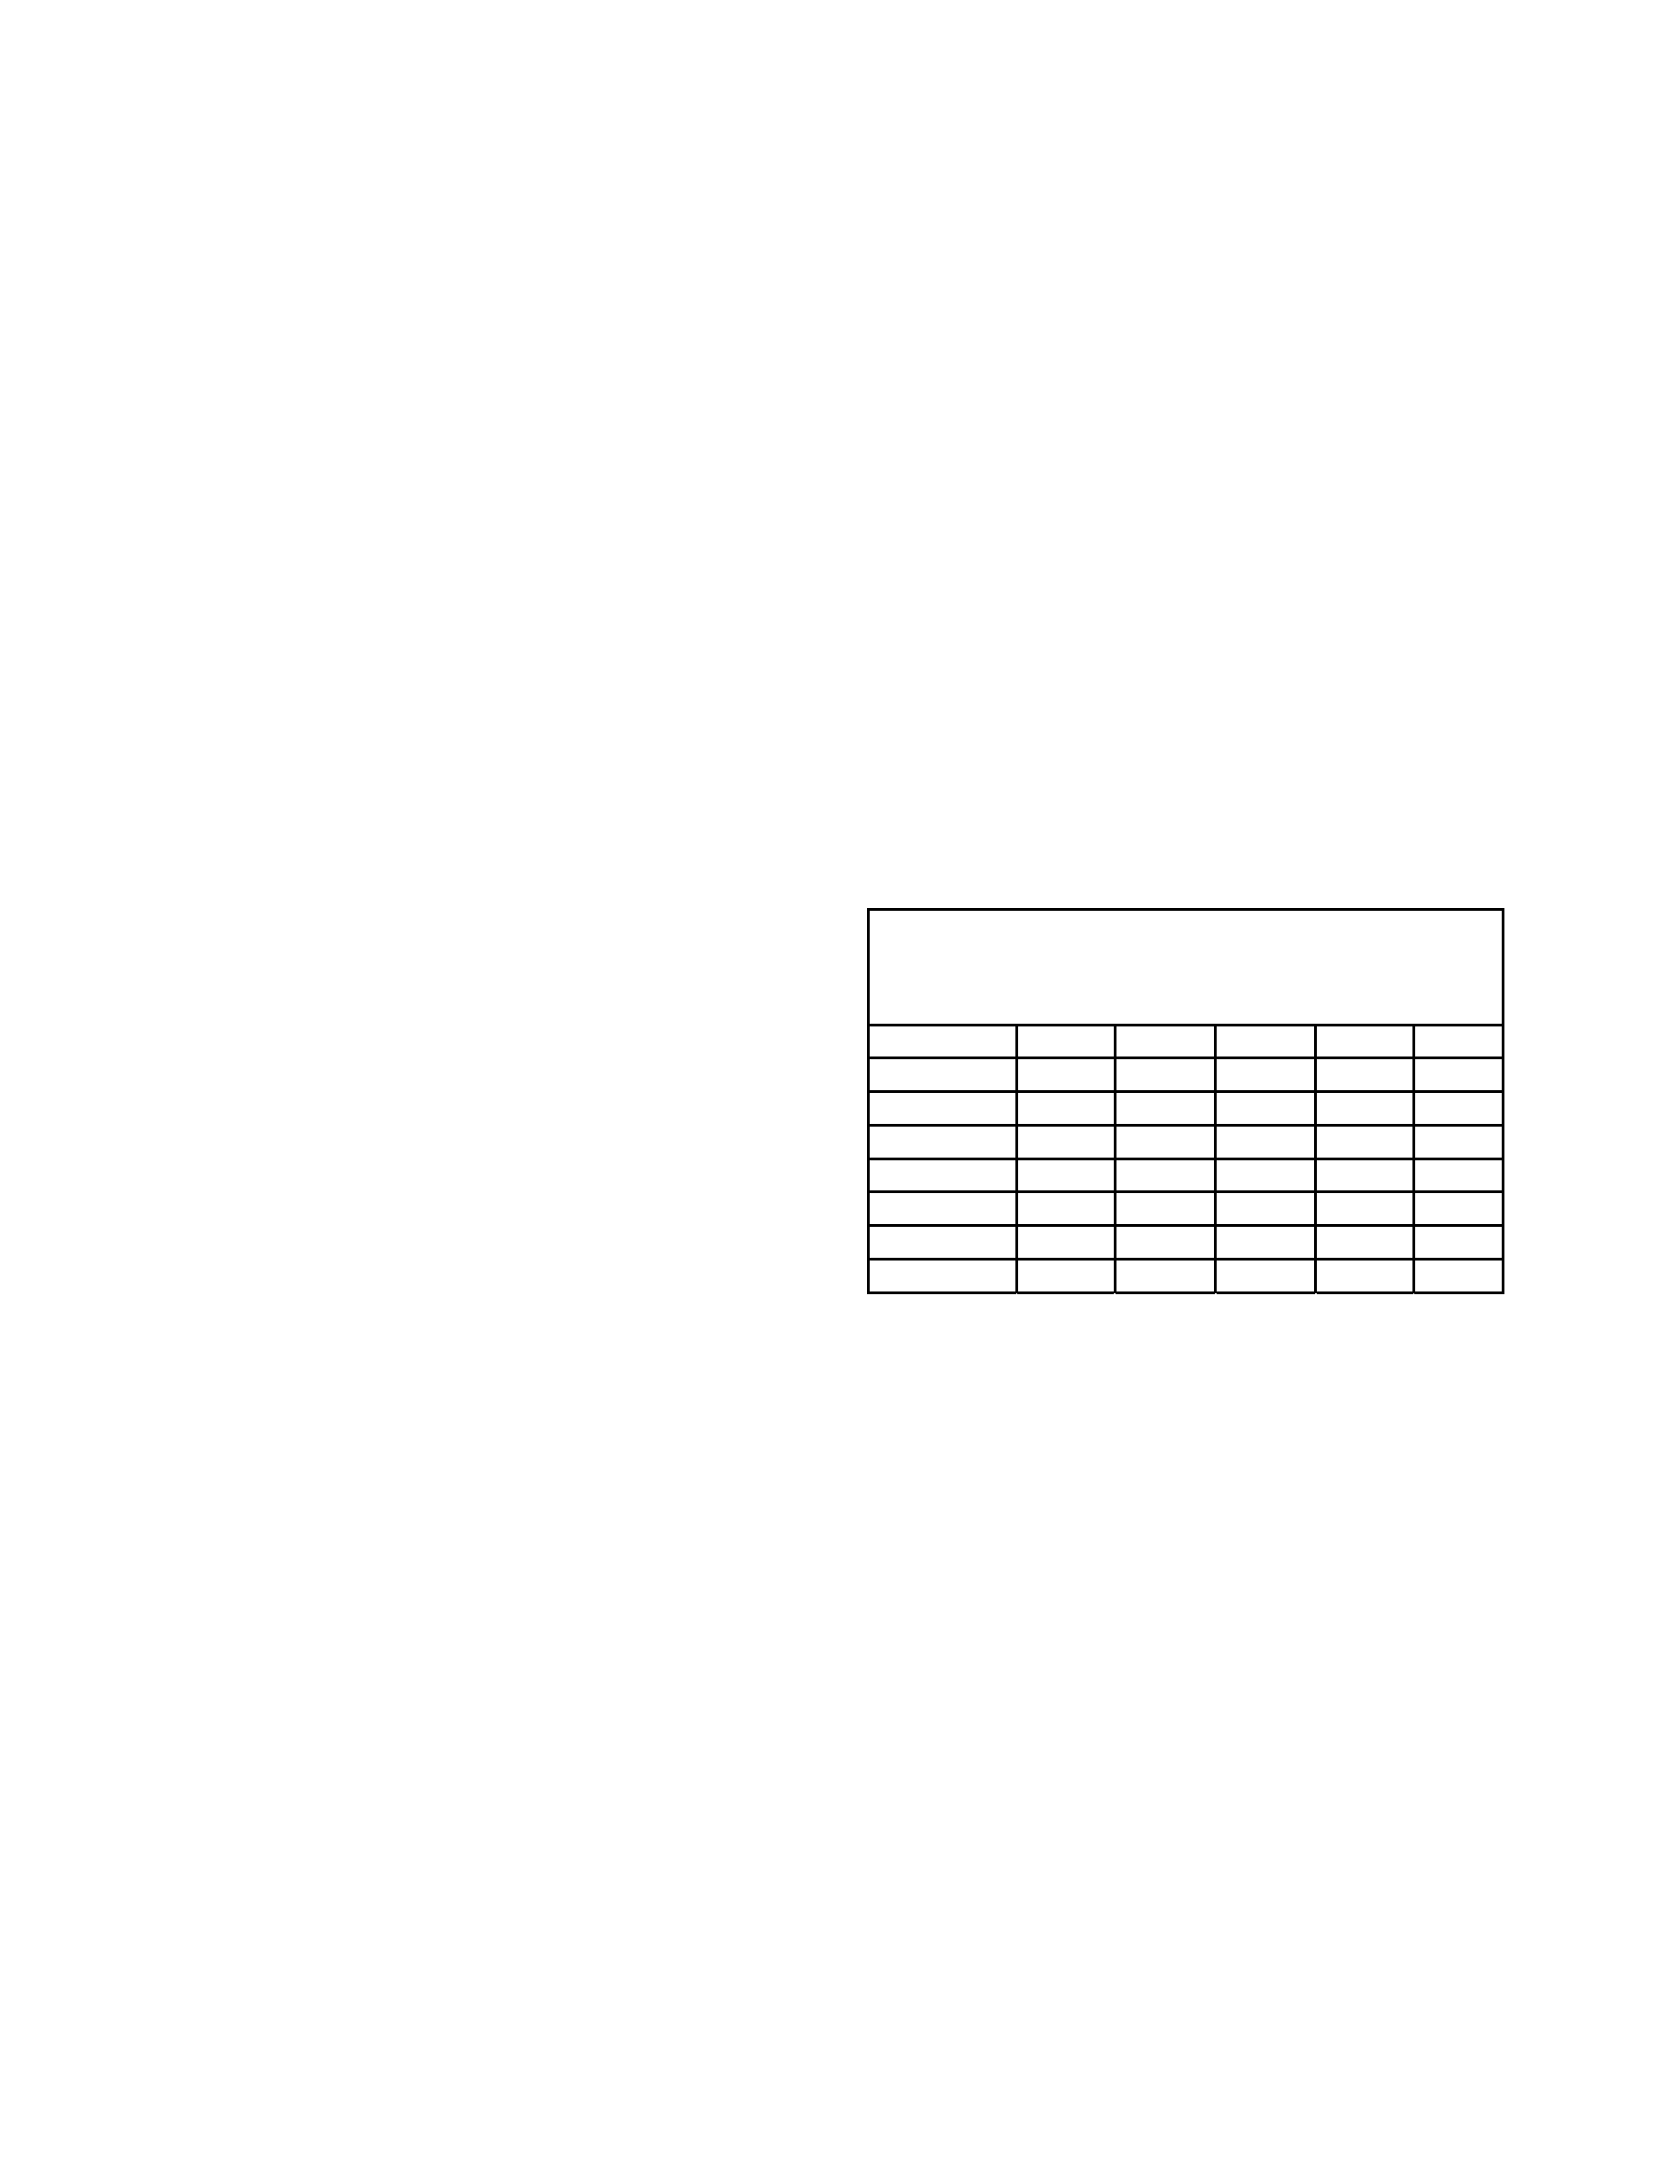
Fleet
race
boat
rotations
Taken
from
the
“
Race
Management
Handbook
”,
©
2001,
US
SAILING
Chapter
5;
5.2,
5.3
“Follow
the
leader”
rotations
“Follow
the
leader”
rotations
can
be
used
with
any
number
of
entries,
odd
or
even.
Their
advan-
tages
are
that
they
are
easy
for
crews
to
remember,
and
are
easily
adaptable
when
established
in
advance,
if
fewer
crews
than
expected
appear
for
the
regatta.
The
drawbacks
to
“follow-the-leader”
rotations
are
that:
(1)
each
crew
to
use
a
boat
always
fol-
lows
the
same
crew
which
has
previously
used
the
boat,
so
it
is
easy
for
one
crew
to
affect
another’s
standing;
and
(2)
they
require
a
larger
number
of
time-consuming
landings
and
exchanges,
either
on
the
exchange
boat
or
ashore.
Each
crew
draws
a
boat
number
for
the
first
race,
and
thereafter
sails
the
next
highest
(or
lowest)
number
each
succeeding
race
(there
is
no
magic
to
use
of
a
higher-numbered
or
lower
numbered
method,
only
personal
preference).
A
simple
“follow
the
leader”
rotation
(sailing
a
higher
numbered
boat)
is
shown
in
Table
5.1.
How
to
exchange
boats
To
exchange
boats
after
the
first
race
1.
The
crew
of
Boat
#1
(Crew
A)
gets
off
on
a
well
fendered
exchange
boat,
and
Boat
#1
is
sailed
away
by
a
non-competitor.
The
crew
of
Boat
#2
(Crew
B)
then
gets
off
on
the
exchange
boat,
and
the
former
crew
of
Boat
#1
takes
Boat
#2
for
the
next
race.
Similarly,
the
former
crew
of
Boat
#3
(Crew
C)
takes
Boat
#4,
etc.,
until
finally
Boat
#1
is
sailed
back
to
the
exchange
boat
for
the
last
crew
(Crew
E).
TABLE
5.1
“Follow
the
Leader”
Rotation
Fleet
Racing
Series
6
Crews,
6
Boats,
5
Races
Race
1
2
3
4
5
Crew
Boat
A
1
2
3
4
5
B
2
3
4
5
6
C
3
4
5
6
1
D
4
5
6
1
2
E
5
6
1
2
3
F
6
1
2
3
4
2.
To
prevent
Crew
A
from
having
a
big
time
advantage
in
preparing
for
subsequent
races,
Boat
#1
(rather
than
Crew
A)
should
always
be
called
first
to
the
exchange
boat
3.
Should
one
or
more
boats
not
sail
the
entire
series,
a
new
rotation
is
easy
to
make.
If
all
crew
listed
start
the
first
race,
the
rotation
should
not
be
changed.
“Direct
swap”
rotations
Whenever
entries
total
an
even
number,
the
“direct
swap”
system
lessens
the
time
for
boat
exchanges
by
having
pairs
of
crews
change
boats
simultaneously.
The
number
of
races
in
which
each
crew
follows
the
same
crew
is
also
markedly
reduced.
For
odd
numbers
of
entries,
use
the
“follow-the-leader”
method.
This
section
discusses
the
method
of
creating
“direct
swap”
boat
rotations.
The
tables
contained
here
are
designed
for
fleet-race
competition
(approximately
90%
of
all
intercollegiate
racing
is
cur-
rently
fleet
racing).’
While
they
are
adaptable
to
team
racing,
most
regatta
organizers
use
the
Hinman
Championship
style
rotations
which
have
been
developed
(see
Tables
in
”Team
racing
rotations
and
boat
pairings”).
Event: Enter event name

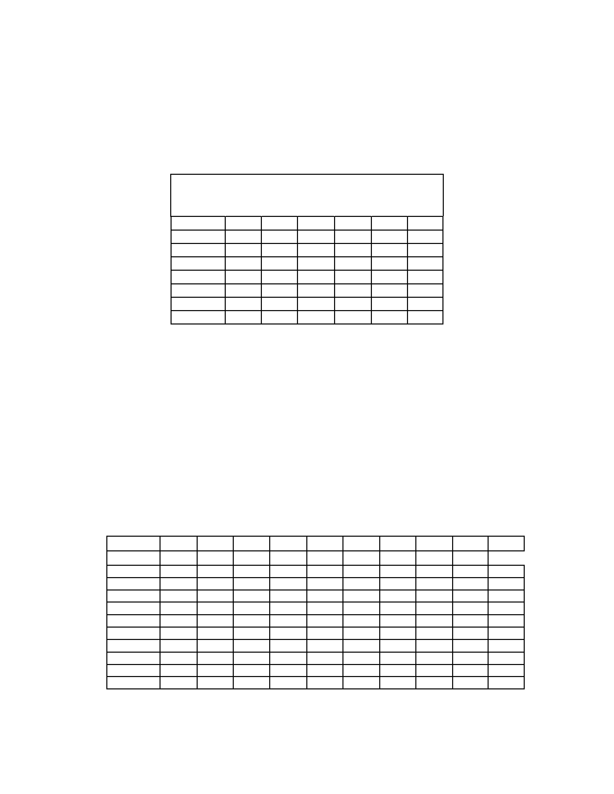
To
create
a
table
(5.2)
of
boat
rotation
for
an
even
number
of
crews:
1.
Down
the
vertical
column
for
the
first
race,
list
boat
numbers
in
ascending
order.
2.
For
the
first
horizontal
row,
list
boats
in
ascending
order.
3.
For
the
second
horizontal
row,
list
boats
in
descending
order.
4.
For
the
remaining
horizontal
rows,
list
boats
alternately
in
ascending
and
descending
order.
TABLE
5.2
Fleet
Race
Direct
Swap
Rotation
6
Crews,
6
Boats,
5
Races
Race
1
2
3
4
5
6
Crew
Boat
A
1
2
3
4
5
6
B
2
1
6
5
4
3
C
3
4
5
6
1
5
D
4
3
2
1
6
5
E
5
6
1
2
3
4
F
6
5
4
3
2
1
For
example,
Table
5.2
shows
a
direct
swap
rotation
for
six
entries.
If
you
have
one
fewer
boats
than
the
number
of
crews,
you
may
still
use
the
direct-swap
format.
Each
crew
sits
out
one
race.
An
example
is
shown
in
Table
5.3.
The
same
concept
applies
where
there
are
ten
crews,
but
only
8
boats.
Each
crew
sits
out
2
races.
Byes
can
be
used
in
either
direct
swap
or
follow-the-leader
rotations.
If
there
is
to
be
more
than
one
bye,
they
should
be
staggered
through
the
rotation
so
that
one
team
or
crew
does
not
have
consecutive
byes.
TABLE
5.3
Fleet
Race
Direct
Swap
Rotation
10
Crews,
9
Boats,
10
Races
Race:
1
2
3
4
5
6
7
8
9
10
Crew:
Boat
A
1
2
3
4
5
6
7
8
9
X
B
2
1
X
9
8
7
6
5
4
3
C
3
4
5
6
7
8
9
X
1
2
D
4
3
2
1
X
9
8
7
6
5
E
5
6
7
8
9
X
1
2
3
4
F
6
5
4
3
2
1
X
9
8
7
G
7
8
9
X
1
2
3
4
5
6
H
8
7
6
5
4
3
2
1
X
9
I
9
X
1
2
3
4
5
6
7
8
J
X
9
8
7
6
5
4
3
2
1
©
2001,
US
SAILING
Event: Enter event name
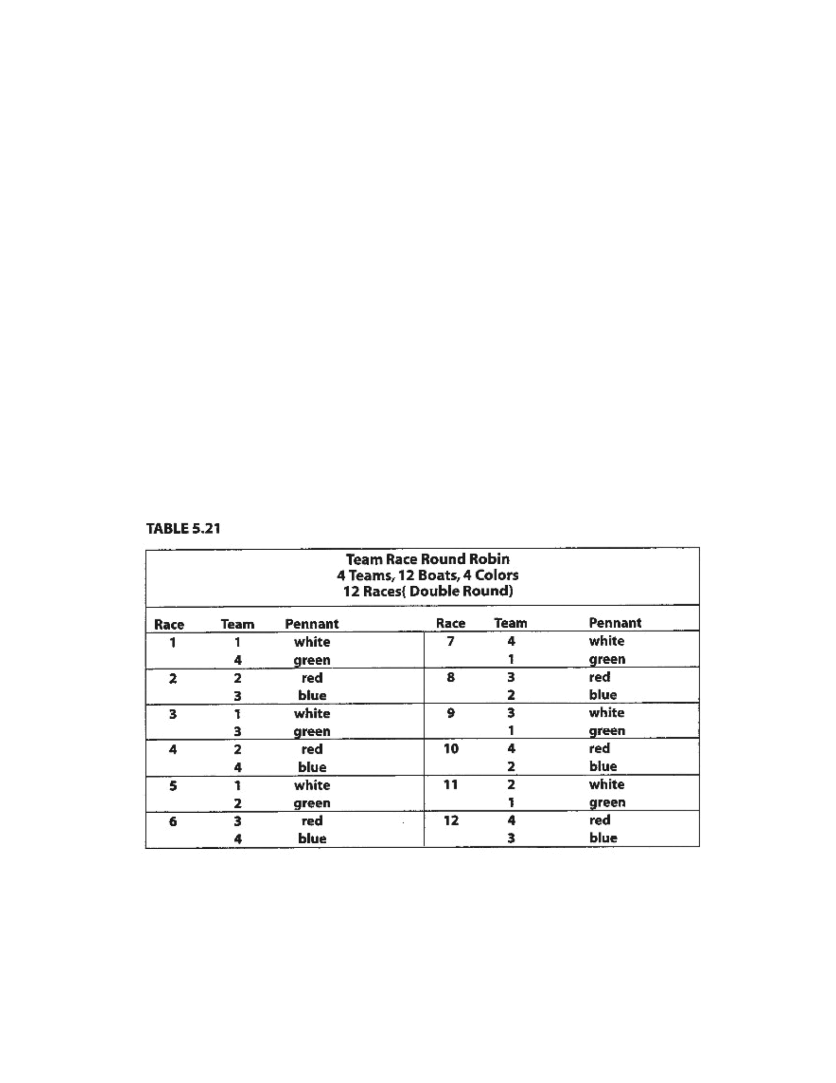
Taken
from
“
Race
Management
Handbook
”,
Chapter
5
©
2001,
US
SAILING
Page
1
of
24
Team
racing
rotations
and
boat
pairings
The
basic
“final-four”
boat
rotation
and
pairings
In
team
racing
championship
rotations
the
boats
carry
an
identifying
characteristic
(usually
a
shroud
flag
or
pennant).
One
designated
group
of
boats
always
races
against
a
second
designated
group
(for
example,
boats
displaying
white
pennants
always
race
against
the
boats
displaying
green
pennants,
red
against
blue,
yellow
against
black,
etc.).
The
teams
in
the
boats
usually
change
after
every
race.
Ideally,
each
team
sails
each
boat
an
equal
number
of
times,
although
is
not
always
possible
unless
a
double
round-robin
is
sailed.
A
shorthand
method
of
referring
to
the
rotations
is
by
number
of
competing
teams
and
number
of
boats
used.
For
example,
a
5-team,
6-boat
rotation
is
referred
to
as
“5x6”;
an
11-team,
24-
boat
rotation
is
referred
to
as
“11x24”.
The
system
assumes
that
the
boats
are
equal,
so
equalization
is
very
important.
“Fairness”
is
then
furthered
by
designing
the
boat
rotations
and
pairings
in
advance,
and
having
the
teams
draw
lots
for
their
positions
in
the
rotation.
The
championship
rotations
were
originally
written
for
the
US
SAILING
Team
Racing
Championship
(Hinman
Trophy)
by
Mrs.
Rich
Treacy
in
1987
for
the
5x6
through
8x6,
and
5x12
through
11x12.
They
have
since
been
expanded
for
18
and
24
boat
rotations.
The
basic
team
racing
direct
swap
is
shown
in
Table
5.21,
in
which
four
teams
meet
in
a
“double
round-robin.”
The
groups
of
boats
(3
per
group)
are
identified
by
four
colored
pennants—red,
blue,
green
and
white,
although
they
can
be
any
colors.
Running
team
races
with
limited
numbers
of
boats
You
can,
however,
run
a
team
racing
series
with
fewer
than
enough
boats
for
all
members
of
each
team.
In
other
words,
12
boats
(4
groups,
3
boats
each)
will
accommodate
4
teams.
But
if
there
are
not
enough
boats,
some
of
the
teams
may
race
while
others
stand
by.
The
teams
then
ex-
change
boats
with
the
next
teams
to
race.
Tables
5.22,5.23,
5.25,5.27
and
5.29
show
rotations
for
round
robins
of
races
for
6
or
12
boats,
for
5
through
9
teams,
respectively.
Event: Enter event name

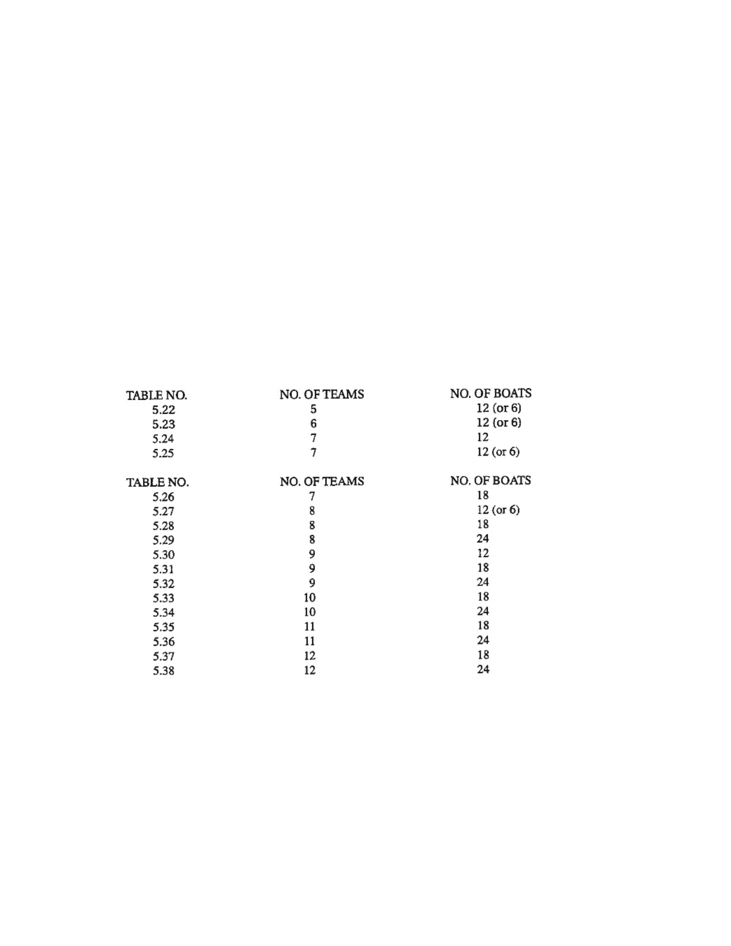
Taken
from
“
Race
Management
Handbook
”,
Chapter
5
©
2001,
US
SAILING
Page
2
of
24
A
“limited
rotation”
variation
on
the
“follow
the
leader”
method
Where
there
are
not
enough
boats
to
accommodate
all
of
the
competing
teams,
a
“limited
rotation”
can
also
be
used.
For
example,
if
ten
teams
are
competing,
but
there
are
only
enough
boats
for
6
teams,
(18
boats),
Ken
Legler
of
Tufts
University
suggests
the
following
round-robin
format:
Six
teams
(A
through
F)
sail
the
first
three
races.
Upon
finishing,
teams
A
and
B
sail
in
to
exchange
with
teams
G
and
H,
while
teams
C
through
F
become
the
first
two
starts
of
the
second
round.
Teams
G
and
H
become
the
third
start
of
round
2.
This
pattern
continues
with
teams
staying
on
the
water
for
either
four
or
two
straight
races
against
other
teams
without
exchanging
boats,
until
it
is
their
turn
to
go
ashore
and
rotate
out.
Using
this
method,
it
is
possible
to
complete
all
45
races
of
a
ten-team
round-robin
(see
formula
on
page
5.27)
in
one
day.
Pairings
and
rotations
for
round-robins
You
may
use
the
following
Tables
in
lieu
of
designing
a
round-robin
rotation.
Each
may
be
used
by
itself
or
in
combination
with
other
formats,
such
as
a
“best-of-three”
final,
a
“final-four”
round-robin,
etc.
(see
“Suggested
Formats”
Section
3.4
above).
As
mentioned
above,
do
not
start
with
a
rotation
which
is
too
ambitious.
Seventy-eight
races
in
a
two
day
event
is
a
realistic
goal
if
your
personnel
expediting
boat
exchanges
are
experienced,
and
the
race
course
is
not
far
from
the
boat
exchange
location.
The
Round-Robin
Tables
which
follow
are:
In
each
of
the
Tables,
only
a
single
round-robin
is
shown.
A
double
round-robin
is
a
repeat
of
the
first
round.
For
double
round-robins,
you
may
want
to
reverse
the
boat
assignments
so
that
at
their
next
meeting
in
round
2,
the
competitors
are
sailing
the
boats
their
opponents
sailed
in
round
1.
The
comments
after
Tables
5.22,5.23,5.25
and
5.27
include
suggestions
how
to
change
the
Table
if
you
are
using
only
6
boats.
Although
they
are
adaptable
to
either
four
groups
(12
boats)
or
two
(6
boats),
eight
teams
is
effectively
the
practical
limit
for
using
6
boats,
because
the
teams
must
wait
so
long
between
races.
Event: Enter event name

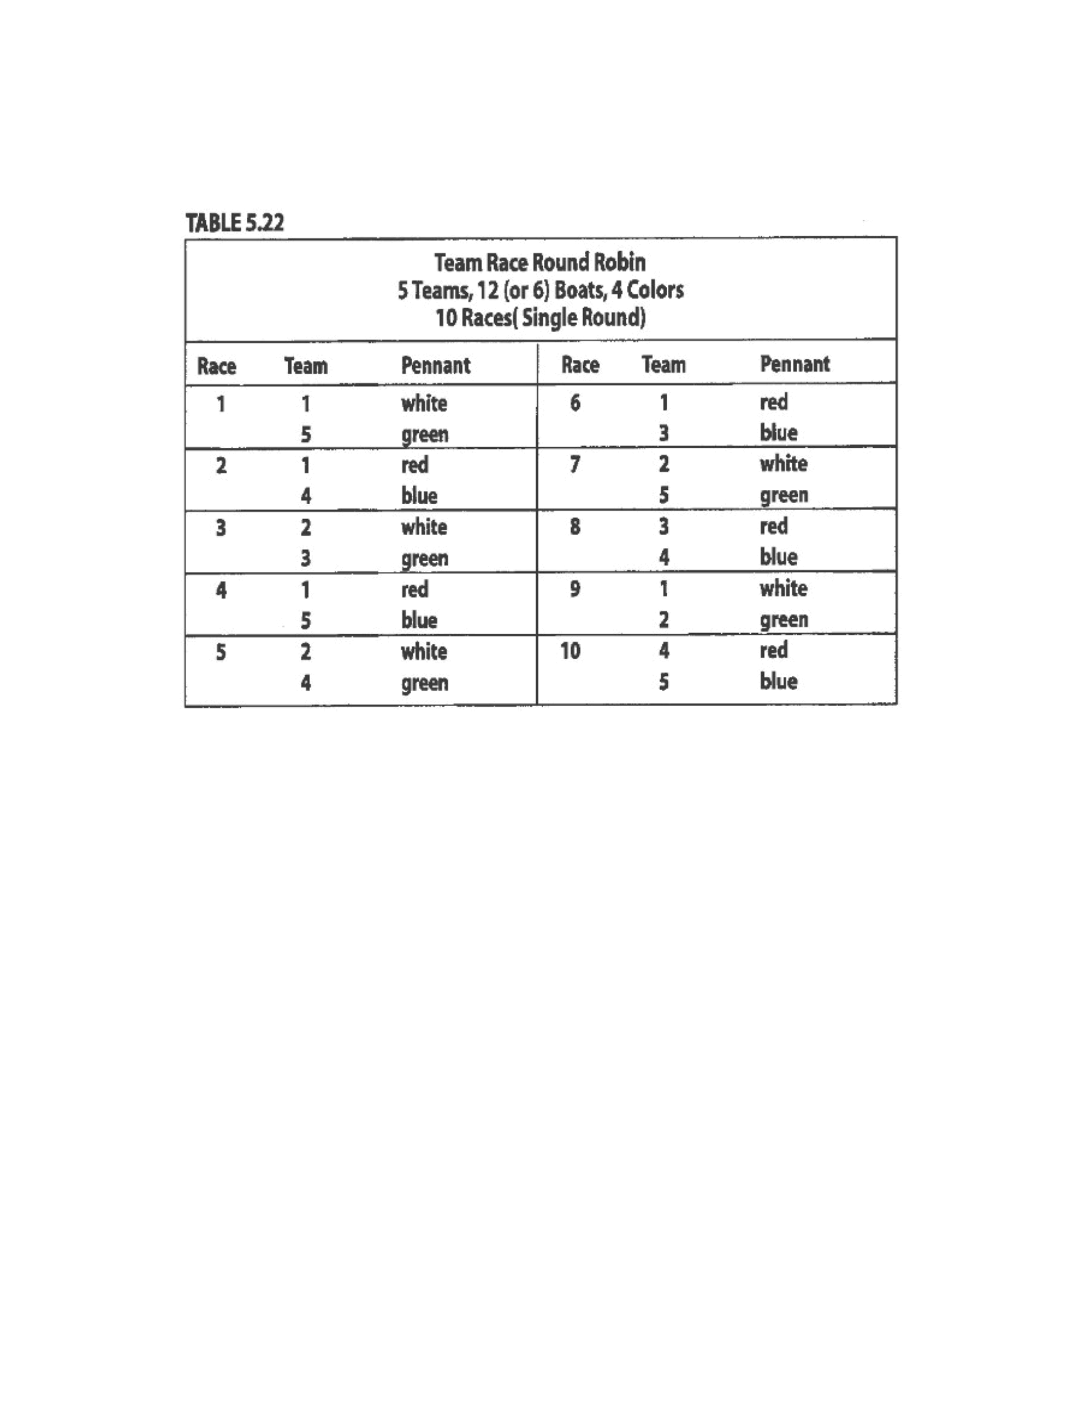
Taken
from
“
Race
Management
Handbook
”,
Chapter
5
©
2001,
US
SAILING
01997.
US
SAIUNG
Comments
to
Table
5.22:
1.
For
a
double
round-robin,
repeat
the
same
format
for
the
second
round.
Time
permitting,
add
a
“best-of-
three”
final
(see
“Suggested
Formats”).
2.
Where
you
have
only
6
boats,
the
pairing
is
the
same,
but
only
two
colors
are
used
(for
example,
white
and
green).
Instead
of
starting
race
2
immediately
after
race
1,
the
teams
must
exchange
boats
after
each
race
with
the
next
teams
to
start.
Event: Enter event name

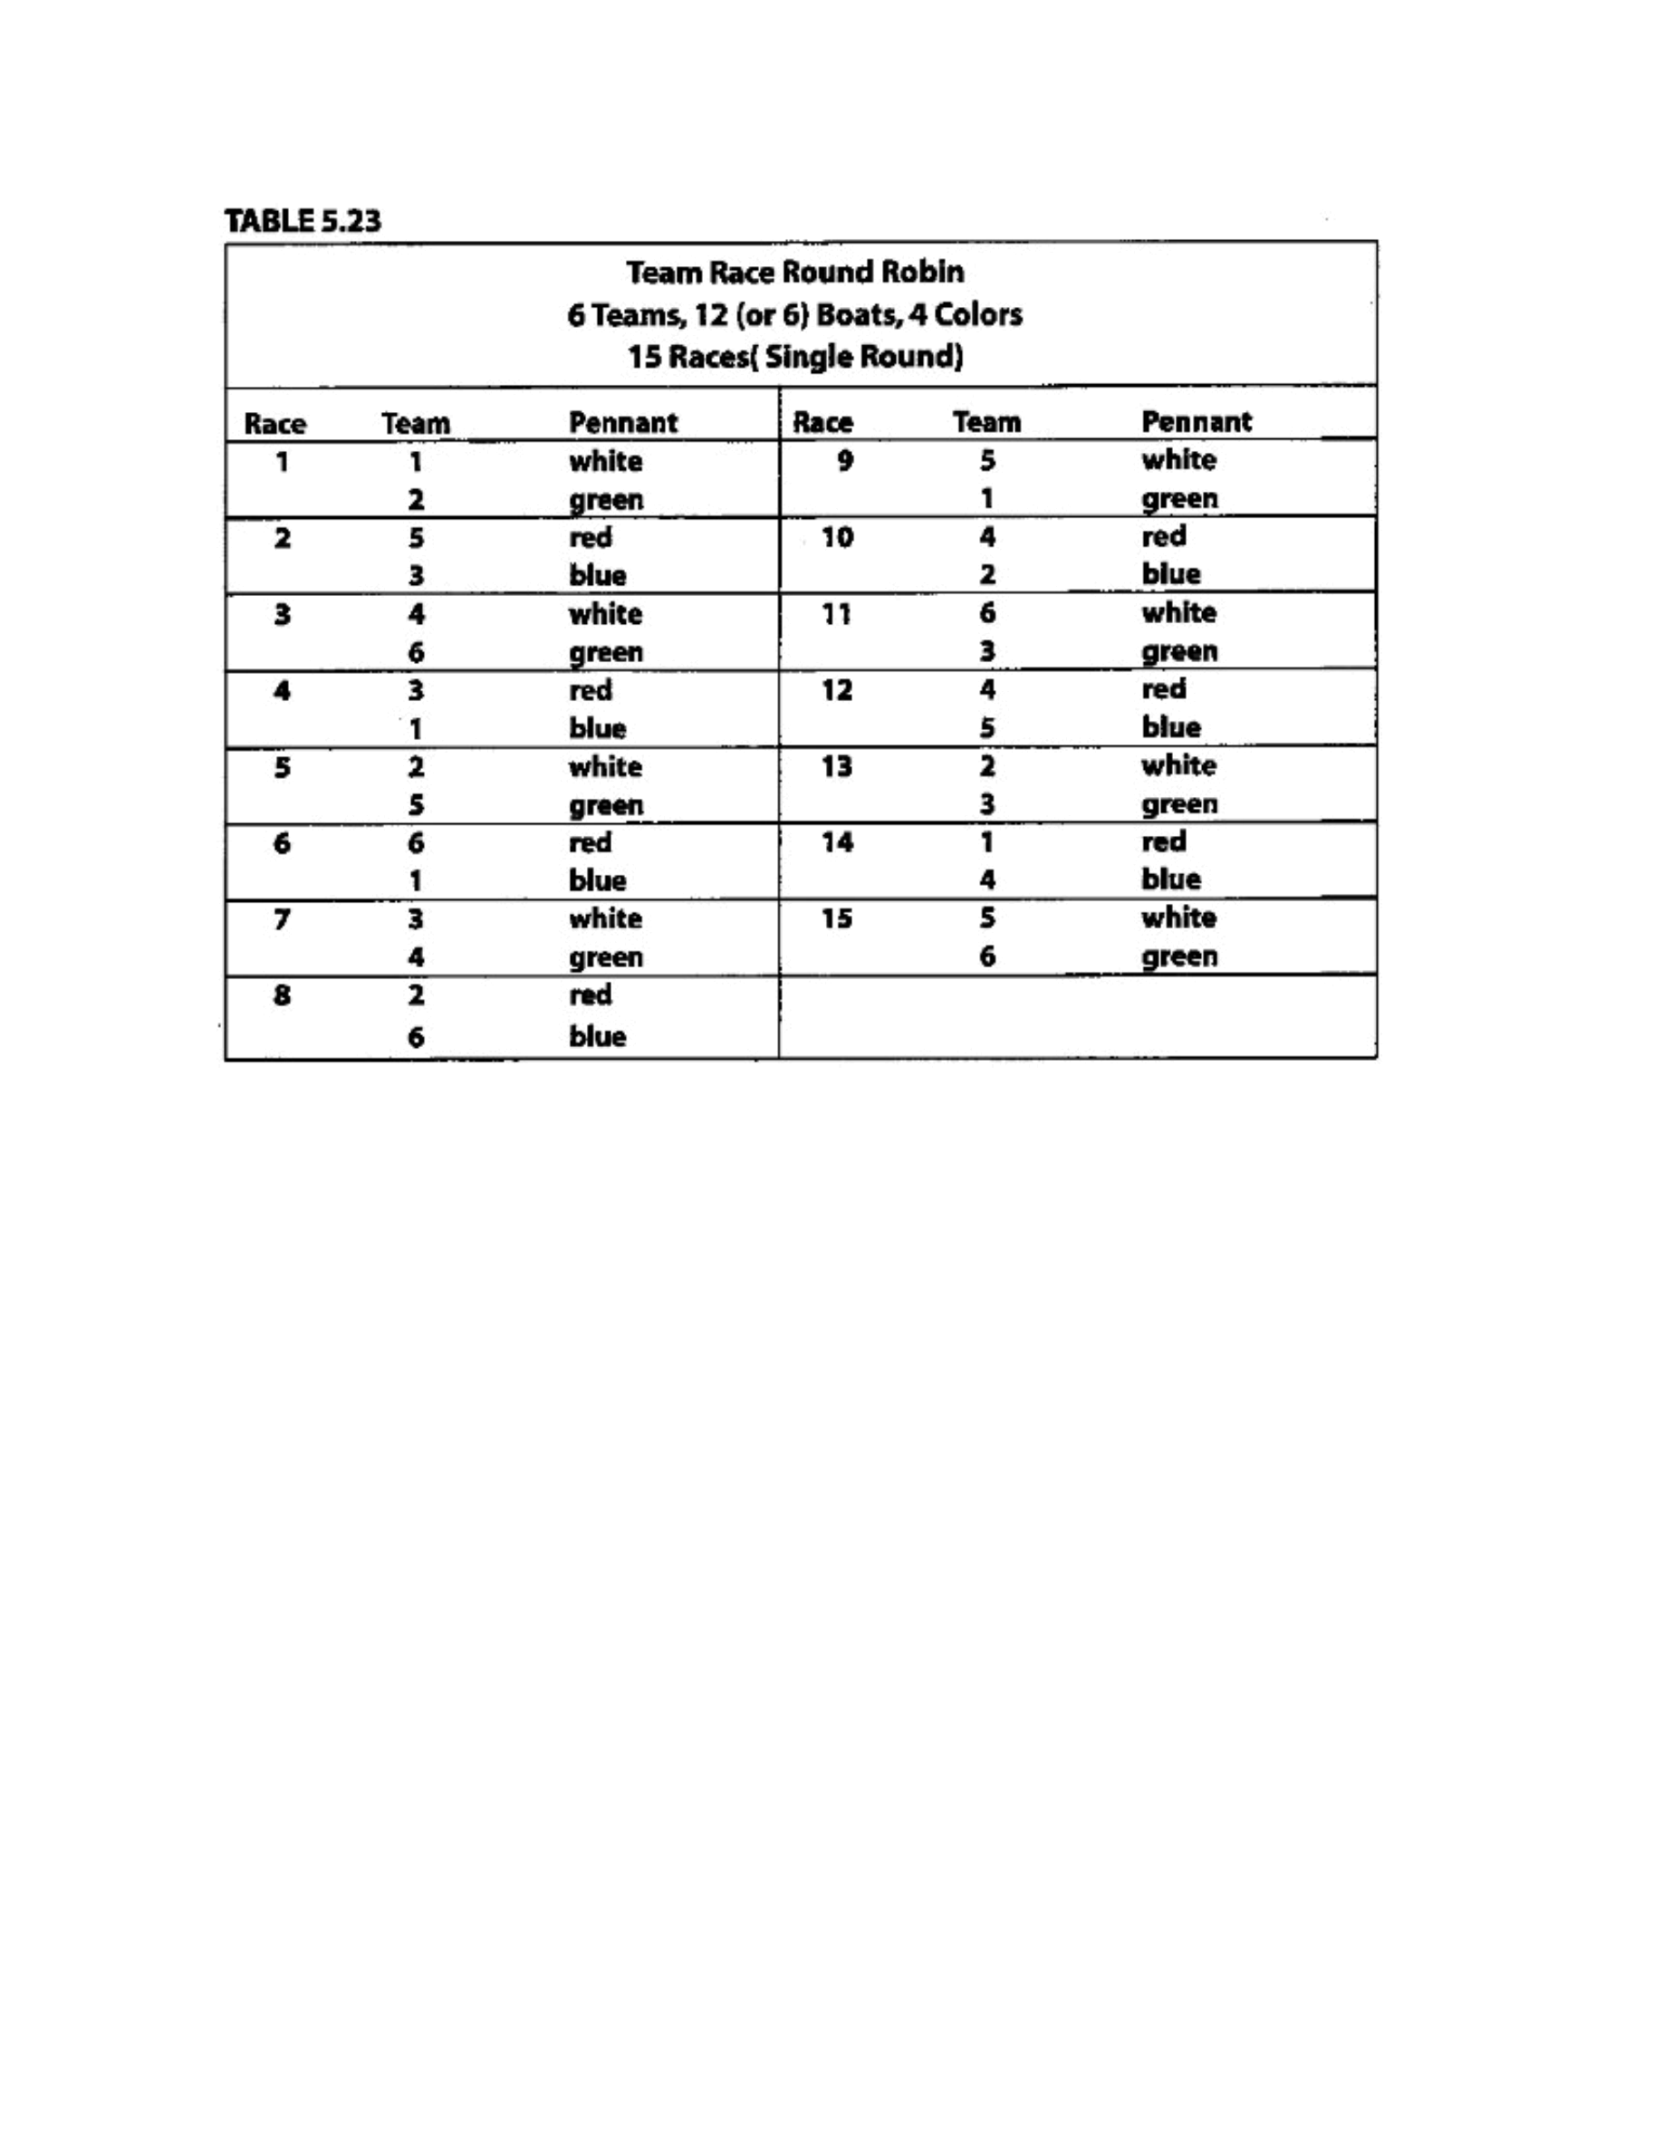
Taken
from
“
Race
Management
Handbook
”,
Chapter
5
©
2001,
US
SAILING
Page
4
of
24
Comments
to
Table
5.23:
1.
For
a
double
round-robin,
repeat
the
same
format
for
the
second
round.
Break
between
races
15
and
16,
since
the
boats
with
the
white
and
green
pennants
will
be
used
in
both
races.
2.
Instead,
you
may
wish
to
use
a
single
round-robin,
followed
by
a
“best-of-three”
final,
with
all
races
counted
(see
“Suggested
Formats”).
3.
Where
you
have
only
6
boats,
the
pairing
is
the
same,
but
only
two
colors
are
used
(for
exam-
ple,
white
and
green).
Instead
of
starting
race
2
immediately
after
race
1,
the
teams
must
exchange
boats
after
each
race
with
the
next
teams
to
start.
4.
The
boat
rotation
for
six
teams
using
18
boats
is
only
slightly
quicker
than
the
12-boat
rotation,
so
only
the
recommended
12-boat
rotation
is
included
here,
between
races
21
and
22,
since
the
boats
with
the
white
and
green
pennants
will
be
used
in
both
races.
3.
Where
you
have
only
6
boats,
the
pairing
is
the
same,
but
only
two
colors
are
used
(for
exam-
ple,
white
and
green).
Instead
of
starting
race
2
immediately
after
race
1,
the
teams
must
exchange
boats
after
each
race
with
the
next
teams
to
start.
4.
Where
you
have
18
boats,
use
Table
5.26.
Event: Enter event name

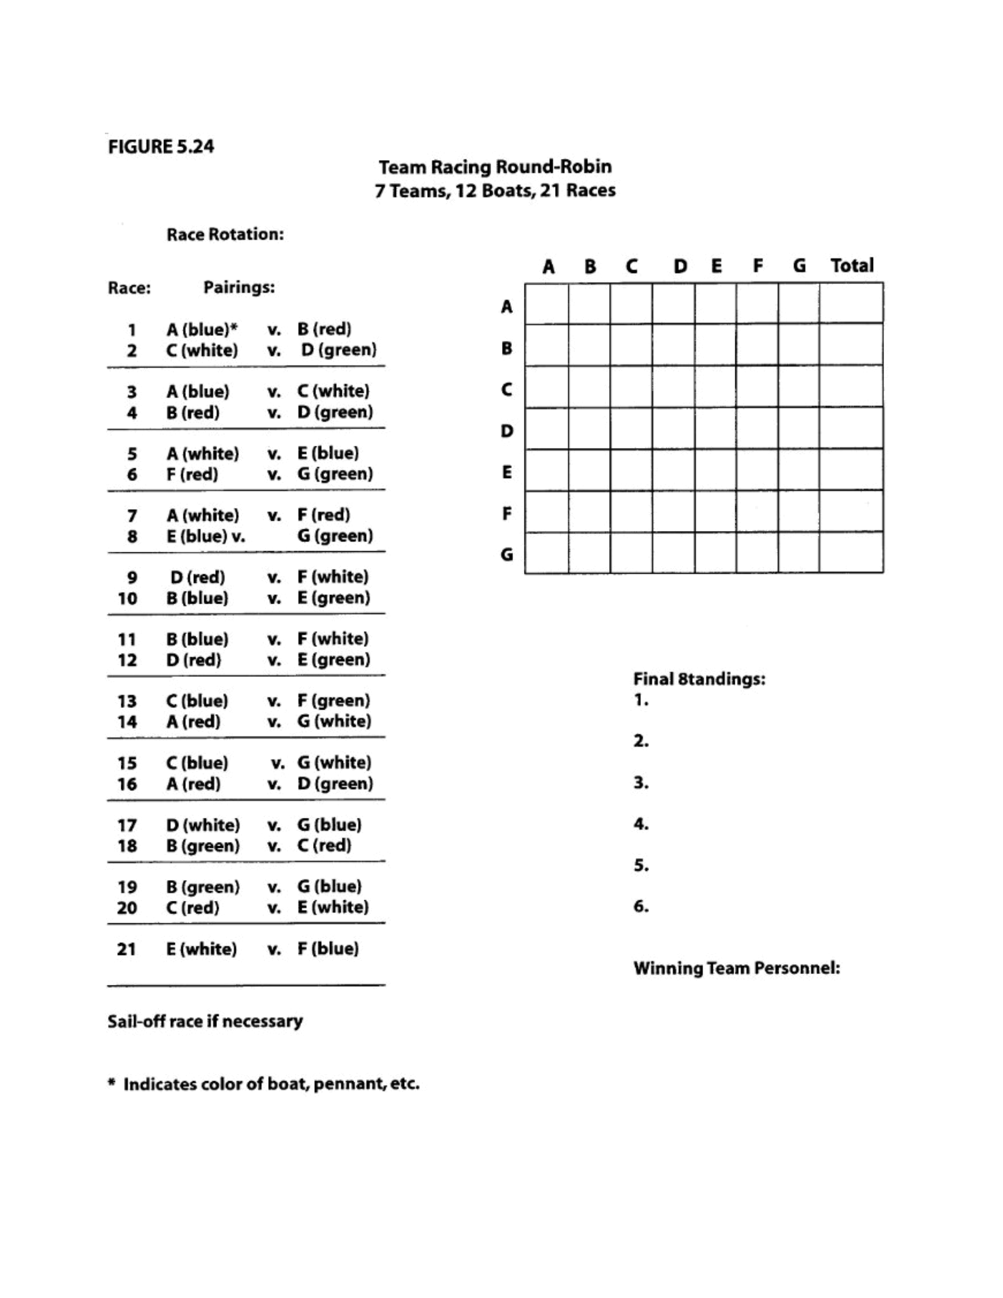
Taken
from
“
Race
Management
Handbook
”,
Chapter
5
©
2001,
US
SAILING
Page
5
of
24
Event: Enter event name

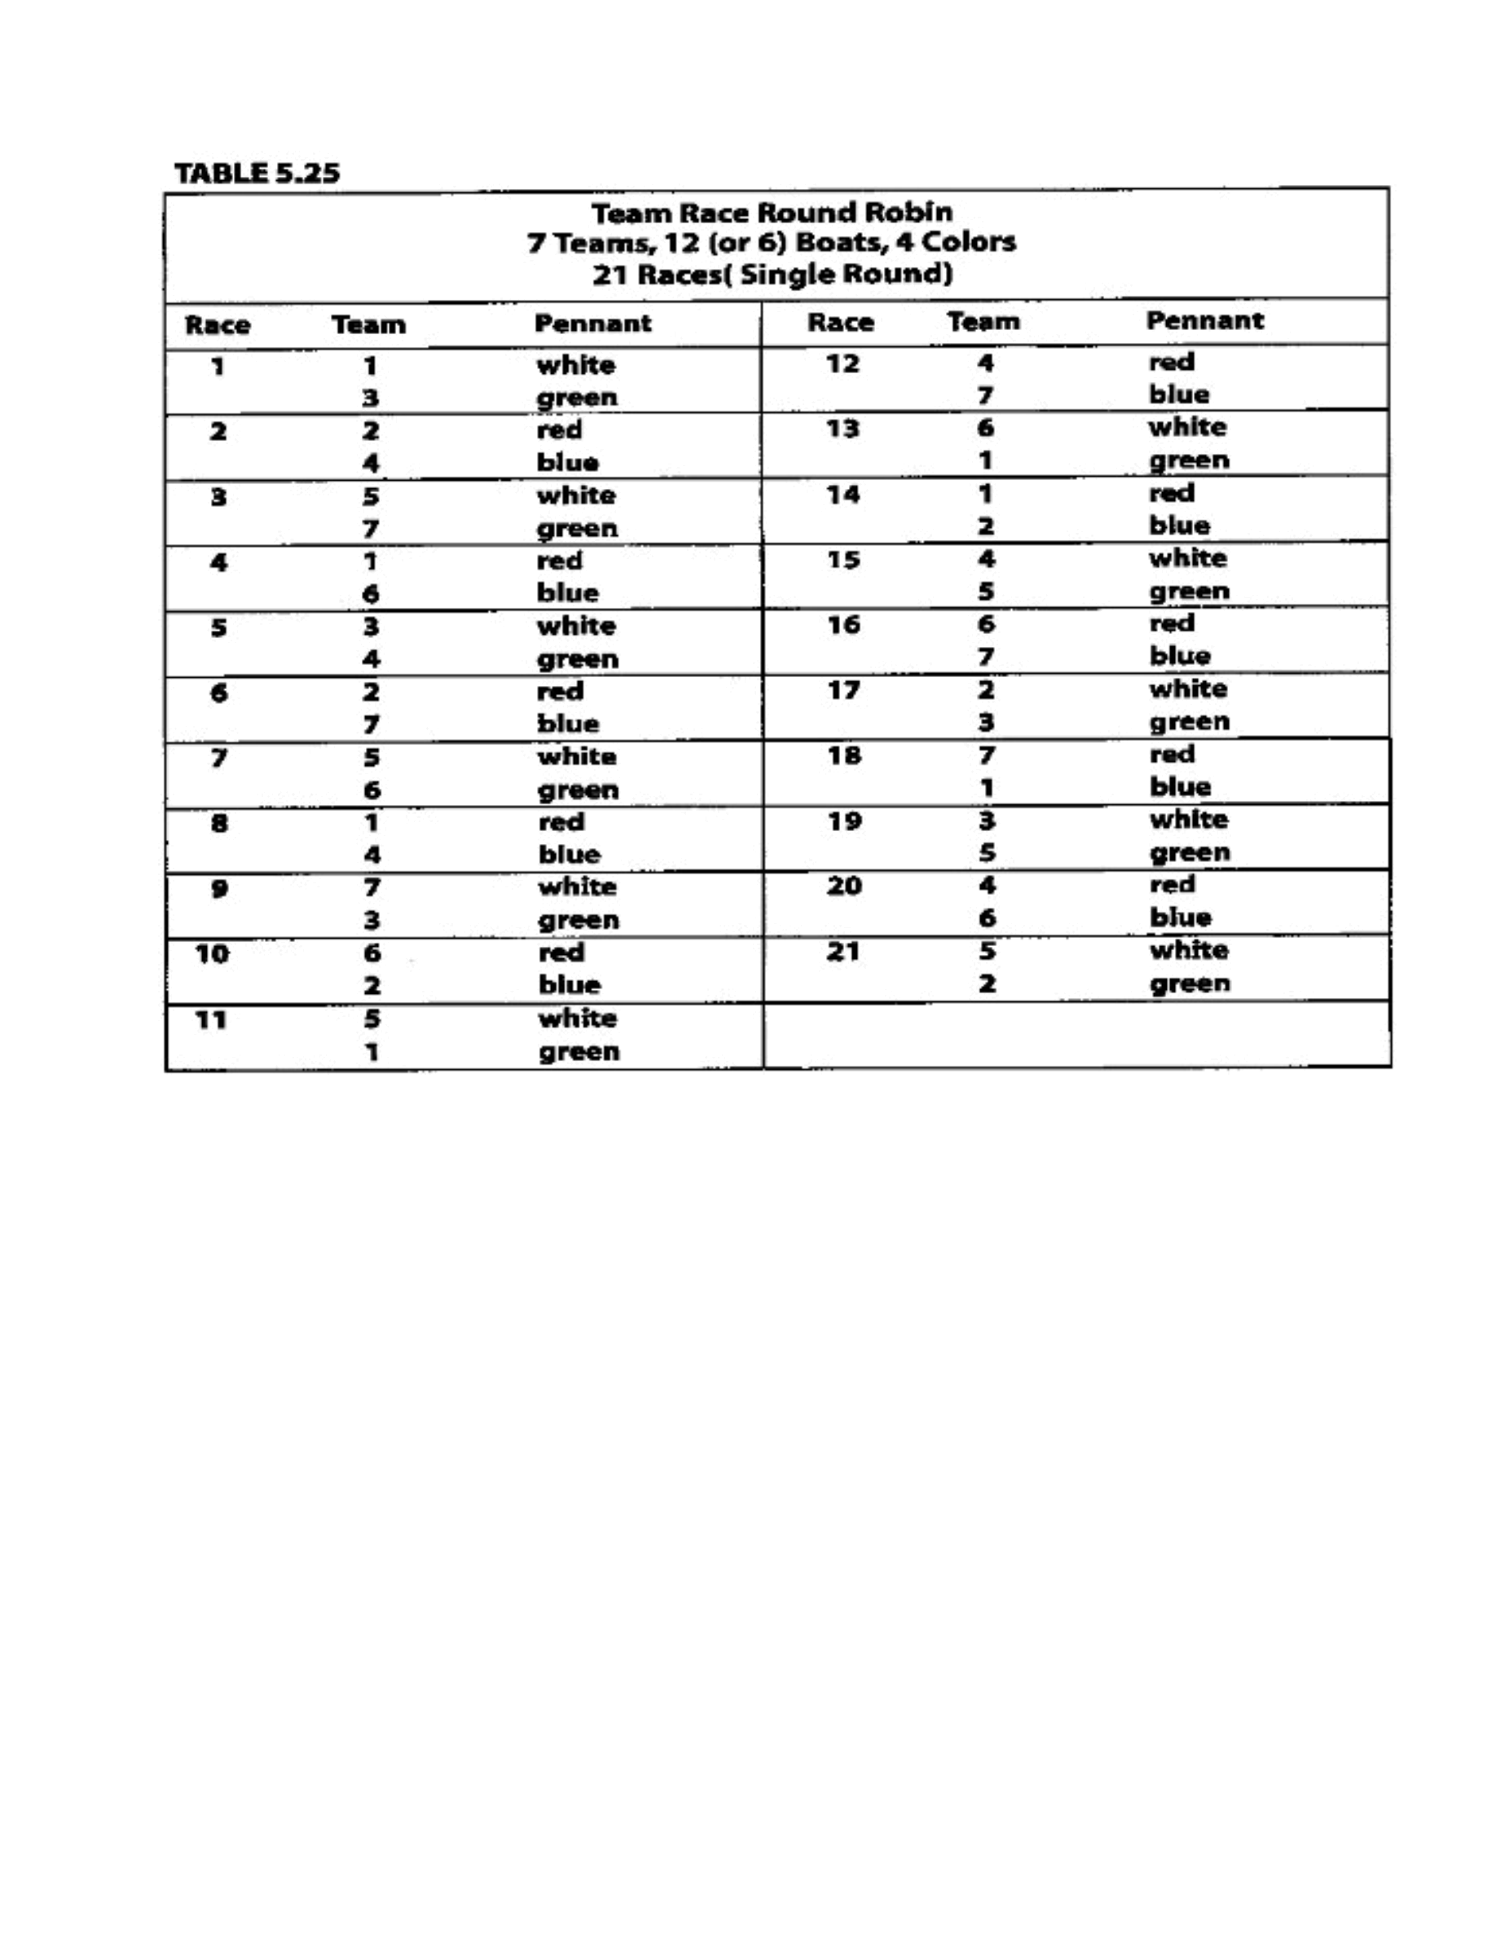
Taken
from
“
Race
Management
Handbook
”,
Chapter
5
©
2001,
US
SAILING
Page
6
of
24
Comments
to
Table
5.25:
1.
Table
5.25
is
the
same
type
of
format
as
Table
5.24,
but
expressed
differently.
2.
You
may
wish
to
use
a
single
round-robin,
followed
by
a
“final
four”
round
robin.
Table
5.21
(see
“Suggested
Formats”).
3.
For
a
double
round-robin,
repeat
the
same
format
for
the
second
round.
Break
between
races
21
and
22,
since
the
boats
with
the
white
and
green
pennants
will
be
used
in
both
races.
3.
Where
you
have
only
6
boats,
the
pairing
is
the
same,
but
only
two
colors
are
used
(for
exam-
ple,
white
and
green).
Instead
of
starting
race
2
immediately
after
race
1,
the
teams
must
exchange
boats
after
each
race
with
the
next
teams
to
start.
5.
Where
you
have
18
boats,
use
Table
5.26.
Event: Enter event name

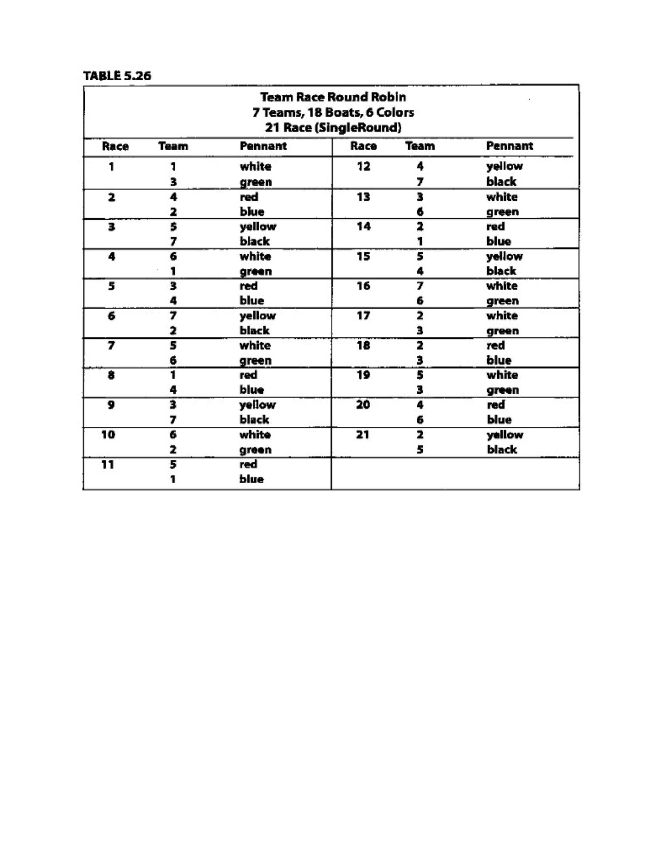
Taken
from
“
Race
Management
Handbook
”,
Chapter
5
©
2001,
US
SAILING
Page
7
of
24
Event: Enter event name

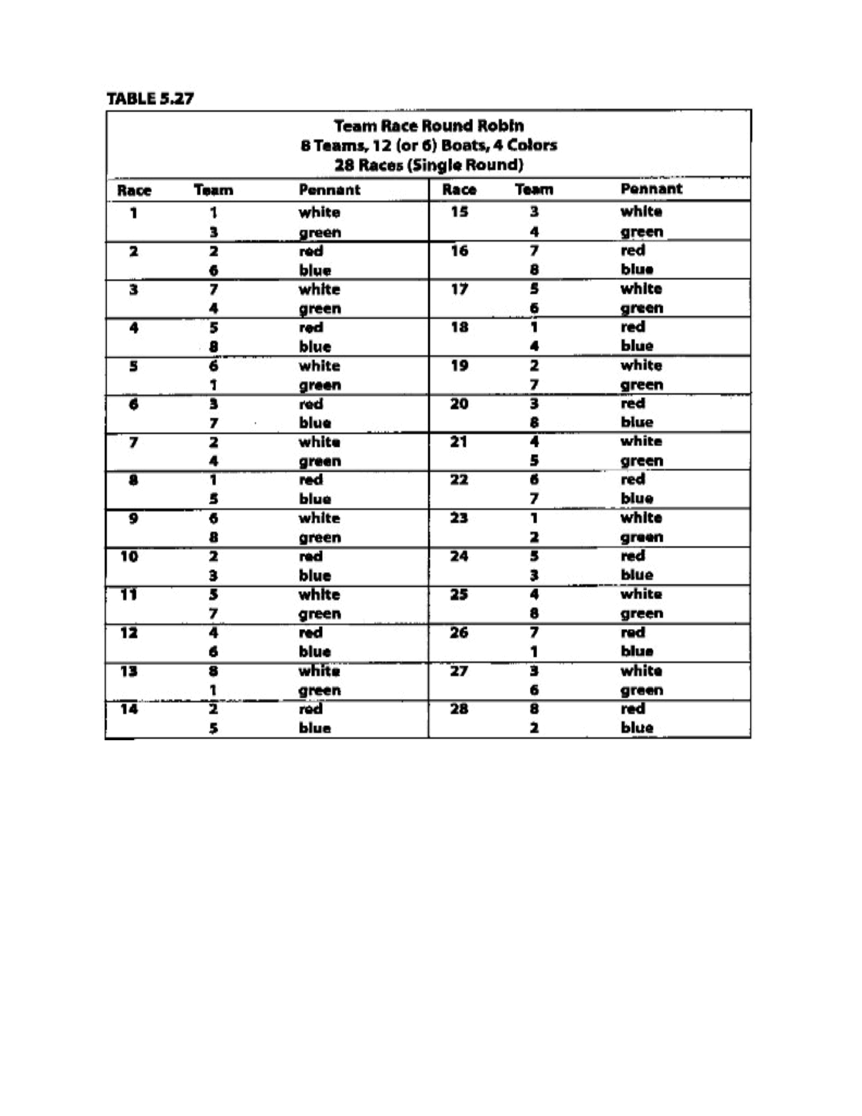
Taken
from
“
Race
Management
Handbook
”,
Chapter
5
©
2001,
US
SAILING
Page
8
of
24
Comments
Table
5.27
1.
For
a
double
round-robin,
repeat
the
same
format
for
the
second
round.
2.
Where
teams
are
unevenly
matched,
use
a
bracket
system
elimination
(Table
5.16).
Where
they
are
evenly
matched,
use
either
a
double
round-robin,
or
a
single
round-robin
followed
by
either
a
“best-of-three”
final
or
a
“final-four”
round-robin
(Table
5.21)
3.
Eight
teams
is
effectively
the
practical
limit
for
using
only
6
boats,
because
of
the
amountof
time
each
team
must
wait
to
race.
Where
you
have
only
6
boats,
the
pairing
is
the
same,
but
only
two
colors
are
used
(for
example,
white
and
green),
Instead
of
starting
race
two
immediately
after
race
1,
the
teams
must
exchange
boats
after
each
race
with
the
next
teams
to
start.
Event: Enter event name

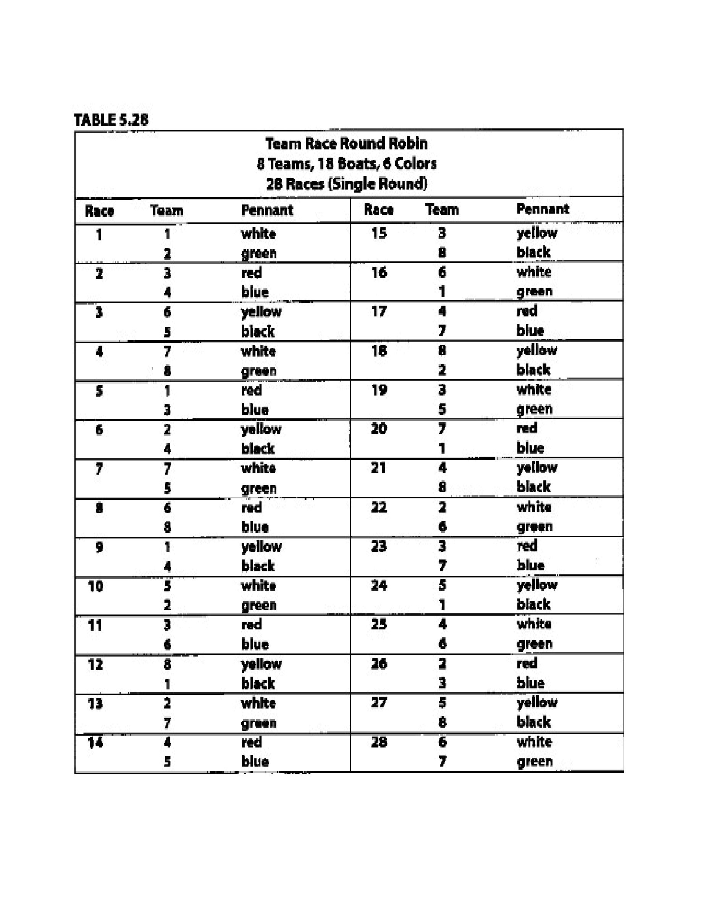
Taken
from
“
Race
Management
Handbook
”,
Chapter
5
©
2001,
US
SAILING
Page
9
of
24
Event: Enter event name

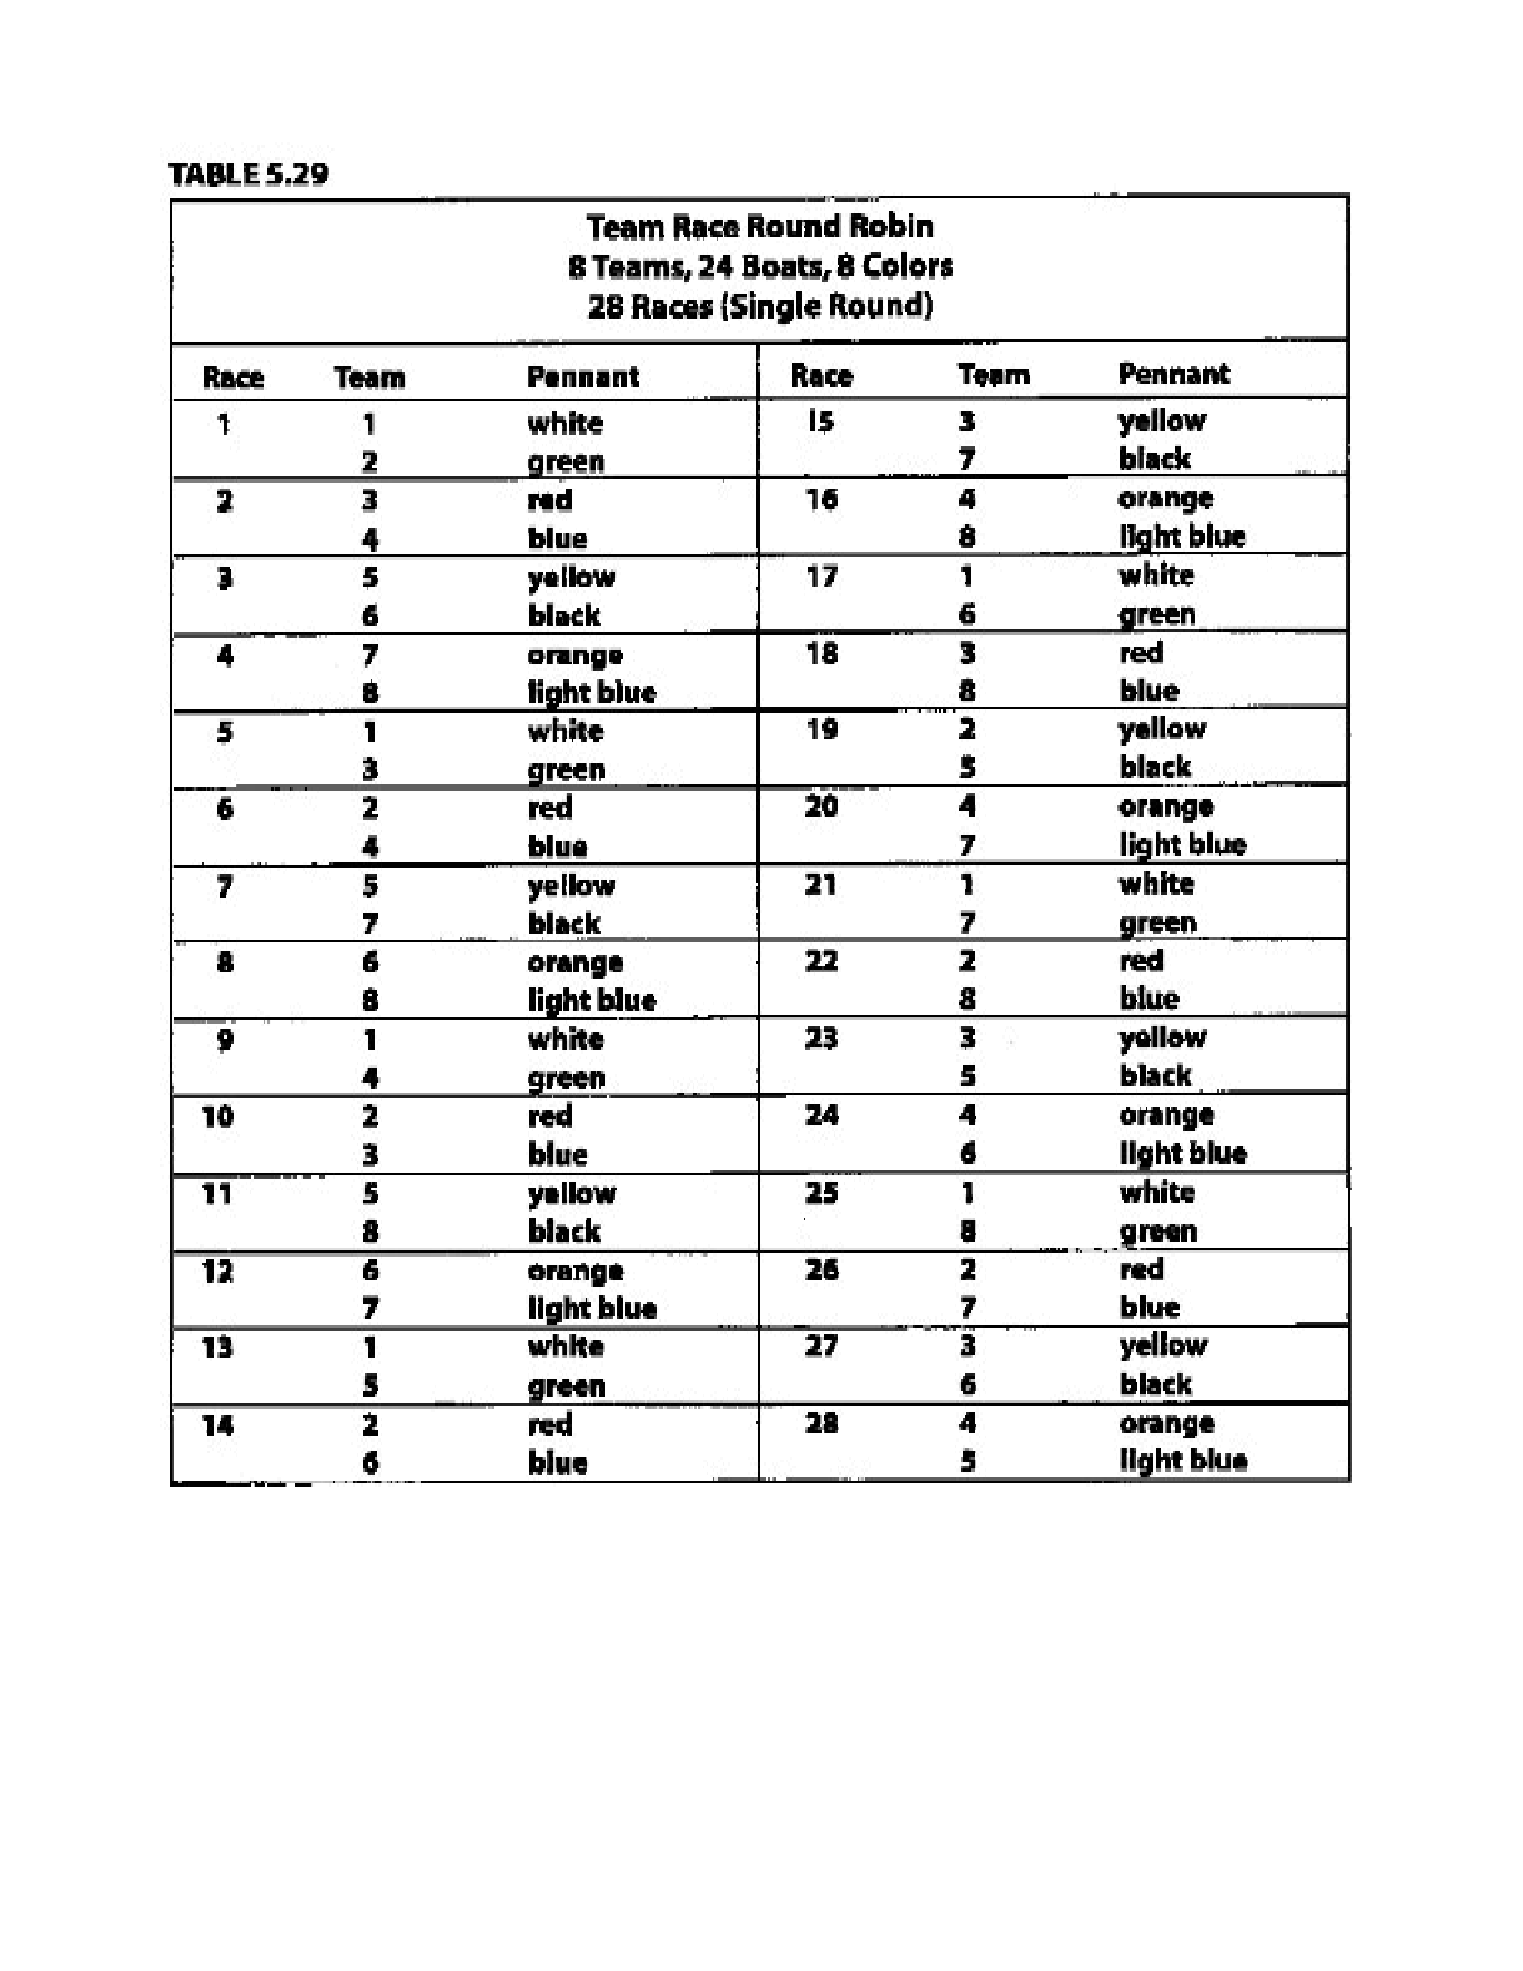
Taken
from
“
Race
Management
Handbook
”,
Chapter
5
©
2001,
US
SAILING
Comment
to
Tables
5.33-
5.38:
Use
these
single
round
robins
with
either
a
“best-of-three”
final
or
a
“final-four”
round
robin
(see
“Suggested
Formats”,
“Basic
final-Four”
and
Table
5.21
above).
Page
10
of
24
Event: Enter event name

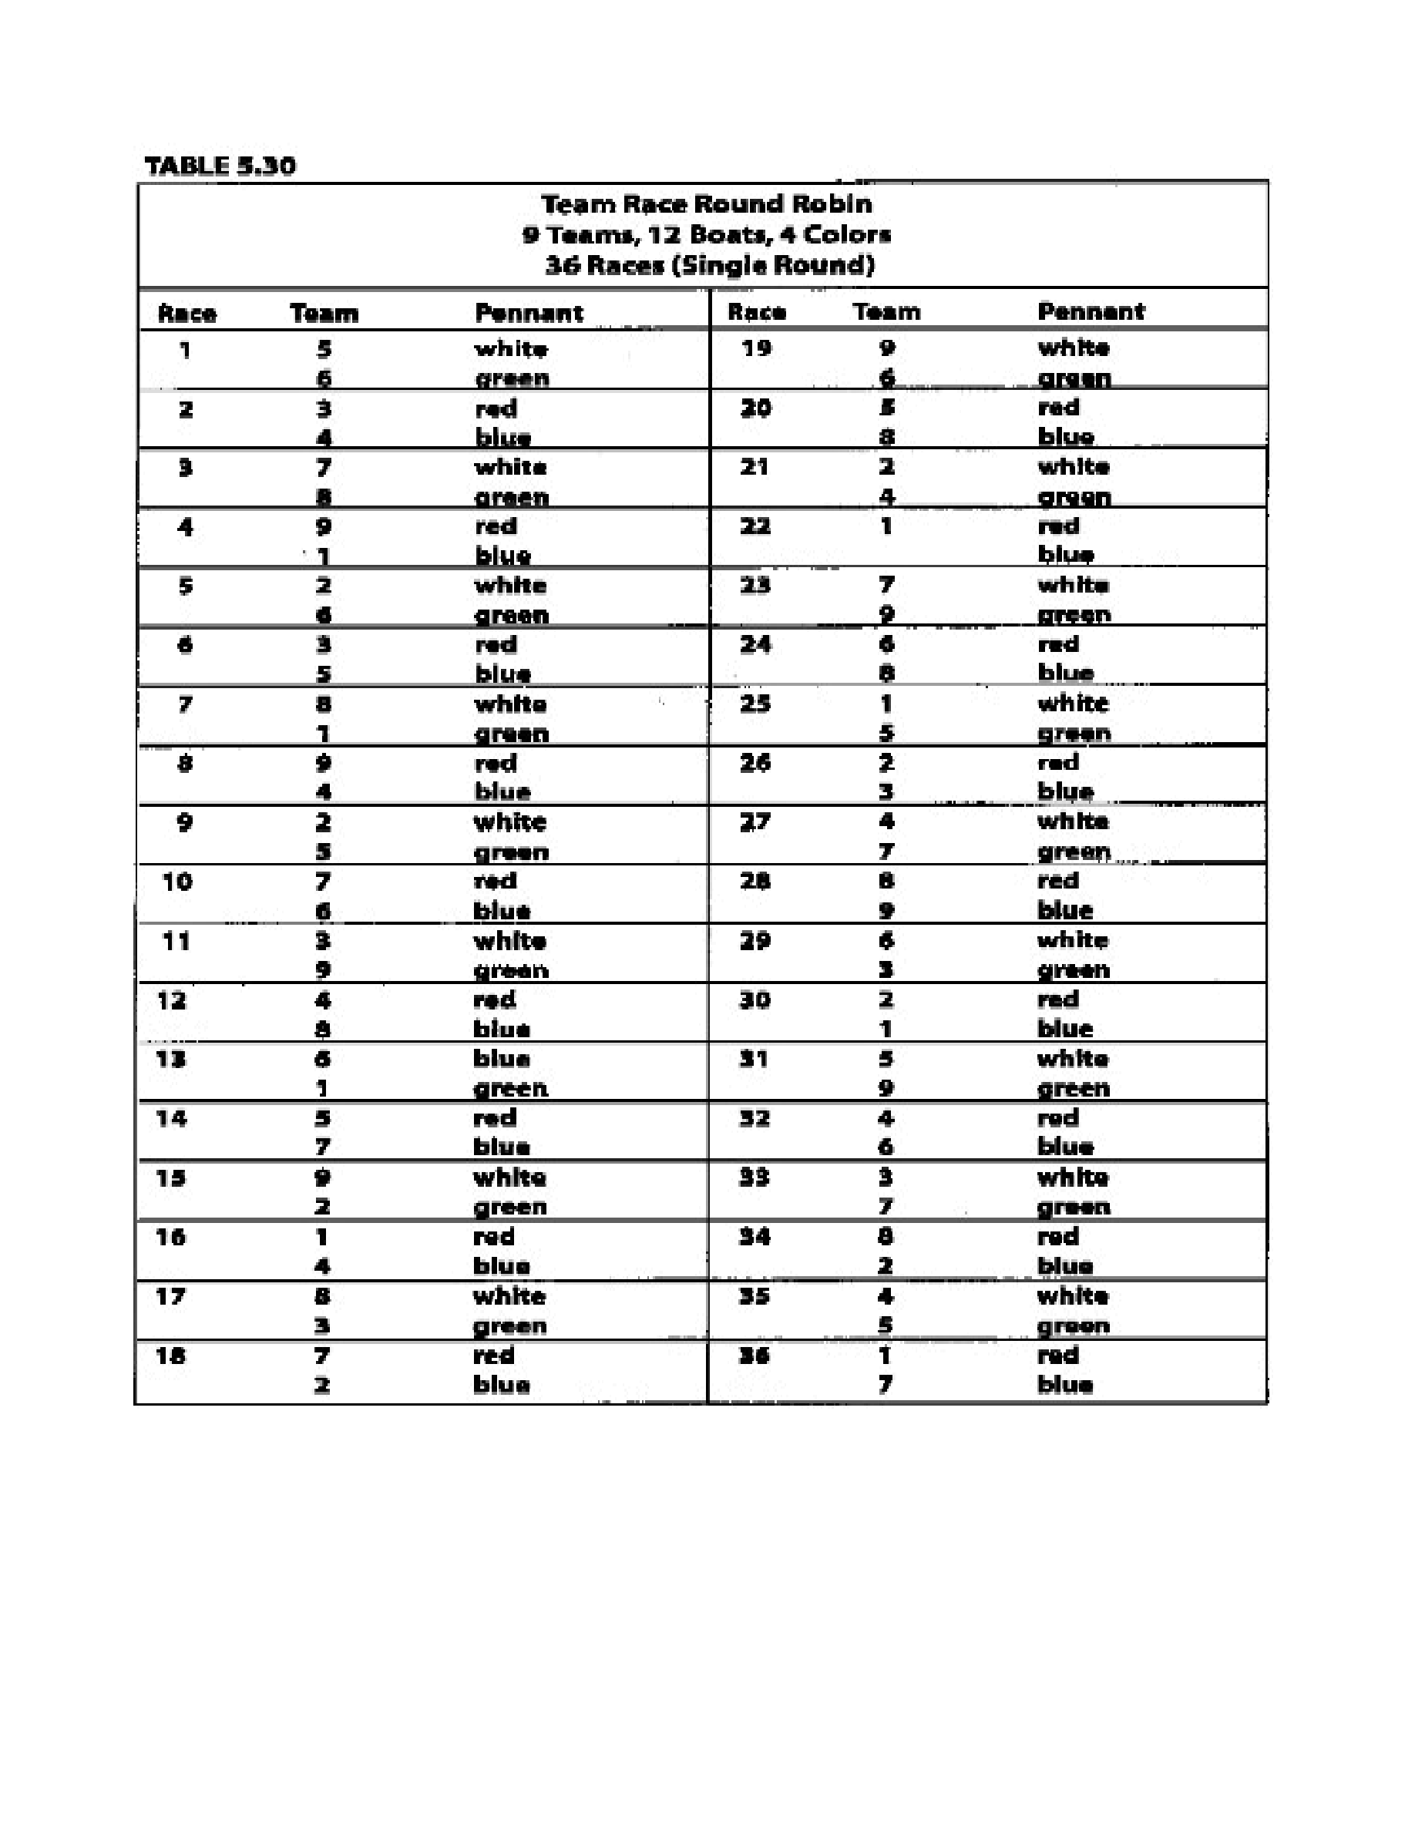
Taken
from
“
Race
Management
Handbook
”,
Chapter
5
©
2001,
US
SAILING
Page
11
of
24
Taken
from
“
Race
Management
Handbook
”,
Chapter
5
©
2001,
US
SAILING
Page
11
of
24
Event: Enter event name

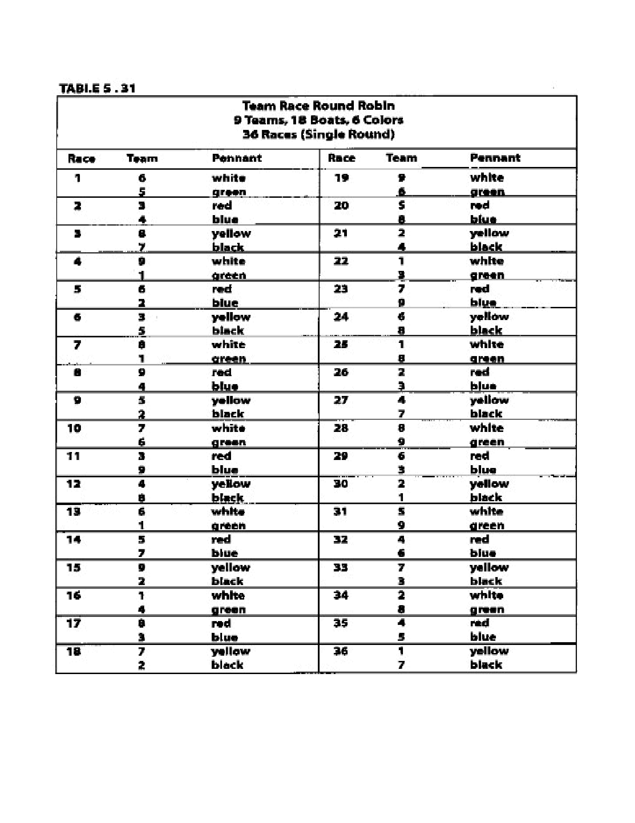
Taken
from
“
Race
Management
Handbook
”,
Chapter
5
©
2001,
US
SAILING
Page
12
of
24
Taken
from
“
Race
Management
Handbook
”,
Chapter
5
©
2001,
US
SAILING
Page
12
of
24
Event: Enter event name

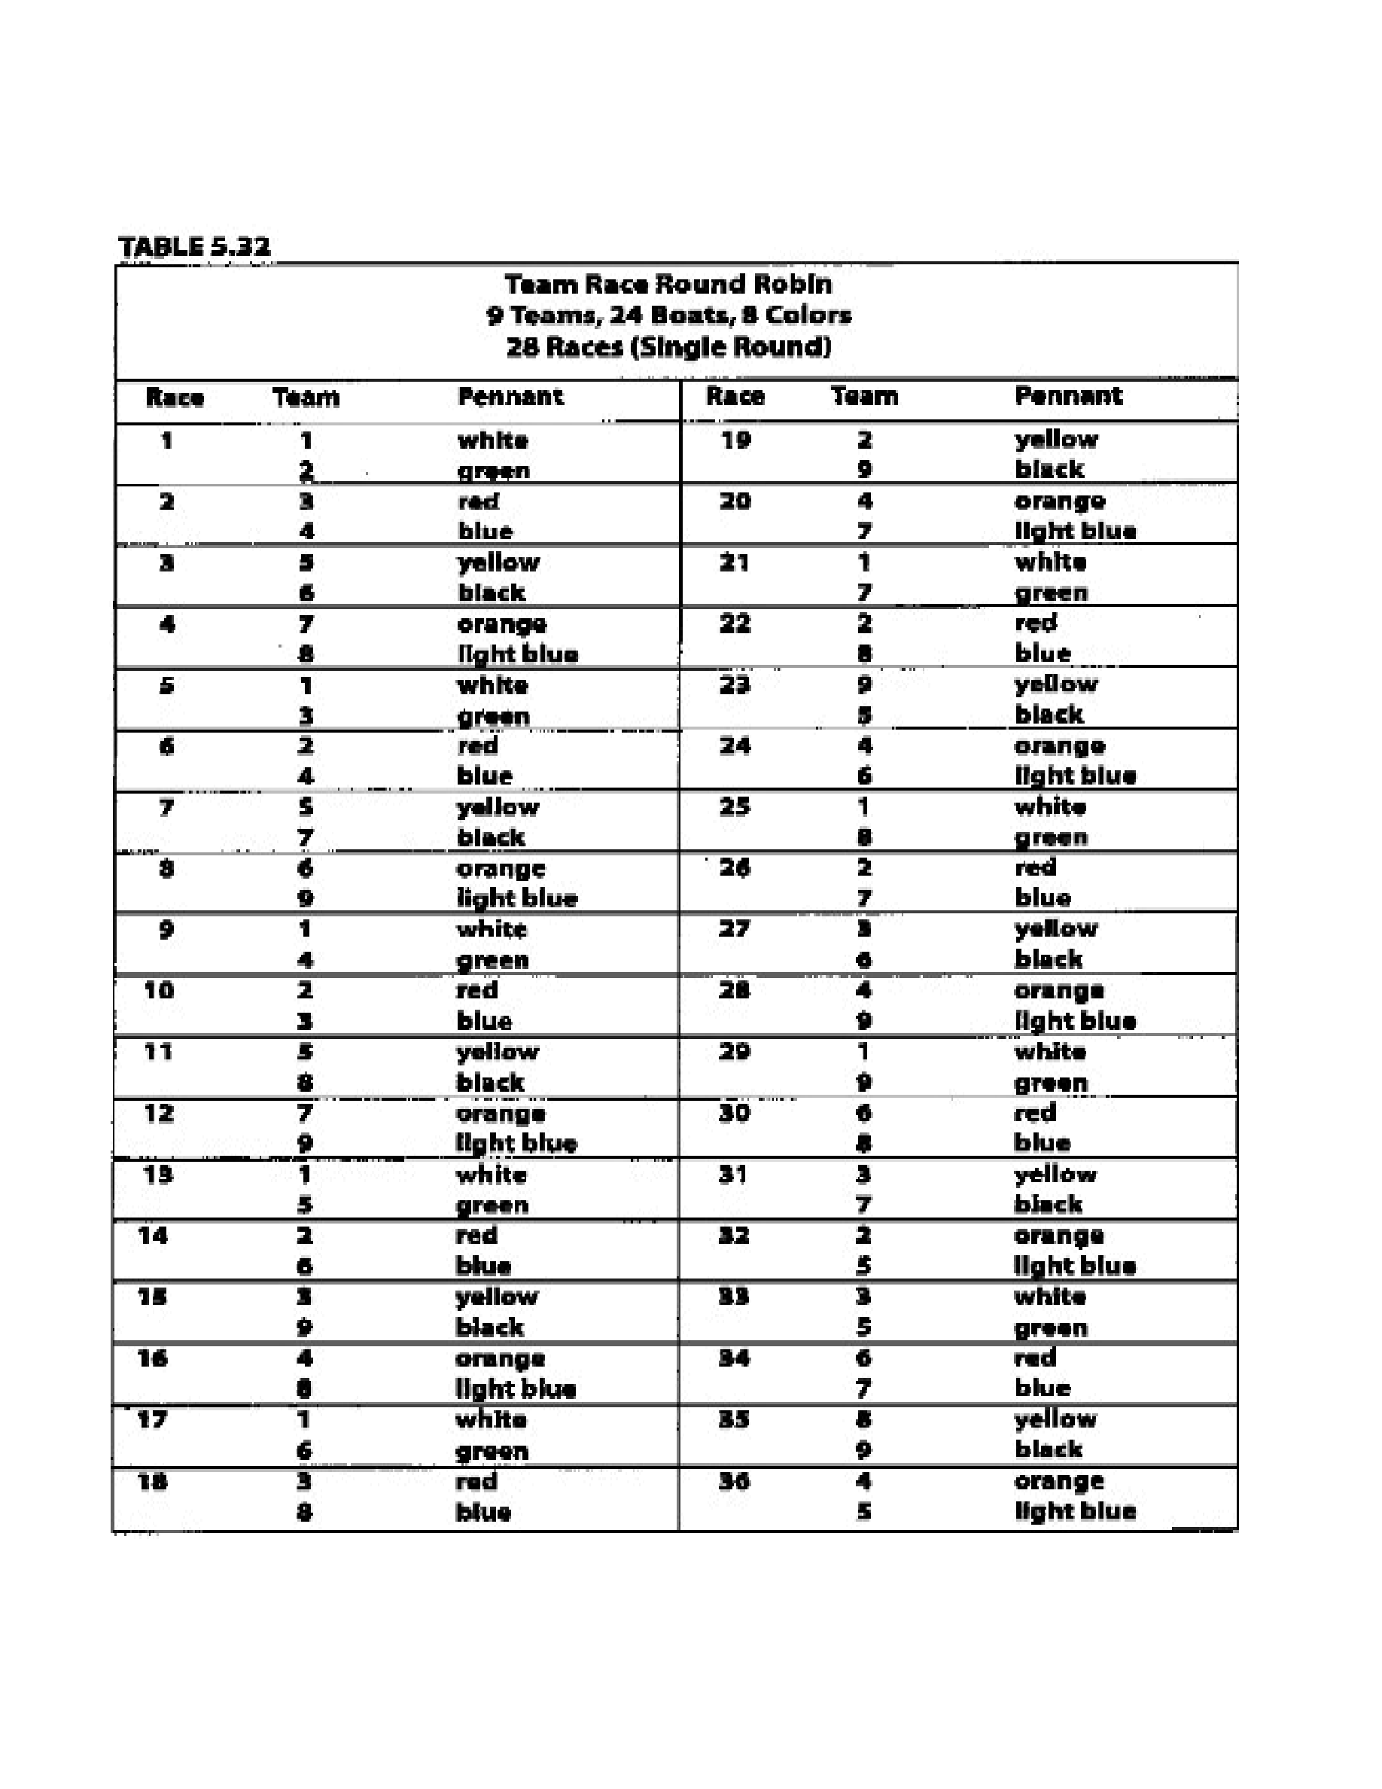
Taken
from
“
Race
Management
Handbook
”,
Chapter
5
©
2001,
US
SAILING
Page
13
of
24
Event: Enter event name

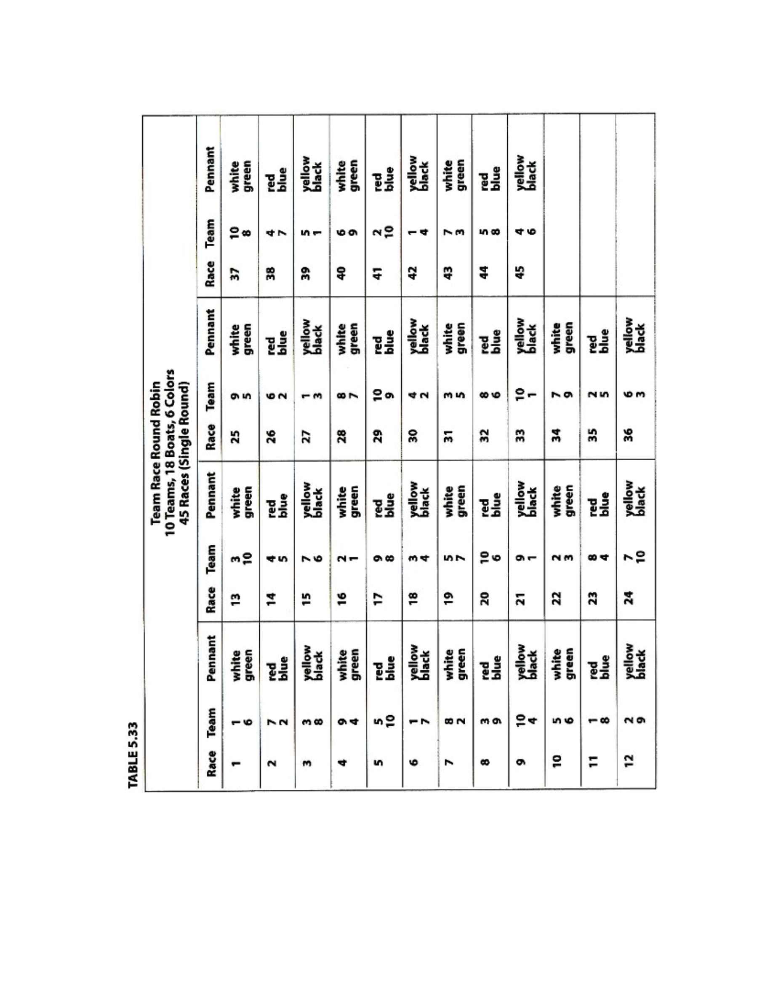
Taken
from
“
Race
Management
Handbook
”,
Chapter
5
©
2001,
US
SAILING
Page
14
of
24
Event: Enter event name

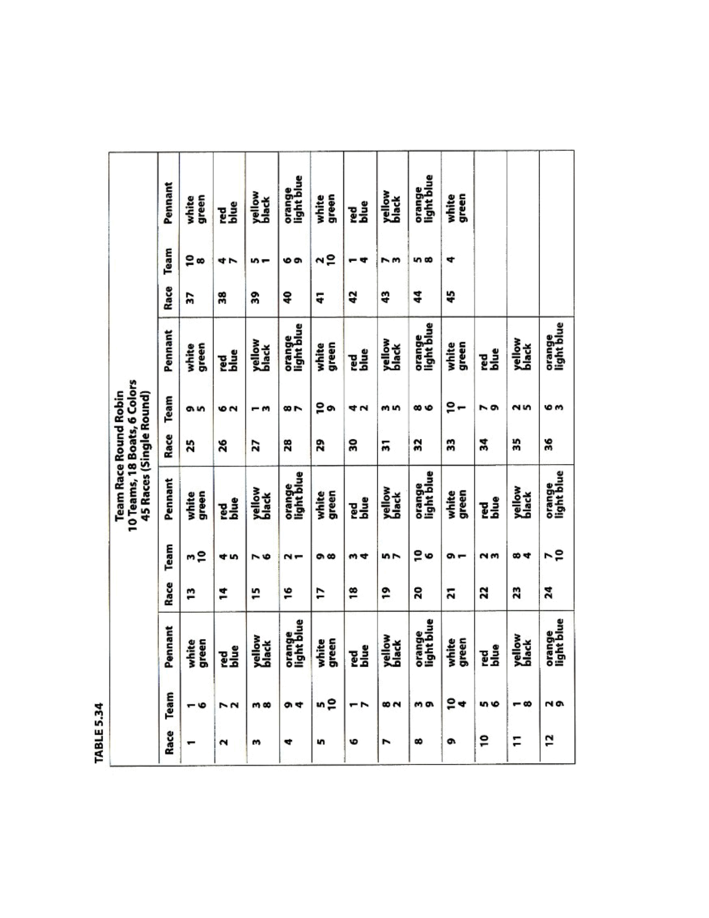
Taken
from
“
Race
Management
Handbook
”,
Chapter
5
©
2001,
US
SAILING
Page
15
of
24
Event: Enter event name

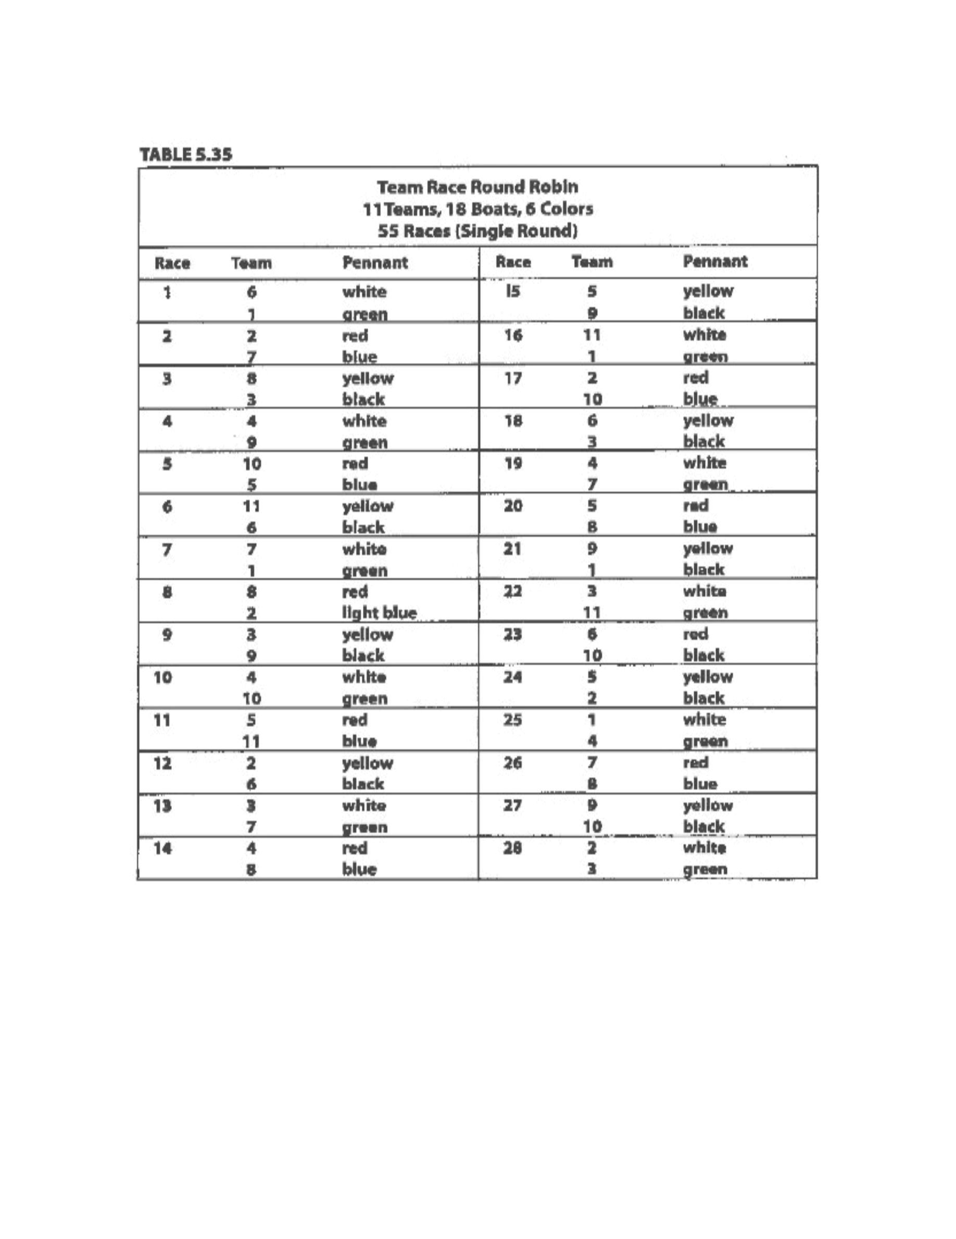
Taken
from
“
Race
Management
Handbook
”,
Chapter
5
©
2001,
US
SAILING
Page
16
of
24
Event: Enter event name

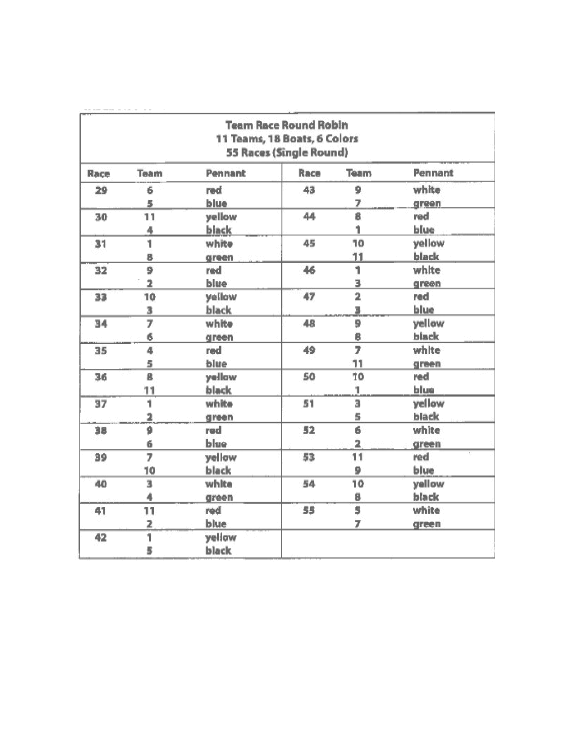
Taken
from
“
Race
Management
Handbook
”,
Chapter
5
©
2001,
US
SAILING
Page
17
of
24
Table
3.35
Continued
Event: Enter event name

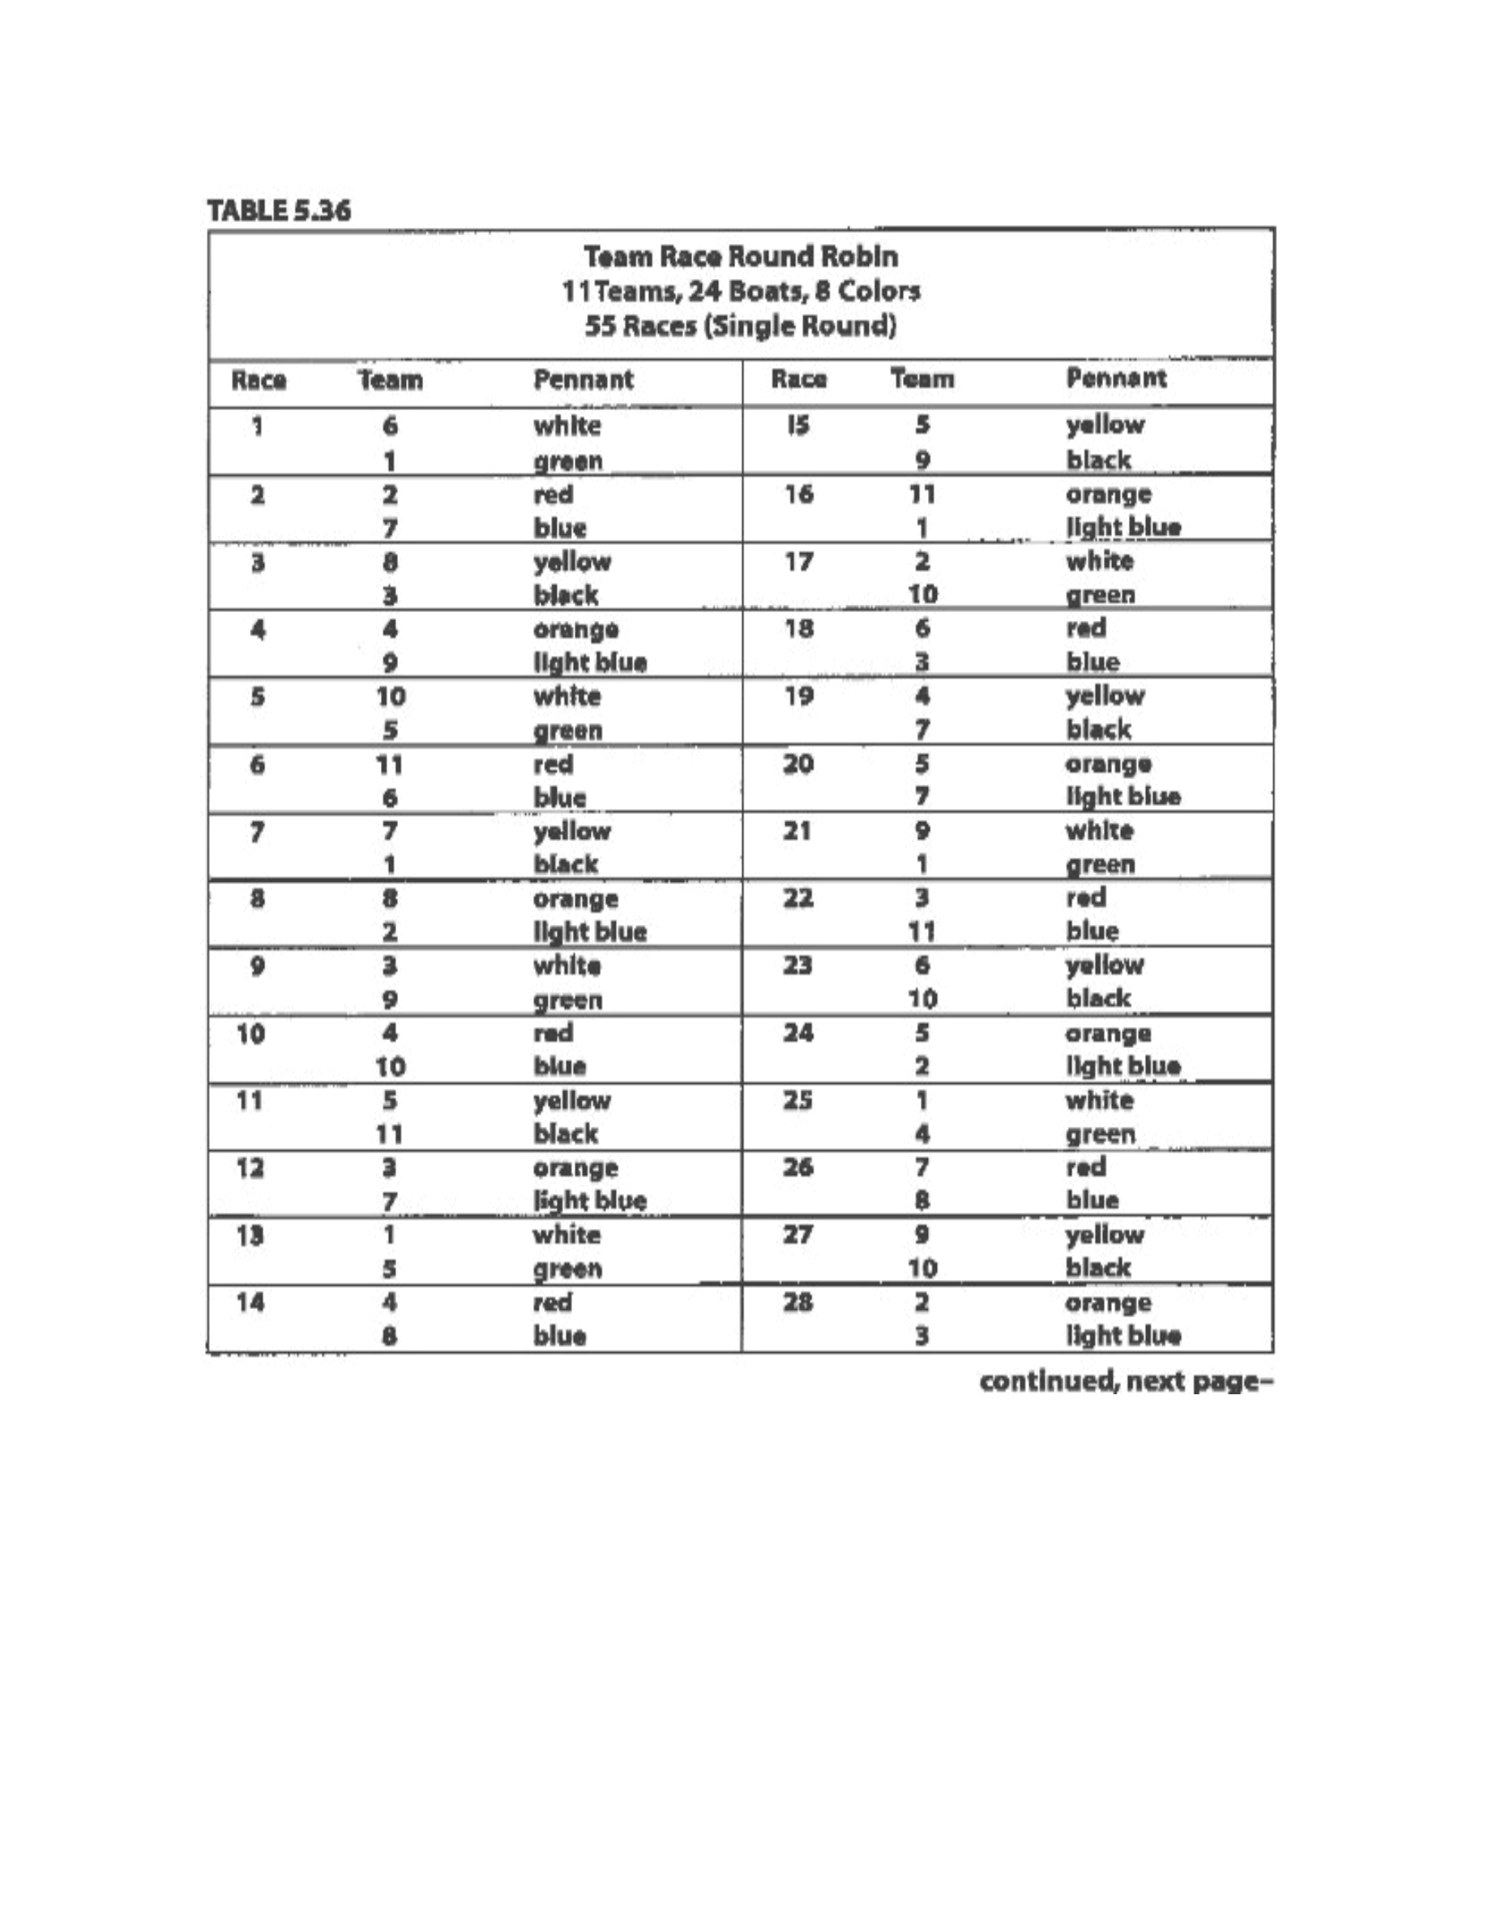
Taken
from
“
Race
Management
Handbook
”,
Chapter
5
©
2001,
US
SAILING
Page
18
of
24
Event: Enter event name

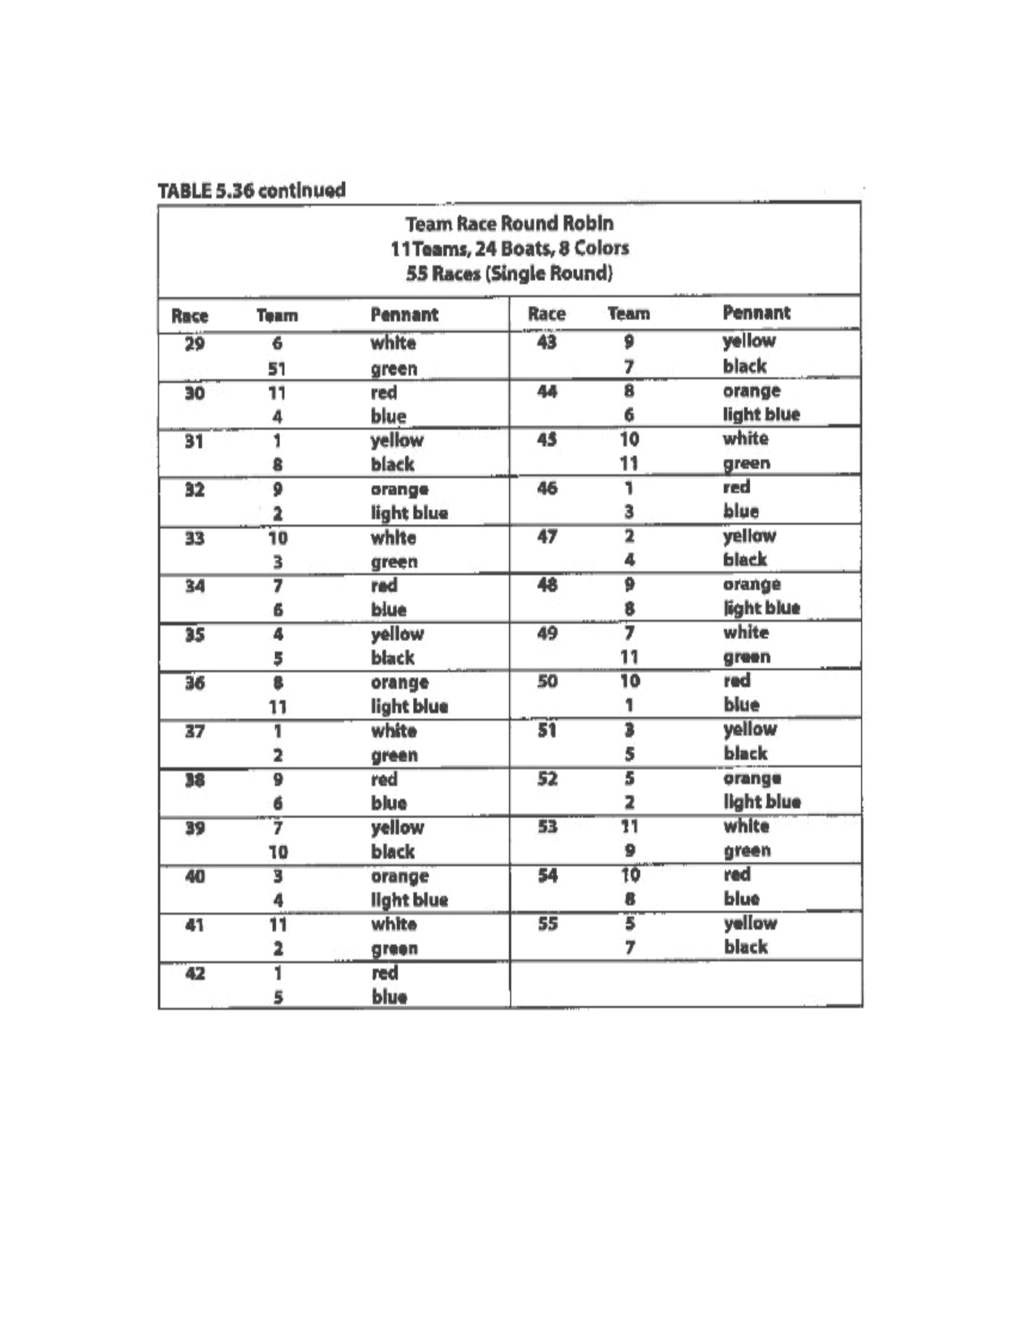
Taken
from
“
Race
Management
Handbook
”,
Chapter
5
©
2001,
US
SAILING
Page
19
of
24
Event: Enter event name

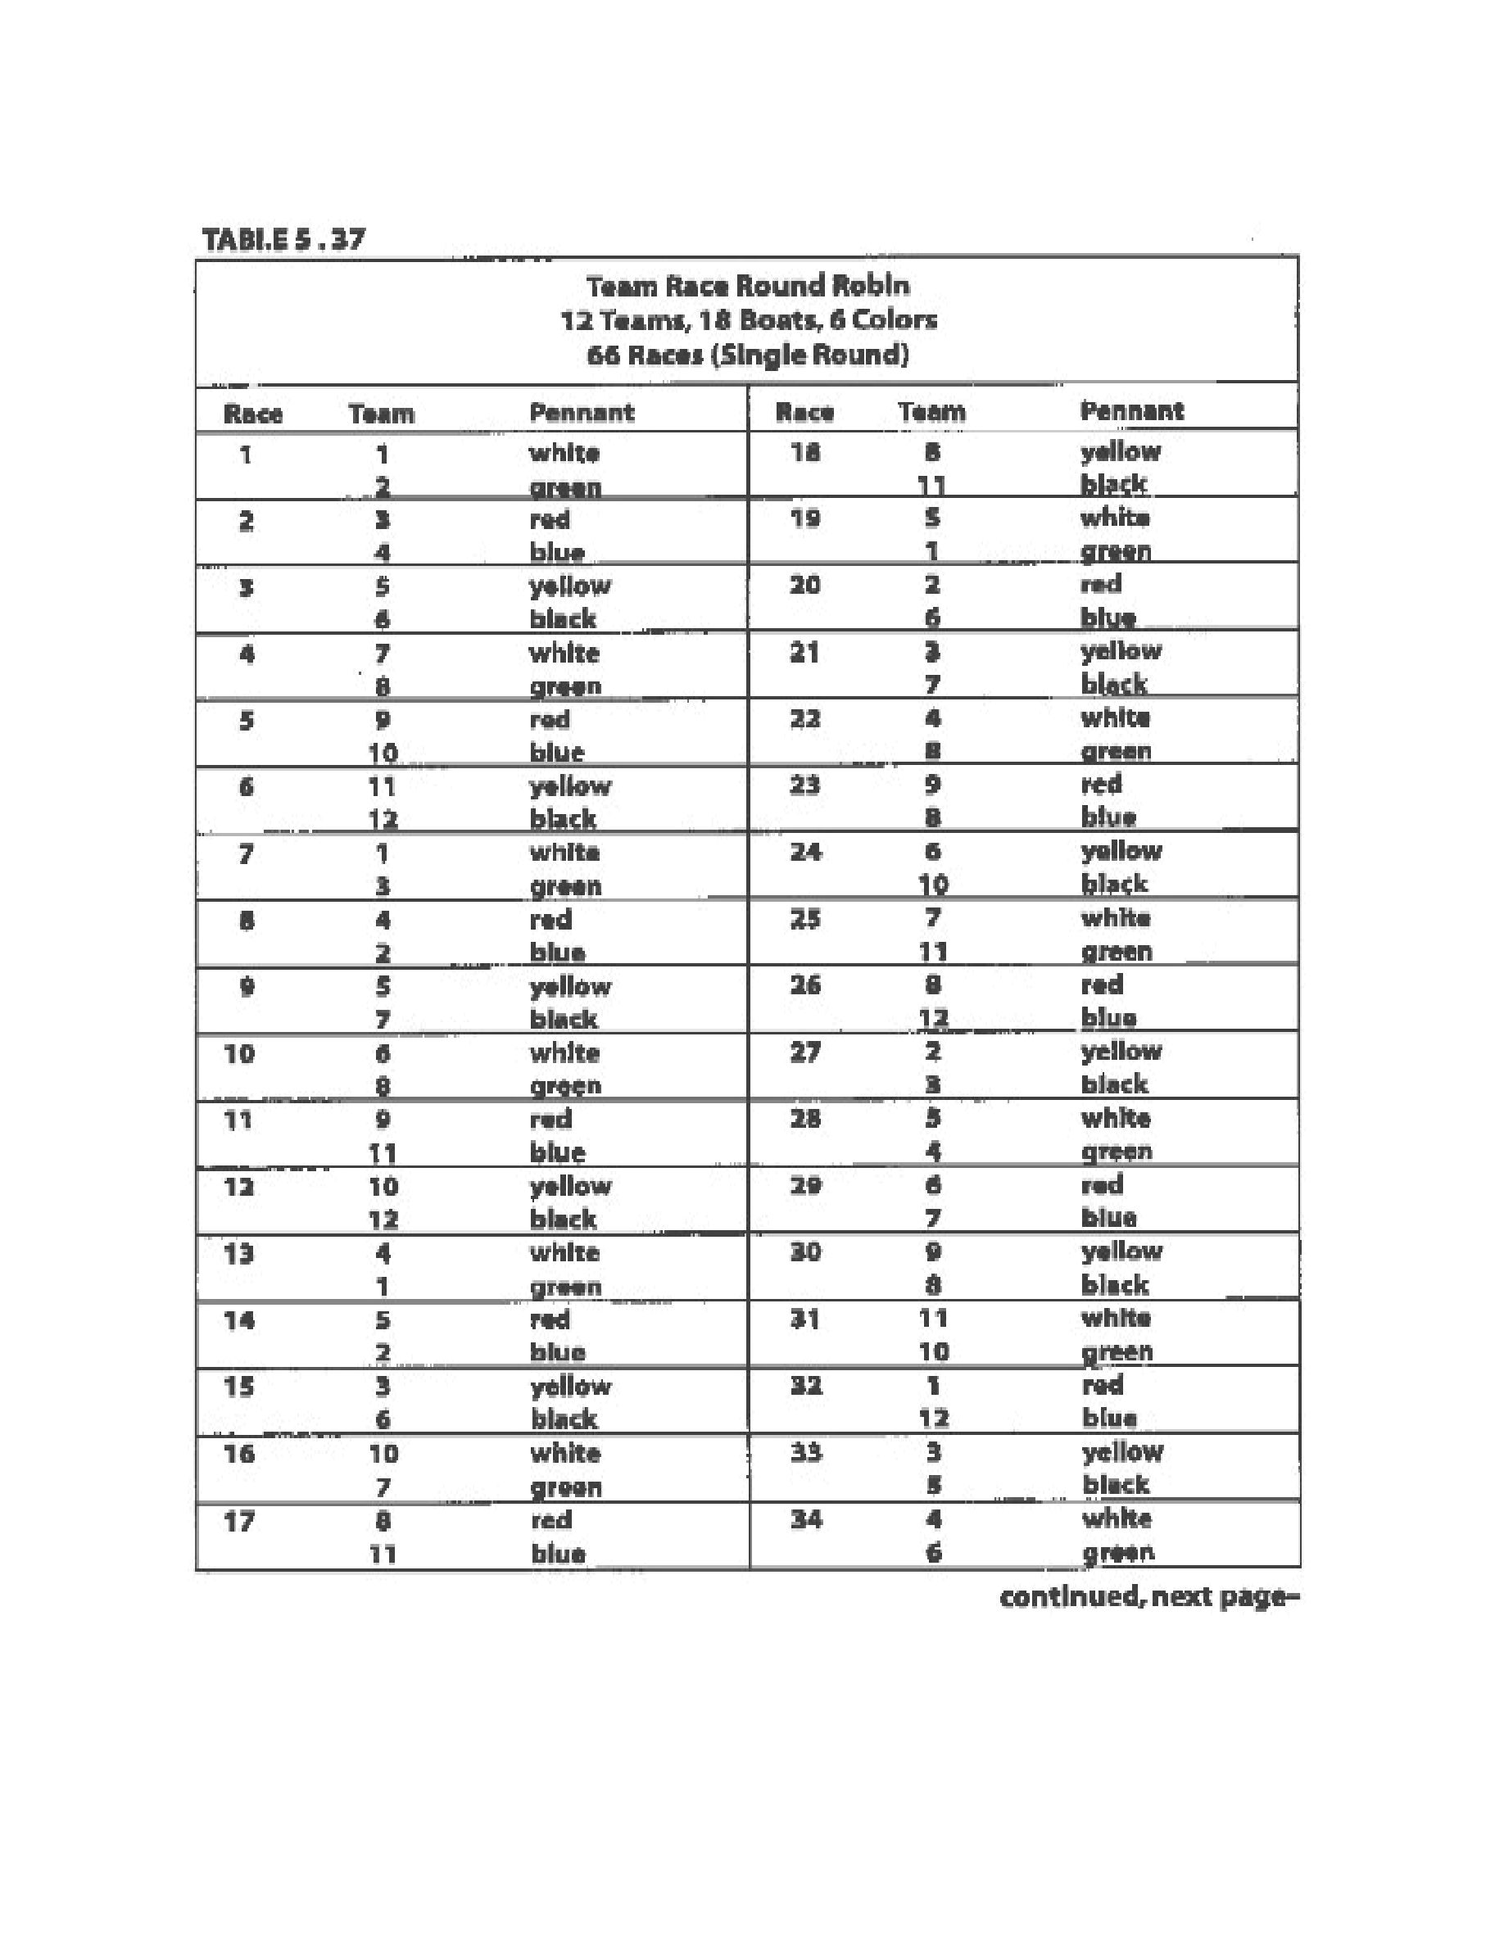
Taken
from
“
Race
Management
Handbook
”,
Chapter
5
©
2001,
US
SAILING
Page
20
of
24
Event: Enter event name

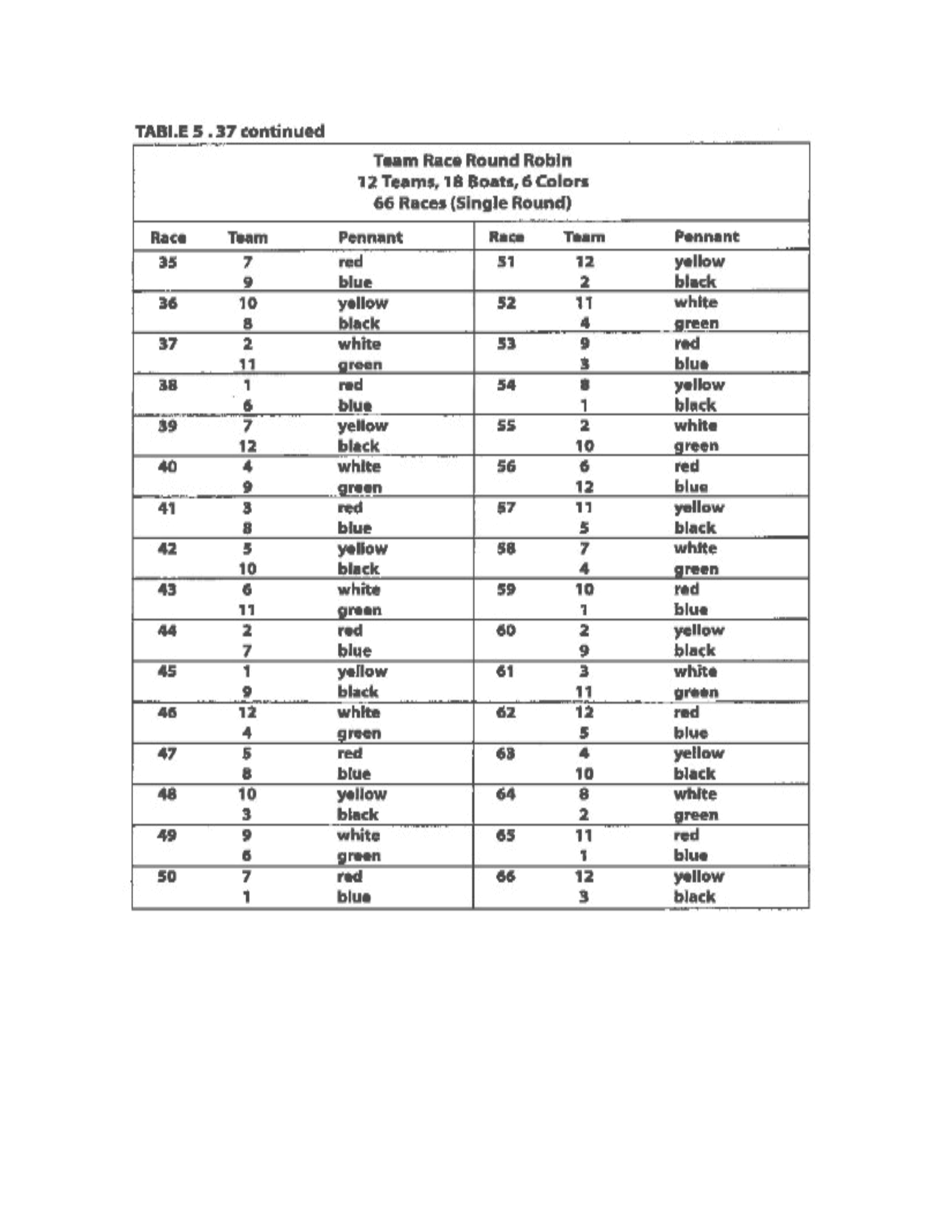
Taken
from
“
Race
Management
Handbook
”,
Chapter
5
©
2001,
US
SAILING
Page
21
of
24
Event: Enter event name

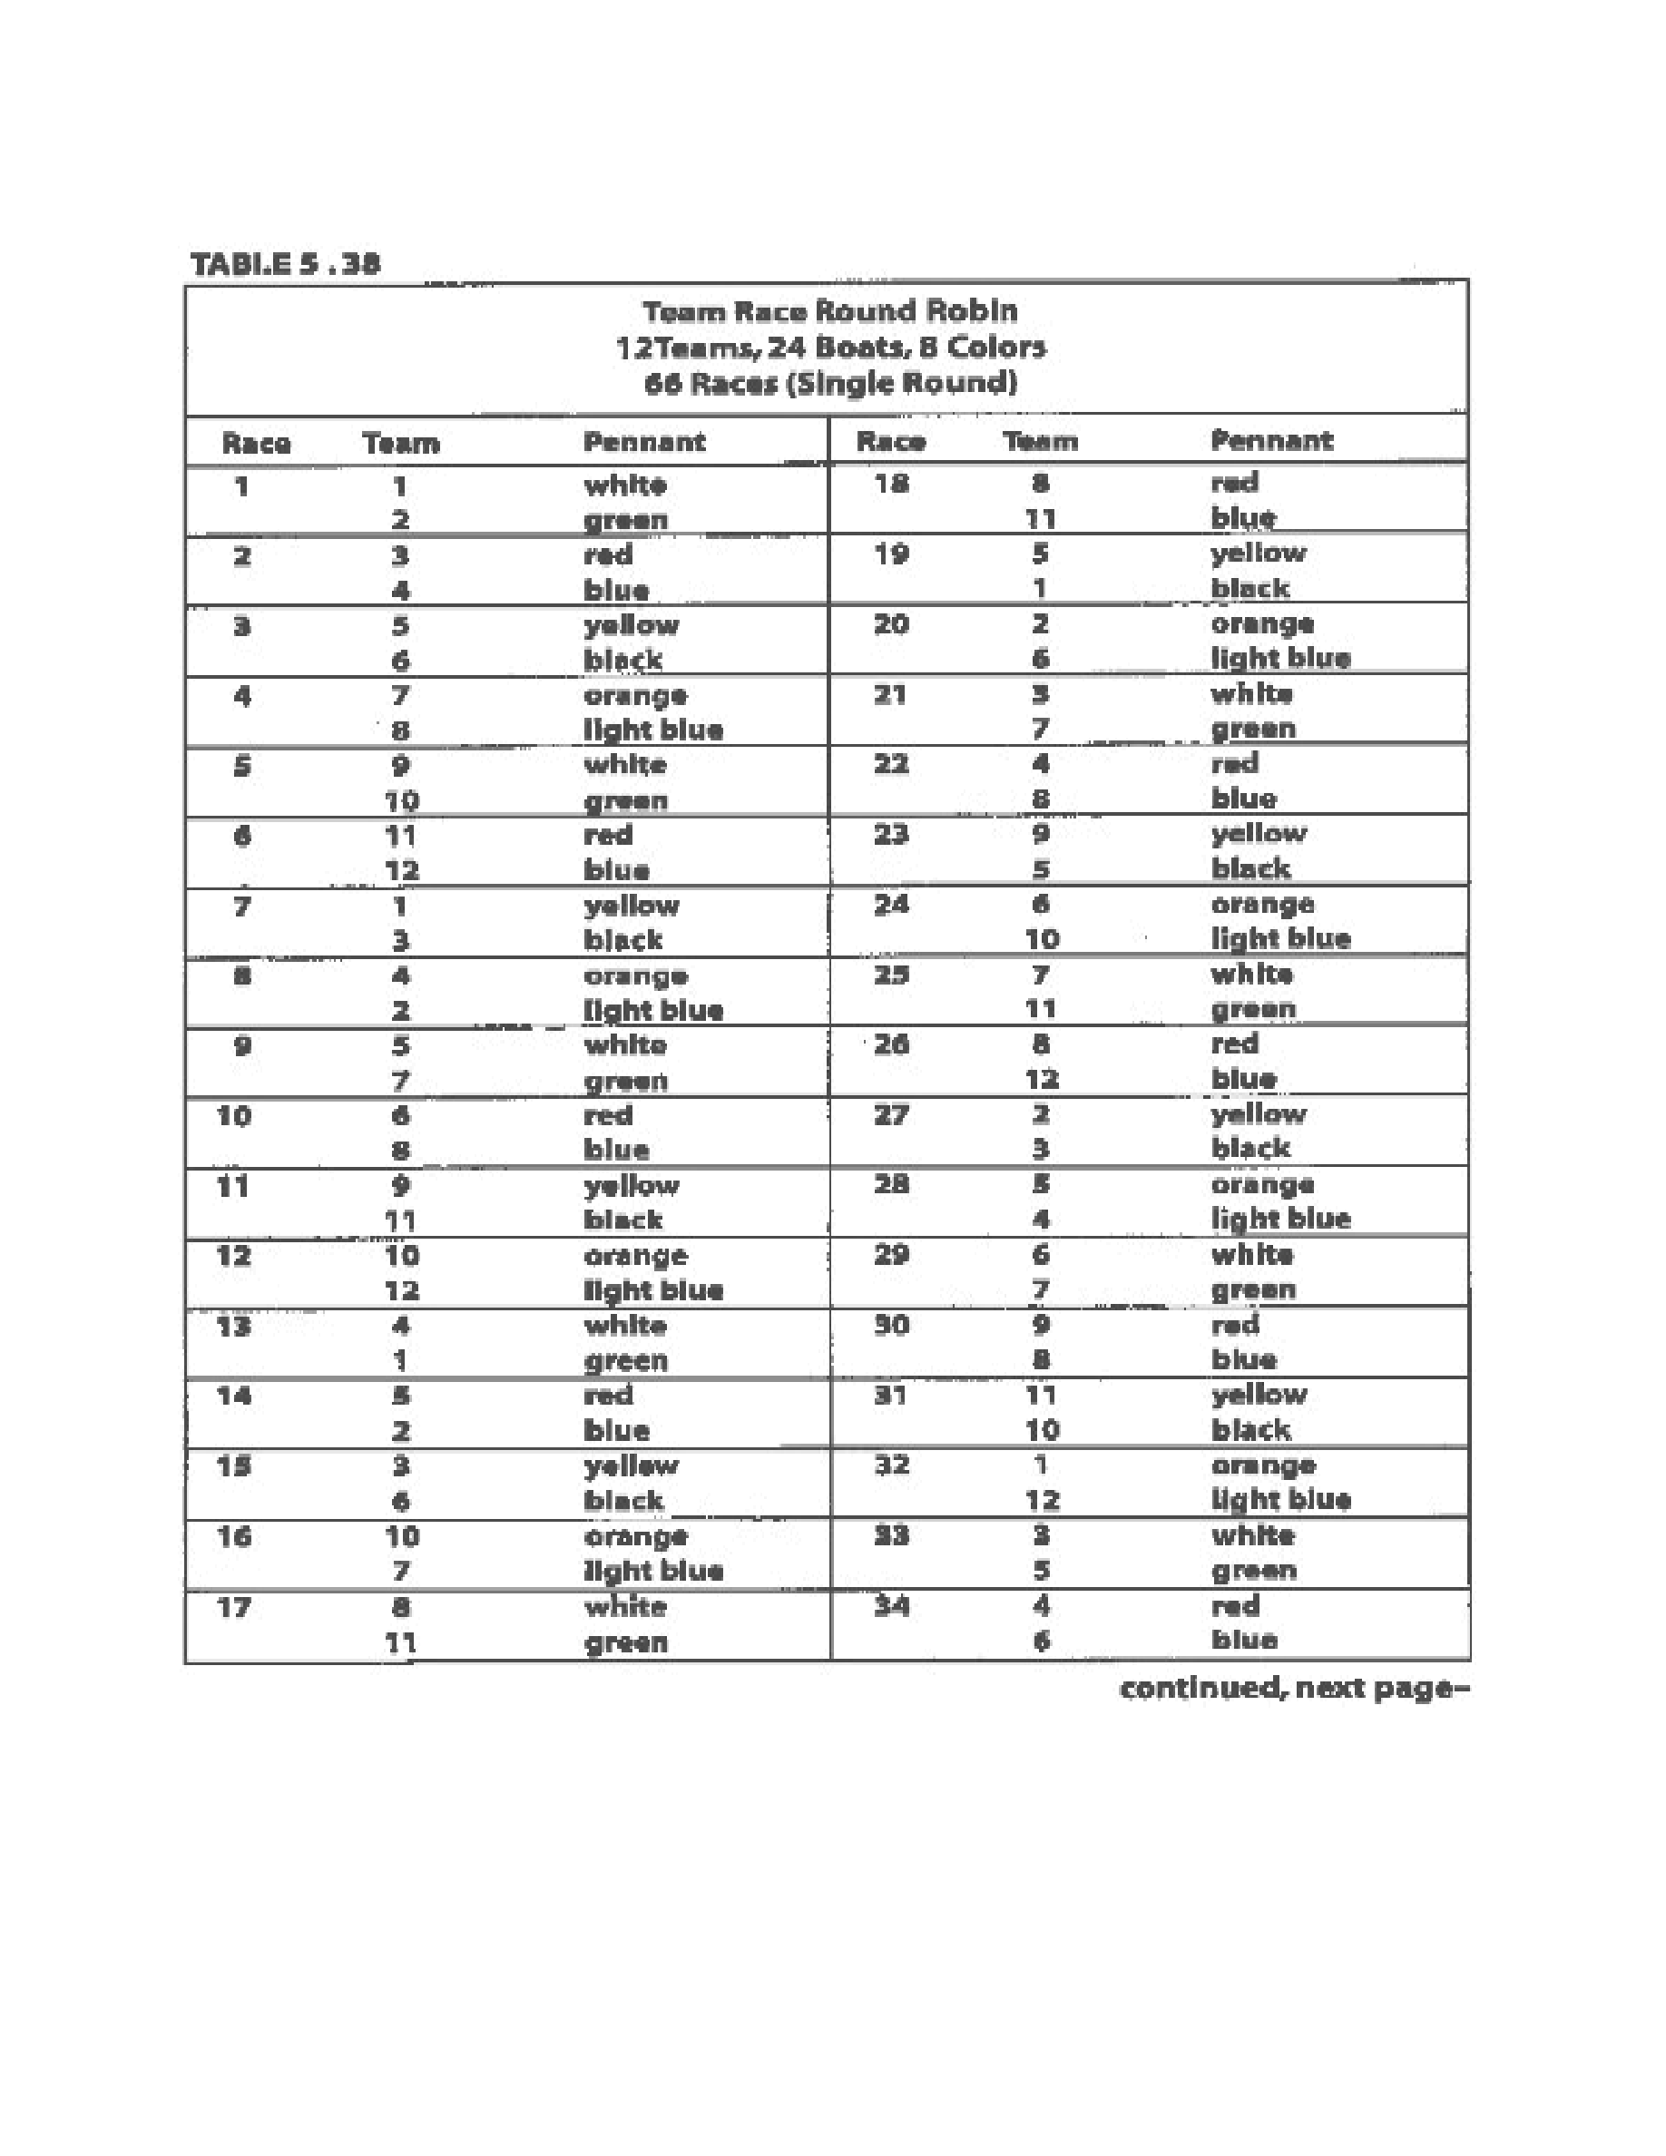
Taken
from
“
Race
Management
Handbook
”,
Chapter
5
©
2001,
US
SAILING
Page
22
of
24
Event: Enter event name

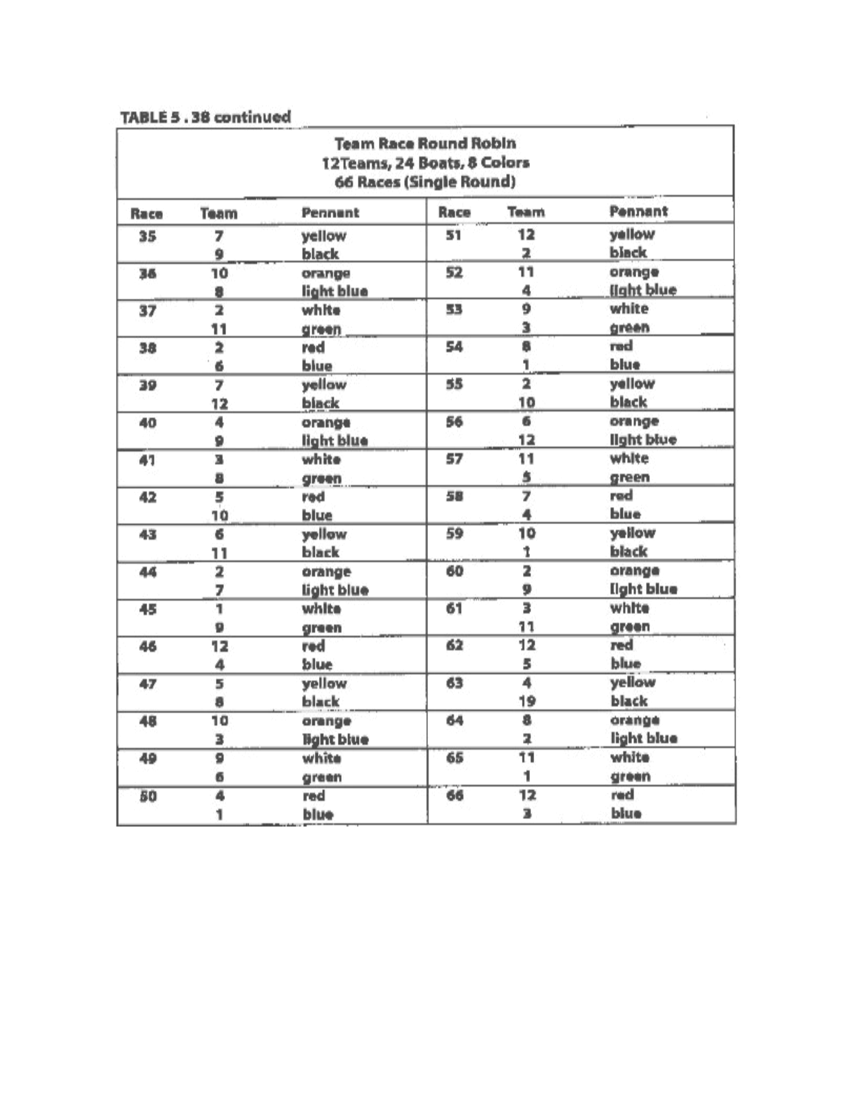
Taken
from
“
Race
Management
Handbook
”,
Chapter
5
©
2001,
US
SAILING
Page
23
of
24
Event: Enter event name

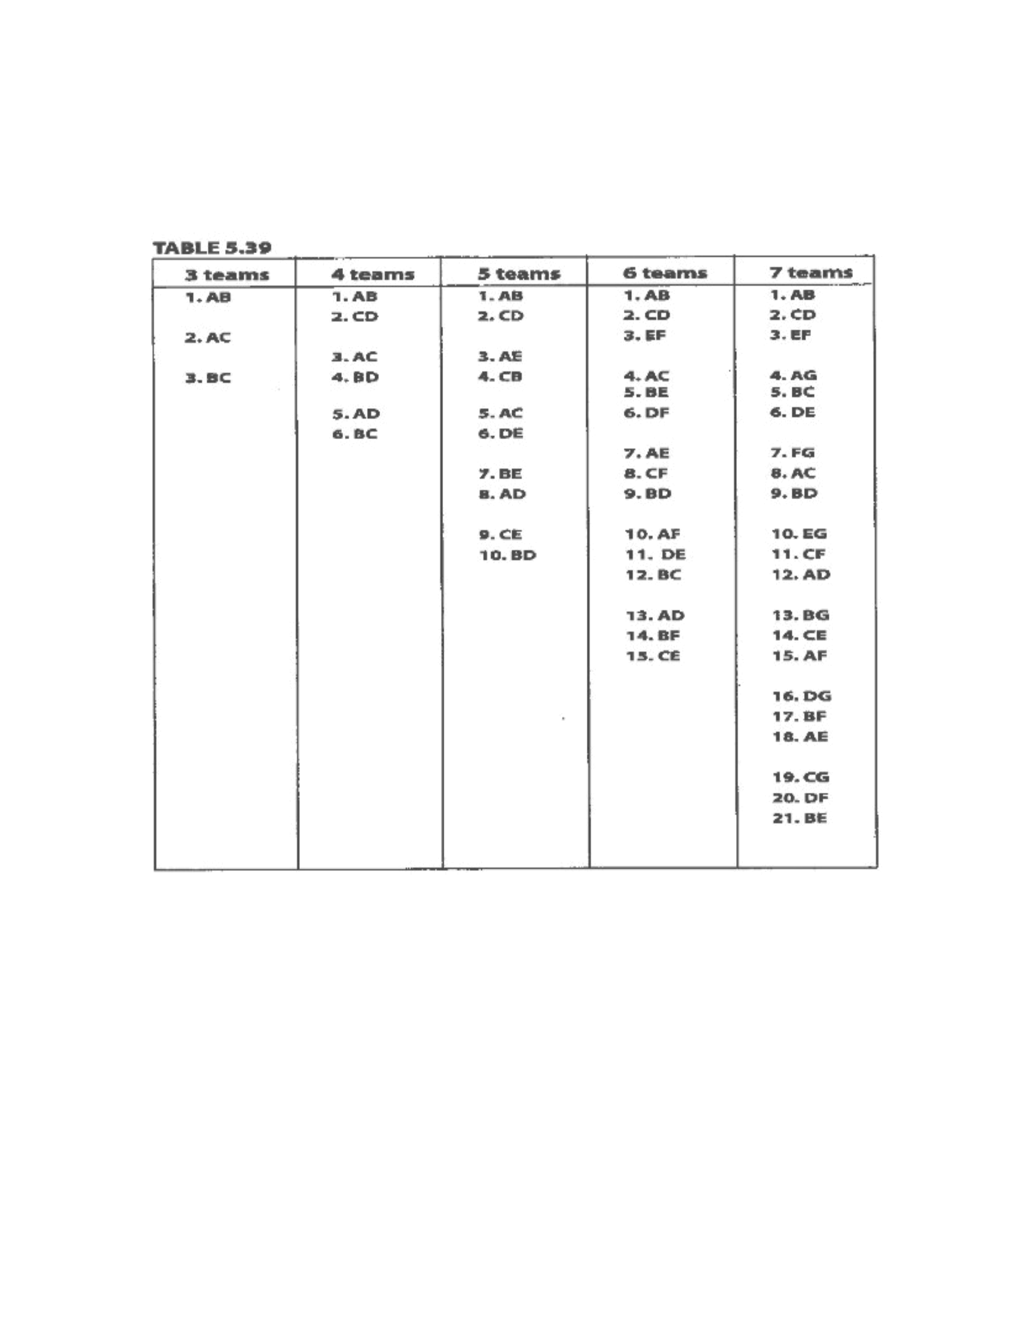
Taken
from
“
Race
Management
Handbook
”,
Chapter
5
©
2001,
US
SAILING
Page
24
of
24
The
easiest
team
racing
events
to
run
are
bring-your-own-boat
(BYOB)
events.
Boats
do
not
have
to
be
acquired,
equalized,
assigned,
rotated,
repaired
or
worried
about.
Also,
the
racing
does
not
need
to
be
run
near
a
rotation
dock
and
races
do
not
need
to
be
postponed
for
breakdowns.
Even
the
rotation
is
easier
to
figure.
In
the
following
rotations
there
is
a
space
in
between
groups
of
races
or
flights.
Event: Enter event name

