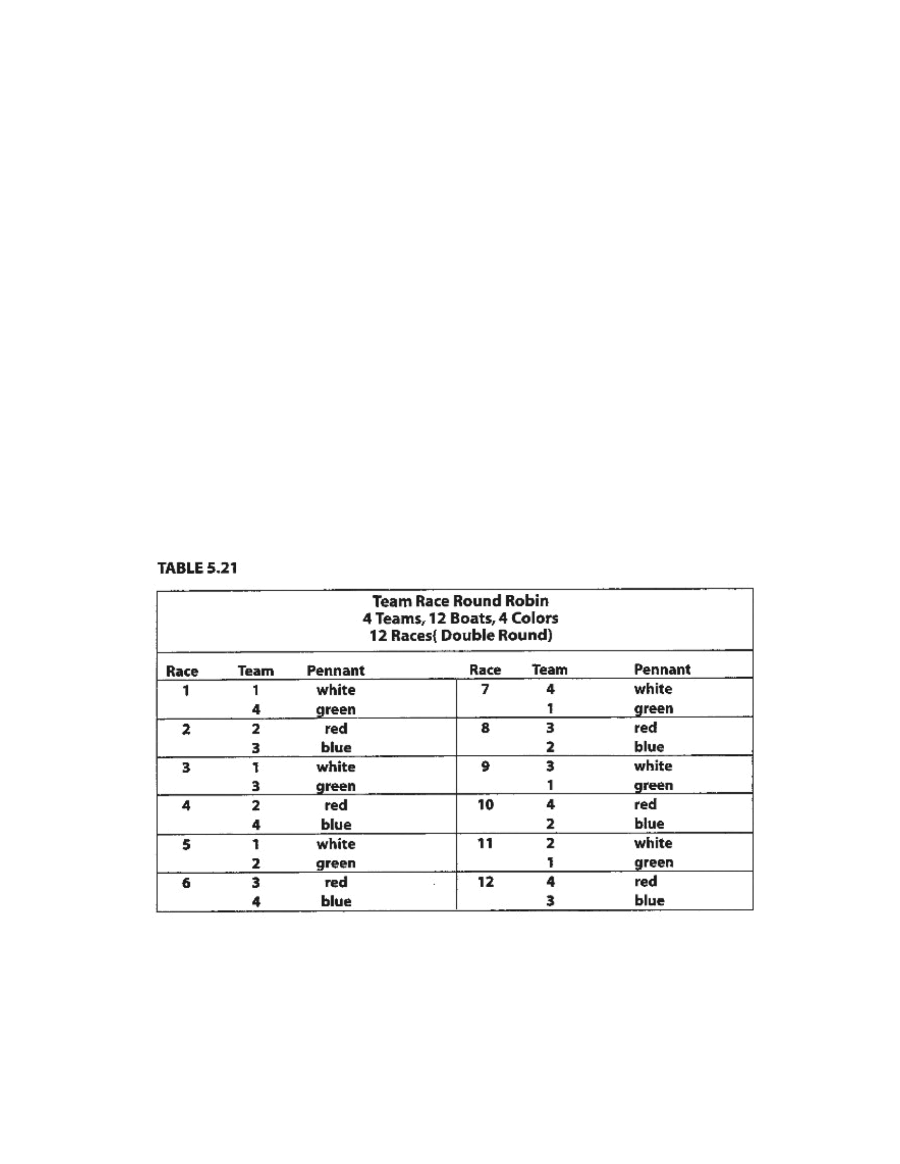
Taken
from
“
Race
Management
Handbook
”,
Chapter
5
©
2001,
US
SAILING
Page
1
of
24
Team
racing
rotations
and
boat
pairings
The
basic
“final-four”
boat
rotation
and
pairings
In
team
racing
championship
rotations
the
boats
carry
an
identifying
characteristic
(usually
a
shroud
flag
or
pennant).
One
designated
group
of
boats
always
races
against
a
second
designated
group
(for
example,
boats
displaying
white
pennants
always
race
against
the
boats
displaying
green
pennants,
red
against
blue,
yellow
against
black,
etc.).
The
teams
in
the
boats
usually
change
after
every
race.
Ideally,
each
team
sails
each
boat
an
equal
number
of
times,
although
is
not
always
possible
unless
a
double
round-robin
is
sailed.
A
shorthand
method
of
referring
to
the
rotations
is
by
number
of
competing
teams
and
number
of
boats
used.
For
example,
a
5-team,
6-boat
rotation
is
referred
to
as
“5x6”;
an
11-team,
24-
boat
rotation
is
referred
to
as
“11x24”.
The
system
assumes
that
the
boats
are
equal,
so
equalization
is
very
important.
“Fairness”
is
then
furthered
by
designing
the
boat
rotations
and
pairings
in
advance,
and
having
the
teams
draw
lots
for
their
positions
in
the
rotation.
The
championship
rotations
were
originally
written
for
the
US
SAILING
Team
Racing
Championship
(Hinman
Trophy)
by
Mrs.
Rich
Treacy
in
1987
for
the
5x6
through
8x6,
and
5x12
through
11x12.
They
have
since
been
expanded
for
18
and
24
boat
rotations.
The
basic
team
racing
direct
swap
is
shown
in
Table
5.21,
in
which
four
teams
meet
in
a
“double
round-robin.”
The
groups
of
boats
(3
per
group)
are
identified
by
four
colored
pennants—red,
blue,
green
and
white,
although
they
can
be
any
colors.
Running
team
races
with
limited
numbers
of
boats
You
can,
however,
run
a
team
racing
series
with
fewer
than
enough
boats
for
all
members
of
each
team.
In
other
words,
12
boats
(4
groups,
3
boats
each)
will
accommodate
4
teams.
But
if
there
are
not
enough
boats,
some
of
the
teams
may
race
while
others
stand
by.
The
teams
then
ex-
change
boats
with
the
next
teams
to
race.
Tables
5.22,5.23,
5.25,5.27
and
5.29
show
rotations
for
round
robins
of
races
for
6
or
12
boats,
for
5
through
9
teams,
respectively.
Event: Enter event name

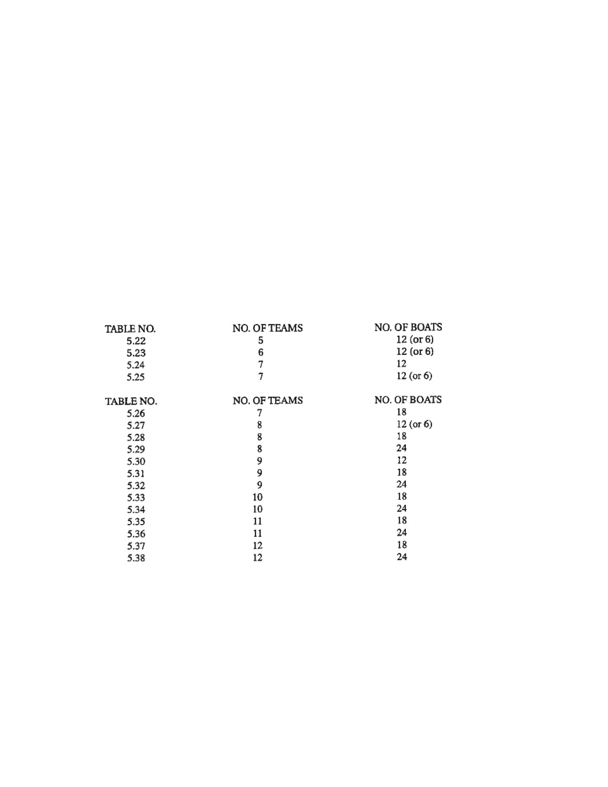
Taken
from
“
Race
Management
Handbook
”,
Chapter
5
©
2001,
US
SAILING
Page
2
of
24
A
“limited
rotation”
variation
on
the
“follow
the
leader”
method
Where
there
are
not
enough
boats
to
accommodate
all
of
the
competing
teams,
a
“limited
rotation”
can
also
be
used.
For
example,
if
ten
teams
are
competing,
but
there
are
only
enough
boats
for
6
teams,
(18
boats),
Ken
Legler
of
Tufts
University
suggests
the
following
round-robin
format:
Six
teams
(A
through
F)
sail
the
first
three
races.
Upon
finishing,
teams
A
and
B
sail
in
to
exchange
with
teams
G
and
H,
while
teams
C
through
F
become
the
first
two
starts
of
the
second
round.
Teams
G
and
H
become
the
third
start
of
round
2.
This
pattern
continues
with
teams
staying
on
the
water
for
either
four
or
two
straight
races
against
other
teams
without
exchanging
boats,
until
it
is
their
turn
to
go
ashore
and
rotate
out.
Using
this
method,
it
is
possible
to
complete
all
45
races
of
a
ten-team
round-robin
(see
formula
on
page
5.27)
in
one
day.
Pairings
and
rotations
for
round-robins
You
may
use
the
following
Tables
in
lieu
of
designing
a
round-robin
rotation.
Each
may
be
used
by
itself
or
in
combination
with
other
formats,
such
as
a
“best-of-three”
final,
a
“final-four”
round-robin,
etc.
(see
“Suggested
Formats”
Section
3.4
above).
As
mentioned
above,
do
not
start
with
a
rotation
which
is
too
ambitious.
Seventy-eight
races
in
a
two
day
event
is
a
realistic
goal
if
your
personnel
expediting
boat
exchanges
are
experienced,
and
the
race
course
is
not
far
from
the
boat
exchange
location.
The
Round-Robin
Tables
which
follow
are:
In
each
of
the
Tables,
only
a
single
round-robin
is
shown.
A
double
round-robin
is
a
repeat
of
the
first
round.
For
double
round-robins,
you
may
want
to
reverse
the
boat
assignments
so
that
at
their
next
meeting
in
round
2,
the
competitors
are
sailing
the
boats
their
opponents
sailed
in
round
1.
The
comments
after
Tables
5.22,5.23,5.25
and
5.27
include
suggestions
how
to
change
the
Table
if
you
are
using
only
6
boats.
Although
they
are
adaptable
to
either
four
groups
(12
boats)
or
two
(6
boats),
eight
teams
is
effectively
the
practical
limit
for
using
6
boats,
because
the
teams
must
wait
so
long
between
races.
Event: Enter event name

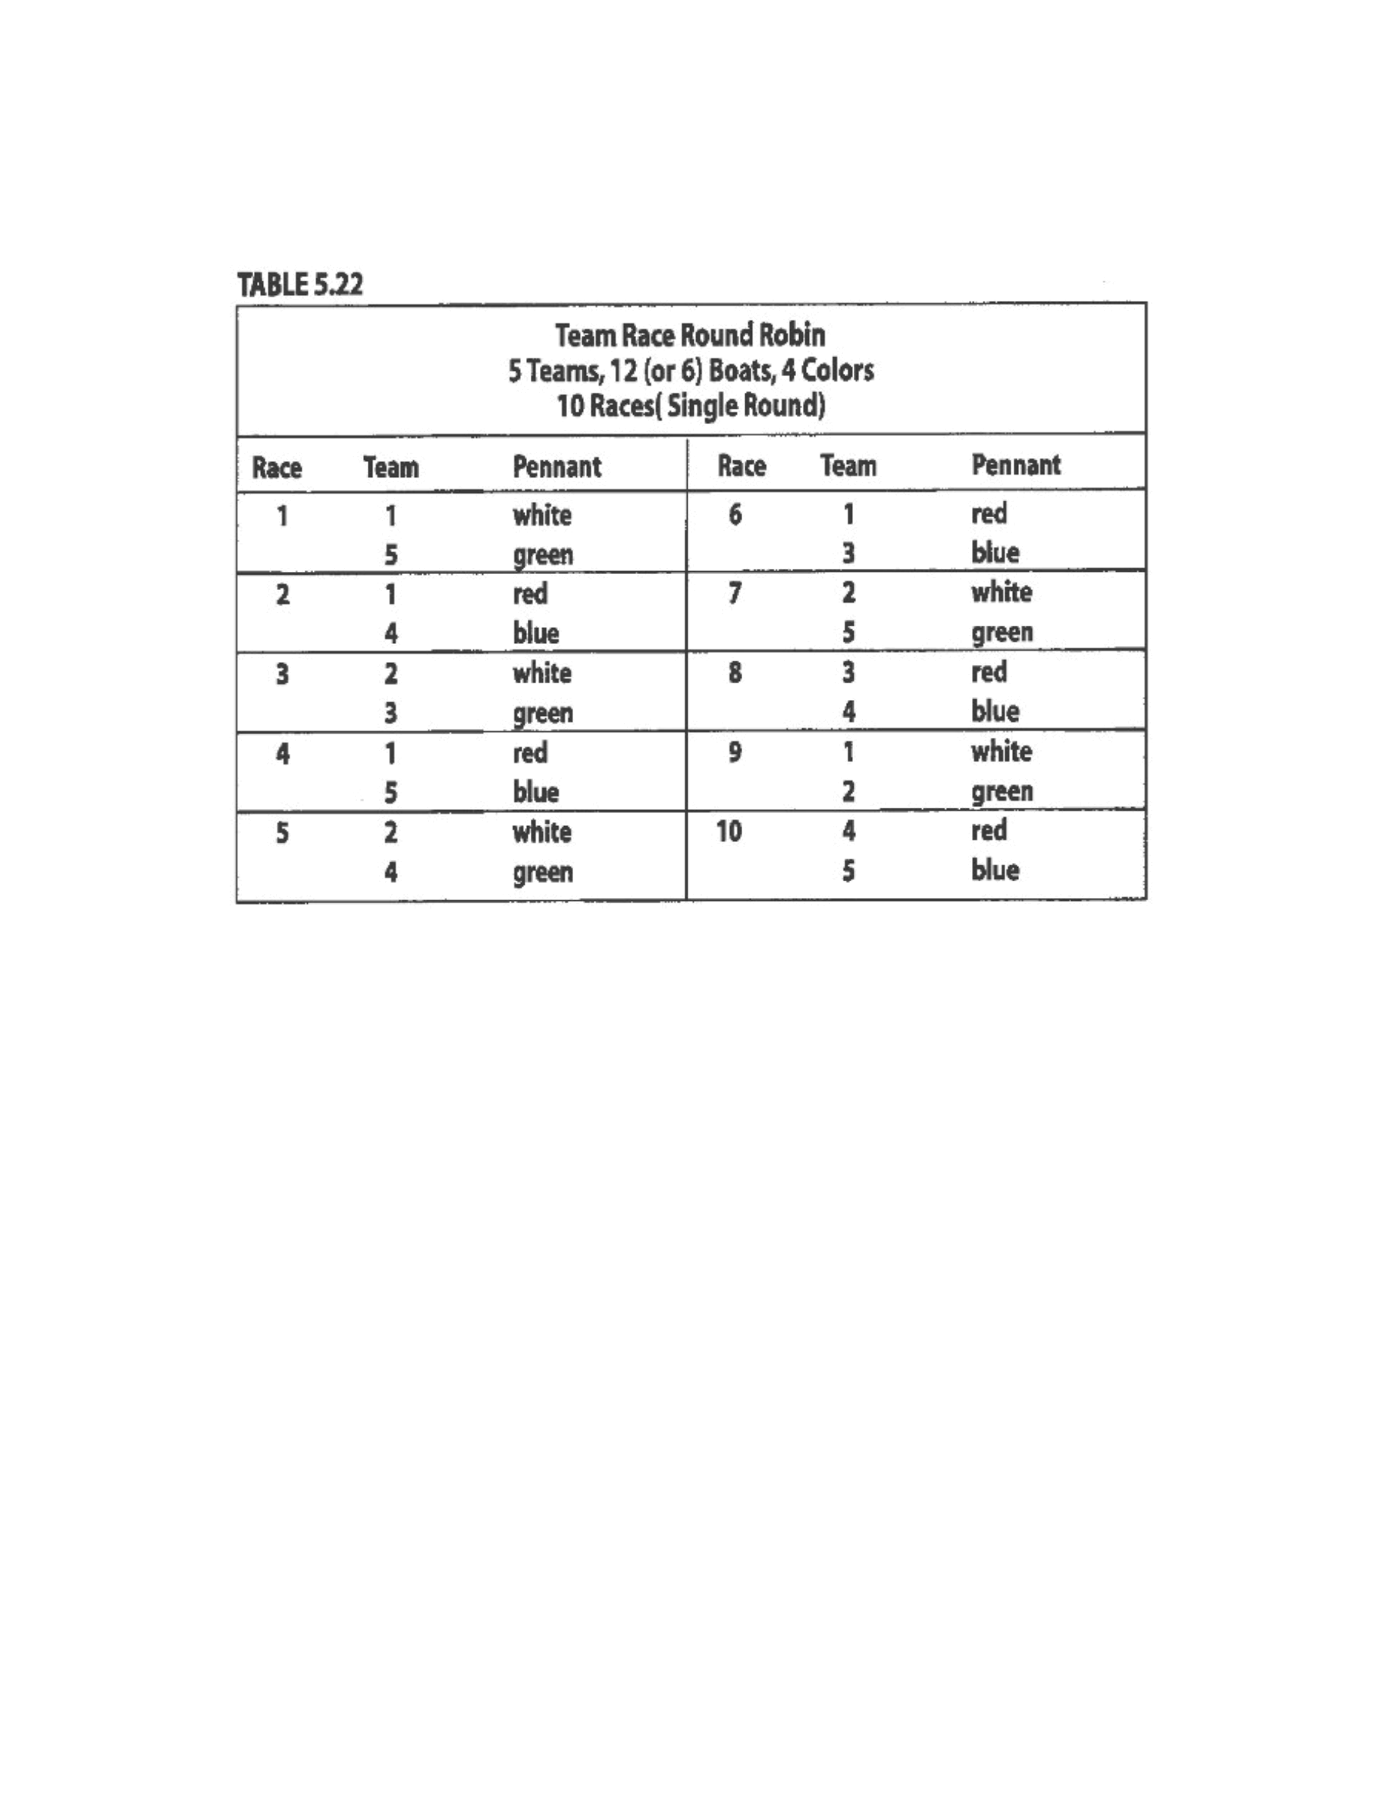
Taken
from
“
Race
Management
Handbook
”,
Chapter
5
©
2001,
US
SAILING
01997.
US
SAIUNG
Comments
to
Table
5.22:
1.
For
a
double
round-robin,
repeat
the
same
format
for
the
second
round.
Time
permitting,
add
a
“best-of-
three”
final
(see
“Suggested
Formats”).
2.
Where
you
have
only
6
boats,
the
pairing
is
the
same,
but
only
two
colors
are
used
(for
example,
white
and
green).
Instead
of
starting
race
2
immediately
after
race
1,
the
teams
must
exchange
boats
after
each
race
with
the
next
teams
to
start.
Event: Enter event name

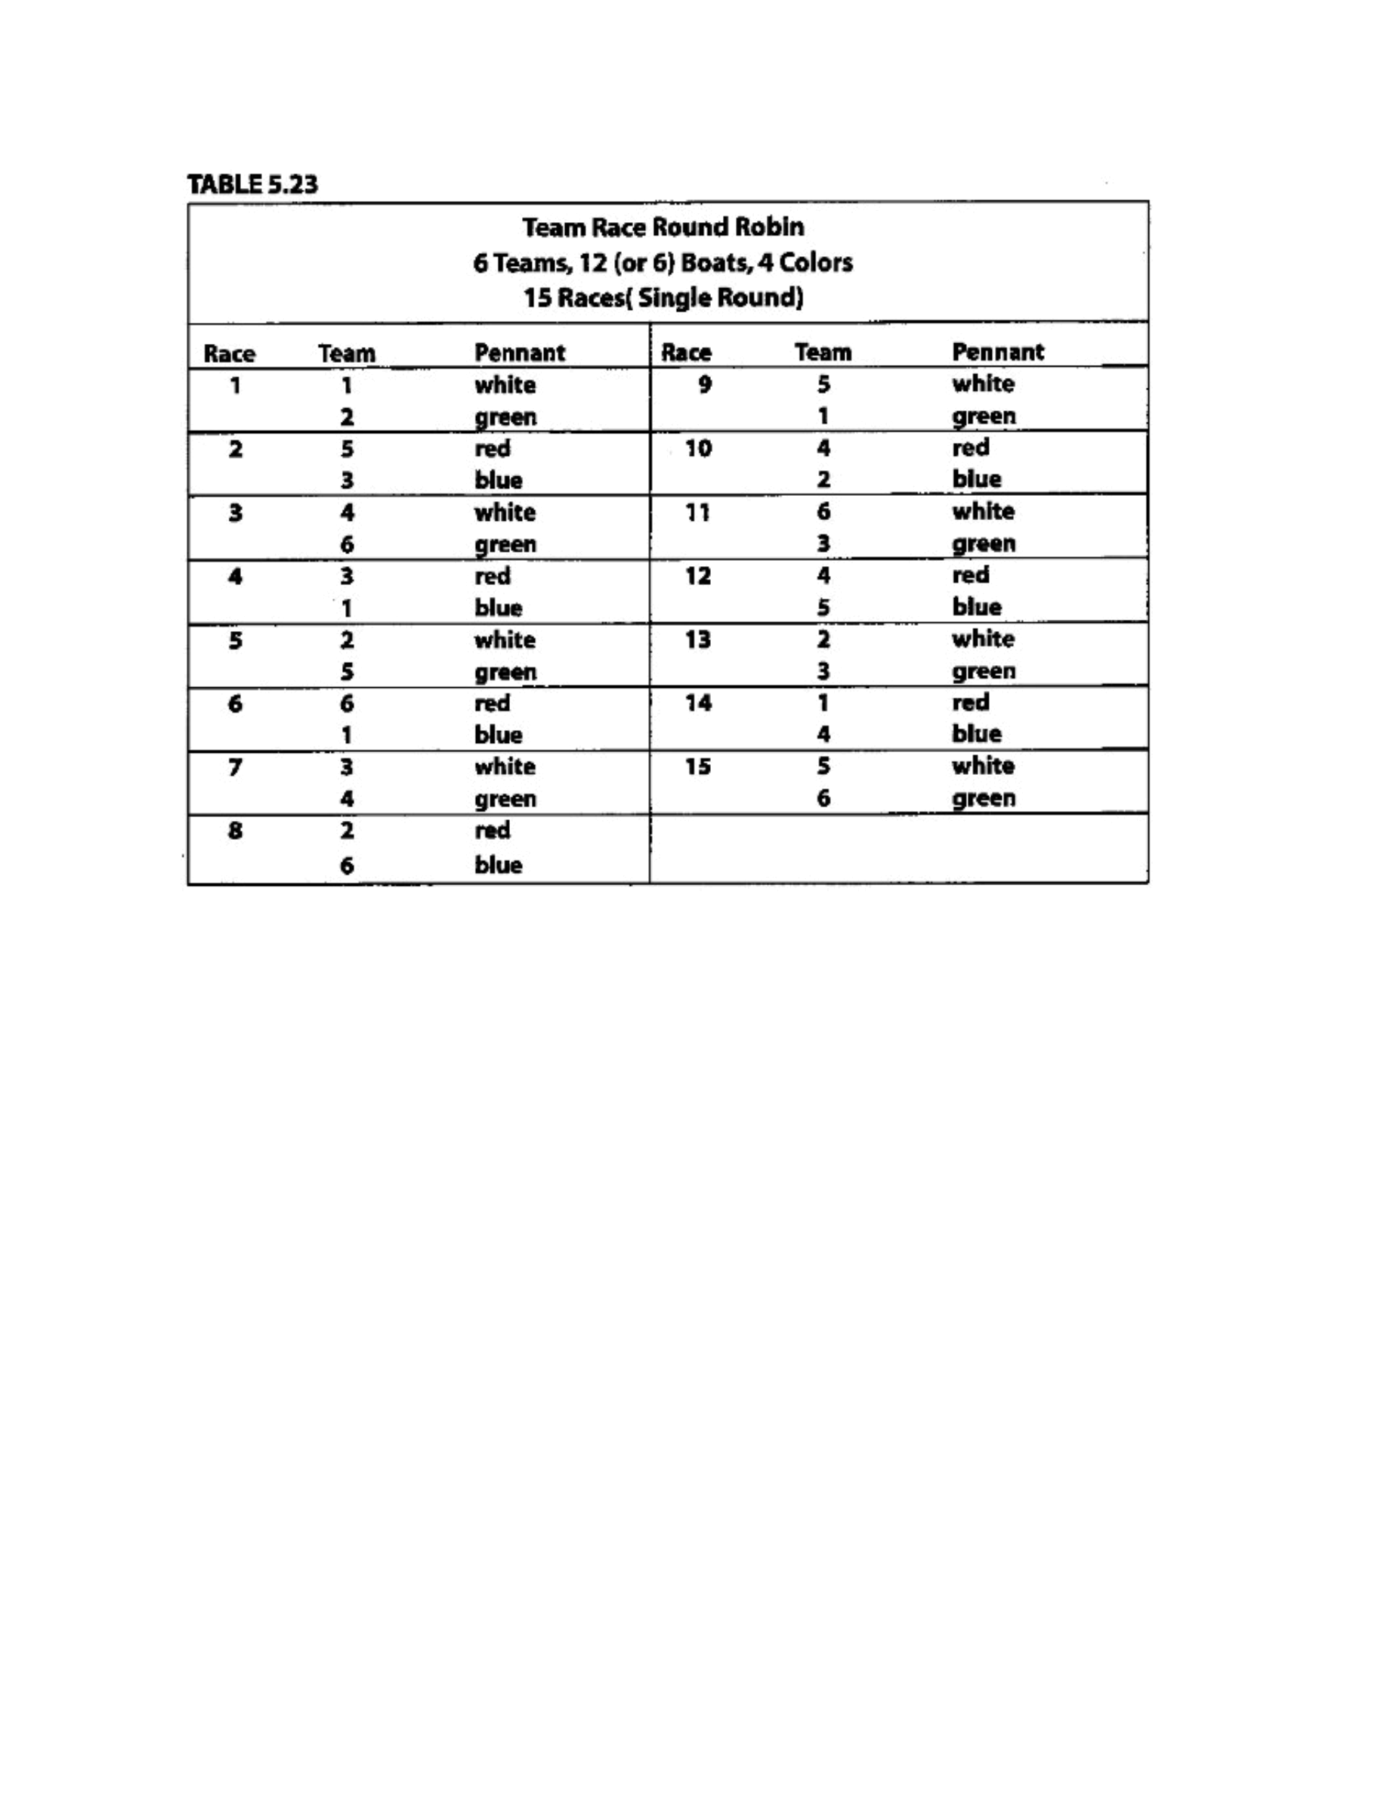
Taken
from
“
Race
Management
Handbook
”,
Chapter
5
©
2001,
US
SAILING
Page
4
of
24
Comments
to
Table
5.23:
1.
For
a
double
round-robin,
repeat
the
same
format
for
the
second
round.
Break
between
races
15
and
16,
since
the
boats
with
the
white
and
green
pennants
will
be
used
in
both
races.
2.
Instead,
you
may
wish
to
use
a
single
round-robin,
followed
by
a
“best-of-three”
final,
with
all
races
counted
(see
“Suggested
Formats”).
3.
Where
you
have
only
6
boats,
the
pairing
is
the
same,
but
only
two
colors
are
used
(for
exam-
ple,
white
and
green).
Instead
of
starting
race
2
immediately
after
race
1,
the
teams
must
exchange
boats
after
each
race
with
the
next
teams
to
start.
4.
The
boat
rotation
for
six
teams
using
18
boats
is
only
slightly
quicker
than
the
12-boat
rotation,
so
only
the
recommended
12-boat
rotation
is
included
here,
between
races
21
and
22,
since
the
boats
with
the
white
and
green
pennants
will
be
used
in
both
races.
3.
Where
you
have
only
6
boats,
the
pairing
is
the
same,
but
only
two
colors
are
used
(for
exam-
ple,
white
and
green).
Instead
of
starting
race
2
immediately
after
race
1,
the
teams
must
exchange
boats
after
each
race
with
the
next
teams
to
start.
4.
Where
you
have
18
boats,
use
Table
5.26.
Event: Enter event name

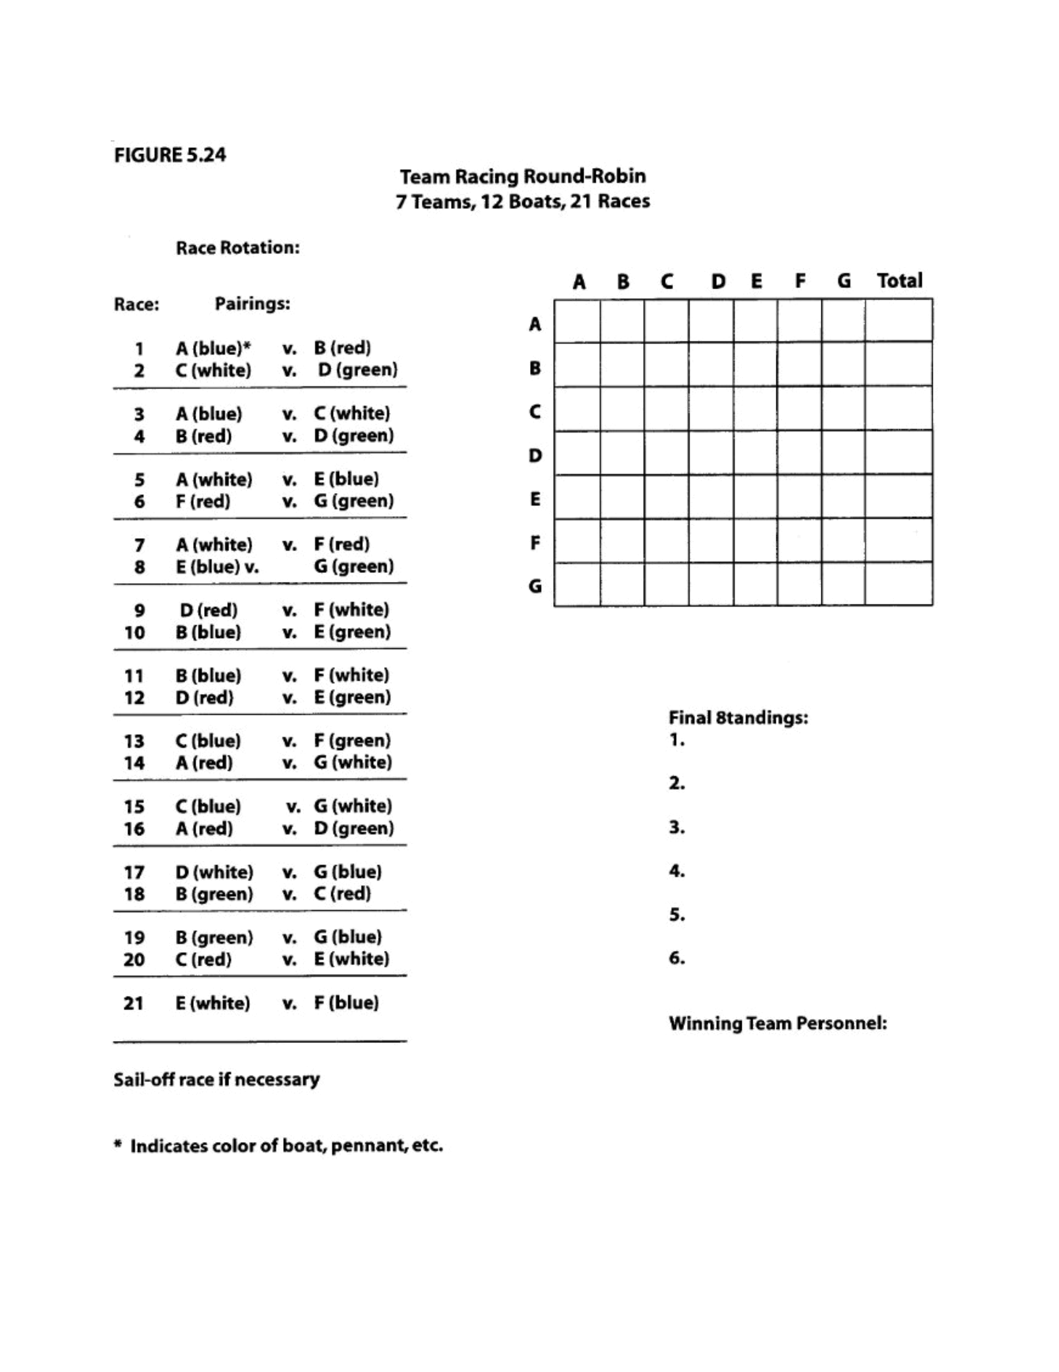
Taken
from
“
Race
Management
Handbook
”,
Chapter
5
©
2001,
US
SAILING
Page
5
of
24
Event: Enter event name

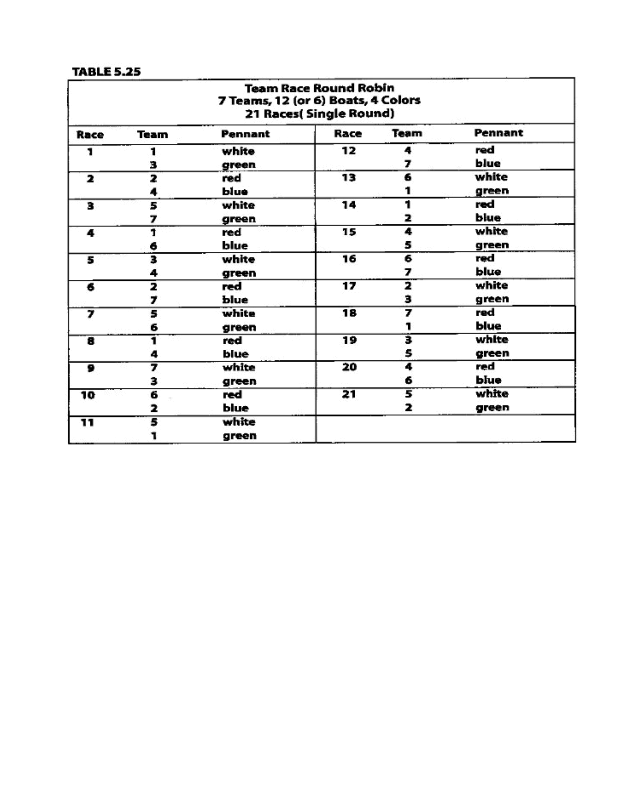
Taken
from
“
Race
Management
Handbook
”,
Chapter
5
©
2001,
US
SAILING
Page
6
of
24
Comments
to
Table
5.25:
1.
Table
5.25
is
the
same
type
of
format
as
Table
5.24,
but
expressed
differently.
2.
You
may
wish
to
use
a
single
round-robin,
followed
by
a
“final
four”
round
robin.
Table
5.21
(see
“Suggested
Formats”).
3.
For
a
double
round-robin,
repeat
the
same
format
for
the
second
round.
Break
between
races
21
and
22,
since
the
boats
with
the
white
and
green
pennants
will
be
used
in
both
races.
3.
Where
you
have
only
6
boats,
the
pairing
is
the
same,
but
only
two
colors
are
used
(for
exam-
ple,
white
and
green).
Instead
of
starting
race
2
immediately
after
race
1,
the
teams
must
exchange
boats
after
each
race
with
the
next
teams
to
start.
5.
Where
you
have
18
boats,
use
Table
5.26.
Event: Enter event name

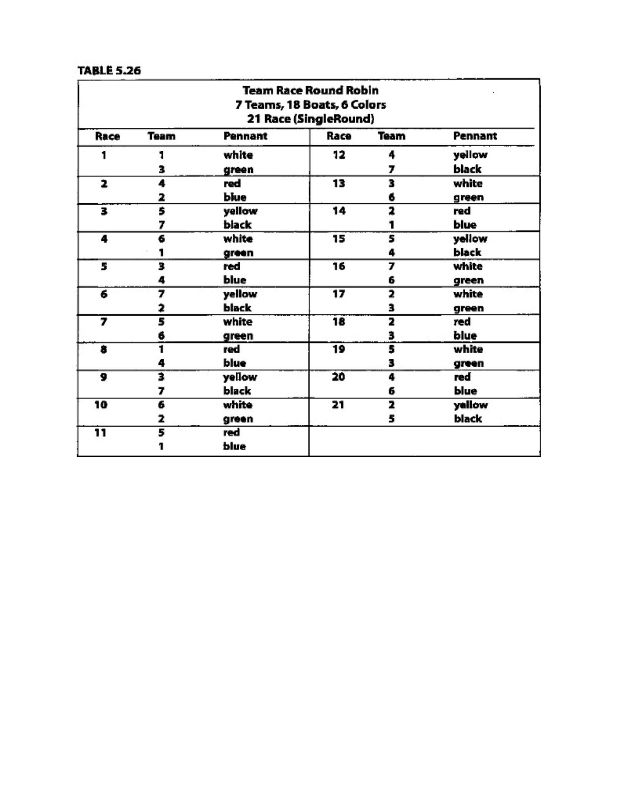
Taken
from
“
Race
Management
Handbook
”,
Chapter
5
©
2001,
US
SAILING
Page
7
of
24
Event: Enter event name

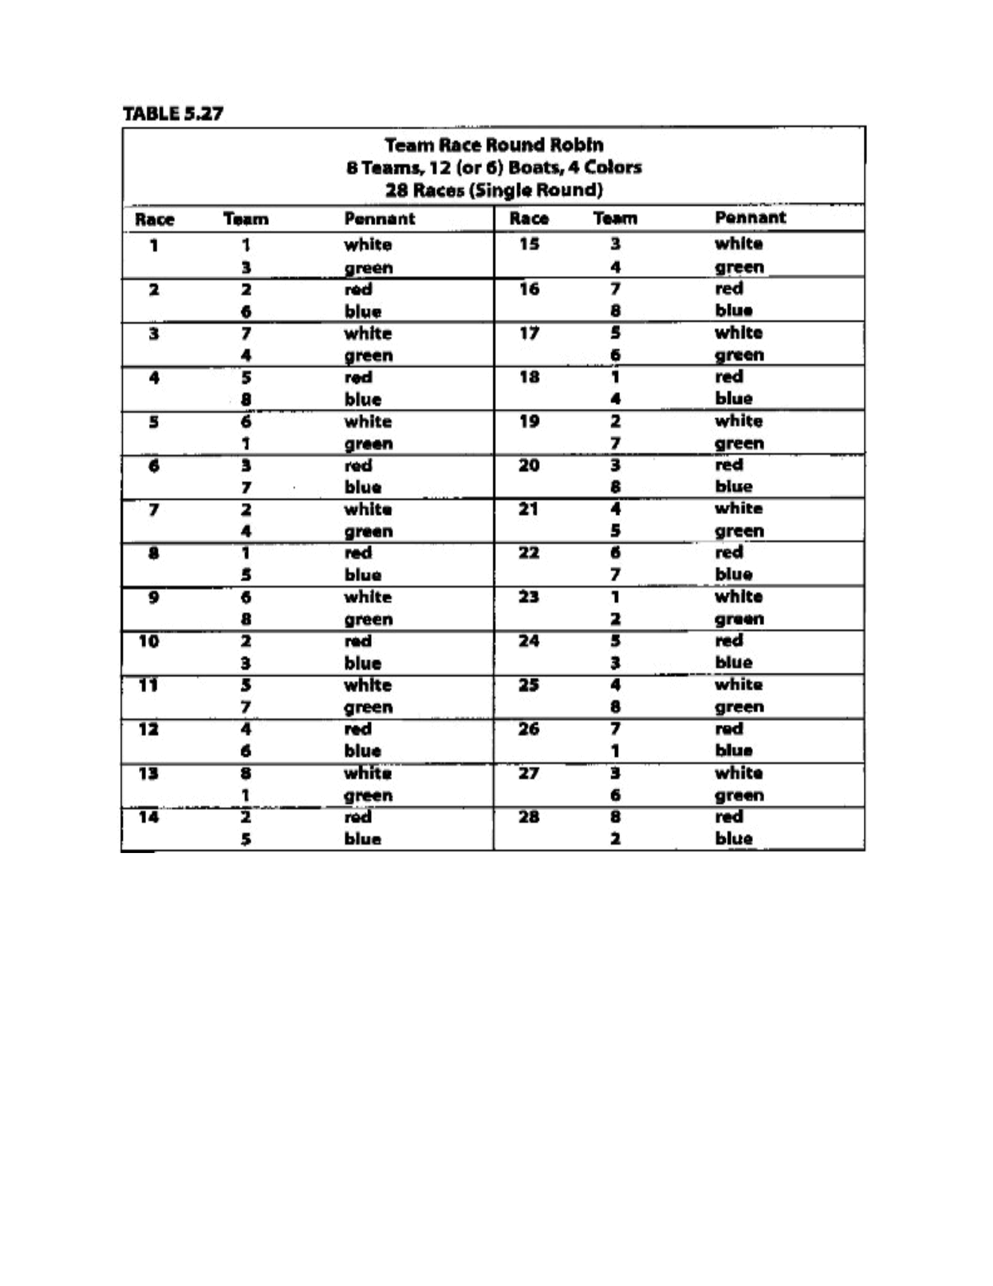
Taken
from
“
Race
Management
Handbook
”,
Chapter
5
©
2001,
US
SAILING
Page
8
of
24
Comments
Table
5.27
1.
For
a
double
round-robin,
repeat
the
same
format
for
the
second
round.
2.
Where
teams
are
unevenly
matched,
use
a
bracket
system
elimination
(Table
5.16).
Where
they
are
evenly
matched,
use
either
a
double
round-robin,
or
a
single
round-robin
followed
by
either
a
“best-of-three”
final
or
a
“final-four”
round-robin
(Table
5.21)
3.
Eight
teams
is
effectively
the
practical
limit
for
using
only
6
boats,
because
of
the
amountof
time
each
team
must
wait
to
race.
Where
you
have
only
6
boats,
the
pairing
is
the
same,
but
only
two
colors
are
used
(for
example,
white
and
green),
Instead
of
starting
race
two
immediately
after
race
1,
the
teams
must
exchange
boats
after
each
race
with
the
next
teams
to
start.
Event: Enter event name

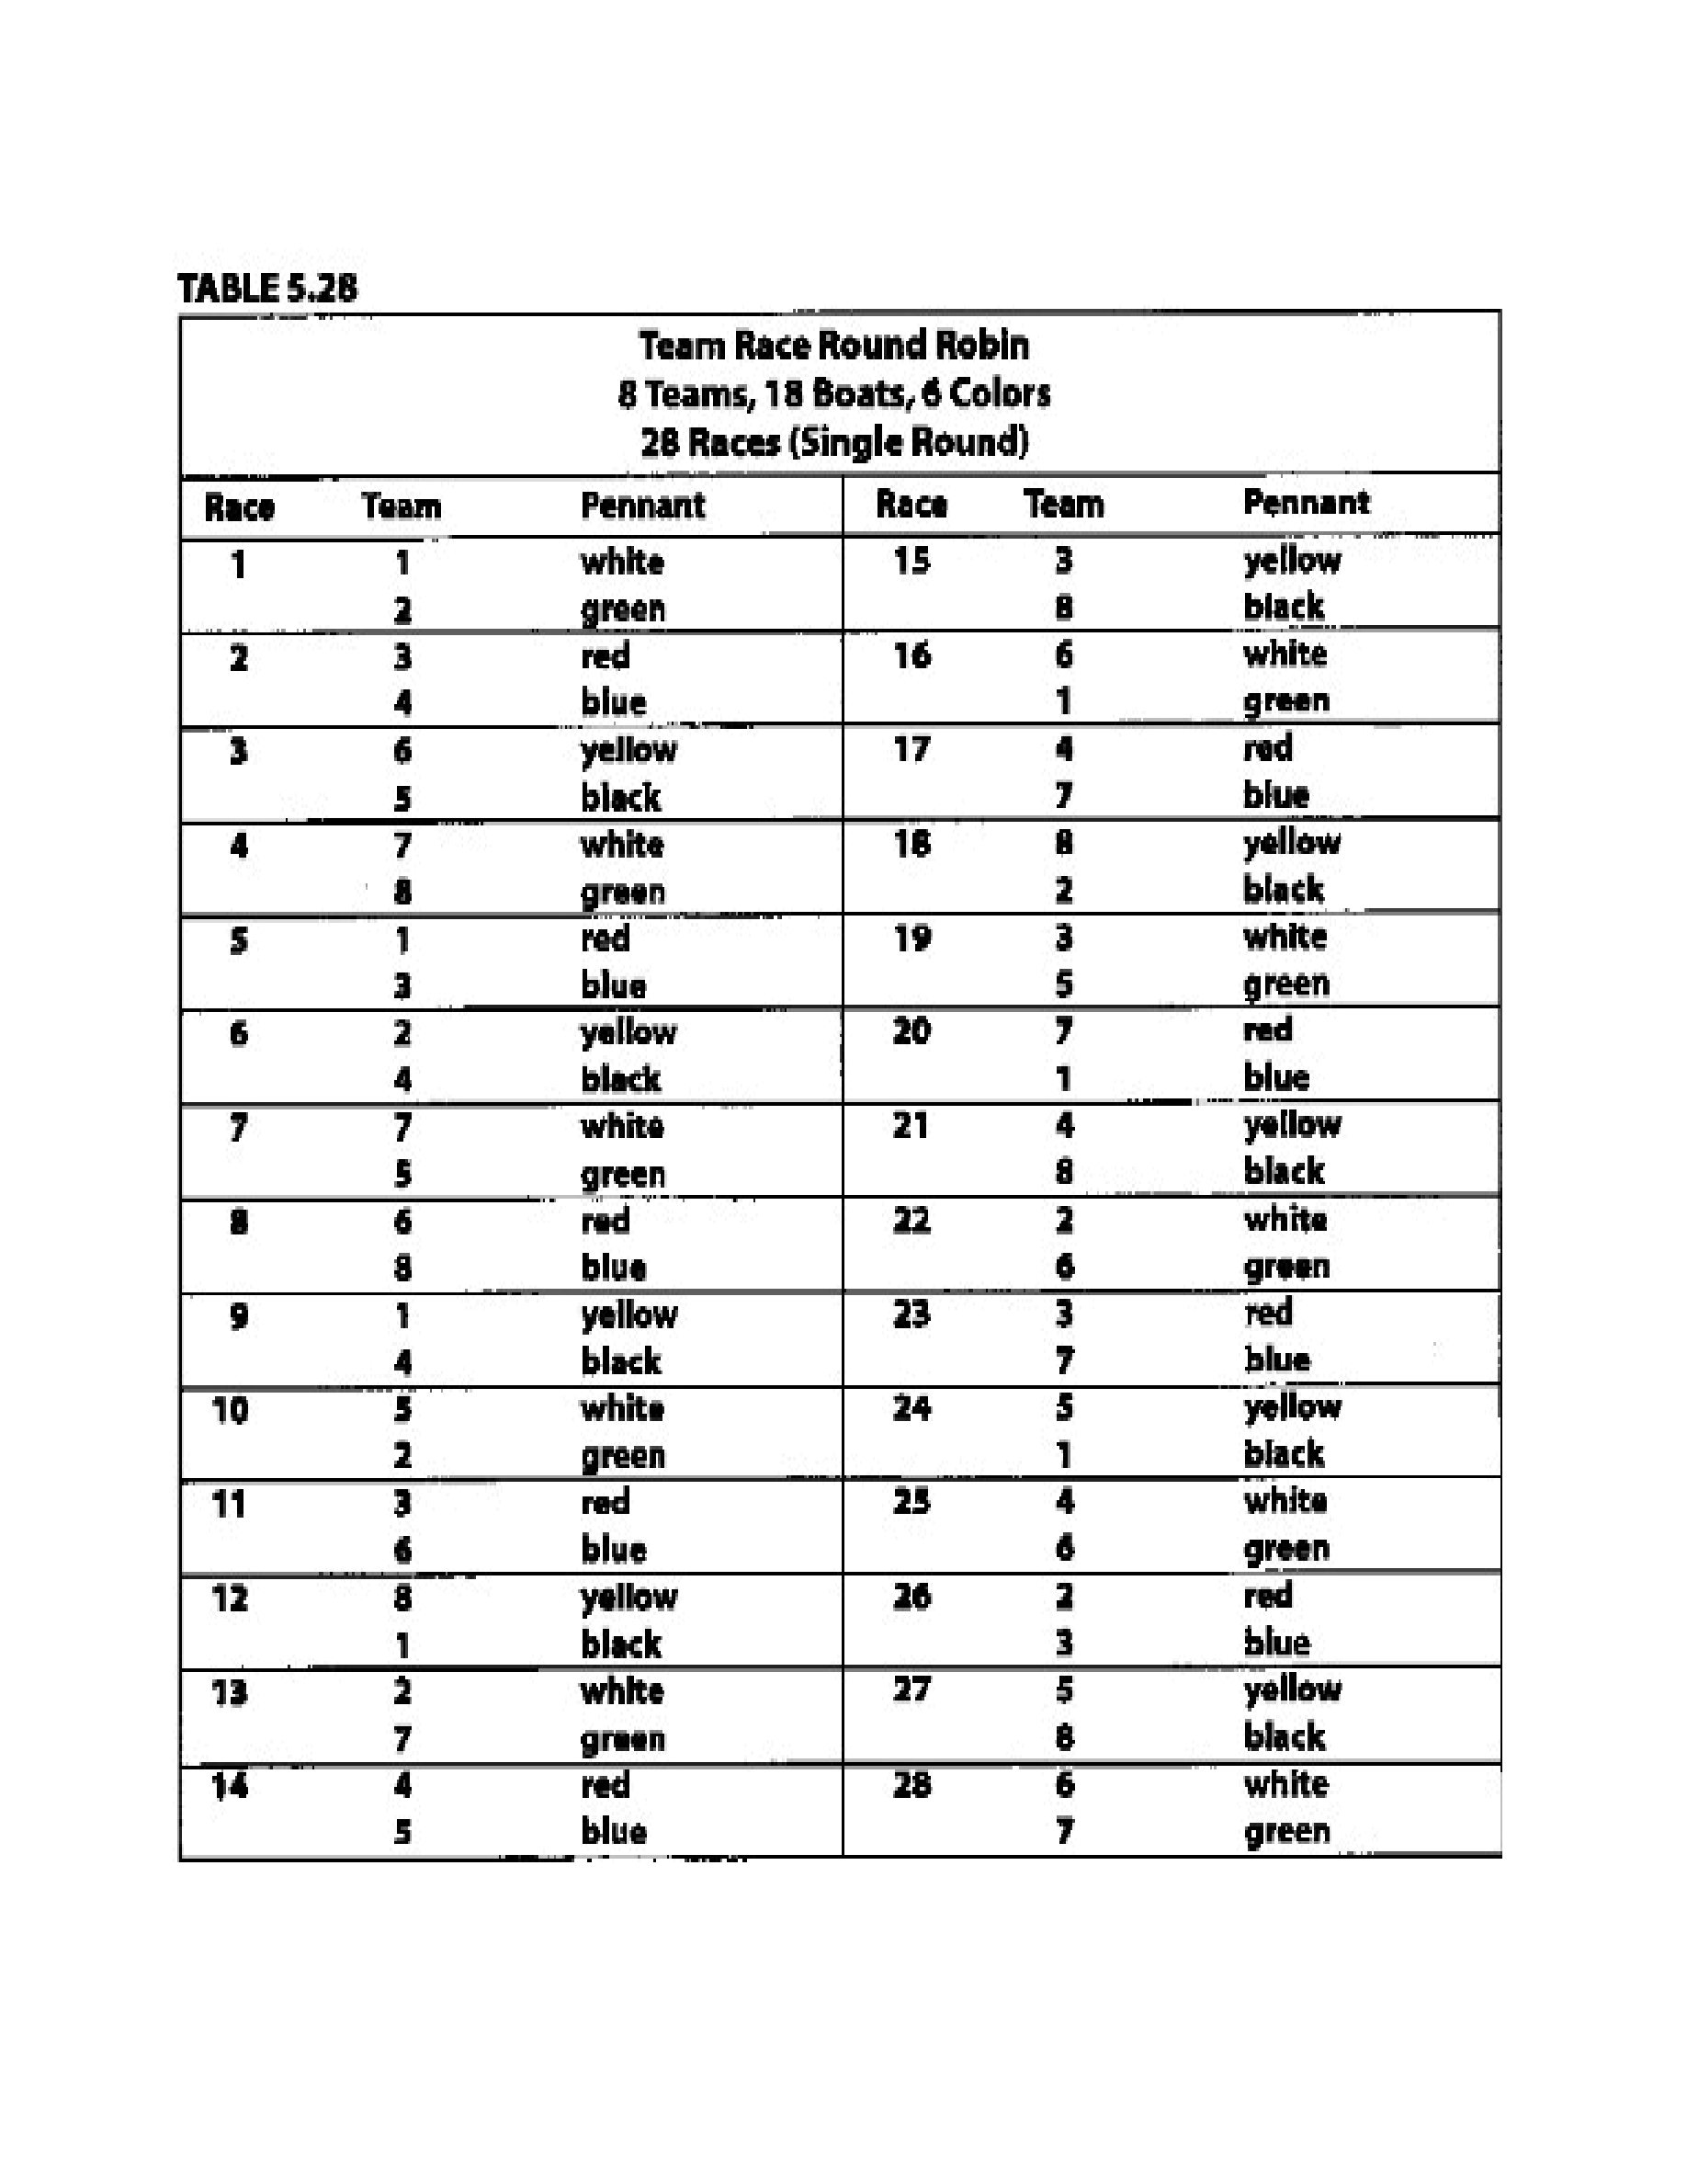
Taken
from
“
Race
Management
Handbook
”,
Chapter
5
©
2001,
US
SAILING
Page
9
of
24
Event: Enter event name

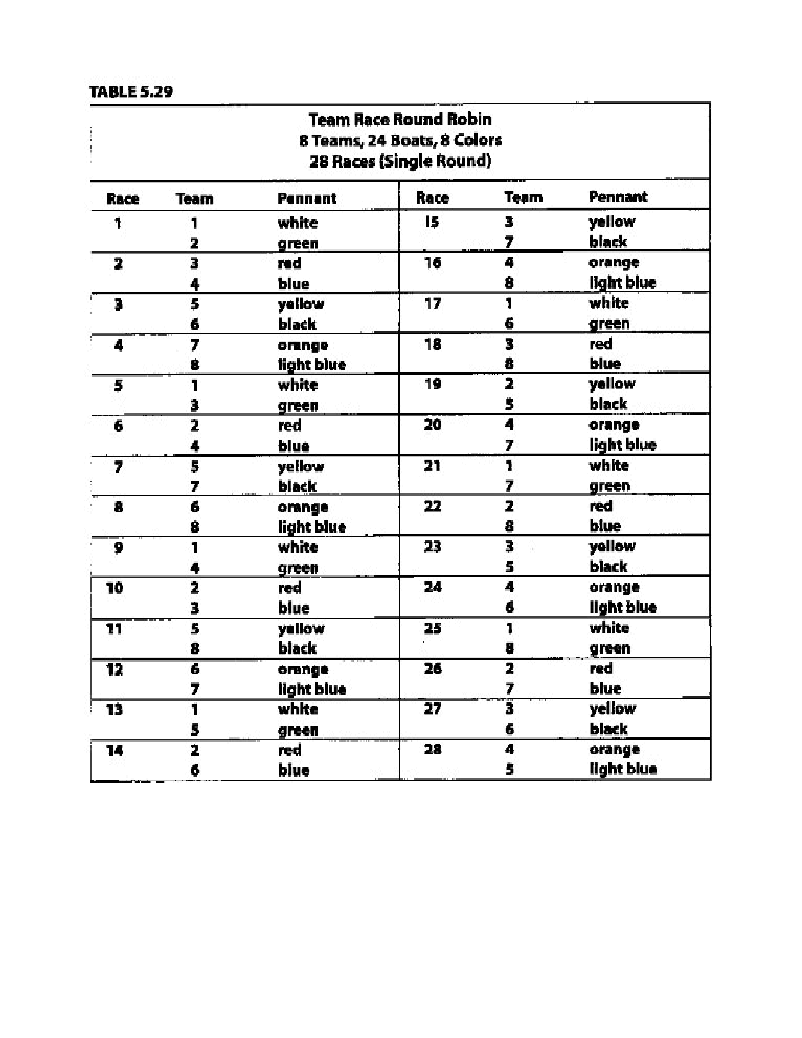
Taken
from
“
Race
Management
Handbook
”,
Chapter
5
©
2001,
US
SAILING
Comment
to
Tables
5.33-
5.38:
Use
these
single
round
robins
with
either
a
“best-of-three”
final
or
a
“final-four”
round
robin
(see
“Suggested
Formats”,
“Basic
final-Four”
and
Table
5.21
above).
Page
10
of
24
Event: Enter event name

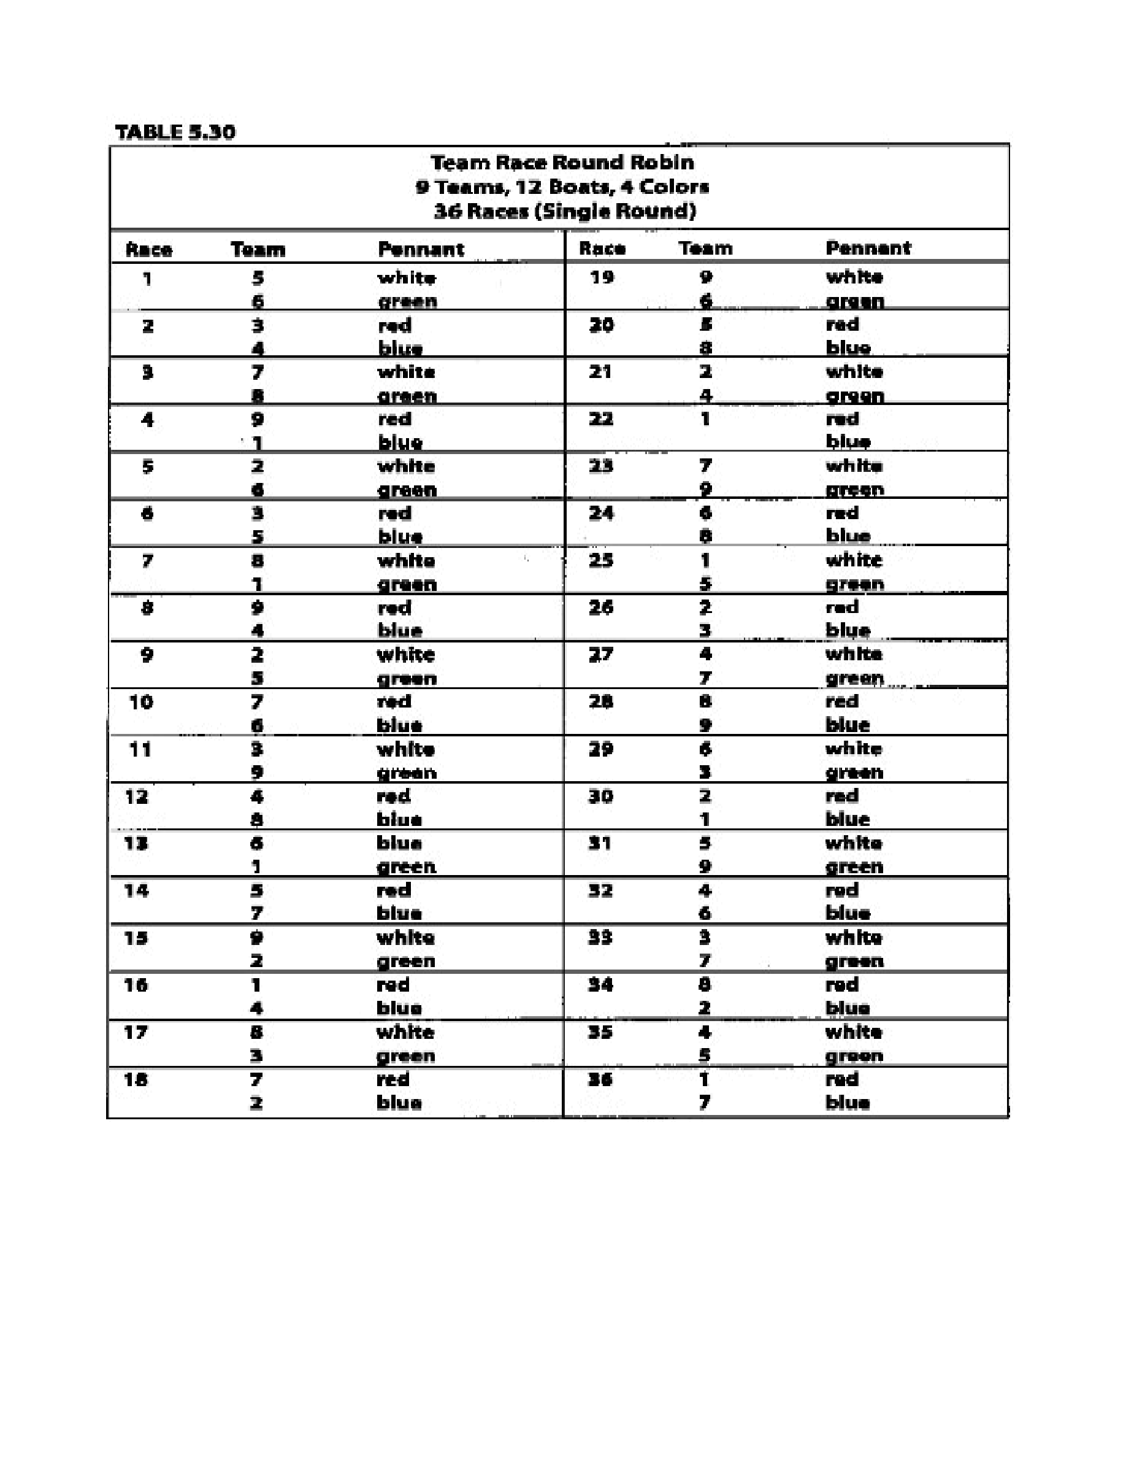
Taken
from
“
Race
Management
Handbook
”,
Chapter
5
©
2001,
US
SAILING
Page
11
of
24
Taken
from
“
Race
Management
Handbook
”,
Chapter
5
©
2001,
US
SAILING
Page
11
of
24
Event: Enter event name

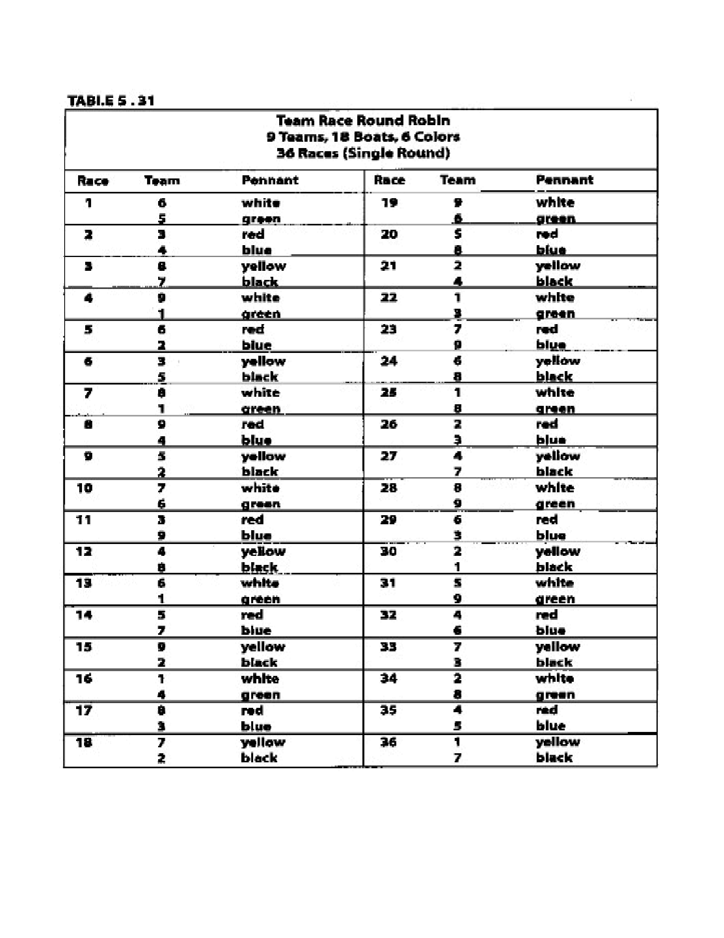
Taken
from
“
Race
Management
Handbook
”,
Chapter
5
©
2001,
US
SAILING
Page
12
of
24
Taken
from
“
Race
Management
Handbook
”,
Chapter
5
©
2001,
US
SAILING
Page
12
of
24
Event: Enter event name

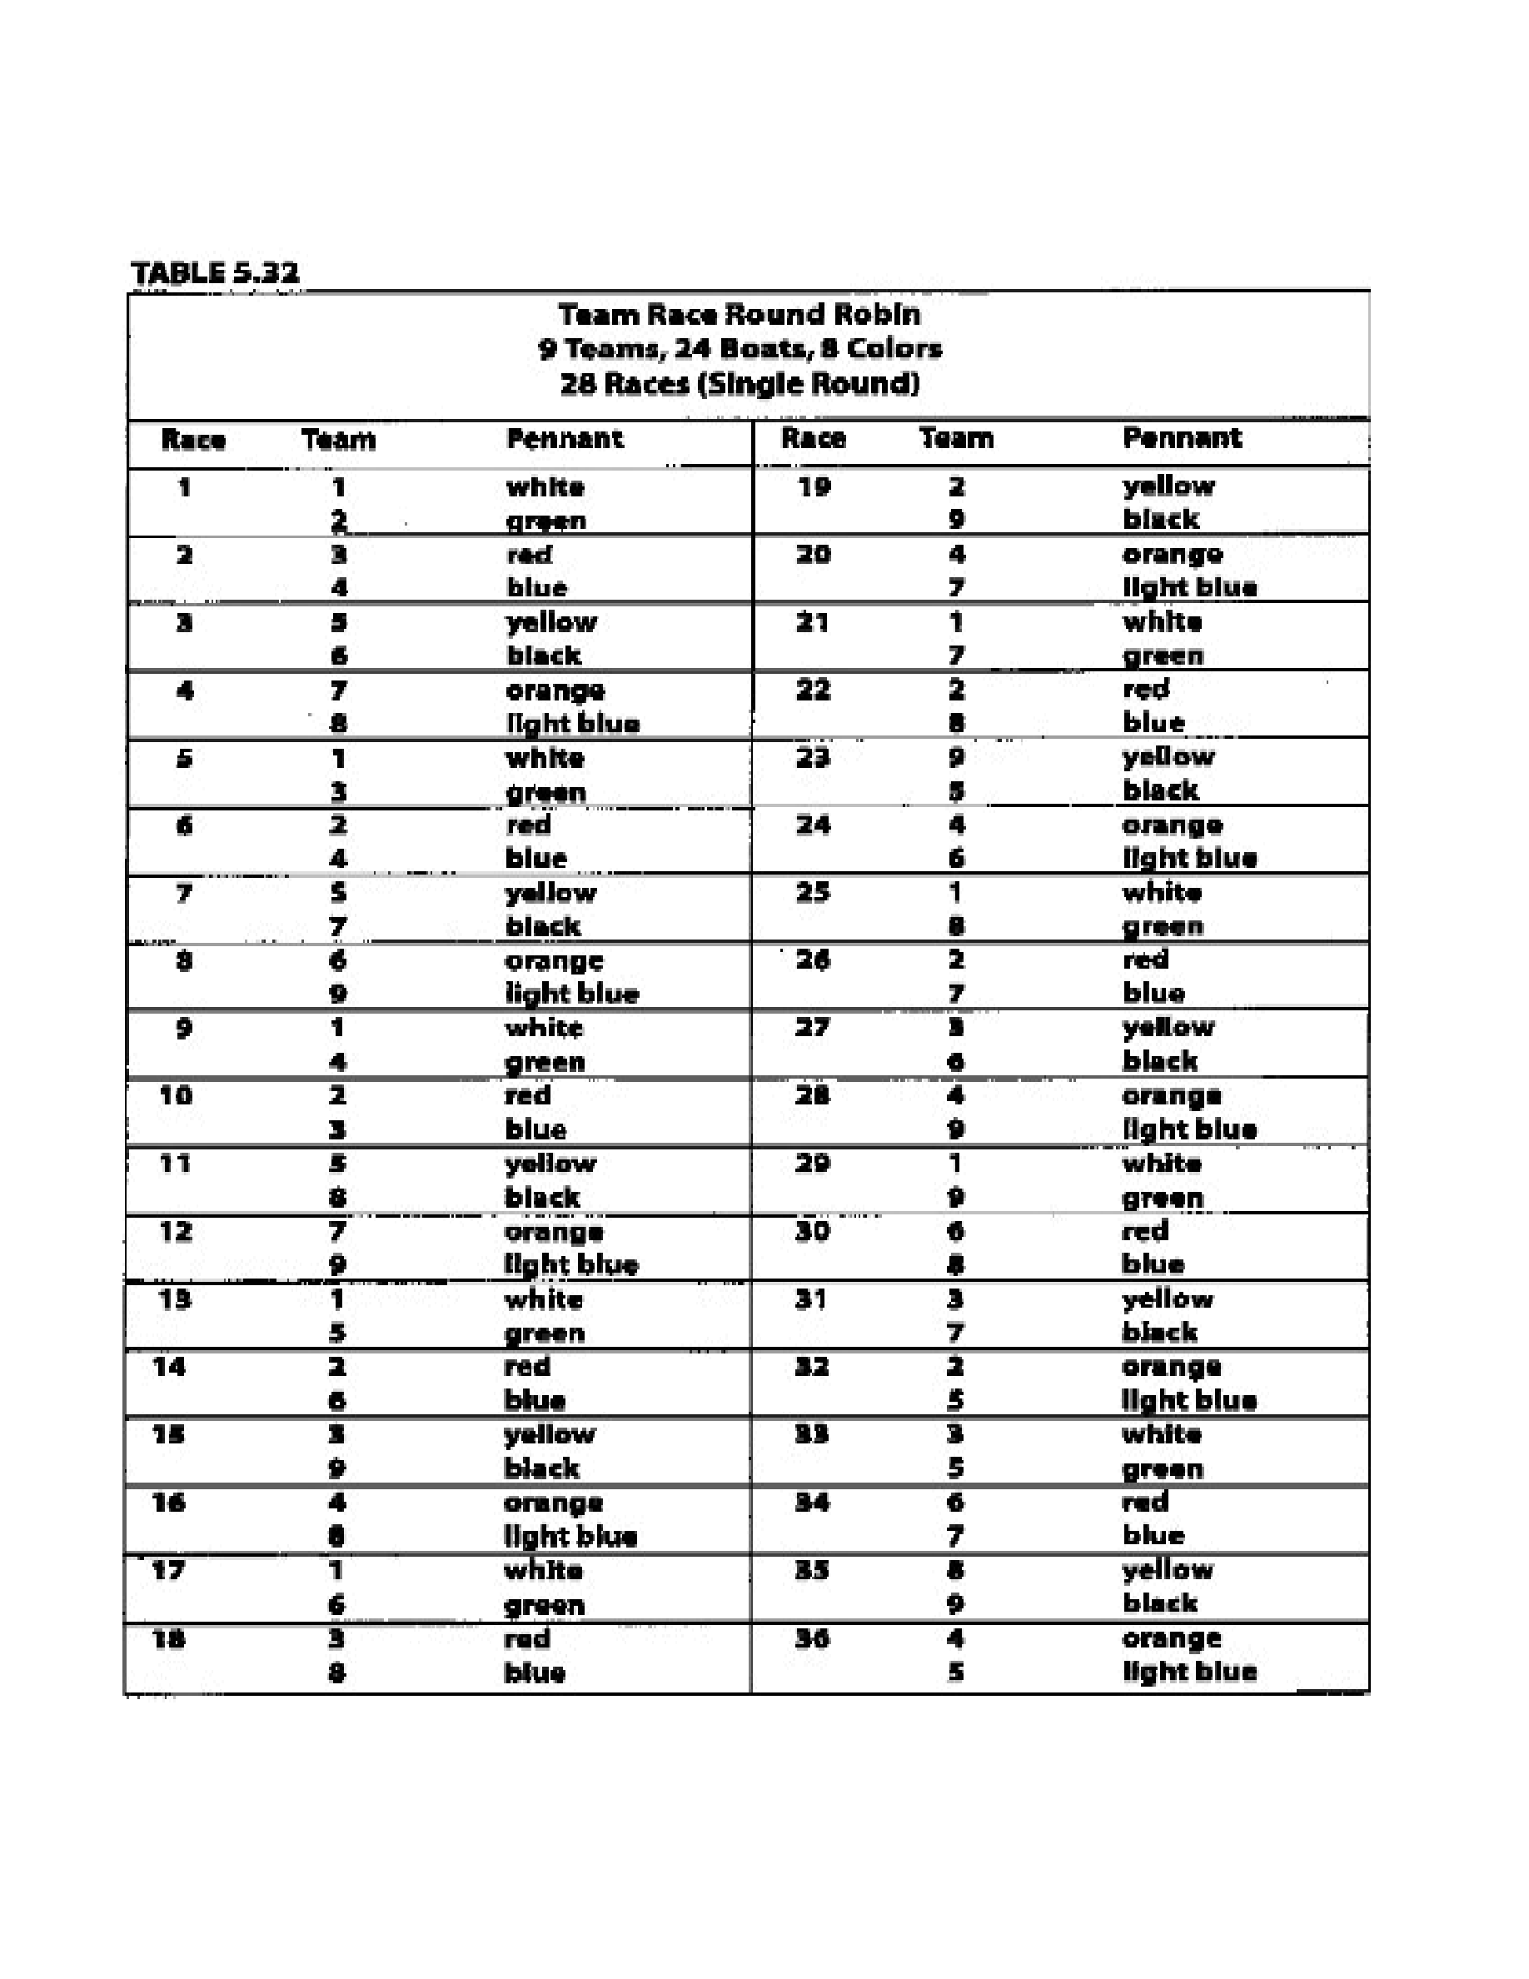
Taken
from
“
Race
Management
Handbook
”,
Chapter
5
©
2001,
US
SAILING
Page
13
of
24
Event: Enter event name

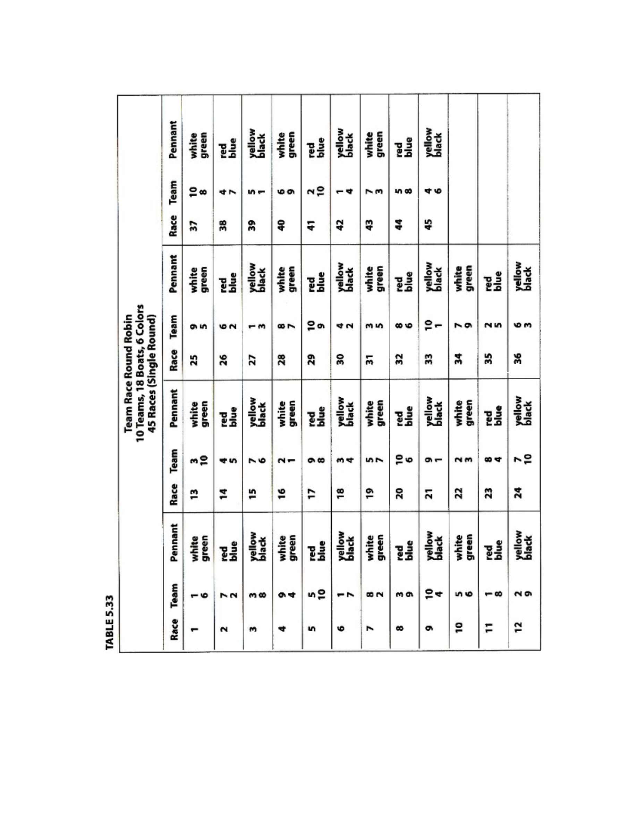
Taken
from
“
Race
Management
Handbook
”,
Chapter
5
©
2001,
US
SAILING
Page
14
of
24
Event: Enter event name

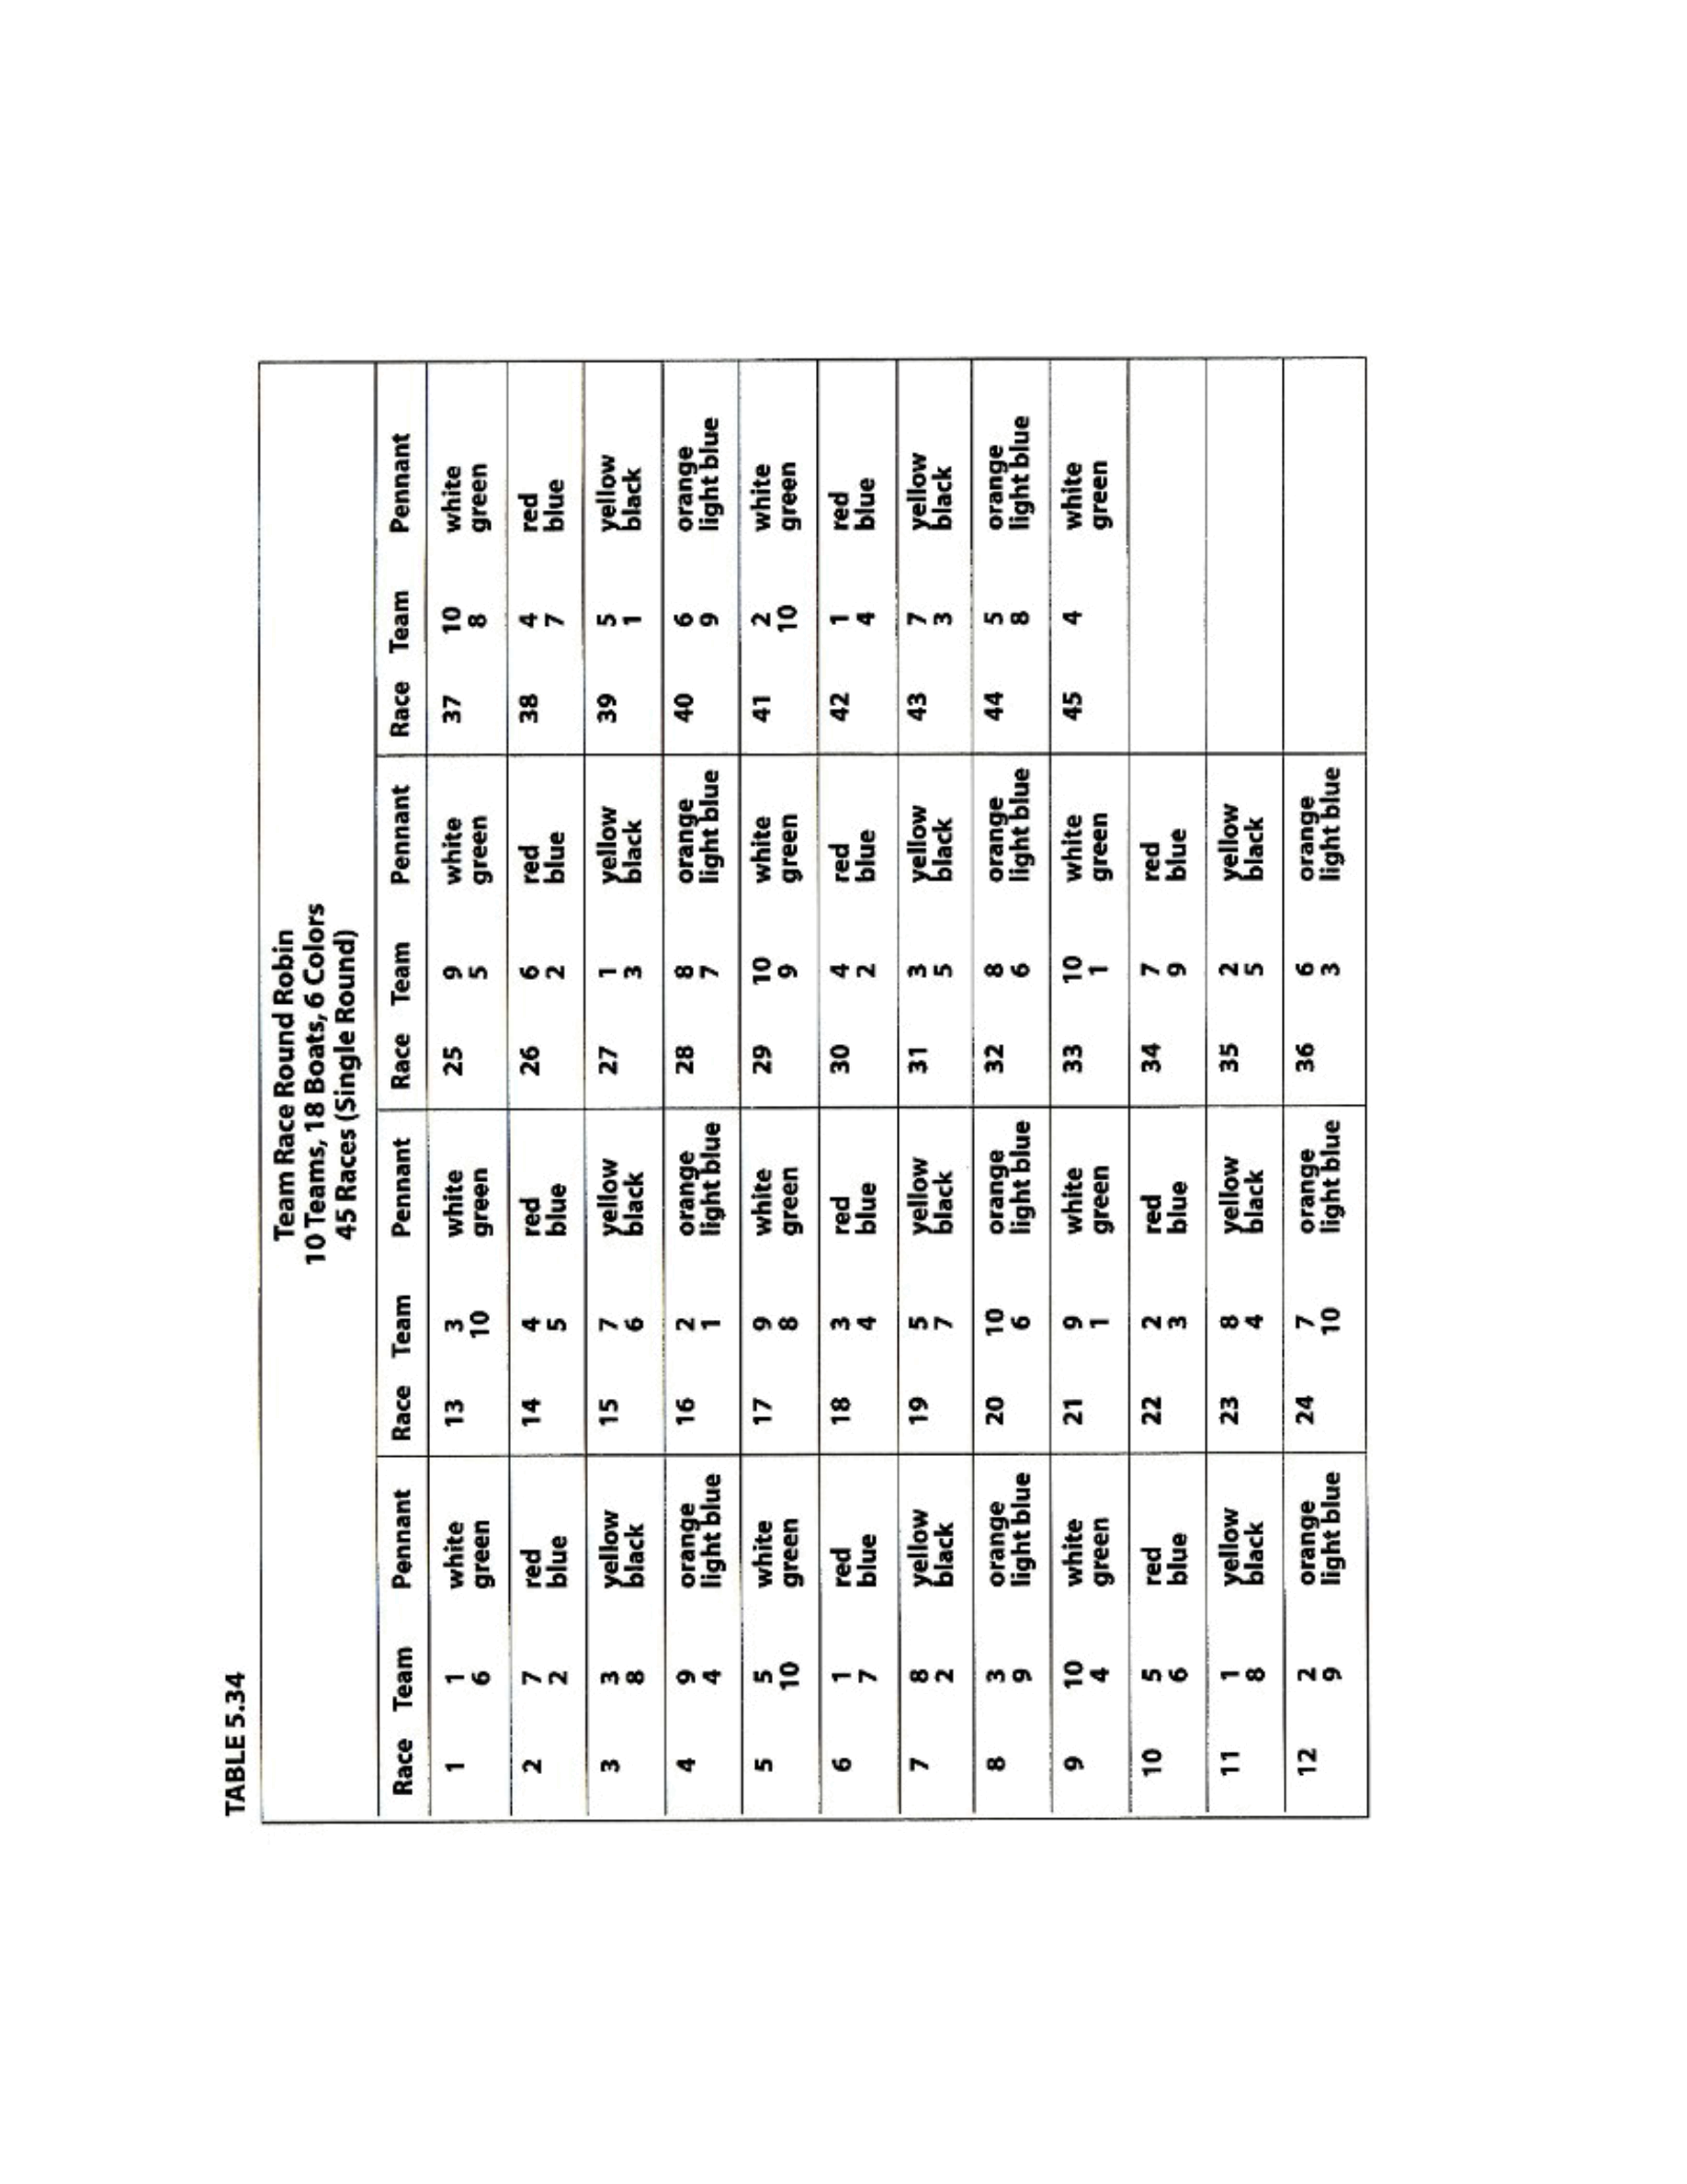
Taken
from
“
Race
Management
Handbook
”,
Chapter
5
©
2001,
US
SAILING
Page
15
of
24
Event: Enter event name

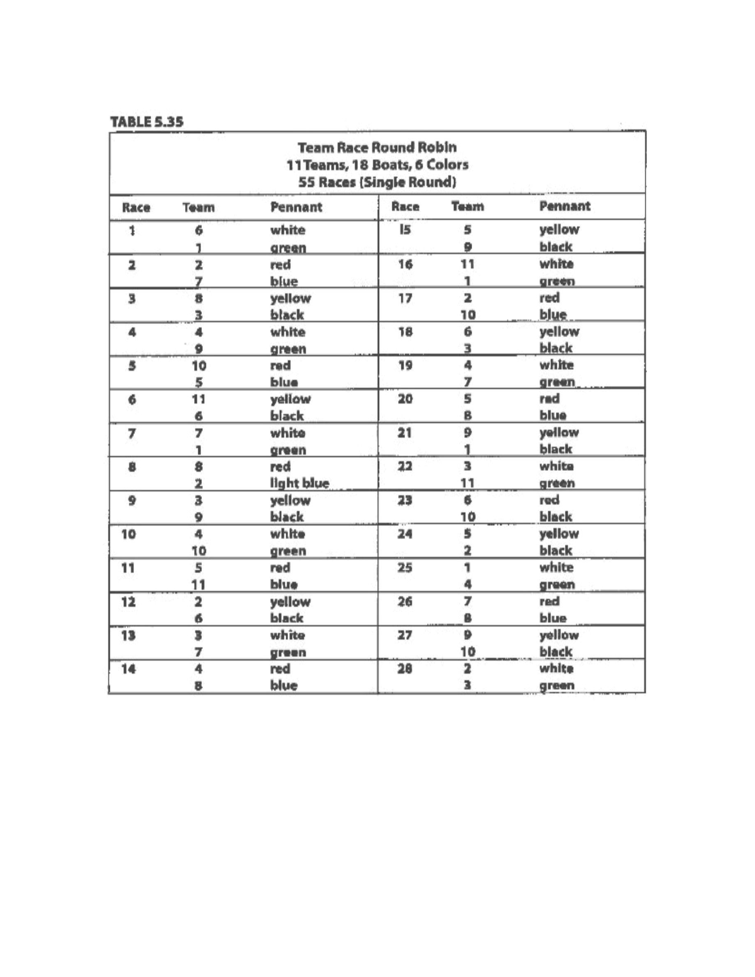
Taken
from
“
Race
Management
Handbook
”,
Chapter
5
©
2001,
US
SAILING
Page
16
of
24
Event: Enter event name

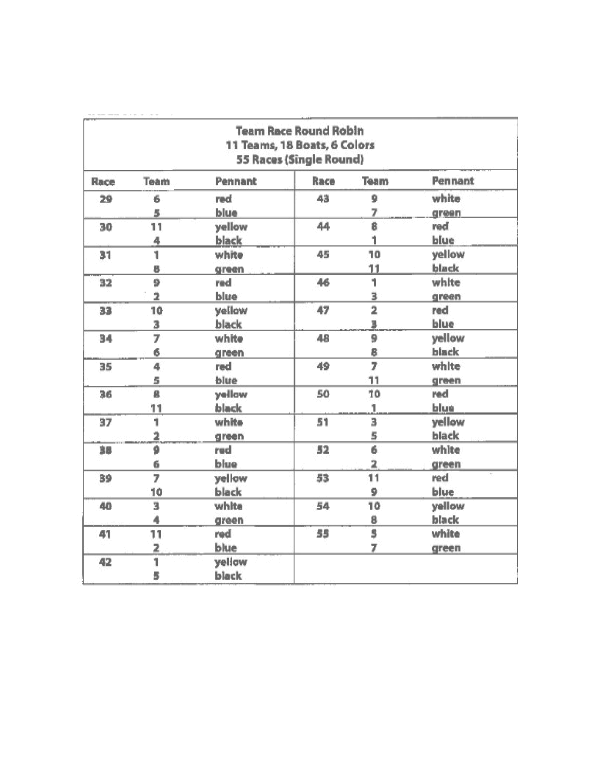
Taken
from
“
Race
Management
Handbook
”,
Chapter
5
©
2001,
US
SAILING
Page
17
of
24
Table
3.35
Continued
Event: Enter event name

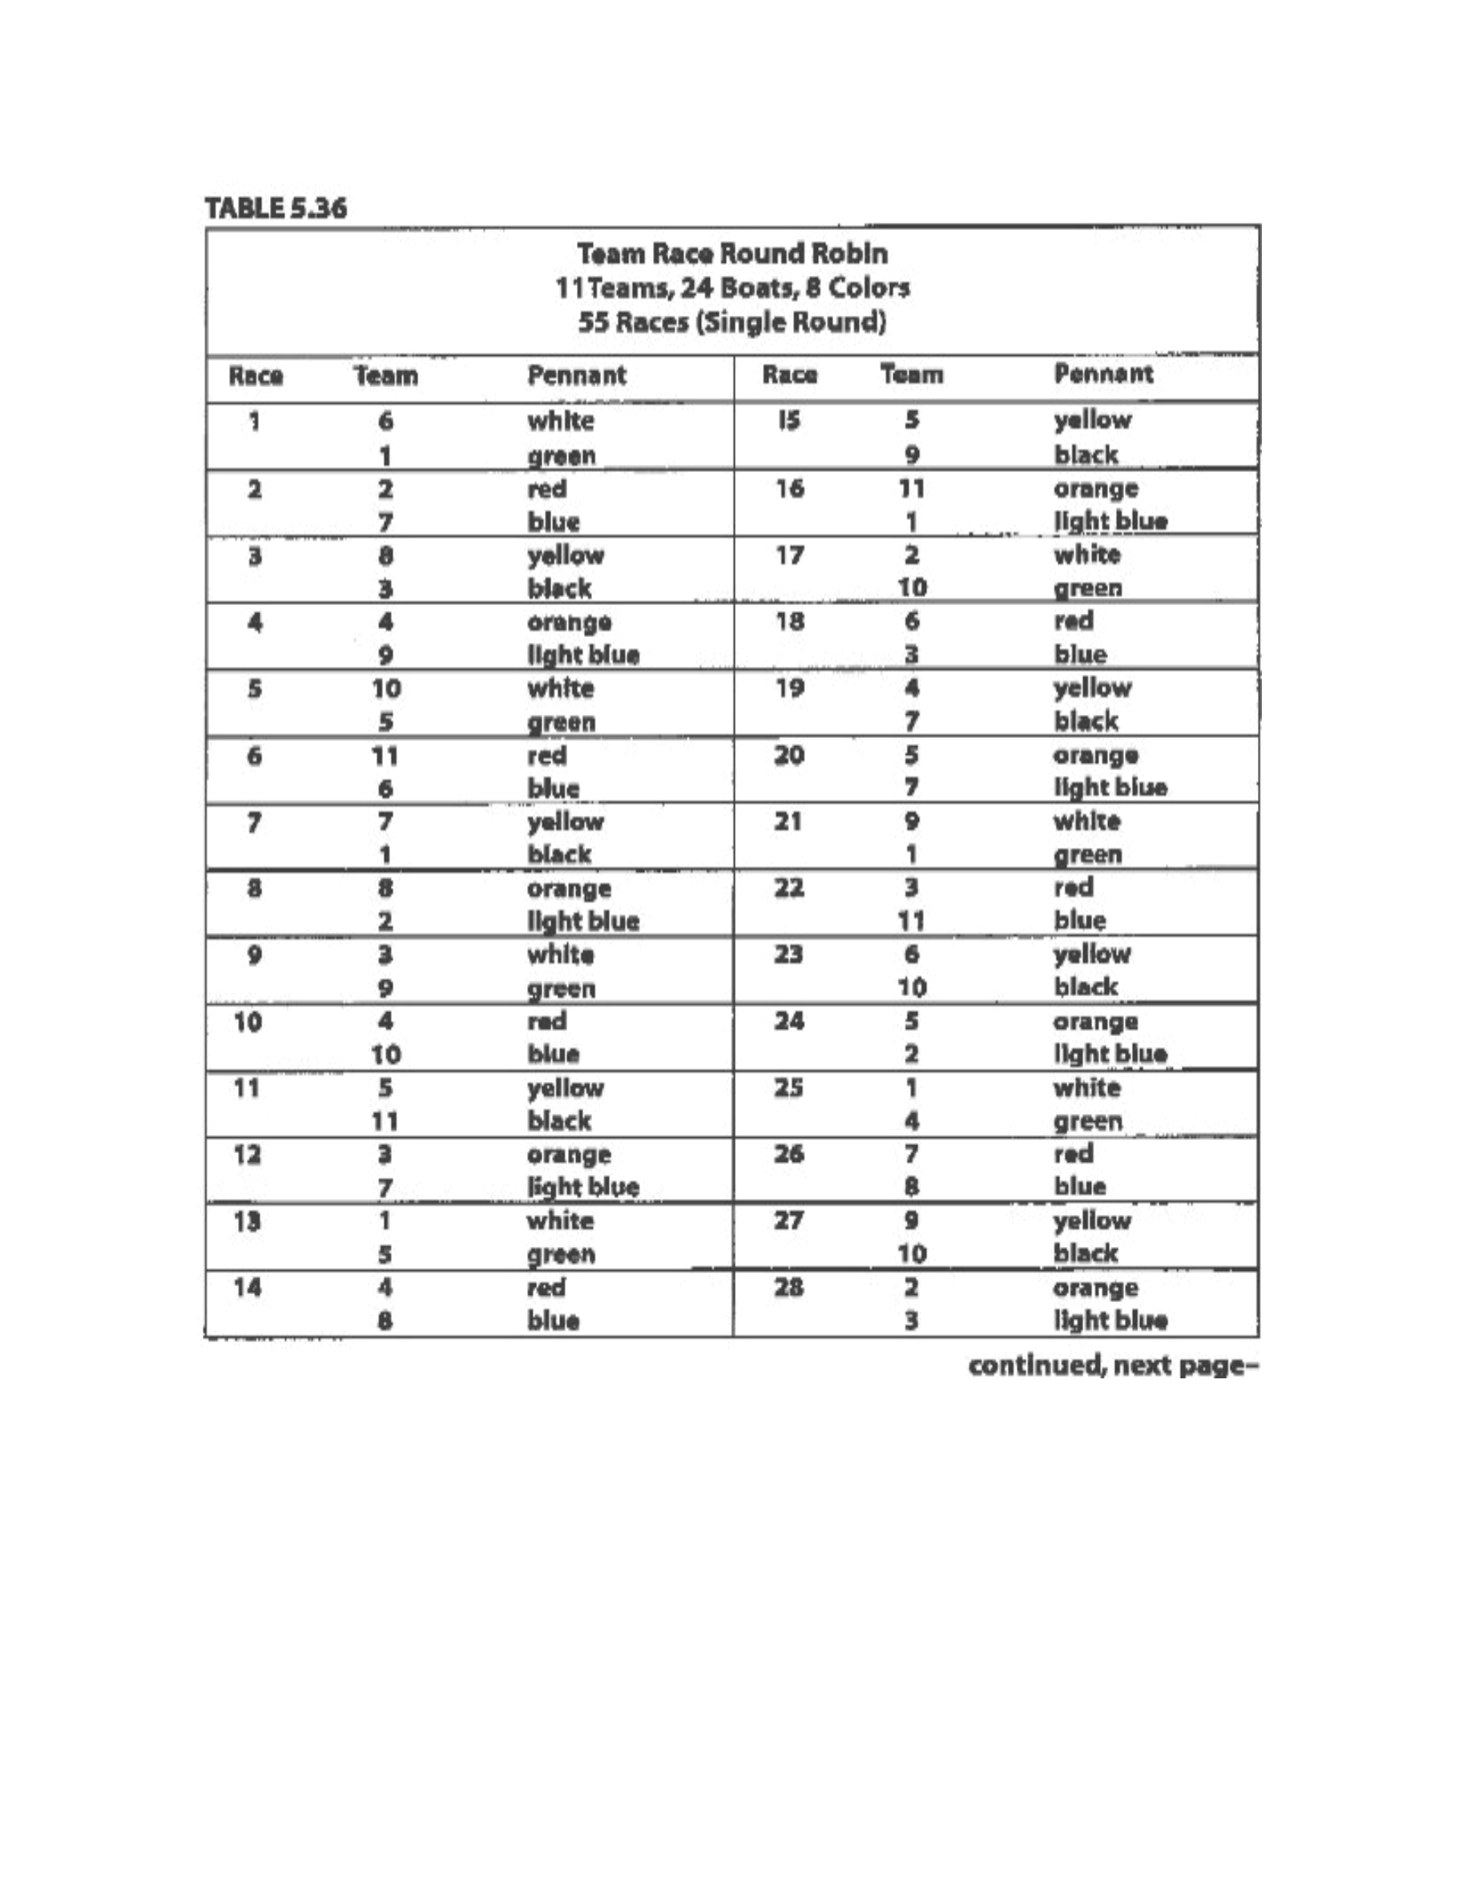
Taken
from
“
Race
Management
Handbook
”,
Chapter
5
©
2001,
US
SAILING
Page
18
of
24
Event: Enter event name

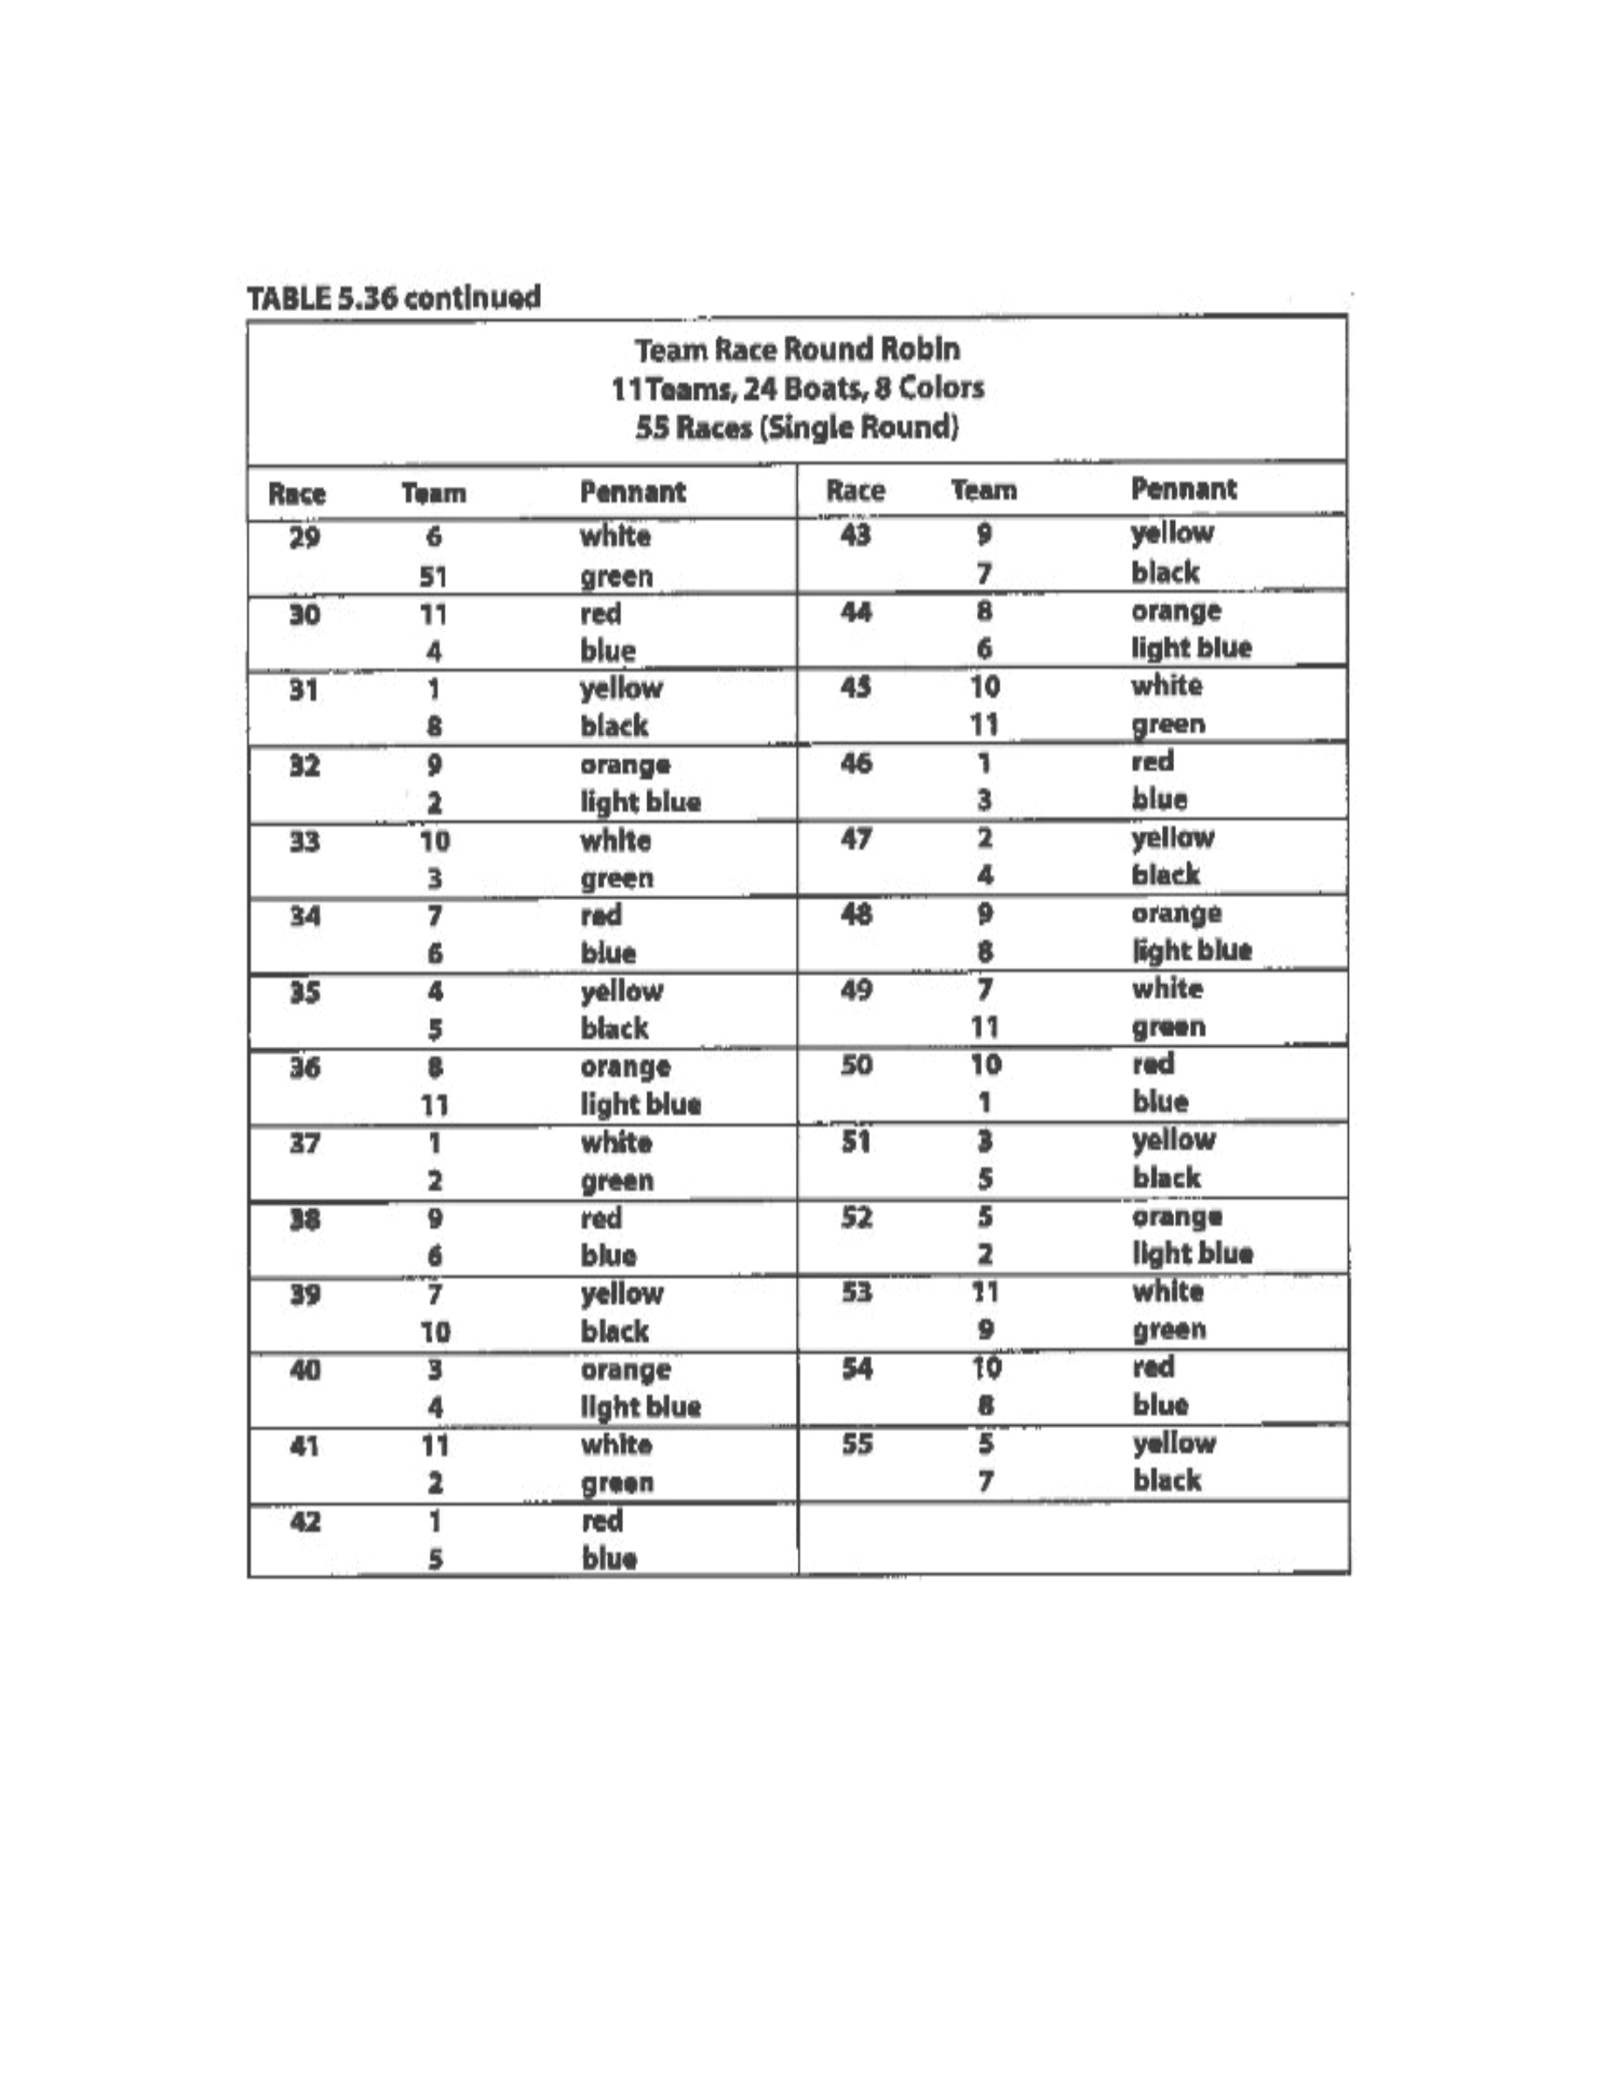
Taken
from
“
Race
Management
Handbook
”,
Chapter
5
©
2001,
US
SAILING
Page
19
of
24
Event: Enter event name

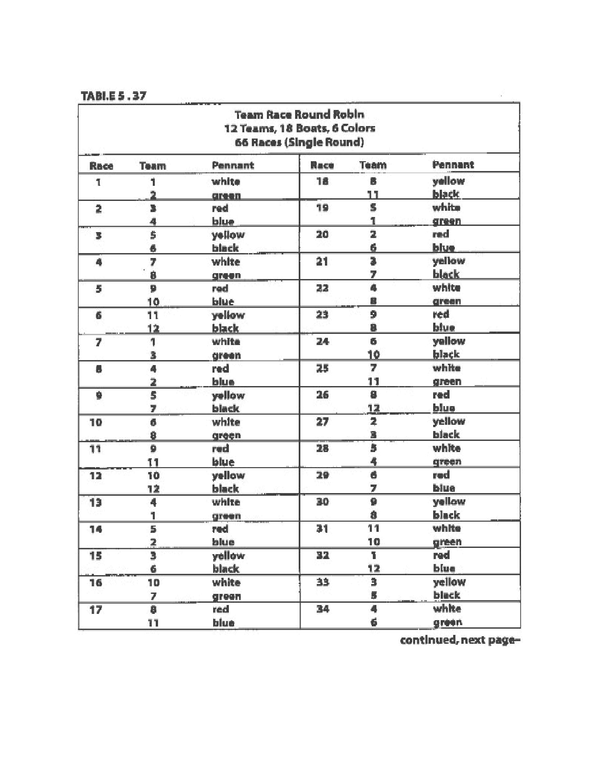
Taken
from
“
Race
Management
Handbook
”,
Chapter
5
©
2001,
US
SAILING
Page
20
of
24
Event: Enter event name

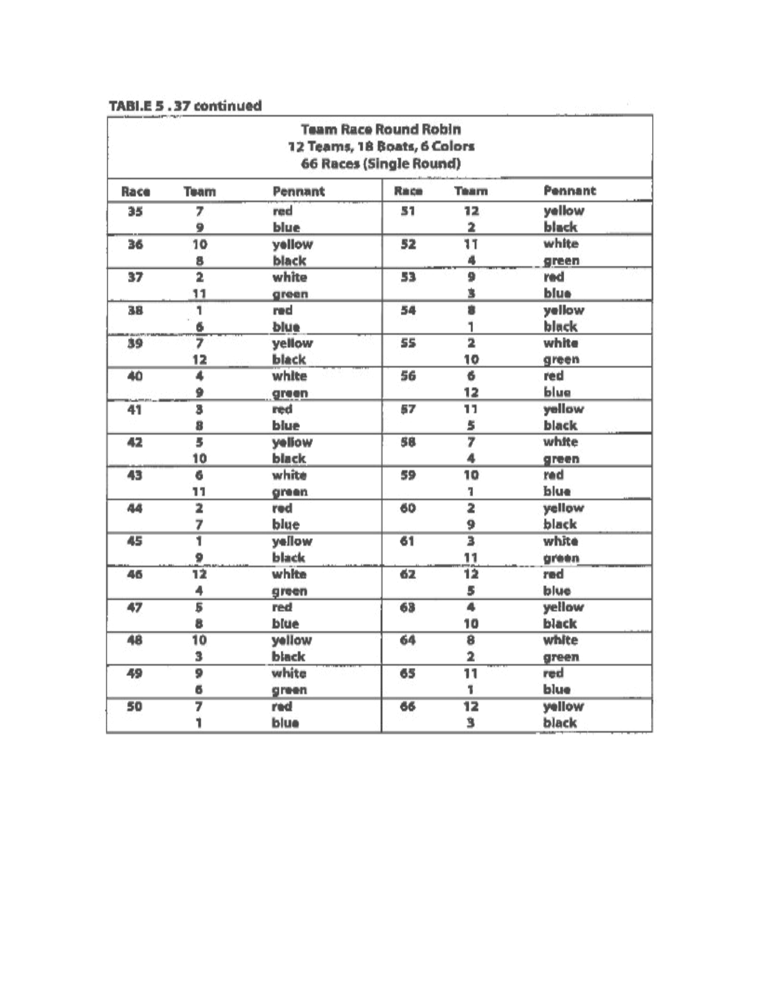
Taken
from
“
Race
Management
Handbook
”,
Chapter
5
©
2001,
US
SAILING
Page
21
of
24
Event: Enter event name

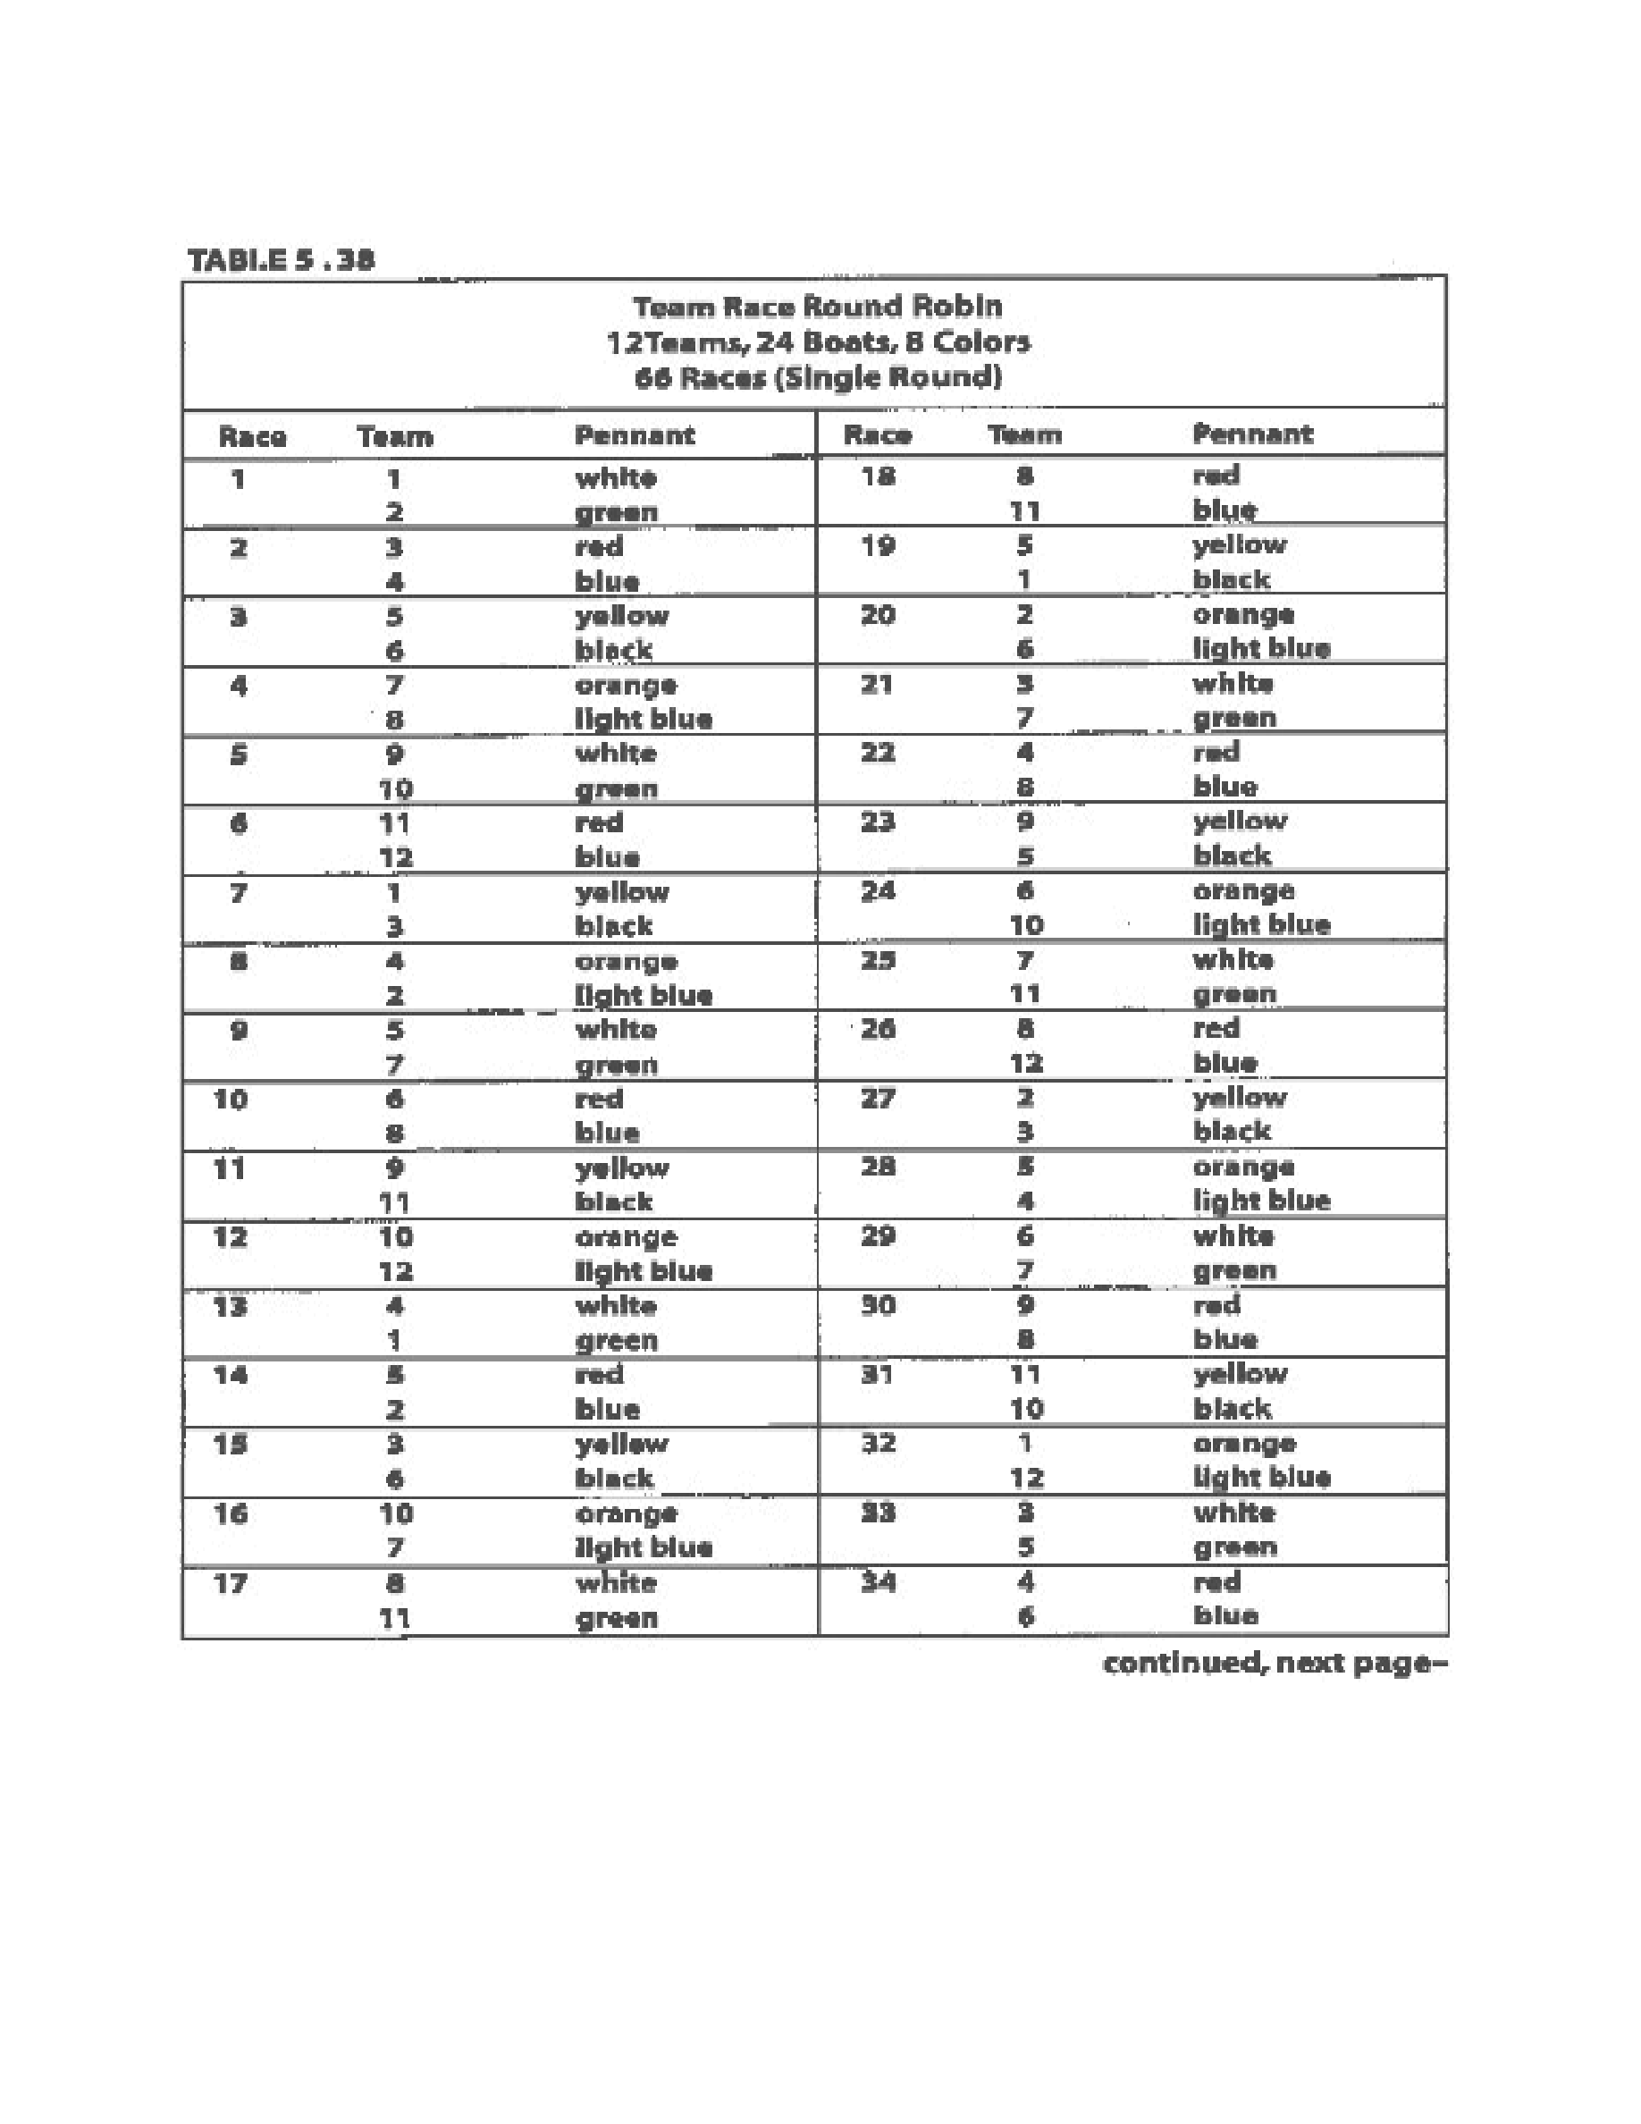
Taken
from
“
Race
Management
Handbook
”,
Chapter
5
©
2001,
US
SAILING
Page
22
of
24
Event: Enter event name

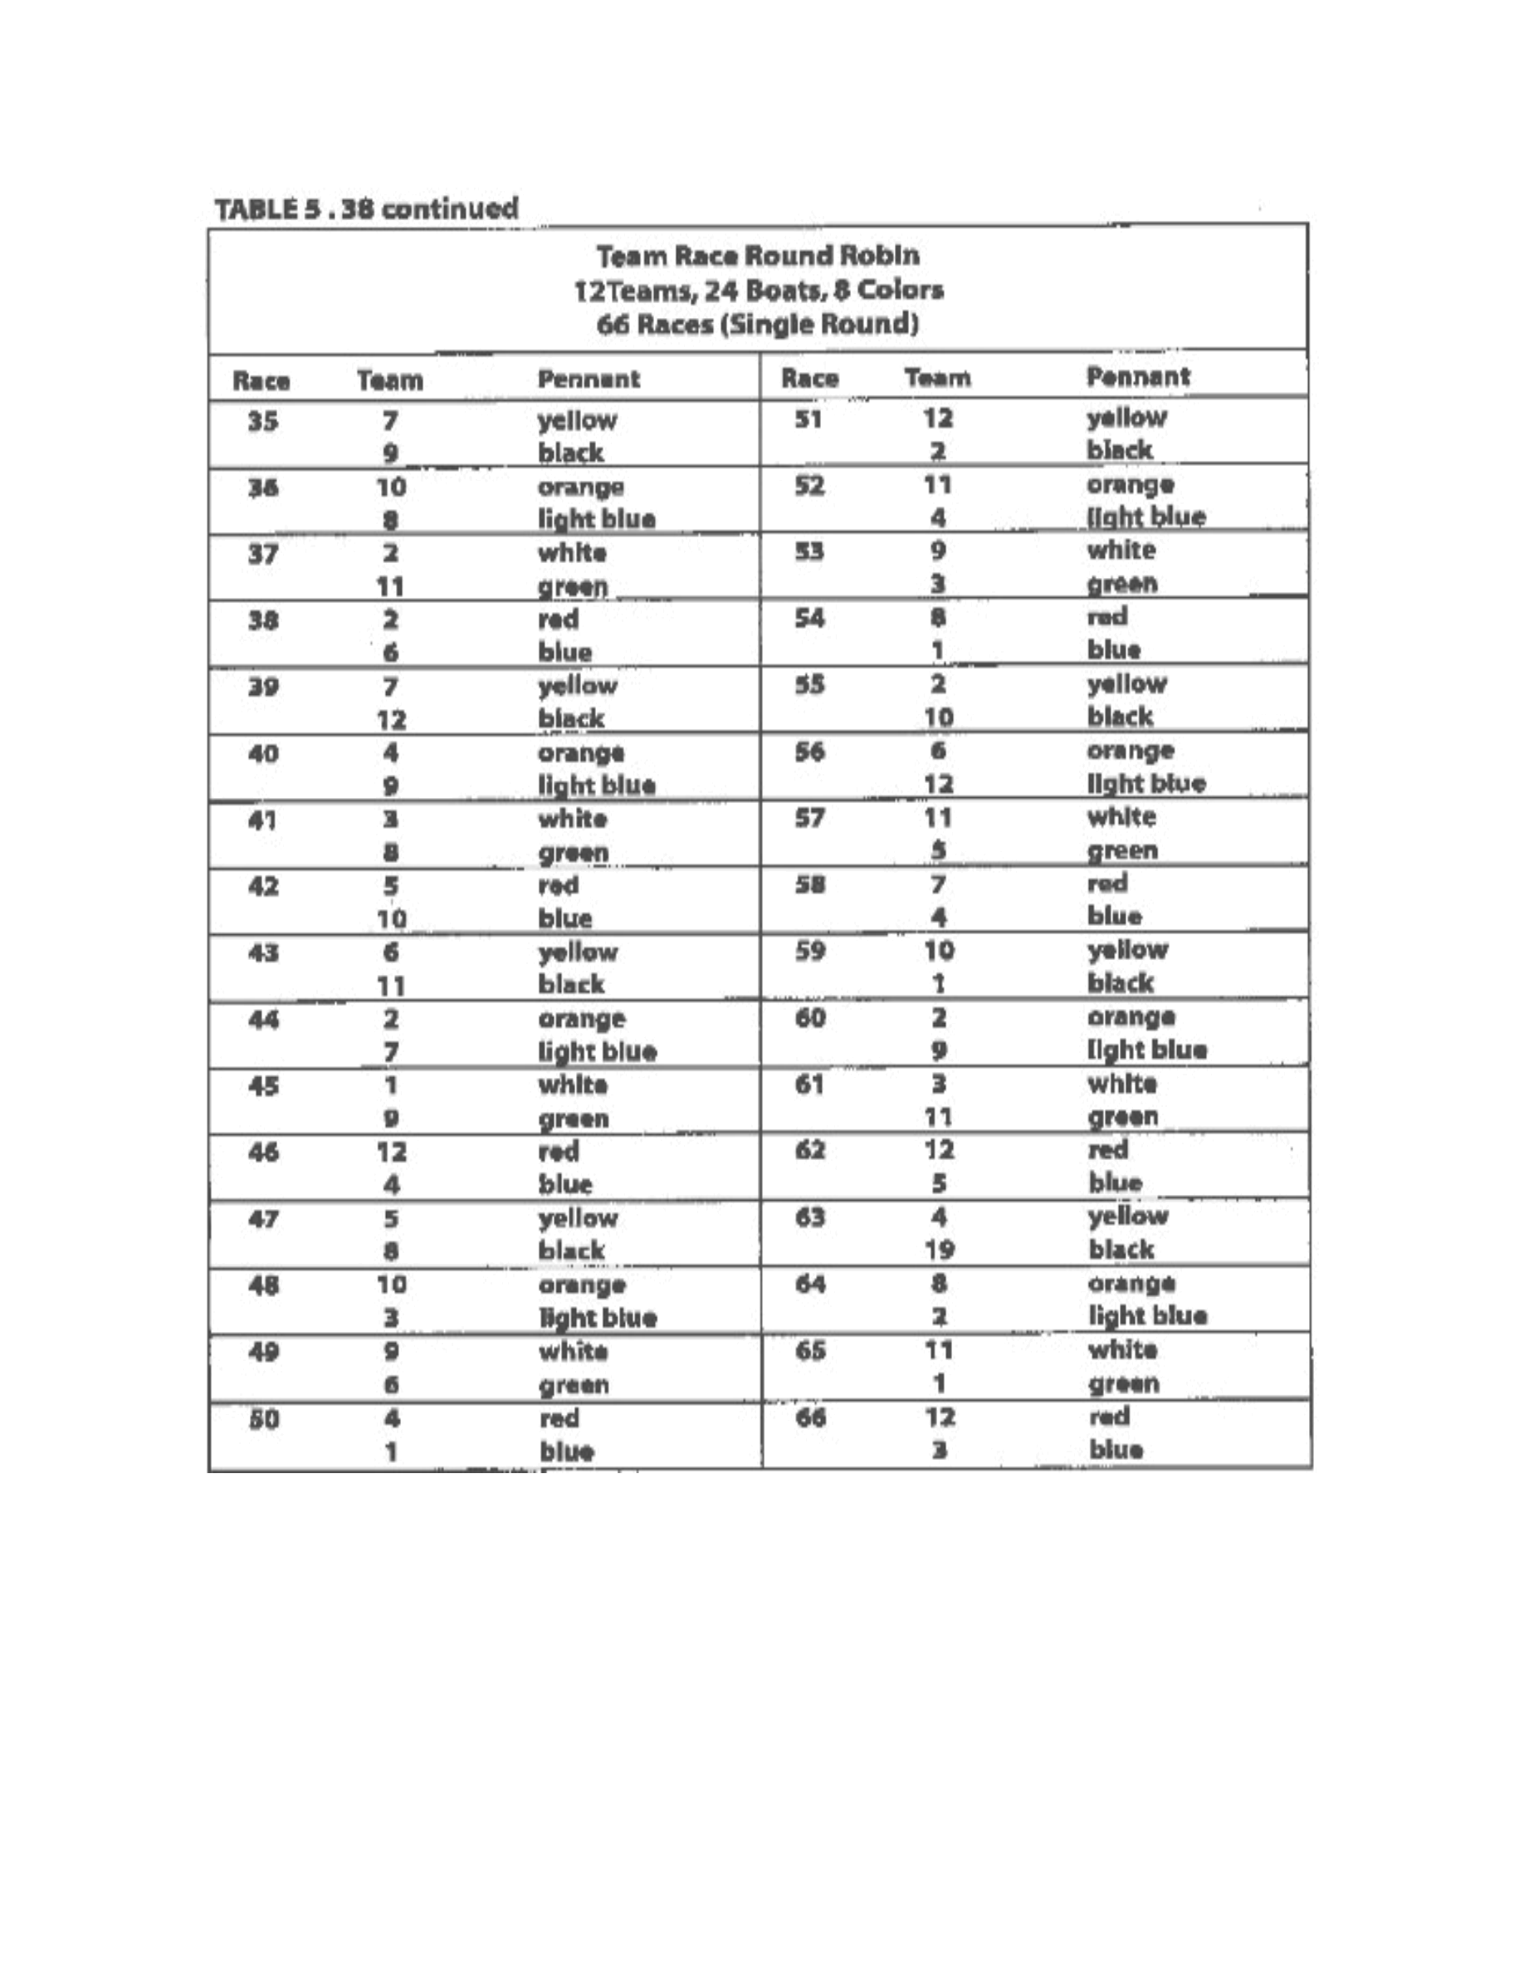
Taken
from
“
Race
Management
Handbook
”,
Chapter
5
©
2001,
US
SAILING
Page
23
of
24
Event: Enter event name

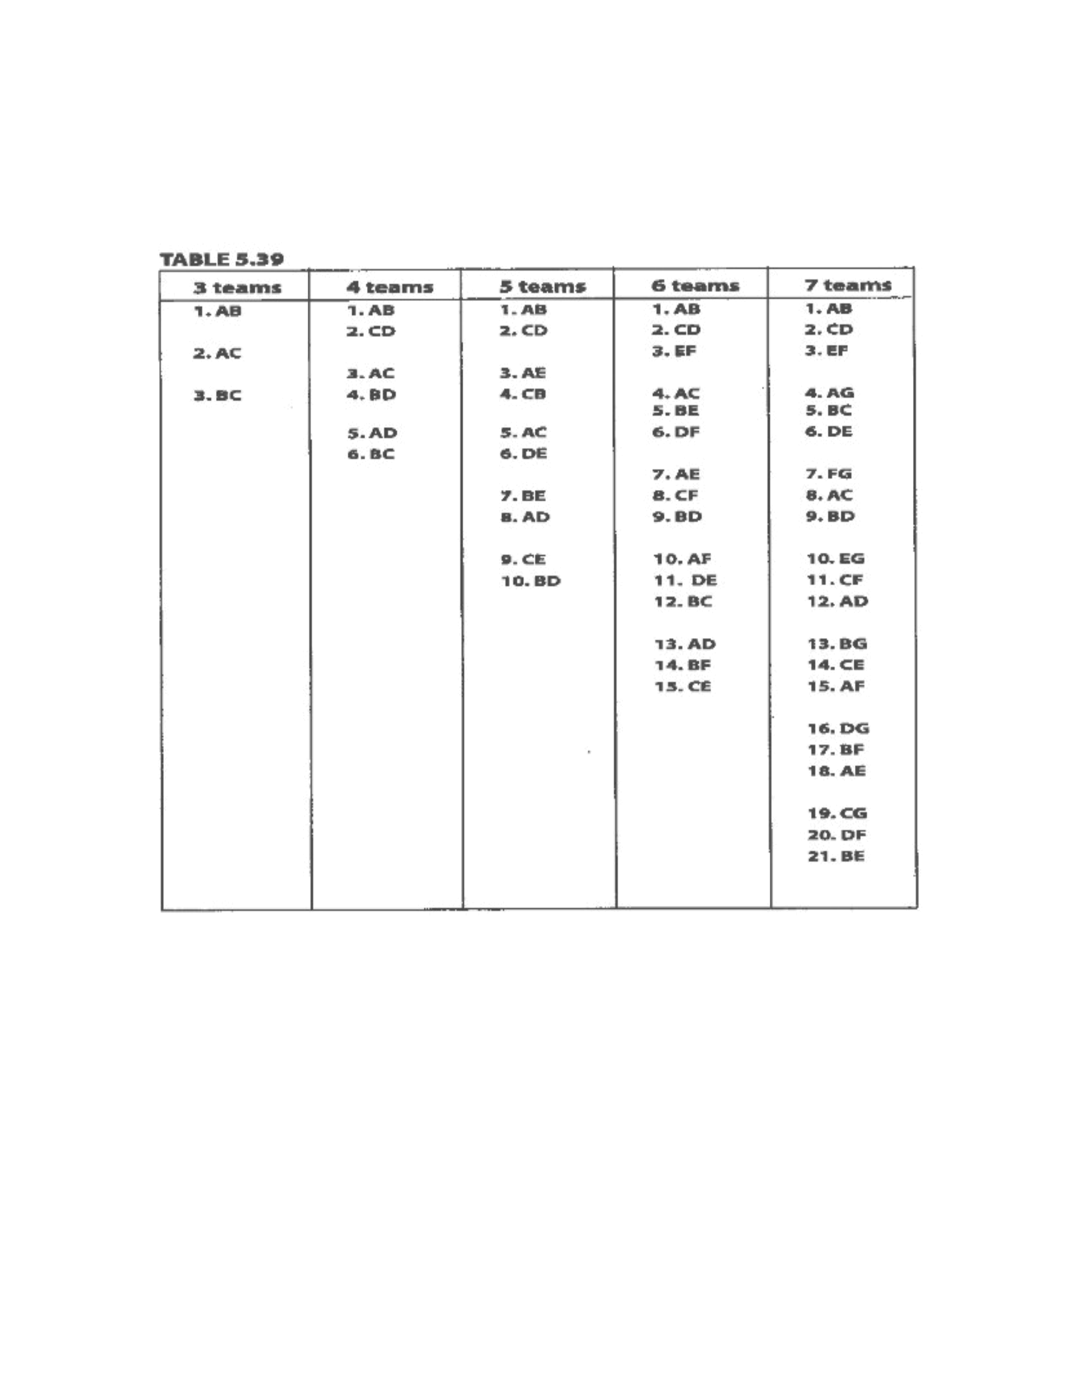
Taken
from
“
Race
Management
Handbook
”,
Chapter
5
©
2001,
US
SAILING
Page
24
of
24
The
easiest
team
racing
events
to
run
are
bring-your-own-boat
(BYOB)
events.
Boats
do
not
have
to
be
acquired,
equalized,
assigned,
rotated,
repaired
or
worried
about.
Also,
the
racing
does
not
need
to
be
run
near
a
rotation
dock
and
races
do
not
need
to
be
postponed
for
breakdowns.
Even
the
rotation
is
easier
to
figure.
In
the
following
rotations
there
is
a
space
in
between
groups
of
races
or
flights.
Event: Enter event name

