**This is a step-by-step visual guide to using the reformat_metdata R script, to create Climpact quality control output graphics**

**Created by Cameron Dow**

1. Download Climpact and familiarize yourself with the process of opening the Climpact GUI ( <https://climpact-sci.org/> )

2. Create the initial data frame with ForestGEO met tower data using lines 1-88 on the R script. Out put data frame will be named “SCBI_mettower_dailymeans_sensor1” and “SCBI_mettower_dailymeans_sensor2”. Pictured below, the first row of the data frame will need to be deleted before continuing.

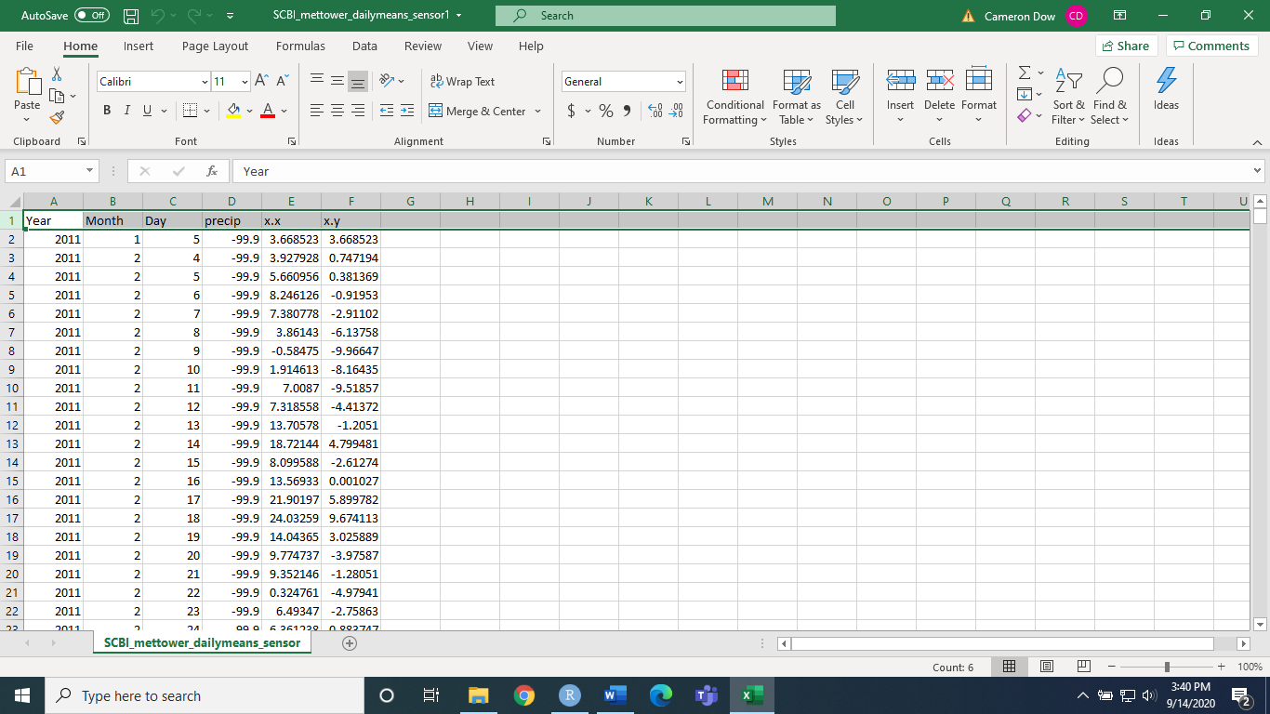

After deleting, save the file, then save as a Text (tab deliminated) file

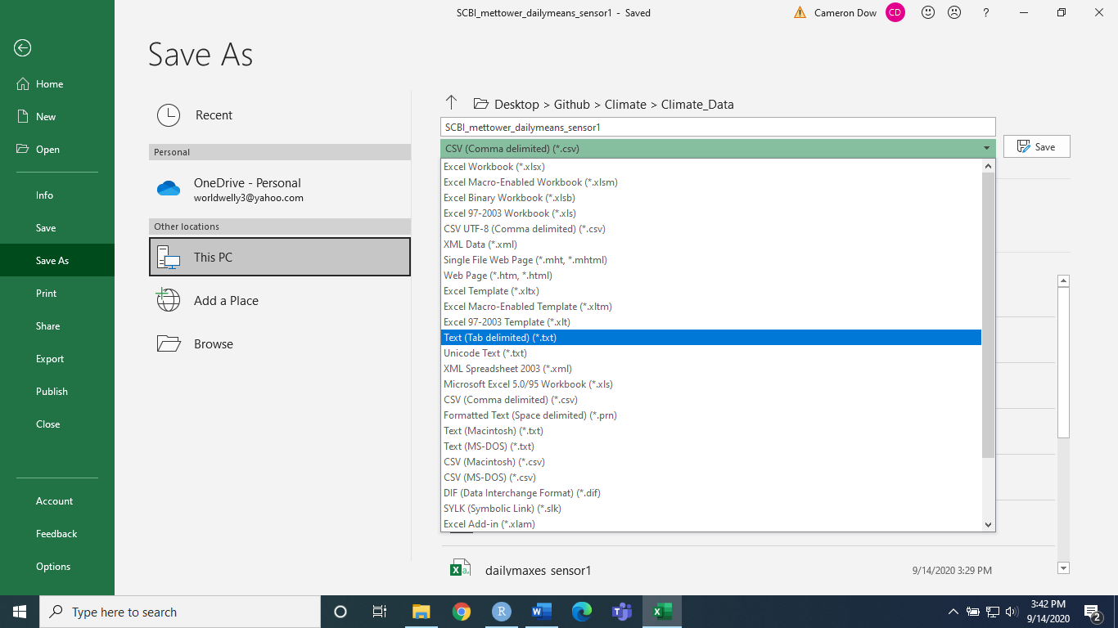

Repeat for sensor 2.

3. Open the Climpact GUI and load in the .txt file for the first sensor. You will get a pop-up informing you that some dates are missing, along with where you can find the txt file containing these dates.

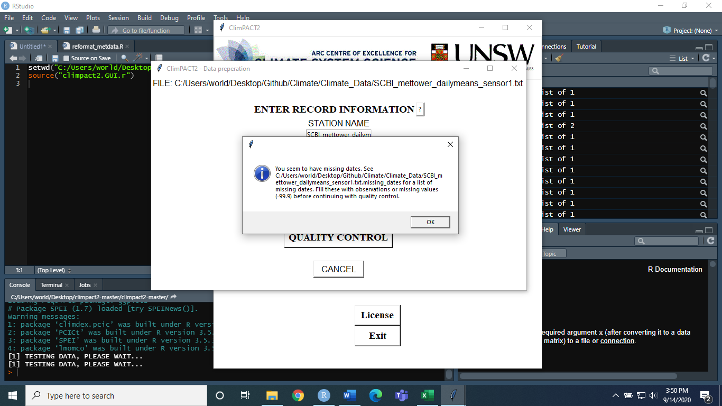

Repeat for second sensor.

Now convert the missing dates file to a csv – will be named something along the lines of SCBI_mettower_dailymeans_sensor1.txt.

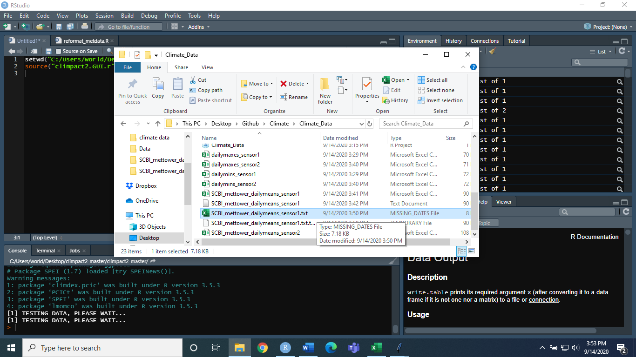

4. Find a supplemental source of met data. In this script, we use data from a nearby NCDC weather station found here: <https://www.ncdc.noaa.gov/cdo-web/datasets/GHCND/stations/GHCND:USC00443229/detail> . This data will be used to fill in gaps within ForestGEO met tower data. Where no supplemental data is available, NA’s will be entered. Run script lines 94-206. The result should be a data frame containing all dates within the specified year range. Again, delete the first row in the csv, and save as txt file.

5. Now open climpact GUI again and load new txt file. If everything worked, you will get a pop-up telling you the quality control is complete.

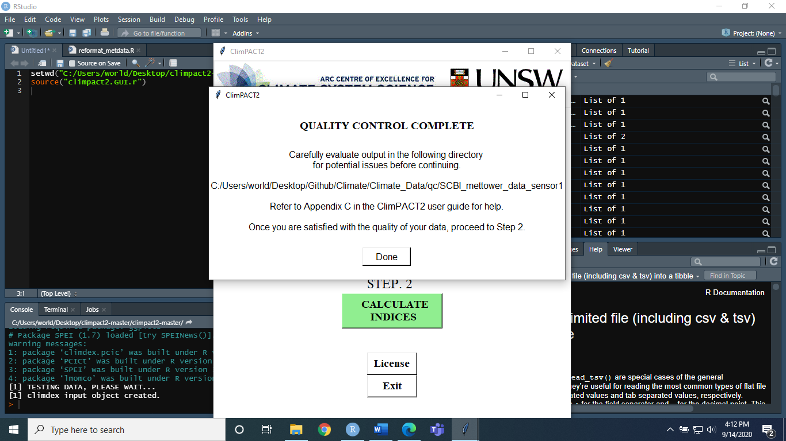

In the folder where your data is located, you will now have a folder named “qc”. In this folder are several plots which will allow a visual inspection of data, as well as a csv containing any outliers identified.

EX.

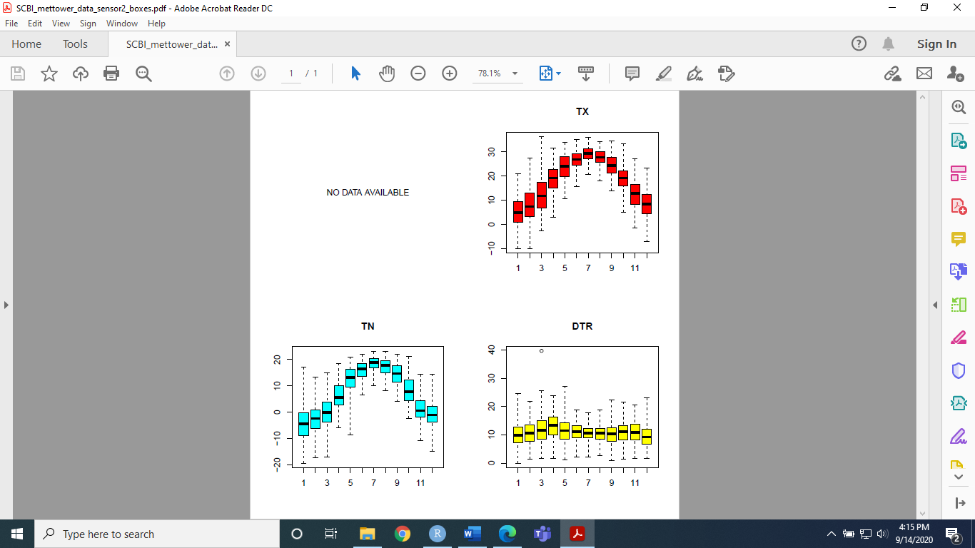

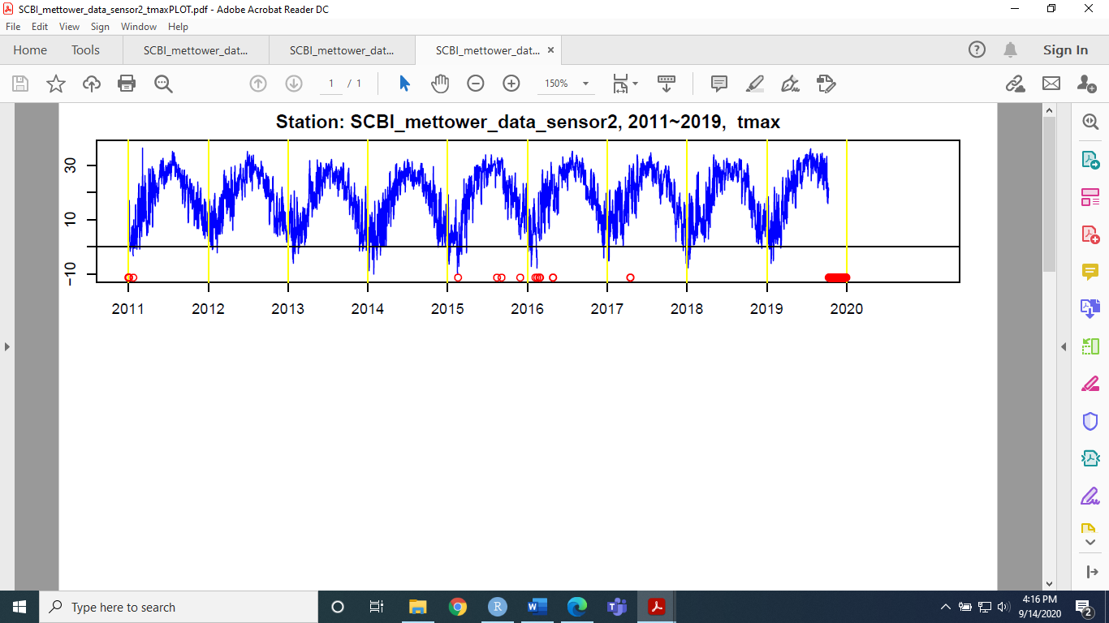

Refer to climpact user guide to learn details about each.