**Title:** Sensitivity of tree growth to drought in seasonally dry tropical forests using long-term dendrometer band measurements

**Authors**

| Name* | Institution | ORCID |
| --- | --- | --- |
| Krishna Anujan | Smithsonian: NZCBI & SERC | 0000-0003-3604-5895 |
| Sean McMahon | Smithsonian: SERC & STRI | 0000-0001-8302-6908 |
| Sarayudh Bunyavejchewin | National Parks Wildlife and Plant Conservation Department, Chatuchak, Bangkok 10900, Thailand | 0000-0002-1976-5041 |
| Stuart J. Davies |  | 0000-0002-8596-7522 |
| Helene C. Muller-Landau |  | 0000-0002-3526-9021 |
| Nantachai Pongpattananurak | Kasetsart University, Thailand | 0000-0001-8687-6182 |
| Kristina Anderson-Teixeira | Smithsonian: NZCBI & STRI | 0000-0001-8461-9713 |

# Summary

* Tropical tree woody growth has long-lasting impacts on the terrestrial carbon pool, but how climate anomalies might impact the growth of tropical tree growth is poorly understood. Standard methods like tree rings and plot inventories may either not represent most species or may not be accurate enough to capture variation in slow-growing species.
* We used a unique data record - manual dendrometer band measurements over 15 years on 1820 trees across 30 species in a seasonally dry tropical forest in Huai Kha Khaeng, Thailand, along with species traits (deciduousness and maximum size), individual characteristics (crown exposure, size) and environment-related water availability to predict the sensitivity of tree growth to drought in two ENSO drought events with different characteristics - a wet-season drought and a dry season drought. We used Bayesian regressions in a causal modelling framework to predict variability among species and individuals in drought sensitivity.
* In the wet-season drought, deciduous species were more sensitive than evergreen species, especially in wetter microsites, while these patterns were not significant in the dry-season drought. After accounting for species differences, more exposed trees were more likely to be negatively impacted than their less exposed counterparts, with exposure showing clear negative impacts compared to size *per se*.
* Large differences among species and individuals in their sensitivity to drought, as well as climatic differences differences among droughts themselves can explain heterogeneity in ecological responses to drought.

# Keywords

# Introduction

Tropical tree woody growth is a key component of aboveground productivity and affects the global carbon carbon cycle, but its sensitivity to climate anomalies is poorly understood.  
- Woody growth has long-lasting effects on the terrestrial carbon pool but is sensitive to interannual variation in temperature and precipitation.  
- Extreme events like drought, with temperature and precipitation outside normal ranges that can lead to growth reductions that varies across species and individuals (Bennett *et al.*, 2015; McGregor *et al.*, 2021).  
- the extent of this variation in drought responses is poorly understood.  
- with changing climate patterns across the global tropics, including novel climatic regimes (Dahinden *et al.*, 2017), there is a need to understand the drivers of this variation, to be able to predict and respond to forest responses to drought.

Growth reductions from droughts are difficult to estimate reliably from whole-plot inventories.  
- Droughts are different but generally leads to low soil moisture, low water tables, vapour pressure, high temperature. - Results in thermal stress, evaporative loss, leaf turgor loss, embolism/cavitation → High mortality and growth reductions across global forests, including the tropics  
- Inventory data are often not at annual scales; smooths over drought/no-drought period.  
- Reductions are often small (<1 mm), and difficult to detect with tape measurements.

Tree species in seasonally dry forests have diverse allocation strategies and traits which can result in differential sensitivities to drought  
- Drought events can be different from each other, but generally lead to low soil moisture, low water tables, low vapour pressure and high temperature (Chitra-Tarak *et al.*, 2021).  
- Results in thermal stress on tissues, evaporative loss, leaf turgor loss and cavitation.  
- Species can be conservative or acquisitive in water and nutrient uptake; differential allocation to growth/survival.  
- Species with drought tolerant traits like deep roots, more negative turgor loss point and … are more resistant to drought (Kunert *et al.*, 2021; **refs?**).  
- Some evidence that both understory and emergent species can have reduced survival during drought (Machado *et al.*, 2023).  
- Deciduous species, with shorter duration with leaves can have acquisitive strategies during leaf on (De Souza *et al.*, 2020).  
- Strategies also affects species distribution with evergreen species covarying with soil moisture (Kunert *et al.*, 2021) and potentially affecting survival and growth.  
- Many hydraulic-related traits vary with tree height (Vinod *et al.*, 2023), including the frequency of dry season deciduous leaf loss – both within species and at the community level (**condit_ref?**; **meakem?**).

Within species, size, exposure and location can affect sensitivity to drought.  
- Large trees tend to undergo greater growth declines during drought compared to smaller trees (e.g., Bennett *et al.*, 2015; McGregor *et al.*, 2021; Anderson-Teixeira *et al.*, 2022).  
- It remains poorly understood the extent to which this is shaped by tree size itself, crown exposure, water access, and traits that tend to covary with size (e.g., decidiousness) – all of which interact to shape drought resistance (Fig. 1).  
- There is theory and evidence that tree size itself matters.  
- Theoretically, we expect that greater height makes trees more vulnerable to drought based on the physics of hydraulic flow through a porous medium, as described by Darcy’s law (Fernández-de-Uña *et al.*, in press; **mcdowell_darcy_2015?**). - Height… (Olson *et al.*, 2018; see refs in Vinod *et al.*, 2023; **couvreurWaterTransportTall2018?**). - As tree size increases, leaves exert lower control over hydraulic resistance (**wolfe_leaves_2023?**). - Chen *et al.* (2022)  
- There is theory and evidence that crown exposure matters (Scharnweber *et al.*, 2019; Vinod *et al.*, 2023; **refs_in_?** vinod_thermal_2023). - Microclimate buffering leads to cooler, moister understory air (Vinod *et al.*, 2023). - Soils under closed canopies would also be cooler during hot times of the year (**lembrechts_global_2022?**). - Reduced evaporative demand would also make them moister, and this might be added to by hydraulic redistribution. - Trees with exposed crowns suffered significant crown dieback at greater rates in the 2012-16 CA drought (Ma *et al.*, 2023).  
- Water access….  
- Larger trees have larger root systems, but do not necessarily access deeper water (**ref_from_Panama?**)  
- Even when trees are accessing deeper water, this does not mean that they’re in better shape during drought. Rather, trees that rely on regular access to deep water may be more vulnerable during severe droughts when those sources are depleted (Chitra-Tarak *et al.*, 2021).  
- indeed, there is evidence that trees near streams undergo greater growth declines (McGregor *et al.*, 2021) and increases in mortality (**zuleta?**) during drought - rather than necessarily helping during drought, water access will shape the size and traits of species living in habitat, with stream habitats tending to have larger trees (**ref?**) and more evergreen trees, and also their average growth rate

-High Crown exposure makes trees more vulnerable to drought, but drought deciduous habit or perennial water access allows them to escape this  
-Disentangling the effects of tree size, crown exposure, water access, and deciduousness on drought sensitivity

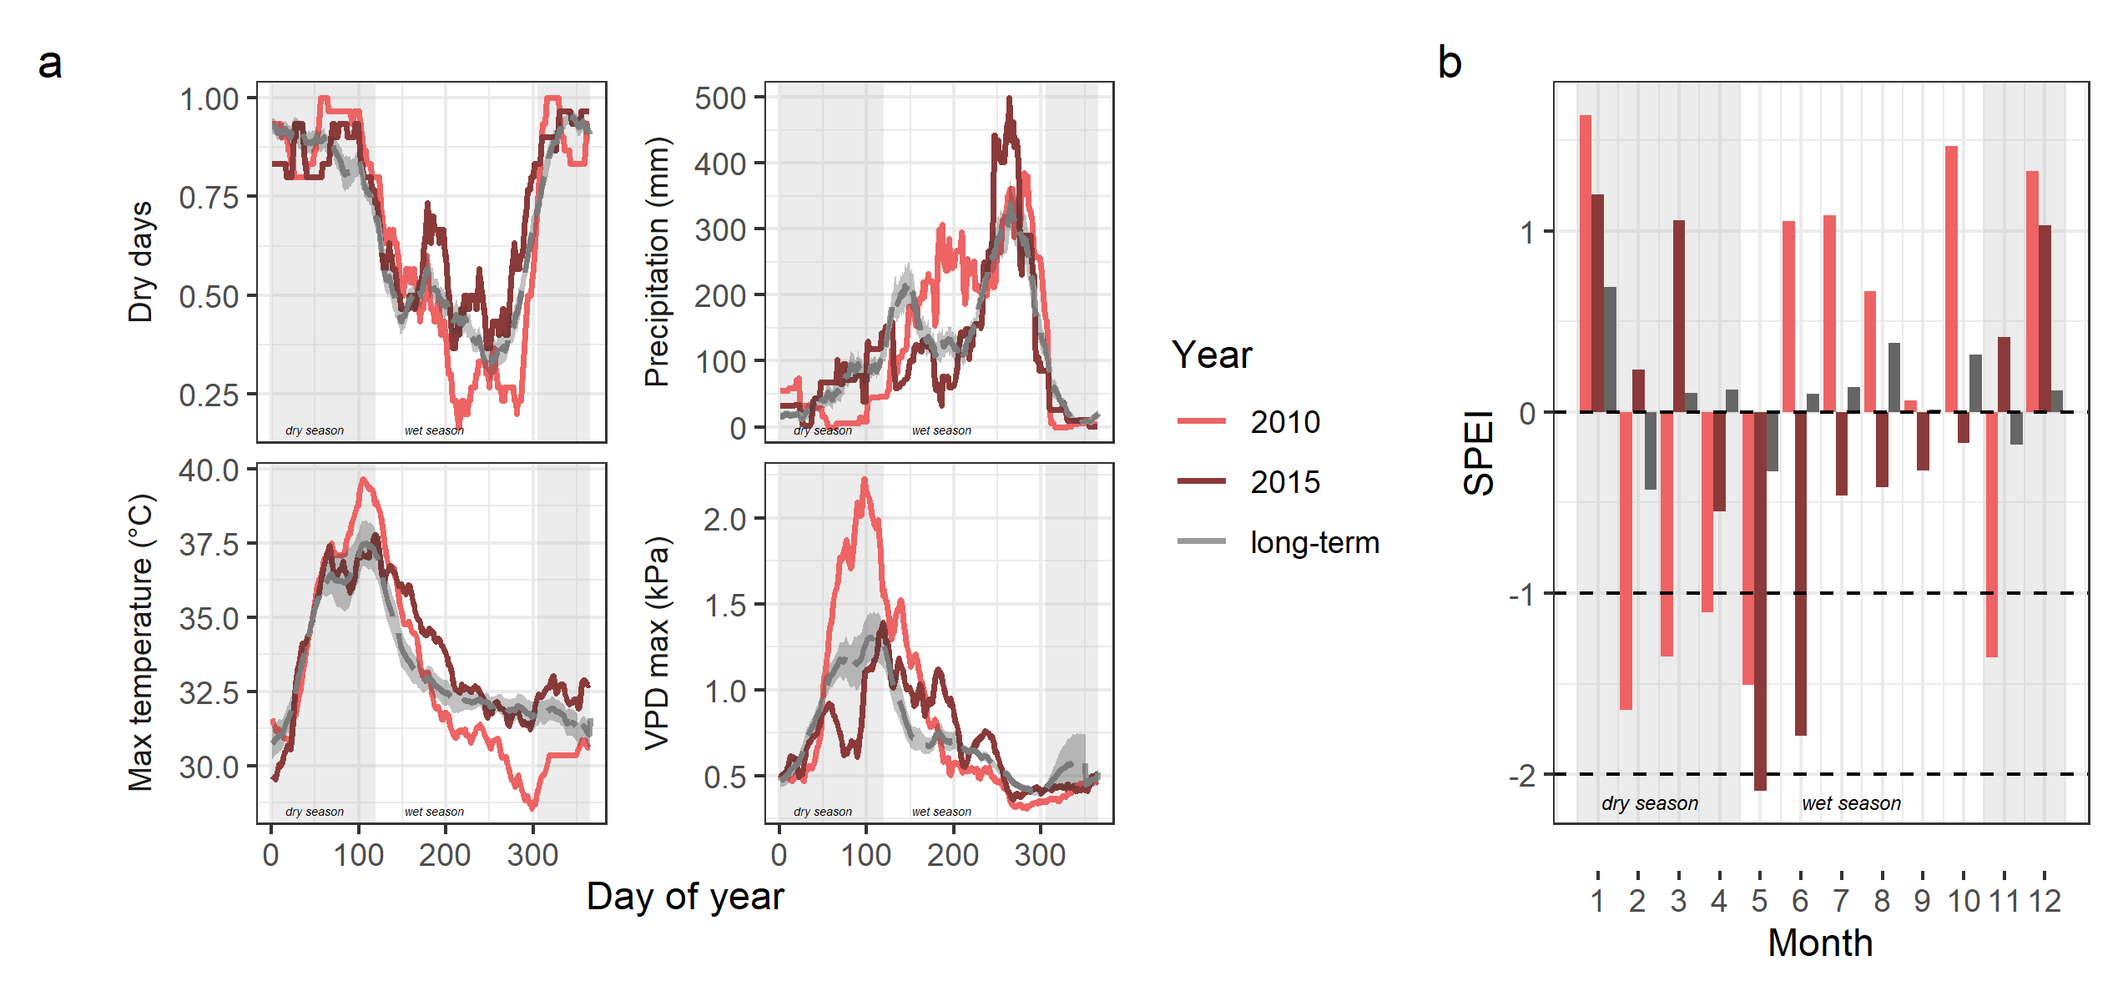

***Figure 1. Climatic characteristics of drought years and average years*** in Huai Kha Khaeng ForestGEO plot. For comments - <https://github.com/forestgeo/growth-precip-thailand/issues/10>

Here we use a 14-year record of dendrometer band measurements in seasonally dry forest in Thailand to test the vulnerability of tropical tree growth to drought. We expect variation in drought sensitivity (growth in drought year/growth in a previous year with normal rainfall) across trees. We ask: i) How much do species vary in drought sensitivity of tree growth? What drives this variation ii) What drives variation among individuals in the sensitivity of growth to drought? We hypothesise that growth sensitivity….

# Materials and Methods

***Sites and data***

We analysed data from manual dendrometer band censuses from 2008-2023 in the Huai Kha Khaeng ForestGEO plot (15.6324 N, 99.217 E), hereafter “HKK”, in the Huai Kha Khaeng Wildlife Sanctuary, Uthai Thani, Thailand. This is a 50-hectare plot in mixed deciduous tropical forest, with a mean annual temperature of 1400 mm and a strong dry season from November to April (Anderson-Teixeira *et al.*, 2015). The dominant canopy species are *Hopea odorata*, *Vatica harmandiana*, *Dipterocarpus alatus* and *Tetrameles nudiflora* and lower layers of the canopy are dominated by sub-canopy evergreen and deciduous species like *Miliusa horsfieldii* and *Polyalthia viridis*. Long-term analysis of tree-ring data shows that tree growth at Huai Kha Khaeng has been influenced by temperature and rainfall (Vlam *et al.*, 2014).

In the HKK plot, metal dendrometer bands were installed in 2008 on 2353 trees across 152 species following standard protocol (Muller-Landau, 2008). Trees were selected were based on the relative abundance of species in the forest, with more individuals banded from the abundant species (ranging from 230 trees to 1 tree per species), and spanning the size and habitat distribution within the plot. On each tree, the dendrometer band was installed at 1.4 m from the ground, a height of 10 cm above the regular point of measure for the whole plot census (typically 1.3 m), except on irregular trunks or buttresses when they were shifted above. All dendrobands were censused two times a year - in the wet and dry season - typically in June and January. During the census, the size of the window opening along the band was measured using Mitutoyo digital callipers (least count = 0.01 mm) and the diameter of the tree at the dendrometer band was measured using standard DBH tape.

Using the late wet/early dry dendrometer band censuses, we calculated annualised growth for each year for each tree. We first removed measurements with likely data entry errors because of misplaced decimals, potential misidentified bands (old band numbers that restarted after stopping) or misidentified individuals (individuals with conflicting metadata across censuses). We used the raw window size measurements combined with the diameter at breast height (DBH) measurement at installation to calculate diameter at each dendroband census using standard equations that uses the chord across the measurement window to estimate the arc, assuming a circular cross section[condit]. Since this was dependent on the diameter measurement at installation, we used a direct measurement at the time of installation if it was available. If the tape measurement at the first window size measurement was not available for any band, we excluded window size measurements until the first available diameter measurement. We then calculated annualised diameter increments for each individual for each year by finding the difference in diameter from the previous year () and adjusting for the number of days between measurements (). To ensure that the data did not smooth over multiple years, we excluded increment measures with missing values for and then excluded large measurement outliers (> 3 standard deviations from the mean across all observations). We repeated the same steps using annual tape measurements made on each dendrobanded tree at each census and removed dendroband measurements that had low agreement with these annualised increments calculated from tape measurements.  
Finally, we excluded trees with negative increments over the whole timeseries, and included only species that had at least 10 individuals, resulting in a final dataset of 1820 individuals across 30 species.

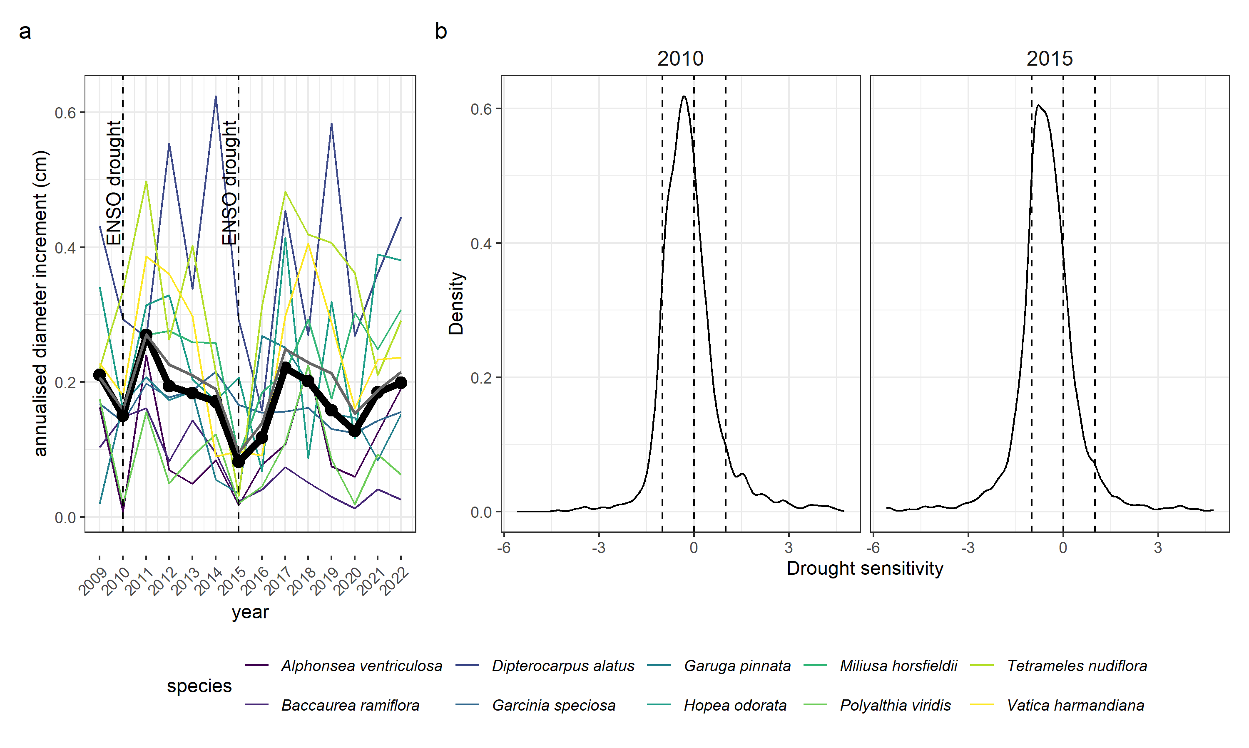

***Figure 2: Growth increment timeseries and drought sensitivity*** across trees and species in the Huai Kha Khaeng ForestGEO plot. a) Median of annualised growth increments across species (colours) and the whole plot (black) from 2009 - 2022 from late wet/early dry season dendroband measurements. 2010 and 2015 were moderate and very strong ENSO events respectively. b) Dsitribution of drought sensitivity of tree growth across all individuals in the two drought years. For comments - <https://github.com/forestgeo/growth-precip-thailand/issues/11>

***Drought years and characteristics***

Combining the growth timeseries from dendrometer band measurements with climatic information, we identified two drought years of interest - 2010 and 2015. To identify drought years, we identified years with low plot-level growth rate and combined this with information on ENSO events that affected the landscape. We chose to identify the years starting from the timeseries, instead of directly using climate variables and their deviation because drought definitions vary widely, and drought characterisation of a year can vary based on the definition selected. Moreover, broad definitions based on climate variables (often not measured at the location), may not capture ecological realities within the plot. Out of the two years with low plot-level growth, 2010 was a moderate ENSO event while 2015 was a very strong ENSO event. These years also corresponded with expert knowledge of major droughts that affected the region. We also note that we chose not to include 2020 in our analysis despite low growth, because a) declines in growth can occur due to various reasons which could have distinct ecological responses in species and individuals b) 2020 did not emerge as a drought year either in the examination of drought indicators or from expert knowledge.

To characterise these two droughts, we used climate data from a weather station near the plot and publicly available climate data for the region. We used daily weather data collected from 2001 to 2019 at the Forest Fire Research Station [CHECK WHERE], located ~20 km from the ForestGEO plot. We first calculated daily values of Vapour Pressure Deficit using the equation

We then calculated rolling means of precipitation, number of dry days (precipitation = 0), VPD and maximum temperature over 15 day periods across the whole year for each year. Finally, we calculated the long-term mean for each variable as the mean of the values of the rolling mean across all years of the dendroband measurements, and the standard error around this mean. We also used the SPEIbase dataset [REF] to calculate the Standardised Precipitation-Evapotranspiration Index, a drought severity index, calculated at the monthly scale. We report monthly SPEI for the two drought years along with long-term mean SPEI for each month.

***Variables for analysis***

For the two drought years, 2010 and 2015, we calculated growth sensitivity for each tree to each drought as a growth anomaly from its mean annual increment. We first calculated the mean annual increment for each tree as the mean of the annualised increments across the whole timeseries. We then calculated sensitivity for each tree for each drought as

By scaling the difference in increment to the mean annual growth of each tree, this metric allows us to compare across slow and fast growing individuals and species.

Across all individuals in the plot, we calculated topographic wetness index for an expectation of the water availability across space based on the concavity/convexity of a location. We used a Digital Elevation Model from a 5 m x 5 m elevation layer collected at plot establishment. We used the *whitebox* package in R (Lindsay, 2016; Wu & Brown, 2022) to fill and breach this layer, calculate flow accumulation at each cell and then calculate TWI as . We defined tree size as the diameter at breast height (calculated from dendrometer band window measurement) at the previous census. We estimated crown exposure for each tree at each census using crown illumination index, an ordinal categorical variable from 1 to 5 (least to most exposed) measured at each dendroband census.

We calculated three species-level traits : deciduousness, maximum size and niche breadth. We defined deciduousness as the mean proportion of canopy loss at maximum loss across individuals in the species, with a score ranging from 1 to 4 where 1 is most evergreen and 4 is most deciduous. We used data published in Williams *et al.* (2008) for the top 30 species. Out of these, data was unavailable for *Alphonsea ventricosa*, an evergreen species, and so we manually assigned it a deciduousness score of 1, in the middle of the evergreen range. An alternate measure of deciduousness is the duration spent at maximum crown loss. This data was strongly correlated with the proportion of crown loss; we chose to use the proportion of crown loss because it was available for a larger list of species. At the species level, we also calculated the maximum size across all individuals in the plot as measured in the 2008 whole-plot census. We calculated niche breadth as the standard deviation of TWI across all observed individuals of each species in the whole plot census in 2008.

***Statistical methods***

We first modelled sensitivity as a simple random intercept model

We then used the predicted sensitivities from this model and tested their correlations with three species-level traits - deciduousness, maximum size and niche breadth using simple linear models.

To model the interactive effects of deciduousness on sensitivity, we modelled

We then calculated predictions across all combinations of values from observed maximum to minimum of TWI and deciduousness within this dataset.

To further disentange the drivers of stem-level drought sensitivity, we modelled:

We chose to model a species random effect on all slopes here to account for variation across species instead of specific traits which may have different effects with each of the variables.

All statistical analyses were performed using R version 4.4.0 (R Core Team, 2024). Mixed models were fit through Bayesian regressions using MCMC methods using the package *brms* [REF]. We ran models using gaussian priors for the data distribution. We ran 4 MCMC chains for 3000 iterations with 1000 of these set as warmup. We extracted draws, calculated distributions using functions from the *posterior* package [REF].

# Results

## Drought characteristics

The two droughts analysed had distinct temporal climatic characteristics, with 2010 primarily a dry season drought and 2015 a wet-season drought (Fig 1). In 2010, drought characteristics of lower precipitation, higher number of dry days, higher maximum temperature, higher VPD than the long-term mean and SPEI values below -1 occurred between February and April, in the dry season. On the other hand, in 2015, similar deviations occurred in May and June, in the wet season. In 2015, SPEI in May was -2, an anomalously low value that was not observed in any month in the entire dendroband census time period, suggesting a severe drought.

## Interannual growth variation and drought sensitivity

The increment timeseries using dendrometer band measurements revealed plot- and species-level patterns in interannual growth variation (Fig 2a). Median annualised growth rate across the years of measurement for the whole plot was 0.17 cm. Median annual increment differed by species with GLUTOB having the lowest (0.06 cm) and DIPTAL the highest (0.36 cm)among the 30 species analysed. The drought year 2015 had the lowest median annual increment 0.08 cm, 52.68% lower than the median across all years. In 2010, the median annual increment was 0.15 cm, 13.33% lower than the median across all years. While there were more species differences in median responses to the 2010 drought, all species had lower increment than a typical year in 2015.

Drought sensitivity across all trees also showed negative sensitivities for both droughts with considerable variation around it (Fig 2b).

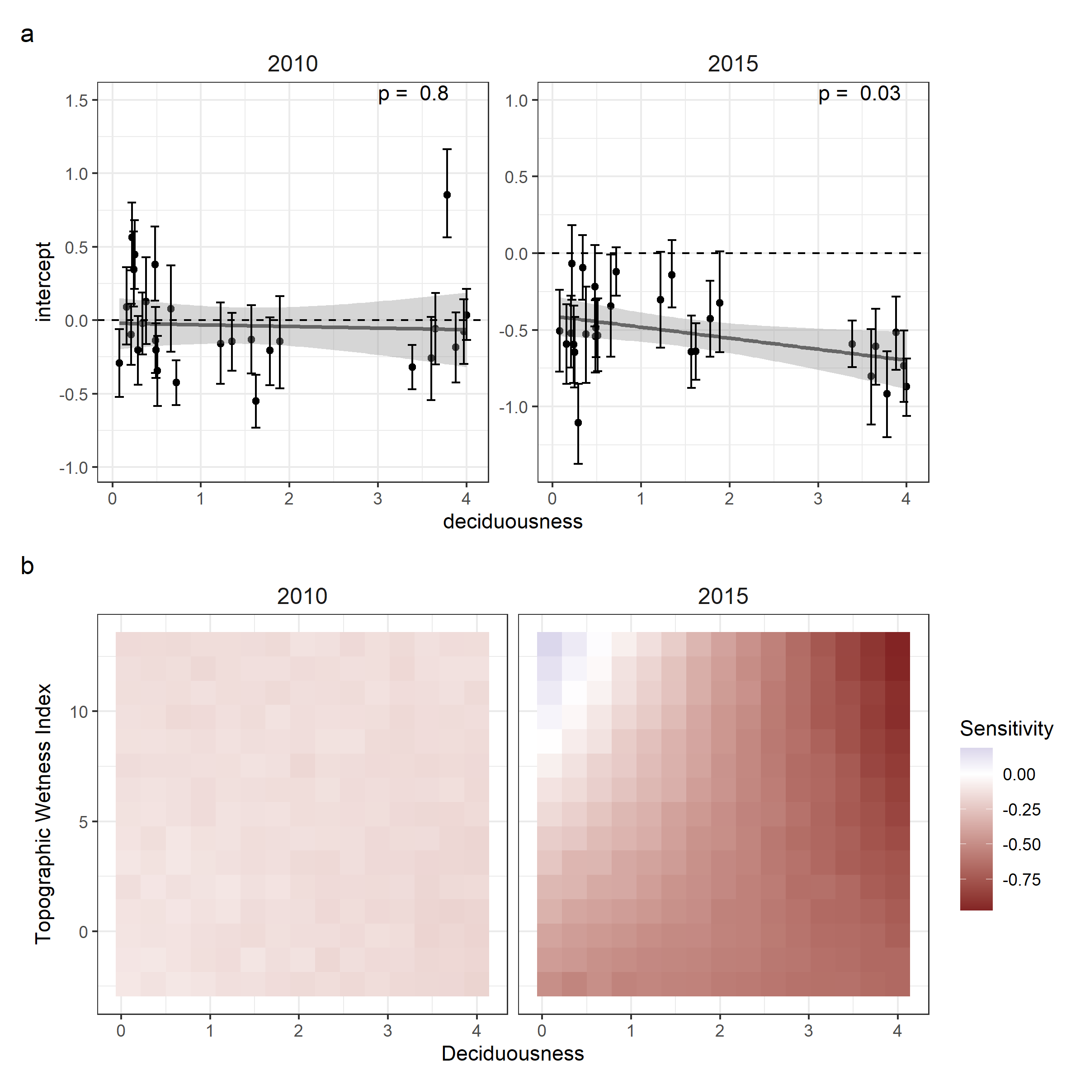

***Figure 3: Variation in sensitivity among species*** in the Huai Kha Khaeng ForestGEO plot during droughts in 2010 and 2015. For comments: <https://github.com/forestgeo/growth-precip-thailand/issues/12>

## Variation in sensitivity among species

## Variation among individuals

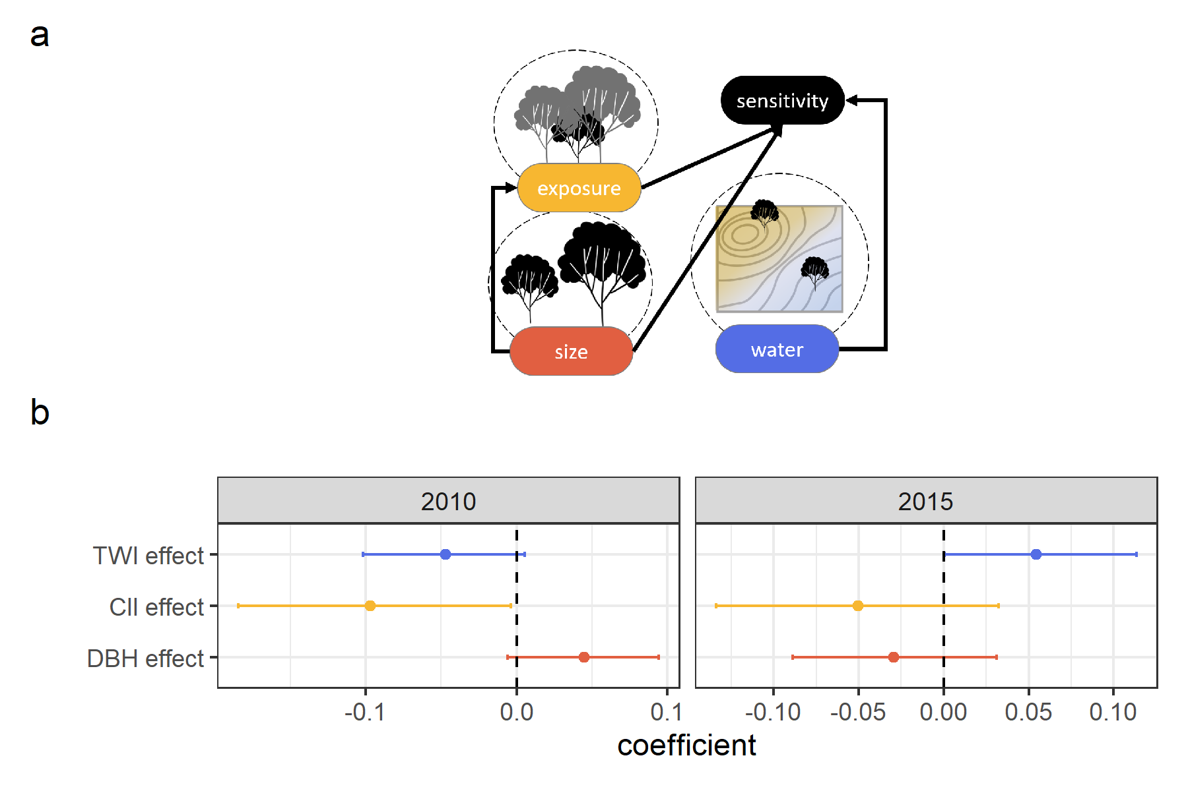

***Figure 4: Drivers of variation in sensitivity among individuals***

# Discussion

# Acknowledgements

Huai Kha Khaeng forest monitoring team. Ekaphan Kraichak, Kanisorn Chowtiwuttakorn. Jose Medina-Vega, Valentine Herrmann, Eugenie Mas. Smithsonian Institution Postdoctoral Fellowship. ForestGEO Analytical Workshop, Asia 2024.

# Competing interests

# Author contributions

# Data availability

# References

**Anderson-Teixeira KJ, Davies SJ, Bennett AC, Gonzalez-Akre EB, Muller-Landau HC, Joseph Wright S, Abu Salim K, Almeyda Zambrano AM, Alonso A, Baltzer JL, *et al.*** **2015**. [CTFS-ForestGEO : A worldwide network monitoring forests in an era of global change](https://doi.org/10.1111/gcb.12712). *Global Change Biology* **21**: 528–549.

**Anderson-Teixeira KJ, Herrmann V, Rollinson CR, Gonzalez B, Gonzalez-Akre EB, Pederson N, Alexander MR, Allen CD, Alfaro-Sánchez R, Awada T, *et al.*** **2022**. [Joint effects of climate, tree size, and year on annual tree growth derived from tree-ring records of ten globally distributed forests](https://doi.org/10.1111/gcb.15934). *Global Change Biology* **28**: 245–266.

**Bennett AC, McDowell NG, Allen CD, Anderson-Teixeira KJ**. **2015**. [Larger trees suffer most during drought in forests worldwide](https://doi.org/10.1038/nplants.2015.139). *Nature Plants* **1**: 15139.

**Chen T, Xu G, Li J, Hu H**. **2022**. [Hydraulic Trait Variation with Tree Height Affects Fruit Quality of Walnut Trees under Drought Stress](https://doi.org/10.3390/agronomy12071647). *Agronomy* **12**: 1647.

**Chitra-Tarak R, Xu C, Aguilar S, Anderson-Teixeira KJ, Chambers J, Detto M, Faybishenko B, Fisher RA, Knox RG, Koven CD, *et al.*** **2021**. [Hydraulically-vulnerable trees survive on deep-water access during droughts in a tropical forest](https://doi.org/10.1111/nph.17464). *New Phytologist* **231**: 1798–1813.

**Dahinden F, Fischer EM, Knutti R**. **2017**. [Future local climate unlike currently observed anywhere](https://doi.org/10.1088/1748-9326/aa75d7). *Environmental Research Letters* **12**: 084004.

**De Souza BC, Carvalho ECD, Oliveira RS, De Araujo FS, De Lima ALA, Rodal MJN**. **2020**. [Drought response strategies of deciduous and evergreen woody species in a seasonally dry neotropical forest](https://doi.org/10.1007/s00442-020-04760-3). *Oecologia* **194**: 221–236.

**Fernández-de-Uña L, Martínez-Vilalta J, Poyatos R, Mencuccini M, McDowell NG**. **in press**. [The role of height-driven constraints and compensations on tree vulnerability to drought](https://doi.org/10.1111/nph.19130). *New Phytologist* **n/a**.

**Kunert N, Zailaa J, Herrmann V, Muller-Landau HC, Wright SJ, Pérez R, McMahon SM, Condit RC, Hubbell SP, Sack L, *et al.*** **2021**. [Leaf turgor loss point shapes local and regional distributions of evergreen but not deciduous tropical trees](https://doi.org/10.1111/nph.17187). *New Phytologist* **230**: 485–496.

**Lindsay JB**. **2016**. Whitebox GAT: A case study in geomorphometric analysis. *Computers & Geosciences* **95**: 75–84.

**Machado S, Valle D, Toh KB, Johnson DJ**. **2023**. [Forest resistance to drought in a humid tropical dipterocarp forest in the Western Ghats of India](https://doi.org/10.1111/btp.13270). *Biotropica* **55**: 1093–1100.

**Ma Q, Su Y, Niu C, Ma Q, Hu T, Luo X, Tai X, Qiu T, Zhang Y, Bales RC, *et al.*** **2023**. [Tree mortality during long-term droughts is lower in structurally complex forest stands](https://doi.org/10.1038/s41467-023-43083-8). *Nature Communications* **14**: 7467.

**McGregor IR, Helcoski R, Kunert N, Tepley AJ, Gonzalez-Akre EB, Herrmann V, Zailaa J, Stovall AEL, Bourg NA, McShea WJ, *et al.*** **2021**. [Tree height and leaf drought tolerance traits shape growth responses across droughts in a temperate broadleaf forest](https://doi.org/10.1111/nph.16996). *New Phytologist* **231**: 601–616.

**Muller-Landau HC**. **2008**. Metal Band Dendrometer Protocol.

**Olson ME, Soriano D, Rosell JA, Anfodillo T, Donoghue MJ, Edwards EJ, León-Gómez C, Dawson T, Martínez JJC, Castorena M, *et al.*** **2018**. [Plant height and hydraulic vulnerability to drought and cold](https://doi.org/10.1073/pnas.1721728115). *Proceedings of the National Academy of Sciences* **115**: 7551–7556.

**R Core Team**. **2024**. *R: A language and environment for statistical computing*. Vienna, Austria: R Foundation for Statistical Computing.

**Scharnweber T, Heinze L, Cruz-García R, van der Maaten-Theunissen M, Wilmking M**. **2019**. [Confessions of solitary oaks: We grow fast but we fear the drought](https://doi.org/10.1016/j.dendro.2019.04.001). *Dendrochronologia* **55**: 43–49.

**Vinod N, Slot M, McGregor IR, Ordway EM, Smith MN, Taylor TC, Sack L, Buckley TN, Anderson-Teixeira KJ**. **2023**. [Thermal sensitivity across forest vertical profiles: Patterns, mechanisms, and ecological implications](https://doi.org/10.1111/nph.18539). *New Phytologist* **237**: 22–47.

**Vlam M, Baker PJ, Bunyavejchewin S, Zuidema PA**. **2014**. [Temperature and rainfall strongly drive temporal growth variation in Asian tropical forest trees](https://doi.org/10.1007/s00442-013-2846-x). *Oecologia* **174**: 1449–1461.

**Williams LJ, Bunyavejchewin S, Baker PJ**. **2008**. [Deciduousness in a seasonal tropical forest in western Thailand: Interannual and intraspecific variation in timing, duration and environmental cues](https://doi.org/10.1007/s00442-007-0938-1). *Oecologia* **155**: 571–582.

**Wu Q, Brown A**. **2022**. *’Whitebox’: ’WhiteboxTools’ R frontend*.