**Title:** Tropical tree drought sensitivity is jointly shaped by drought characteristics, species adaptations, and individual microenvironments

**Authors**

Krishna Anujan1,2* ORCiD: 0000-0003-3604-5895  
Sean McMahon2,3 ORCiD: 0000-0001-8302-6908  
Sarayudh Bunyavejchewin4 ORCiD: 0000-0002-1976-5041  
Stuart J. Davies3 ORCiD: 0000-0002-8596-7522  
Helene C. Muller-Landau3 ORCiD : 0000-0002-3526-9021  
Nantachai Pongpattananurak4,5 ORCiD: 0000-0001-8687-6182  
Kristina Anderson-Teixeira1,3 ORCiD: 0000-0001-8461-9713

**Affiliations:**

1Smithsonian’s National Zoo and Conservation Biology Institute, Front Royal, VA, USA  
2Smithsonian Environmental Research Centre, Edgewater, MD, USA  
3Smithsonian Tropical Research Institute, Panama  
44Thai Long-Term Forest Ecological Research, Kasetsart University, Bangkok, Thailand  
55Department of Forest Biology, Faculty of Forestry, Kasetsart University, Bangkok 10900, Thailand

*=corresponding author

**Running title:**

**Article Type:** Letter

**Number of Words in Abstract:** 150  
**Number of Words in Main Text:** 5134  
**Number of References:** 54  
**Number of Figures:** 5  
**Number of Tables:** 1  
**Number of Text boxes:** 0

**Corresponding author address:** [anujank@si.edu](mailto:anujank@si.edu)

# Keywords

# Statement of Authorship

KA, SM, SJD and KAT conceptualised the analysis. SB, SJD and NP have been leading long-term data collection at HKK, while HMM created and helped execute the dendrometer band protocol. KA cleaned the data and conducted formal analysis with support from SM, SJD, HMM and KAT. KA wrote the original draft of the manuscript with support from KAT and SM. All authors contributed to revision, review and editing of the manuscript.

# Data Accessibility Statement

# Conflict of Interest

The authors declare no conflict of interest.

# Abstract (150 words)

An observed increase in the frequency and severity of droughts threatens forest health worldwide, with important implications for this critical carbon sink. Tree species adaptations to hot and dry conditions–for example, dry season deciduousness in tropical seasonal forests–might confer drought resistance, but such resistance may be variable across species, microenvironments, and drought events. We analysed dendrometer band measurements on 1820 trees across 30 species in a seasonally dry tropical forest in Western Thailand to assess tree growth responses to three climatically distinct droughts. Species and individuals exhibited a wide range of growth responses within each drought, and these responses differed in intensity and affect among the drought events. Deciduous species were more sensitive to wet-season drought than evergreen species, and wetter microclimates amplified this difference. Exposed trees showed more sensitivity to drought, but larger sized trees or trees in wetter topographic positions seemed to buffer growth declines. Heterogeneous drought responses of species and individuals indicate potential spatiotemporal insurance effects in diverse forests in the face of increased drought.

# Introduction

Intense droughts are becoming more frequent, affecting the demography, diversity, and carbon (C) cycling of forests globally (IPCC 2023). However, our ability to predict drought impacts on tree woody growth and ecosystem C sequestration remains limited, particularly for tropical forests, whose critical C sink is threatened by drought (Brando *et al.* 2019) but for which long-term records of annual woody tree growth are rare (Zuidema *et al.* 2022). For forests worldwide, separate studies have shown that drought characteristics, species traits, and microenvironment all affect tree growth responses (e.g., Bennett *et al.* 2015; McGregor *et al.* 2021), but we know little about their combined effects or potential interactions, which could fundamentally alter our understanding of forest responses to drought. Specifically, if drought tolerance is influenced independently by drought characteristics, species traits, and microenvironment, tree drought responses may be conserved, and therefore linearly predictable; i.e., a species with low sensitivity to past droughts would have low sensitivity in any microhabitat and any drought. In contrast, if these factors interact, the species and individuals that exhibit resistance to one drought may prove more vulnerable in a different drought. The complexity and diversity of drought responses may act as a mechanism for promoting species diversity and stabilizing ecosystem function as drought regimes intensify (Dahinden *et al.* 2017; Luo & Keenan 2022; Naumann *et al.* 2018).

Drought is notoriously hard to define and encompasses a variety of types based on the meteorological variables affected and the timing, severity and duration of the climatic anomalies (Slette *et al.* 2019). Although forest drought responses are often considered to follow consistent patterns across droughts (e.g., Bennett *et al.* 2015; Brando *et al.* 2019), droughts with different timing, duration, or intensity may have distinct effects on tree growth, especially in seasonal forests that have evolved phenological strategies to handle regular periods of climatic stress (Albert *et al.* 2019) (Gao *et al.* 2018). In tropical forests with dry seasons unfavorable to growth, tree drought responses may vary dramatically depending on the timing of drought relative to seasonal cycles of climate, photosynthesis, and woody growth (García-Cervigón *et al.* 2020). Analyses to date have found that tropical tree growth is particularly sensitive to dry season precipitation (Clark *et al.* 2021; Clark *et al.* 2010; Zuidema *et al.* 2022); however, these analyses represent only a very limited set of tropical tree species and climates. It remains unknown how diverse assemblages of tropical tree species respond to different types of droughts, including those that intensify or conflict with regular seasonal cycles.

Tree species adaptations to cope with drought vary widely in type and strength, often leading to classification of species as “drought tolerant” or “drought sensitive” (Guillemot *et al.* 2022; Oliveira *et al.* 2021; Vico *et al.* 2017). In tropical seasonal forests in particular, trees have evolved to maximise growth, reproduction, and survival under dry seasons, with strategies ranging along a spectrum from hydraulic safety to efficiency, leading to tolerance or avoidance of dry conditions (González-M. *et al.* 2021). Dry-season deciduousness represents an extreme “avoidance” strategy along this continuum, where species lose leaves during the dry season to avoid foliar water loss and have acquisitive strategies during leaf-on periods (De Souza *et al.* 2020). Other strategies include deep roots (hydraulic safety, to access deeper water in the dry season), more negative leaf water potential at turgor loss point (, hydraulic safety, to maintain gas exchange and photosynthesis under hot and dry conditions), and *large vessels (hydraulic efficiency)* (Chitra-Tarak *et al.* 2021; González-M. *et al.* 2021). Under drought conditions, some of these strategies can lend drought resistance while others can amplify drought sensitivity, especially under severe droughts (Chitra-Tarak *et al.* 2021; González-M. *et al.* 2021; Kunert *et al.* 2021). Moreover, besides being constant or adaptively conserved, these strategies can also have developmental or ecophysiological controls. For example, some species regulate negative ’s, leaf deciduousness, and root depth based on environmental cues, leading to intraspecific or interannual variation and potentially resulting in spatiotemporal variation in drought responses (Hulshof & Swenson 2010; Williams *et al.* 2008).

Microenvironments defined by horizontal topographic and edaphic variation, and vertical light and thermal variation further shape individual tree experience of and response to drought. While habitats with relatively moist soils (e.g., low-lying topographic positions) are clearly more hospitable during drought, trees in these microenvironments may be more vulnerable if less drought-adapted (e.g., less negative , Kunert *et al.* (2021)) or acclimatized (**refs?**). Indeed, during drought trees near streams experienced greater growth declines in a temperate forest (McGregor *et al.* 2021) and increased mortality in a tropical forest (Zuleta *et al.* 2017). Tree crowns in canopy or emergent positions are exposed to higher evaporative demand and thermal stress driven by higher solar radiation, wind speed, and vapor pressure deficit (Vinod *et al.* 2023), and such exposure makes trees more vulnerable to drought (Ma *et al.* 2023; Scharnweber *et al.* 2019). These aboveground gradients in crown exposure are at least partially offset by the tendency for large trees to have larger and often deeper root systems and greater stem water storage (Fernández-de-Uña *et al.* 2023) and therefore the potential to access more reliable water sources (Stahl *et al.* 2013). However, trees with deeper roots that rely on regular access to deep water may be more vulnerable during severe droughts when those sources are depleted (Chitra-Tarak *et al.* 2021). While the overall tendency is that larger trees suffer greater growth declines during drought (Bennett *et al.* 2015), it remains unclear whether this is driven primarily by crown exposure, by greater height itself makes trees more vulnerable to drought based on the physics of hydraulic flow through a porous medium (Fernández-de-Uña *et al.* 2023; McDowell & Allen 2015), or by trait differences across vertical axis (Vinod *et al.* 2023). Thus, horizontal and vertical microenvironmental gradients modify tree drought responses, likely in interaction with drought characteristics and species traits.

We hypothesize that tree drought sensitivity is jointly and interactively shaped by drought characteristics, species adaptations, and microenvironments, resulting in variable drought responses of species and individuals across droughts, and of species across microhabitats. Specifically, we test predictions that: i) both species and individuals respond differently to different droughts; ii) deciduous species, which rely on wet seasons for growth, are particularly sensitive to wet season drought; and, iii) exposed trees are more sensitive to drought, but water availability, either through larger topographic location or tree size (and corresponding rooting volume), can buffer growth declines. We tested these hypotheses using a 14-year record of dendrometer band measurements in a dry seasonal evergreen forest (Bunyavejchewin *et al.* 2011) in Thailand. With data on 1820 trees across 30 species we built Bayesian regression models in a causal modelling framework to account for potential confounding relationships among the variables. This analysis adds important insight into the complexity of seasonal dry forest response to drought in species-rich tropical forests.

Table 1: Summary table of hypotheses tested, effects of variables on drought sensitivity and corresponding evidence. For each variable x year combination, "+" indicates a positive effect, "-" indicates a negative effect and "n.s." indicates that the effect was not statistically significant.

|  | 2010 | 2015 | 2020 | evidence |
| --- | --- | --- | --- | --- |
| **Drought characteristics** |  |  |  |  |
| Timing | dry season | wet season | dry to wet | Fig 1 |
| 1- to 12-mo SPEI classification | drought | severe drought | drought | Fig 1 |
| **Species effects** |  |  |  |  |
| Deciduousness | n.s. | - | + | Fig 3 |
| 2010 sensitivity |  | n.s. | n.s. | Fig S5 |
| **Microenvironment & individual effects** |  |  |  |  |
| Topographic Wetness Index (TWI) | - | + | + | Fig 3, 4 |
| Deciduousness:TWI | n.s. | - | n.s. | Fig 3 |
| crown exposure | n.s. | - | n.s. | Fig 4, 5 |
| other size effects | + | - | n.s. | Fig 4 |
| 2010 sensitivity |  | n.s. | n.s. | Fig S6 |

# Materials and Methods

***Sites and data***

Our study site was the Huai Kha Khaeng ForestGEO plot (15.6324 N, 99.217 E), hereafter “HKK”, in the Huai Kha Khaeng Wildlife Sanctuary, Uthai Thani, Thailand. This is a 50-hectare plot in dry seasonal evergreen forest, with mean annual precipitation of 1400 mm and a strong dry season from November to April (Anderson-Teixeira *et al.* 2015). The region is periodically affected by droughts associated with the *El Niño* Southern Oscillation (ENSO, Räsänen *et al.* 2016). The dominant canopy species are *Hopea odorata*, *Vatica harmandiana*, *Dipterocarpus alatus* and *Tetrameles nudiflora* and lower layers of the canopy are dominated by sub-canopy evergreen and deciduous species like *Miliusa horsfieldii* and *Polyalthia viridis*.

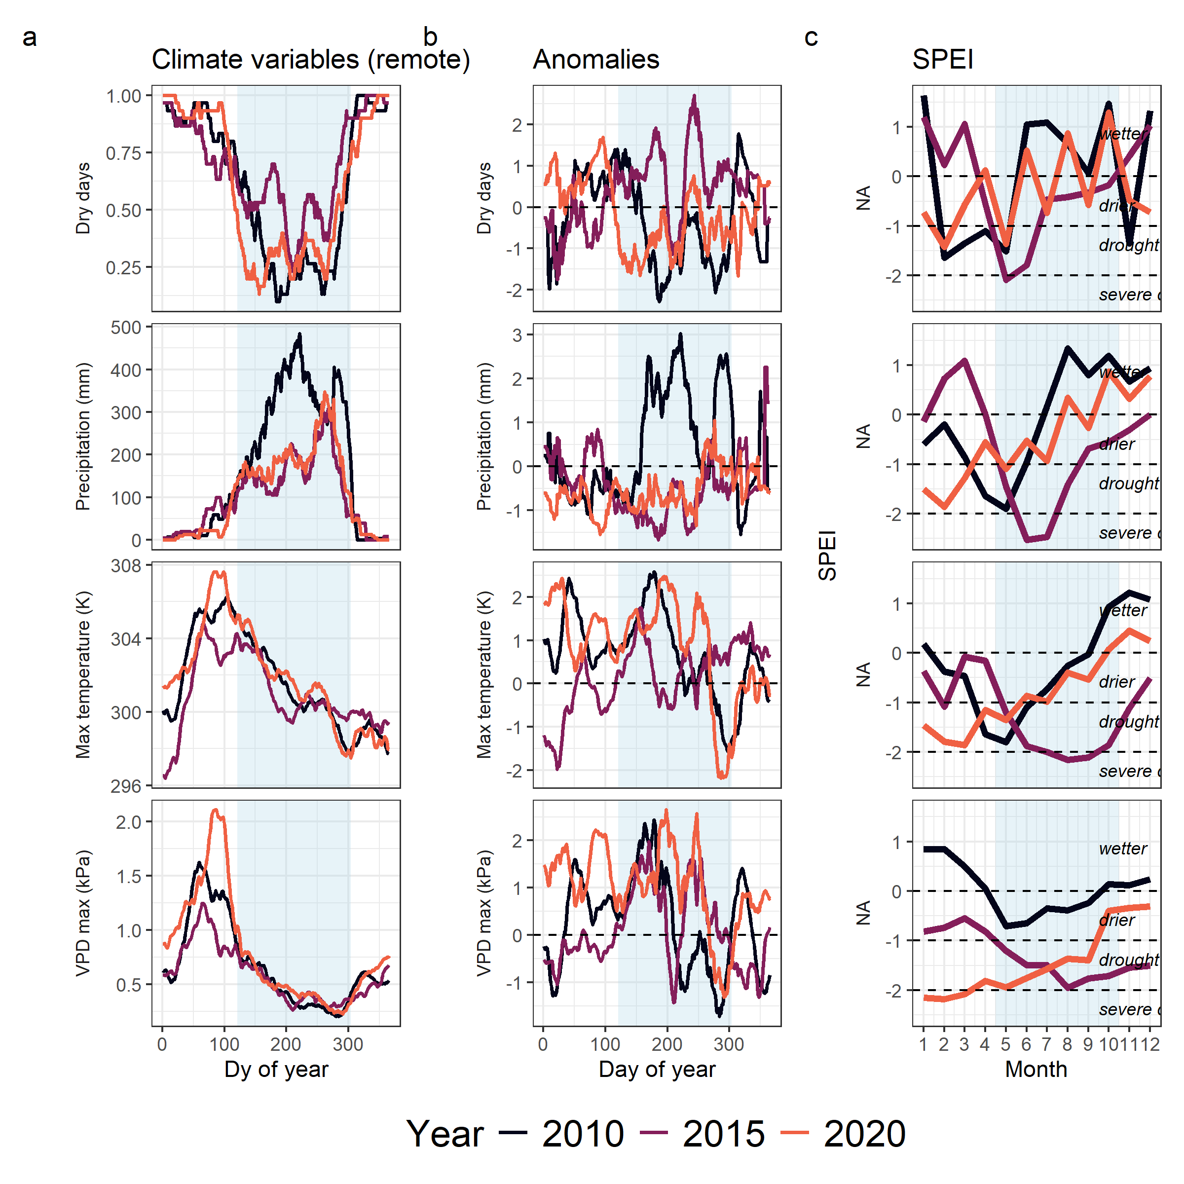

***Figure 1. Climatic characteristics of the focal drought years (red in 2010, brown in 2015) compared with the average across years*** 2008-2019 (grey dashed) and its standard deviation (grey shading) in the Huai Kha Khaeng ForestGEO plot, for four daily climate variables: dry days, precipitation, maximum temperature and VPD. (a) 30-day running means. (b) Anomalies of the drought year running means from the averages, in units of standard deviations. (c) Standardised Precipitation Evapotranspiration Index (SPEI) values for the drought years at four different time scales for each month for each drought year. A k-month SPEI integrates over k months ending in the month current month. Across all panels, light blue background represents the average wet season, from May to October. For comments - <https://github.com/forestgeo/growth-precip-thailand/issues/10>

In HKK, metal dendrometer bands were installed in 2008 on 2353 trees across 152 species following the standard ForestGEO protocol (Muller-Landau 2008). Selected were a size-stratified and spatially stratified random sample, with additional trees chosen to fill out sample sizes for selected species of interest. Thus relative abudances among the selected trees largely reflected abundance variation in the plot as a whole, with more individuals banded from the abundant species (n=1 to 230 trees per species). On each tree, the dendrometer band was installed at a height of 10 cm above the regular point of measurement for the whole plot census meaning installation at 1.4 m on most trees, and at higher heights on buttressed trees with higher measurement points. Dendrobands were censused twice a year with the measurement periods typically centred in June and January. During each census, the size of the window opening along the band was measured using Mitutoyo digital callipers (precision = 0.01 mm) and the diameter of the tree at the dendrometer band was measured using standard DBH tape.

***Calculating annualised growth increments***

Using the late wet/early dry dendrometer band censuses, we calculated annualised growth for each year and tree. We first conducted quality control on the dataset, removing measurements that appeared likely to be data entry errors (misplaced decimals), potential misidentified bands (old band numbers that restarted after stopping) or misidentified individuals (individuals with conflicting metadata across censuses). We used window size measurements combined with the diameter measurement at installation to calculate diameter at each dendroband census using standard equations that uses the chord across the measurement window to estimate the arc, assuming a circular cross section(Condit n.d.). We used a direct measurement of at the time of installation if it was available; if not, we excluded window size measurements until the first available diameter measurement. We calculated annualised diameter increments for each individual for each year by finding the difference in diameter from the previous year () and adjusting for the number of days () between measurements ().

We excluded large measurement outliers (> 3 standard deviations from the mean increment across all observations). Diameter tape measurements themselves are not precise enough for calculating drought sensitivity; error for each measurement is 1 mm, error for growth is 2 mm. In comparison, median annual growth across trees in HKK is ~1.4 mm and calculating deviation from annual growth needs sub-mm precision. However, we used tape measurements to flag likely errors in the dendrometer dataset. We calculated increments from annual tape measurements made on each dendrobanded tree at each census and removed dendroband measurements that had low agreement. Finally, we excluded trees with negative increments over the whole timeseries, and included only species that had at least 10 individuals, resulting in a final dataset of 1820 individuals of 30 species.

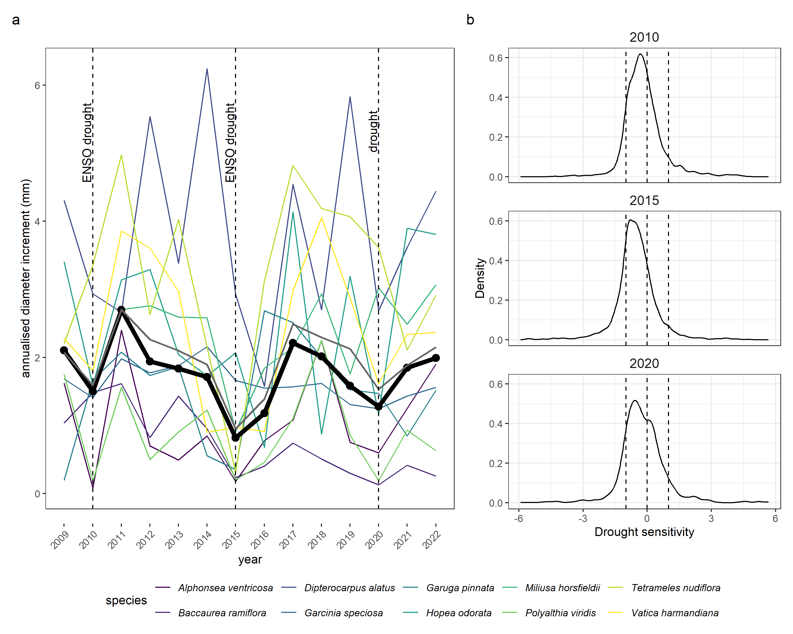

***Figure 2: Growth increment timeseries and drought responses*** across trees and species in the Huai Kha Khaeng ForestGEO plot. a) Median of annualised growth increments across ten dominant species (colours) and all trees (black) from 2009 to 2022. b) Distribution of drought sensitivity of tree growth across all individuals in the two drought years (see main text for equation). For comments - <https://github.com/forestgeo/growth-precip-thailand/issues/11>

***Drought years and characteristics***

We identified 2010, 2015 and 2020 as drought years of interest in the dendroband timeseries based on two drought indices and corroborated by meteorological data, local expertise, and plot-level growth responses. We calculated Standardised Precipitation-Evapotranspiration Index (SPEI) at 1-, 3-, 6- and 12- month scales using the SPEIbase dataset (Vicente-Serrano *et al.* 2010). Defining drought as periods with long-term SPEI < -1 resulted in identification of 2010, 2015 and 2020 as drought events. These years also corresponded with expert knowledge of major droughts that affected the region as well as meteorological records (see next paragraph; Fig. 1) and plot-level growth declines in the timeseries (Fig. 2). Among these, 2010 and 2015 were El Niño years; 2010 was a moderate El Niño event while 2015 was a very strong El Niño event (Oceanic Niño Index Bamston *et al.* (1997)).

To characterise the three droughts, we used daily weather data obtained from publicly available data sources. We used data from CHIRPS (Funk *et al.* 2015) for daily total precipitation and ERA5Land (Muñoz-Sabater *et al.* 2021) to calculate daily maximum temperature and vapour pressure deficit (VPD, Raesch (2020)). We then calculated rolling means of precipitation, number of dry days (precipitation = 0), VPD and maximum temperature over 30-day periods across the whole timeseries. Finally, we calculated daily rolling anomalies for each variable for the drought years from the long-term daily expectation as

***Variables for analysis***

For the three drought years, we calculated growth sensitivity for each tree to each drought as a growth anomaly from its mean annual increment over the entire time series.

We first calculated the mean annual increment for each tree from annualised increment . We then calculated sensitivity for each tree for each drought year as

By scaling the increment deviation to the mean annual growth of each tree, this metric allows us to compare across slow and fast growing individuals and species.

Across all individuals, we calculated Topographic Wetness Index (TWI) for an expectation of the water availability across space based on the total upslope area and the slope at the location. We used a Digital Elevation Model from a 5 m x 5 m elevation layer collected at plot establishment and the *whitebox* package in R (Lindsay 2016; Wu & Brown 2022) to calculate flow accumulation at each cell and then calculate TWI as . For an alternate estimate of wetness (Topographic Position Index) and associated results, see supplementary material. We defined tree size as the diameter at breast height (calculated from dendrometer band window measurement) at the previous census. We estimated crown exposure for each tree at each census using crown illumination index (CII), an ordinal categorical variable from 1 to 5 (least to most exposed) measured at each dendroband census. We centred and scaled TWI and DBH across the range of observed values.

We assigned deciduousness as a species level trait using data published in Williams *et al.* (2008) for the top 30 species. We defined species deciduousness as the mean over trees of the proportion of crown leaf loss at maximum, with a score ranging from 0 to 4 where 0 is most evergreen and 4 is most deciduous. Data were unavailable for *Alphonsea ventricosa*, an evergreen species, and so we manually assigned it a deciduousness score of 1. We also considered using the duration of time spent at maximum crown loss as an alternative measure of deciduousness. This was strongly correlated with the proportion of crown loss; we chose to use the proportion of crown loss because it was available for more species.

***Statistical methods***

We analysed tree responses to individual droughts by fitting separate models. We fit alternative models for sensitivity including a null model with just species random effects, a model including only fixed effects of species deciduousness and habitat wetness and a model including size (DBH), light environment (CII) and habitat wetness as well as species random effects on all these. We first modelled sensitivity as a simple random intercept model

We then used the predicted sensitivities from this model and tested their correlations with deciduousness using simple linear models.

To model the interactive effects of deciduousness and wetness on sensitivity, we modelled

We then calculated predictions across all combinations of values from observed maximum to minimum of TWI and deciduousness within this dataset.

To further disentange the microenvironmental drivers of drought sensitivity, we simultaneously modelled:

and

Simultaneously modelling the effect of variables on sensitivity and the effect of DBH on CII in this way allows us to disentangle causual linkages between these processes. We chose to model a species random effect on all slopes here to account for variation across species instead of specific traits which may have different effects with each of the variables. However, we also ran simpler models with species random effects only on the intercept, the results of which are reported in the Supplementary Material. Across all models, we used Gaussian priors for the distribution of the response variable sensitivity, considered CII as an monotonic predictor (ordered factor) and centred and scaled the other predictors. We modelled CII as an ordinal categorical variable with a cumulative logit link function. In the combined form, the model therefore used a multivariate distribution of Gaussian and logit.

All statistical analyses were performed using R version 4.4.0 (R Core Team 2024). Mixed models were fit through Bayesian regressions using MCMC methods using the package *brms* (Bürkner 2017). We ran 4 MCMC chains for 3000 iterations with 1000 of these set as warmup. We extracted draws, calculated distributions and checked convergence using functions from the *posterior* package (Bürkner *et al.* 2023; Vehtari *et al.* 2021).

# Results

## Drought characteristics

The droughts analysed had distinct climatic and temporal characteristics, with 2010 primarily a dry-season drought, 2015 a wet-season drought and 2020 showing mixed characteristics (Table 1, Fig 1). The 2010 drought showed 30-day-mean meteorological anomalies between February and May including lower precipitation (min anomaly **<-1** SD), higher number of dry days (anomaly **~1.5** SD), higher maximum temperature (anomaly **>2** SD), and higher VPD (anomaly **>2** SD), including in the wet season. 1- to 6-month SPEI values reached minima between -1.5 and -2, indicative of severe drought, while the 12-month values remained above -1, indicative of mild drought. In 2015, pronounced meteorological anomalies on the 30-day scale occurred during the wet season, including precipitation (anomaly **<-1.5** SD), number of dry days (max anomaly **>2** SD), maximum monthly temperatures (anomaly **+1.5** SD), and monthly maximum VPD (max anomaly **+2** SD). 1- to 12-month SPEI values crossed minima -2, lowest in the dendroband census period and indicative of severe drought. In 2020, meteorological anomalies were pronounced both in the dry and wet seasons, including maximum temperature (**>2** SD) and VPD (**>2** SD). 3- and 6-month SPEI values reached minima ~2 in February, indicative of borderline severe drought. 12-month SPEI showed severe drought conditions from January to April, and moderate drought from May to September, spanning both dry and wet seasons.

## Growth responses to drought

Drought years were associated with lower plot-level growth and stronger tree-level sensitivities, with the strongest negative response in 2015 (Fig 2). Median plot-level annual growth rate across years of measurement was 1.73 2.79 mm. The drought year 2015 had the lowest median increment 0.82 mm, 52.68% lower than the median across all years. In the 2010 and 2020 droughts, the median increments were 1.5 mm and 1.28 mm respectively, 13.33% and 26.3% lower than the median across all years. Median drought sensitivity across all trees in 2010, 2015 and 2020 were -0.27 0.92, -0.55 0.98 and -0.3 1.1 respectively.

## Species and functional group drought responses

Median annual increment varied among species with *Gluta obovata* having the lowest (0.61 1.95 mm) and *Dipterocarpus alatus* the highest (3.58 3.42 mm) among the 30 species analysed.  
While median species responses to the 2010 and 2020 droughts were variable, all species had lower median increment than a typical year in 2015. In 2010, species-level sensitivities ranged from -0.94 for *Alphonsea ventricosa* to 0.65 for *Afzelia xylocarpa*. In 2015, these ranged from -1.06 for *Dimocarpus longan* to 0.02 for *Mitrephora thorelii*. In 2020, sensitivities ranged from -0.98 for *Gluta obovata* to 0.77 for *Afzelia xylocarpa*.

Species median sensitivities to the three droughts were not correlated with each other, although on average, species had more negative sensitivities to the 2015 drought than the 2010 or 2020 droughts, in alignment with median sensitivities across all trees (for 2010 and 2015 Pearson’s correlation coefficient r = 0.11, p = 0.57, for 2015 and 2020 was r = -0.16, p = 0.39, and for 2010 and 2020 r = 0.16, p = 0.4, Fig S5).

Deciduous and evergreen species showed heterogenous responses to different droughts. Deciduous species were more drought sensitive than evergreen species in 2015 (Fig 3a, r = -0.41, p = 0.03), but the opposite was true in 2020 (0.41, p = 0.03). There was no difference in 2010 (r = -0.05, p = 0.8). Models of all trees with TWI and deciduousness as predictors showed that the conditional effect of deciduousness on sensitivity (controlling for topographic wetness) was significant and negative in 2015 (-0.08; 90% CI -0.12,-0.04), positive in 2020 (0.19; 90% CI 0.15,0.23), but no relationship in 2010 (-0.02, 90% CI -0.05, 0.02).

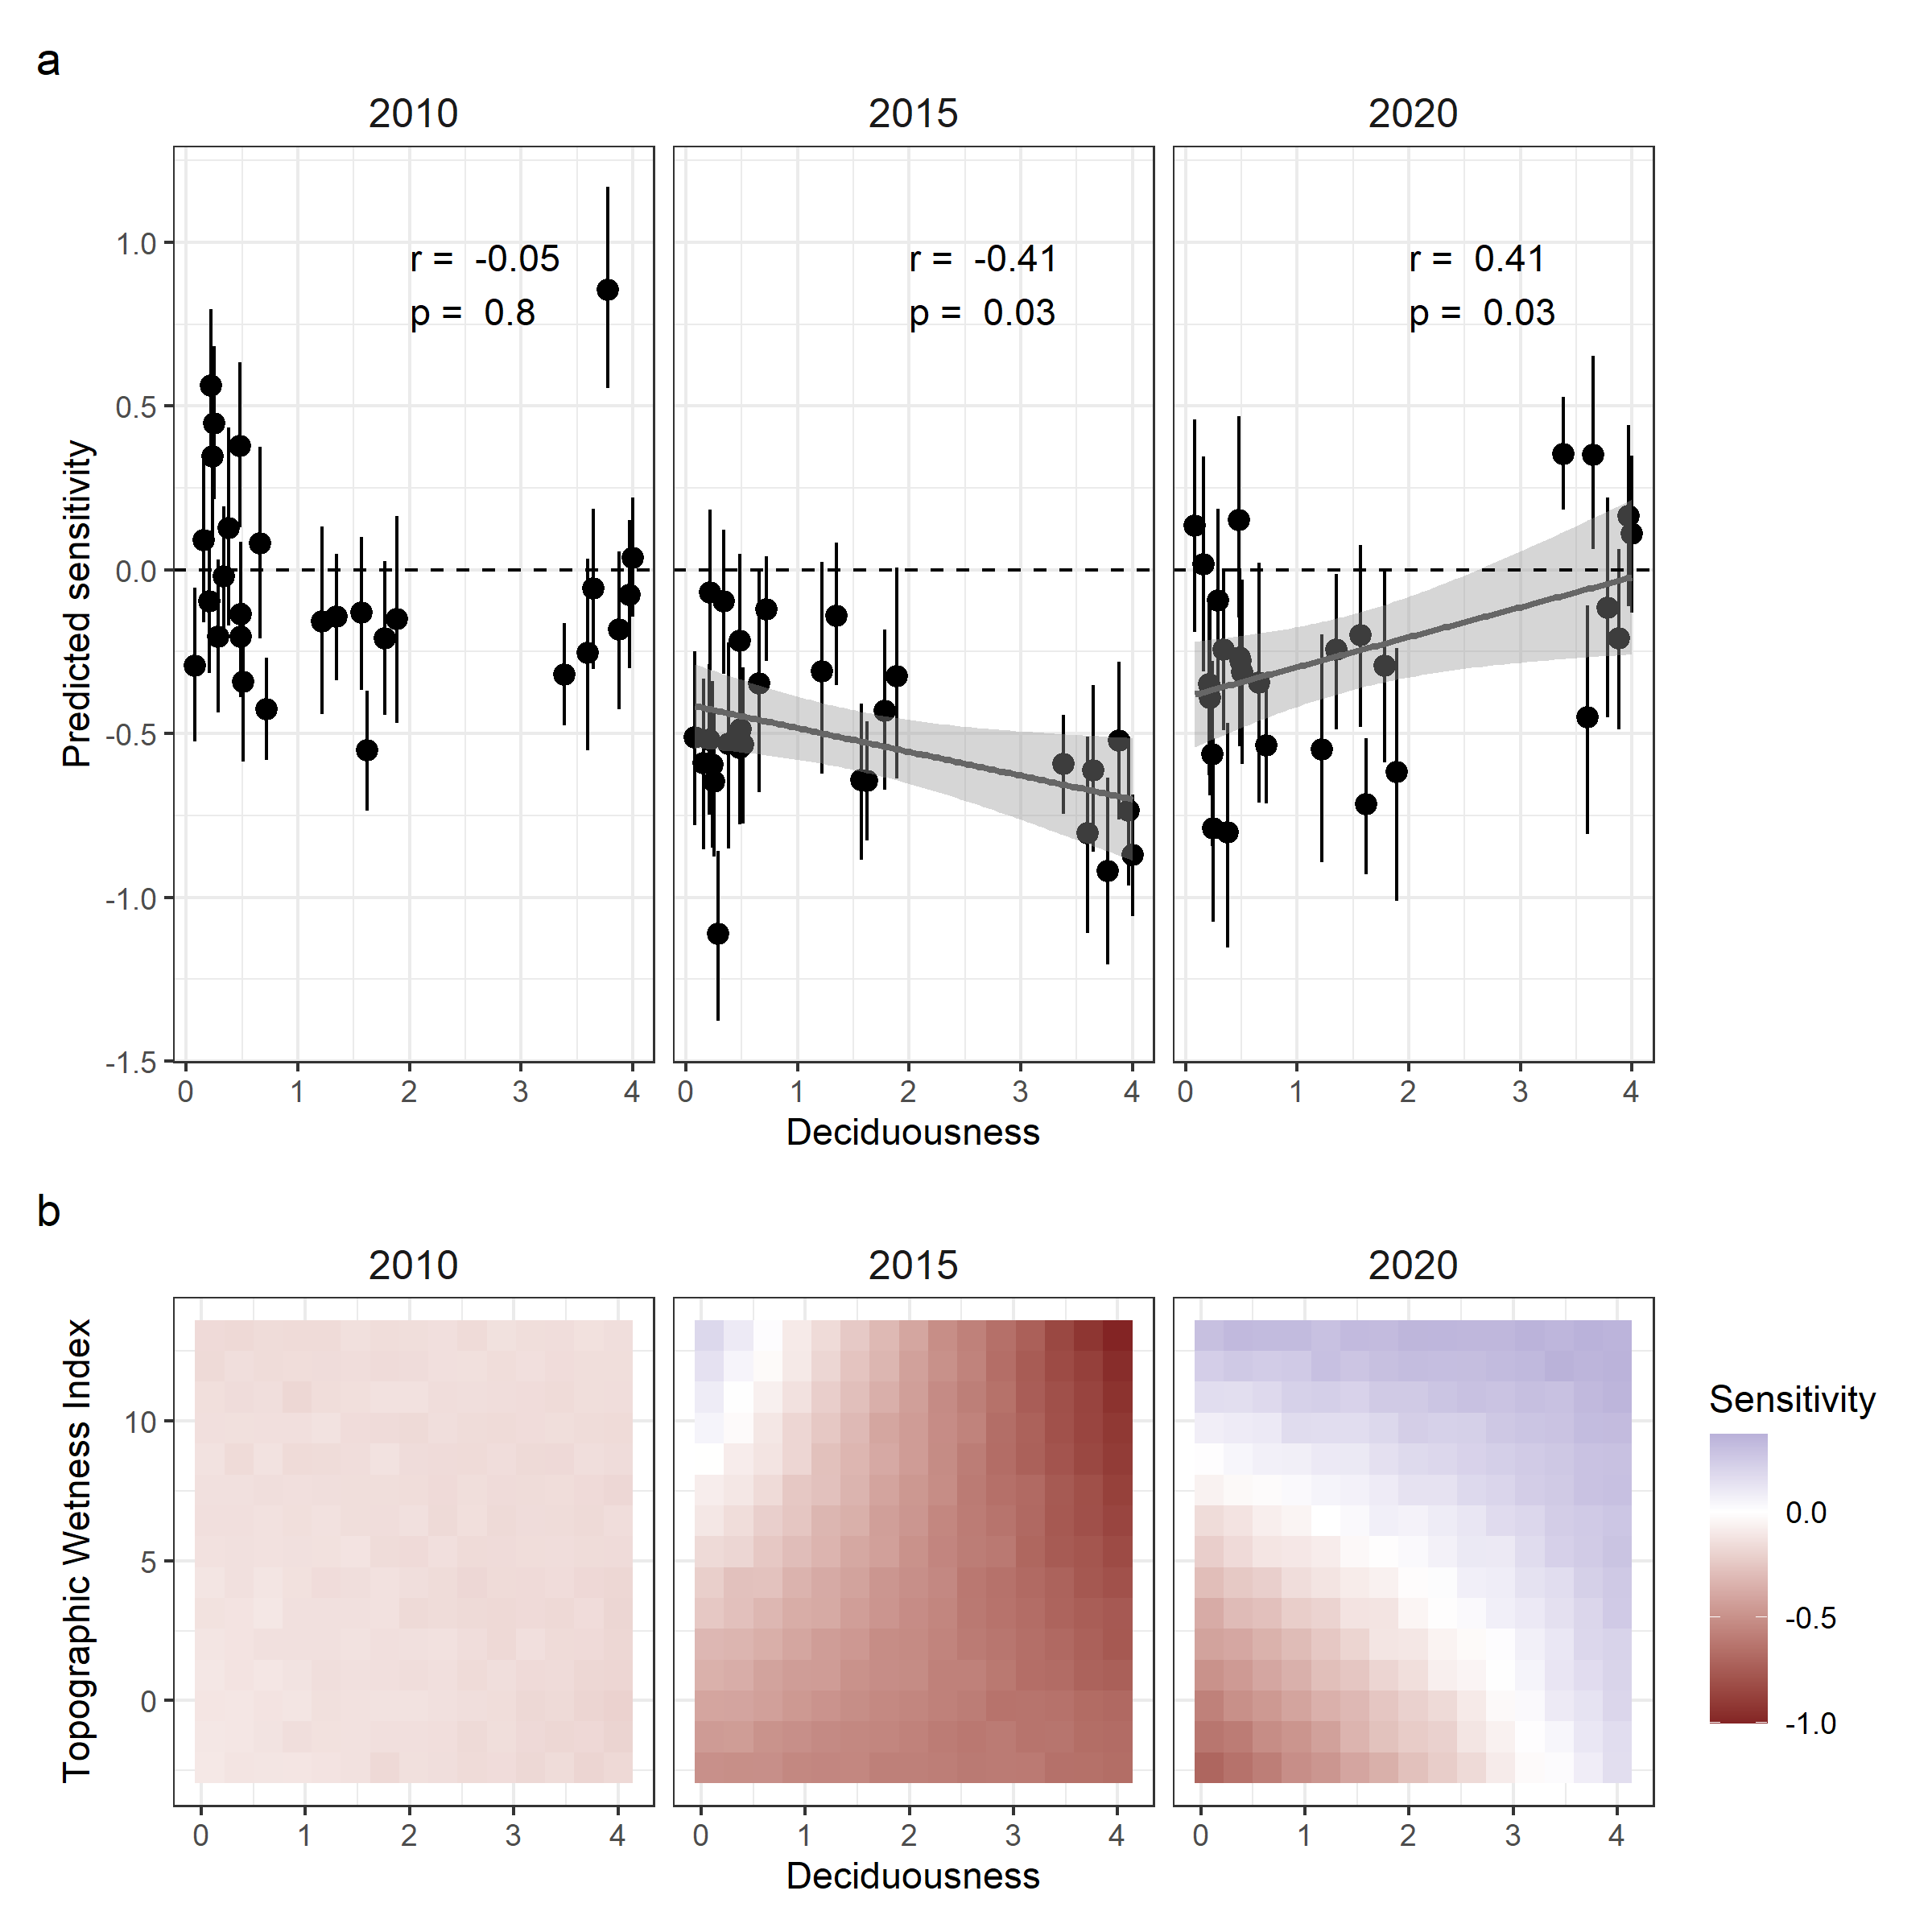

***Figure 3: Variation in sensitivity among species*** in the Huai Kha Khaeng ForestGEO plot during droughts in 2010, 2015 and 2020. a) Relationship of the mean species sensitivities from model fits of an intercept-only model, with mean species deciduousness values. Line shown for significant correlation. b) Predicted sensitivity values across the observed range of deciduousness and topographic wetness index from a model with TWI, deciduosness and their interaction across all trees modelled for each drought year separately. For comments: <https://github.com/forestgeo/growth-precip-thailand/issues/12>

## Microenvironment and individual effects

The test of whether individual trees responded similarly to the three drought events showed no correlation (Fig S6).

TWI showed significant positive effect in 2015 and 2020 but no significant effect on sensitivity in 2010. Across all trees, the model with TWI and deciduousness showed that TWI had no effect on drought sensitivity in 2010 (median effect =0, 90% CI -0.04, 0.03) but a positive effect in 2015 (median effect =0.05, 90% CI 0.01, 0.08) and 2020 (median effect =0.07, 90% CI 0.02, 0.11). The interaction between TWI and deciduousness was significantly negative in 2015 (median effect =-0.02, 90% CI -0.03, 0) but was not significant in 2010 (median effect =0, 90% CI -0.01, 0.02) or 2020, (median effect =-0.01, 90% CI -0.03, 0.01) Predicted sensitivities of deciduous trees were more negative than evergreen trees in 2015, with this effect stronger in wetter sites (Fig 3b). In 2020, predicted sensitivities of deciduous trees were more positive than evergreen trees and this effect was observable in drier sites (Fig 3b).

The differing effects of TWI on sensitivity in the three droughts, along with the influence of deciduousness, were confirmed by models that controlled for crown exposure and DBH as well as species variation in intercept and slopes (Fig 4a). These models showed small negative effect of wetness in 2010 (median effect =-0.04, 90% CI -0.09, 0.02), but a positive effect of wetness in 2015 (median effect =0.05, 90% CI 0, 0.11) and 2020 (median effect =0.06, 90% CI 0.01, 0.12). Predictions across the range of observed variables also showed that deciduous species generally had larger negative sensitivities in 2015, which did not increase with TWI (Fig 4c).  
Mean sensitivities across species and their response to TWI were not associated with deciduousness in 2010 or 2020, mirroring the response in the interaction model.

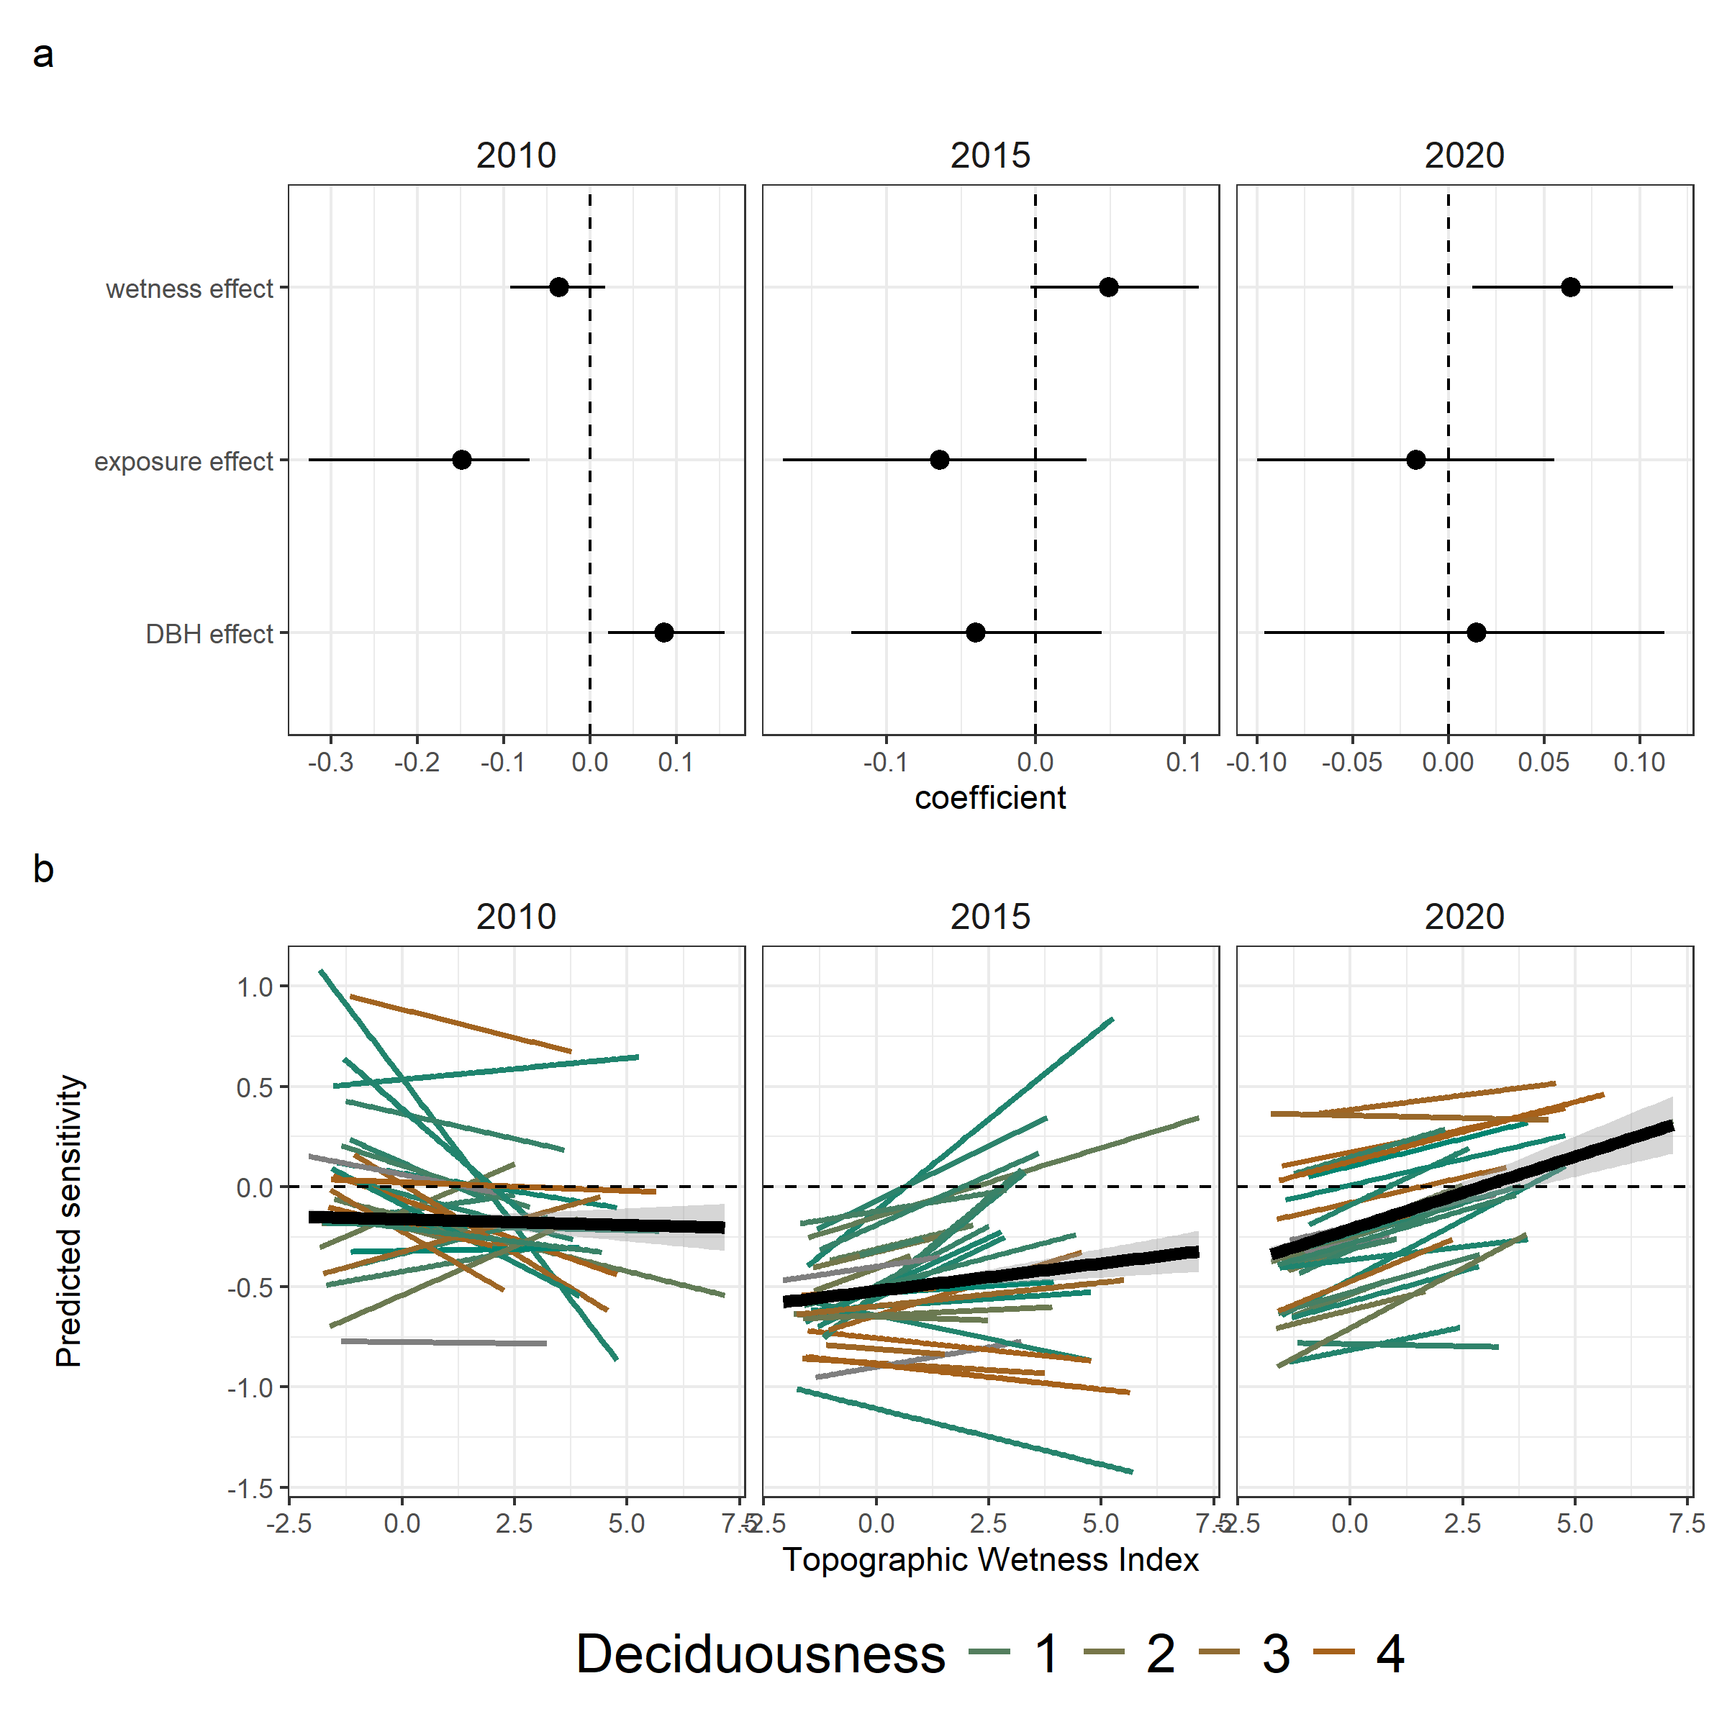

***Figure 4: Drivers of variation in sensitivity among individuals***. All panels represent model results from models (one for each year) predicting sensitivity with microenvironment conditions with species random effect on all slopes. a) Coefficient plots showing median effects and 90% CI for wetness, exposure and DBH of tree. b) Predicted relationship of drought sensitivity with topographic wetness index across all species derived from model predictions. Black line represents overall relationship (panel a); coloured lines for each species reflects deciduousness values. For comments - <https://github.com/forestgeo/growth-precip-thailand/issues/13>

Crown exposure was associated with greater growth declines in all three droughts. In the same models with species random effects on intercept and slope, the simplex parameter for the ordered factor crown exposure in 2010 was significant and negative (median effect =-0.15, 90% CI -0.33, -0.07), while in 2015 and 2020 the negative effect was not as strong (2015 median effect =-0.06, 90% CI -0.17, 0.03; 2020 median effect = -0.02, 90% CI -0.1, 0.06). Predicted effects of crown exposure on sensitivity decreased monotonically, with a decrease to negative sensitivities in category 4 and 5 in 2010, but all crown exposure categories had negative sensitivities in 2015 (Fig 5b).

Trees with larger DBH had higher crown exposure in 2010 (median effect = 4.01, 90% CI 3.74, 4.3), 2015 (4.19, 90% CI 3.92, 4.48) and 2020 (3.75, 90% CI 3.5, 4) (Fig 5a). Controlling for the direct effect of exposure, the remaining effect of DBH *per se* was significantly positive in 2010, and not significant in 2015 or 2020 (Fig 4a, Fig 5a).

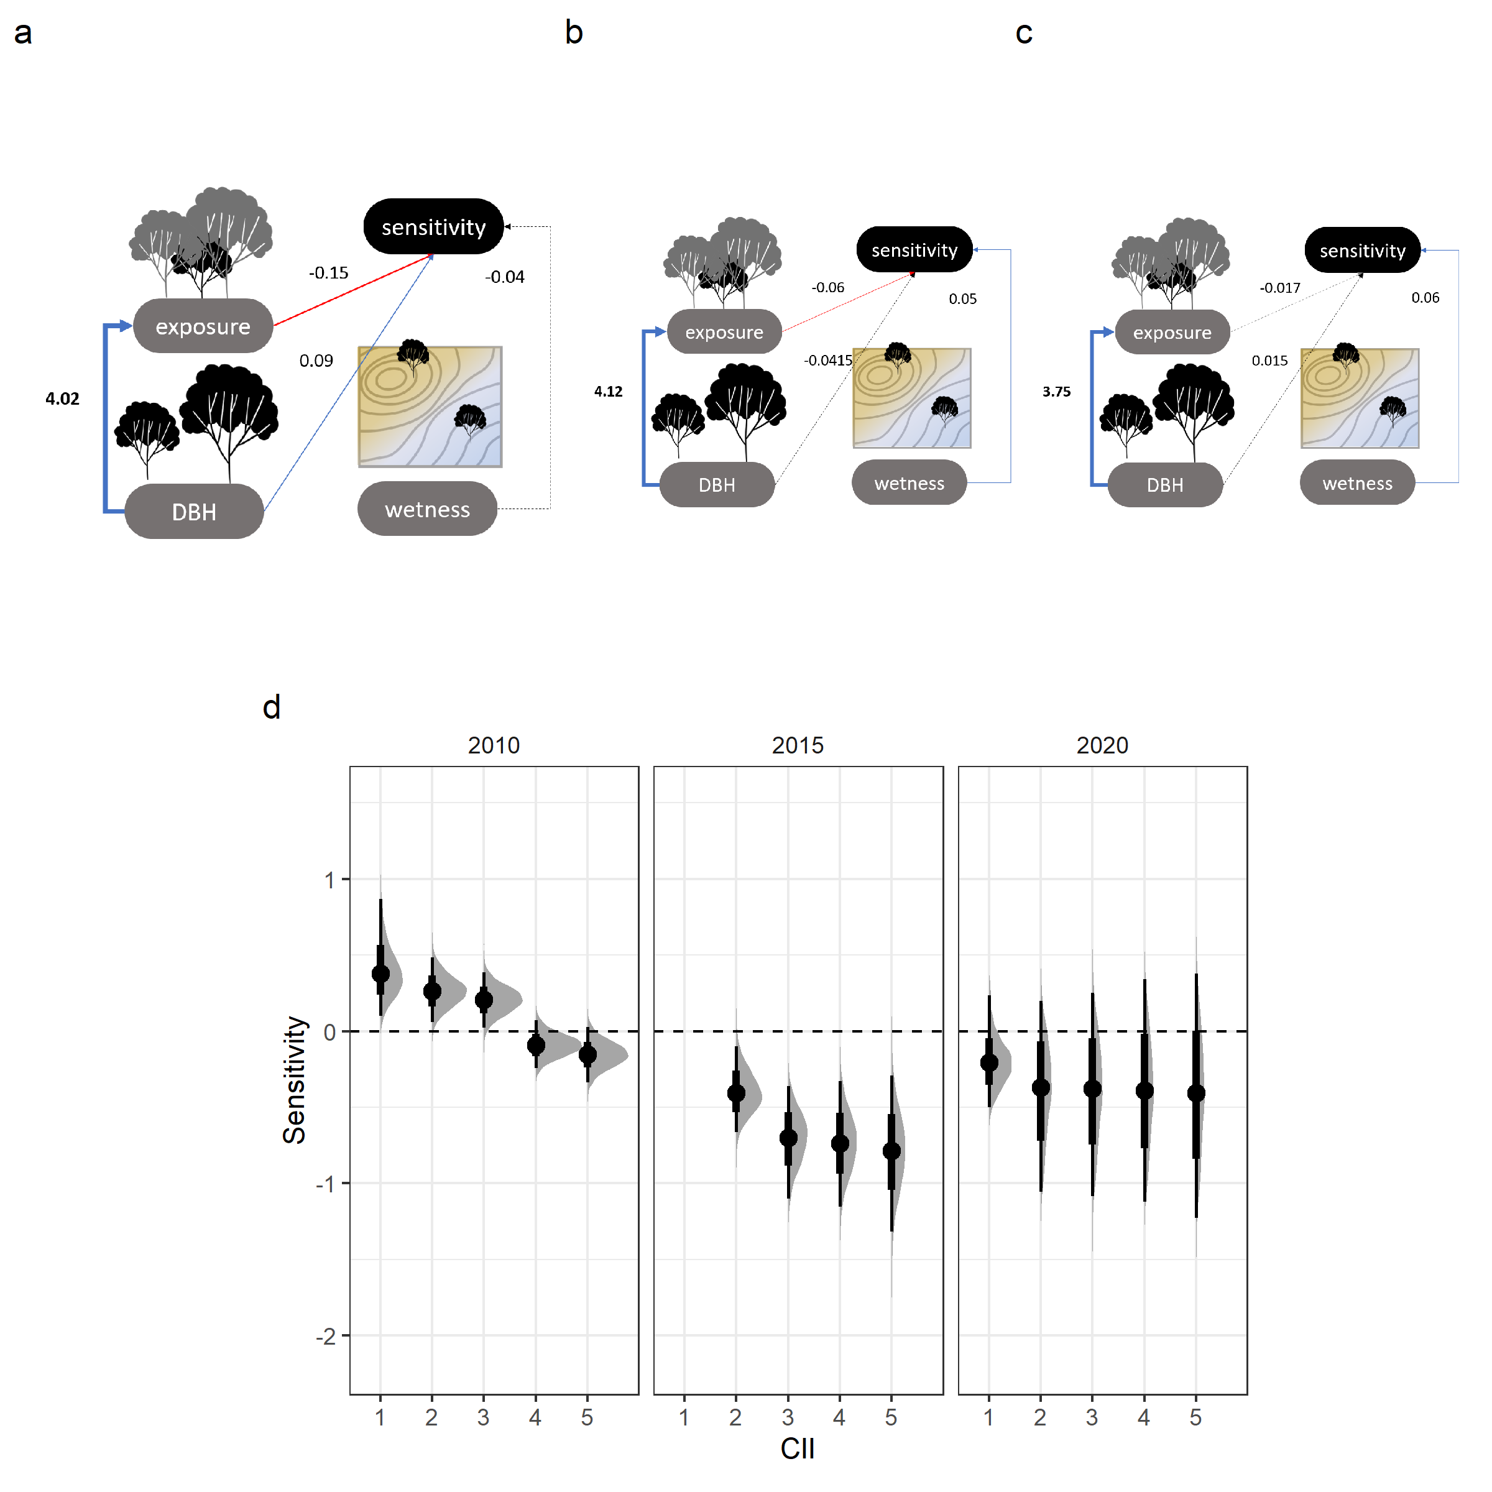

***Figure 5: Effects of size, exposure and water availability*** from combined models. Hypothesised relationships between microenvironment variables and drought sensitivity with their modelled effects in the HKK ForestGEO plot in the droughts of a) 2010, b) 2015 and c) 2020. Solid lines represent relationships where 90% credible intervals do not overlap 0, blue and red lines represent positive and negative effects respectively and line thickness is scaled to the effect size. d) Modelled sensitivity across crown exposure classes in 2010, 2015 and 2020. For comments - <https://github.com/forestgeo/growth-precip-thailand/issues/14>

# Discussion

We show that, in one tropical seasonal forest, the drought sensitivity of tree growth is jointly and interactively shaped by drought characteristics, species adaptations, and local environmental conditions (Table 1). Analysing three droughts in a 14-year dendrometer band time series, we found lower-than-average growth in drought years, resulting in lower plot-level growth (Fig 2). Across droughts, there was little consistency in species- or individual-level drought responses, reflecting dissimilar effects of a key species trait (deciduousness) and variables linked to water access (TWI, DBH) under differing drought conditions. Despite lower absolute extremes of temperature, vapor pressure deficit, and number of dry days (Fig. 2a), severe drought in the wet season (2015) elicited stronger responses across trees, especially deciduous species, which are expected to have stronger seasonality in growth phenology (Fig 3). Interestingly, in 2015 and 2020 (but not 2010), evergreen and deciduous species had divergent responses, especially along a wetness gradient; deciduous species suffered worse declines in wetter sites in 2015 and evergreen species suffered in drier sites in 2020 (Fig 3b, Fig 4b). Although trees with more exposed crowns were consistently more sensitive to drought, additional effects of DBH – presumably including rooting volume and depth – were dissimilar between the drought events (Fig 4a). It is possible that water availability buffered exposure-associated growth declines through different mechanisms in the two different droughts; larger trees fared better in the dry-season drought while trees in wetter sites suffered smaller growth declines in the wet-season drought (Fig 5). Taken together, these results indicate that joint and interactive effects of drought characteristics, species traits, and individual microenvironments produce important heterogeneity in individual and species drought responses of tropical trees. This finding that individual droughts have divergent effects on species and individuals may contribute to the maintenance of species diveristy and ecosystem stability.

While our analysis of 30 species across size classes and habitats spans spatial and ecological variation realistically and beyond the scope of previous analyses, we are limited in quantitatively analysing differences associated with drought characteristics because of limited sample size. The three droughts analyzed differed in multiple aspects, including ENSO strength, seasonal timing, magnitude and duration of meteorological extremes and anomalies, and severity as classified with SPEI (Fig. 1). However, our finding that a wet-season drought in 2015 had greater impact on woody growth than a dry-season drought in 2010 questions the generality of previous findings. Tree ring studies from this site (Anderson-Teixeira *et al.* 2022; Vlam *et al.* 2014) and across the tropics (Zuidema *et al.* 2022) have asserted that tree growth is most sensitive to dry-season precipitation. But given that the 2015 drought was more anomalous on multi-month time scales (Fig. 1) does not align with this assumption. Generalization of tropical tree growth responses to any specific drought seems to require fine-scale monitoring of growth (i.e., dendrometer band measurements or dendrochronology when possible) from species that might span drought strategies over different timings and intensities of droughts. Advancing efforts to collect these data is critical to our assessment and prediction of drought responses of tropical forets to changing precipitation patterns.

Periodic hot/dry conditions in tropical dry forests could create selective pressures for adaptative variation towards drought resistance potnetially resulting in a greater diversity of drought responses here compared to other bioclimatic zones where adaptive pressures and thus ecological variability are different. We have demonstrated that species identity and a key species adaptation (decidousness) interact with drought characteristics and microenvironment to shape drought responses in a dry seasonal evergreen forest. Strong seasonality in tropical dry forests exerts selective pressures on hydraulic strategies and has resulted in diversification along the hydraulic safety-efficiency axis with diverse strategies to maximise tree vital rates (González-M. *et al.* 2021; Oliveira *et al.* 2021). The degree of adaptive variation along the water use axis might be comparable to other dry climatic systems (e.g. temperate drylands reported in Vasey *et al.* (2022)), but it may not apply to the wet or everwet tropics, where tree-environment relations and evolutionary strategies may be substantially different. Paralleling the rarity of long-term records of annual tree growth in less seasonal tropical forests (Zuidema *et al.* 2022), we know exceedingly little about how tropical tree species with different traits respond to different types of drought, and how these responses may be modified by microenvironment. Again, continued expansion of dendrometer band records and ecophysiological studies will be essential to understanding the diversity and complexity of tropical tree drought responses, as well as if and how this diversity may promote community-level insurance effects under drought across tropical forests in general.

Trees with more exposed crowns exhibited greater growth declines, while sub-canopy trees grew more than average during the 2010 drought. This finding is consistent with the concept that larger trees tend to suffer more during drought (Bennett *et al.* 2015), but adds the important insight that it is crown position – as opposed to size *per se* – that is primarily responsible for this pattern. The strong and consistent negative effect of crown position makes sense in light of pronounced gradients in drought stress across forest vertical profiles (Vinod *et al.* 2023). We show that residual effects of size, presumably including root water access and biophysical challenges linked to height itself, may act in different directions depending on the drought characteristics (Figs. 4, 5). Together, these findings imply that while canopy and emergent trees face the greatest stress and exhibit the most negative growth responses, a suite of species traits and microenvironmental characteristics modify growth responses in interaction with drought characteristics.

Despite consistent observations of plot-level growth declines across drought events, we show that this scale obscures a variety of species- and tree-level ecological responses that are heterogeneous across droughts. An important implication is that drought responses inferred from tree-ring records derived from the few species known to form reliable, dateable annual rings (n=4 at HKK; Vlam *et al.* (2014)) are unlikely to be representative of the drought responses of the entire community. For example, one of the few annual-ring-forming species at HKK, deciduous *Afzelia xylocarpa*, had the most distinct response across the three events; it’s growth nearly doubled in the 2010 and 2020 droughts but was severely reduced in the wet-season drought (Fig. S5). More generally, tree-ring records are likely to give a biased picture of drought responses, as ring formation is caused by dry-season dormancy (often associated with deciduous leaf habit) and sampling often targets large trees with exposed crowns and dry microenvironments (Speer 2010)– all factors shown here to influence drought sensitivity. Our analyses reveal a complex heterogeneity of drought responses, including the contrasting influence of deciduousness in three different droughts, showing that ecological and evolutionary strategies make particular species and trees resistant to some droughts but vulnerable to others. These distinct responses of species and individuals to droughts suggests potential spatiotemporal insurance effects among tropical tree response, in alignment with recent global analyses (Liu *et al.* (2022)).

Our study reveals that drought sensitivity is not a static trait associated to particular species, traits, or microenvironments, but rather a dynamic response shaped interactively by these factors and drought characteristics. Despite net decreased growth at the plot level (in agreement with landscape-scale in Aguirre-Gutiérrez *et al.* (2022) and Bennett *et al.* (2023)), we show evidence that the same strategies are not uniformly successful across spatiotemporal climatic variation. Static traits are often used to explain and predict forest responses to drought, especially in the tropics where long-term records are few (Guillemot *et al.* 2022; Vico *et al.* 2017). More inclusive frameworks for drought responses encompass ecological complexity and covarying traits with environment (e.g., Trugman *et al.* 2021) but still assume consistent sensitivity of individual trees across events. However, we demonstrate that drought responses of tropical trees are not linearly predictable across drought events, but rather are shaped by the unique characteristics of each drought based on interactions between species adaptations and local environmental conditions. Without overriding the net negative effects of drought on tropical tree growth, these complexities reduce the likelihood of any given species or tree suffering severe growth declines under multiple consecutive droughts, thereby promoting diversity and stabilizing functioning of diverse tropical forests under drought.

# Acknowledgements

We acknowledge the continued contributions of the monitoring team of the 50-ha forest dynamics plot at HKK in collecting data and maintaining the dendrometer bands. Ekaphan Kraichak and Kanisorn Chowtiwuttakorn helped with procuring elevation and climate datasets. José Medina-Vega, Valentine Herrmann and Eugenie Más provided input on improving analyses. KA was supported by the Smithsonian Institution Postdoctoral Fellowship and the ForestGEO Analytical Workshop, Asia 2024 (supported by NSF grant DEB-[CHECK] to SJD) in completing this work.

# References

Aguirre-Gutiérrez, J., Berenguer, E., Oliveras Menor, I., Bauman, D., Corral-Rivas, J.J., Nava-Miranda, M.G., *et al.* (2022). [Functional susceptibility of tropical forests to climate change](https://doi.org/10.1038/s41559-022-01747-6). *Nature Ecology & Evolution*, 6, 878–889.

Albert, L.P., Restrepo-Coupe, N., Smith, M.N., Wu, J., Chavana-Bryant, C., Prohaska, N., *et al.* (2019). [Cryptic phenology in plants: Case studies, implications, and recommendations](https://doi.org/10.1111/gcb.14759). *Global Change Biology*, 25, 3591–3608.

Anderson-Teixeira, K.J., Davies, S.J., Bennett, A.C., Gonzalez-Akre, E.B., Muller-Landau, H.C., Joseph Wright, S., *et al.* (2015). [CTFS-ForestGEO : A worldwide network monitoring forests in an era of global change](https://doi.org/10.1111/gcb.12712). *Global Change Biology*, 21, 528–549.

Anderson-Teixeira, K.J., Herrmann, V., Rollinson, C.R., Gonzalez, B., Gonzalez-Akre, E.B., Pederson, N., *et al.* (2022). [Joint effects of climate, tree size, and year on annual tree growth derived from tree-ring records of ten globally distributed forests](https://doi.org/10.1111/gcb.15934). *Global Change Biology*, 28, 245–266.

Bamston, A.G., Chelliah, M. & Goldenberg, S.B. (1997). [Documentation of a highly ENSO-related sst region in the equatorial pacific: Research note](https://doi.org/10.1080/07055900.1997.9649597). *Atmosphere-Ocean*, 35, 367–383.

Bennett, A.C., McDowell, N.G., Allen, C.D. & Anderson-Teixeira, K.J. (2015). [Larger trees suffer most during drought in forests worldwide](https://doi.org/10.1038/nplants.2015.139). *Nature Plants*, 1, 15139.

Bennett, A.C., Rodrigues de Sousa, T., Monteagudo-Mendoza, A., Esquivel-Muelbert, A., Morandi, P.S., Coelho de Souza, F., *et al.* (2023). [Sensitivity of South American tropical forests to an extreme climate anomaly](https://doi.org/10.1038/s41558-023-01776-4). *Nature Climate Change*, 13, 967–974.

Brando, P.M., Paolucci, L., Ummenhofer, C.C., Ordway, E.M., Hartmann, H., Cattau, M.E., *et al.* (2019). [Droughts, Wildfires, and Forest Carbon Cycling: A Pantropical Synthesis](https://doi.org/10.1146/annurev-earth-082517-010235). *Annual Review of Earth and Planetary Sciences*, 47, 555–581.

Bunyavejchewin, S., Baker, P.J. & Davies, S.J. (2011). Seasonally dry tropical forests in continental Southeast Asia: Structure, compositon and dynamics. In: *The Ecology and Conservation of Seasonally Dry Forests in Asia*. Smithsonian Institution Scholarly Press, United States, pp. 9–35.

Bürkner, P.-C. (2017). [**Brms** : An *R* Package for Bayesian Multilevel Models Using *Stan*](https://doi.org/10.18637/jss.v080.i01). *Journal of Statistical Software*, 80.

Bürkner, P.-C., Gabry, J., Kay, M. & Vehtari, A. (2023). Posterior: Tools for working with posterior distributions.

Chitra-Tarak, R., Xu, C., Aguilar, S., Anderson-Teixeira, K.J., Chambers, J., Detto, M., *et al.* (2021). [Hydraulically-vulnerable trees survive on deep-water access during droughts in a tropical forest](https://doi.org/10.1111/nph.17464). *New Phytologist*, 231, 1798–1813.

Clark, D.A., Clark, D.B. & Oberbauer, S.F. (2021). [Annual Tropical-Rainforest Productivity Through Two Decades: Complex Responses to Climatic Factors, [CO2] and Storm Damage](https://doi.org/10.1029/2021JG006557). *Journal of Geophysical Research: Biogeosciences*, 126, e2021JG006557.

Clark, D.B., Clark, D.A. & Oberbauer, S.F. (2010). [Annual wood production in a tropical rain forest in NE Costa Rica linked to climatic variation but not to increasing CO2](https://doi.org/10.1111/j.1365-2486.2009.02004.x). *Global Change Biology*, 16, 747–759.

Condit, R. (n.d.). Dendrometer to Diameter.

Dahinden, F., Fischer, E.M. & Knutti, R. (2017). [Future local climate unlike currently observed anywhere](https://doi.org/10.1088/1748-9326/aa75d7). *Environmental Research Letters*, 12, 084004.

De Souza, B.C., Carvalho, E.C.D., Oliveira, R.S., De Araujo, F.S., De Lima, A.L.A. & Rodal, M.J.N. (2020). [Drought response strategies of deciduous and evergreen woody species in a seasonally dry neotropical forest](https://doi.org/10.1007/s00442-020-04760-3). *Oecologia*, 194, 221–236.

Fernández-de-Uña, L., Martínez-Vilalta, J., Poyatos, R., Mencuccini, M. & McDowell, N.G. (2023). [The role of height-driven constraints and compensations on tree vulnerability to drought](https://doi.org/10.1111/nph.19130). *New Phytologist*, 239, 2083–2098.

Funk, C., Peterson, P., Landsfeld, M., Pedreros, D., Verdin, J., Shukla, S., *et al.* (2015). [The climate hazards infrared precipitation with stations—a new environmental record for monitoring extremes](https://doi.org/10.1038/sdata.2015.66). *Scientific Data*, 2, 150066.

Gao, S., Liu, R., Zhou, T., Fang, W., Yi, C., Lu, R., *et al.* (2018). [Dynamic responses of tree-ring growth to multiple dimensions of drought](https://doi.org/10.1111/gcb.14367). *Global Change Biology*, 24, 5380–5390.

García-Cervigón, A.I., Camarero, J.J., Cueva, E., Espinosa, C.I. & Escudero, A. (2020). [Climate seasonality and tree growth strategies in a tropical dry forest](https://doi.org/10.1111/jvs.12840). *Journal of Vegetation Science*, 31, 266–280.

González-M., R., Posada, J.M., Carmona, C.P., Garzón, F., Salinas, V., Idárraga-Piedrahita, Á., *et al.* (2021). [Diverging functional strategies but high sensitivity to an extreme drought in tropical dry forests](https://doi.org/10.1111/ele.13659). *Ecology Letters*, 24, 451–463.

Guillemot, J., Martin-StPaul, N.K., Bulascoschi, L., Poorter, L., Morin, X., Pinho, B.X., *et al.* (2022). [Small and slow is safe: On the drought tolerance of tropical tree species](https://doi.org/10.1111/gcb.16082). *Global Change Biology*, 28, 2622–2638.

Hulshof, C.M. & Swenson, N.G. (2010). [Variation in leaf functional trait values within and across individuals and species: An example from a Costa Rican dry forest](https://doi.org/10.1111/j.1365-2435.2009.01614.x). *Functional Ecology*, 24, 217–223.

IPCC. (2023). [*Climate Change 2021 – The Physical Science Basis: Working Group I Contribution to the Sixth Assessment Report of the Intergovernmental Panel on Climate Change*](https://doi.org/10.1017/9781009157896). 1st edn. Cambridge University Press.

Kunert, N., Zailaa, J., Herrmann, V., Muller-Landau, H.C., Wright, S.J., Pérez, R., *et al.* (2021). [Leaf turgor loss point shapes local and regional distributions of evergreen but not deciduous tropical trees](https://doi.org/10.1111/nph.17187). *New Phytologist*, 230, 485–496.

Lindsay, J.B. (2016). Whitebox GAT: A case study in geomorphometric analysis. *Computers & Geosciences*, 95, 75–84.

Liu, D., Wang, T., Peñuelas, J. & Piao, S. (2022). [Drought resistance enhanced by tree species diversity in global forests](https://doi.org/10.1038/s41561-022-01026-w). *Nature Geoscience*, 15, 800–804.

Luo, X. & Keenan, T.F. (2022). [Tropical extreme droughts drive long-term increase in atmospheric CO2 growth rate variability](https://doi.org/10.1038/s41467-022-28824-5). *Nature Communications*, 13, 1193.

Ma, Q., Su, Y., Niu, C., Ma, Q., Hu, T., Luo, X., *et al.* (2023). [Tree mortality during long-term droughts is lower in structurally complex forest stands](https://doi.org/10.1038/s41467-023-43083-8). *Nature Communications*, 14, 7467.

McDowell, N.G. & Allen, C.D. (2015). [Darcy’s law predicts widespread forest mortality under climate warming](https://doi.org/10.1038/nclimate2641). *Nature Climate Change*, 5, 669–672.

McGregor, I.R., Helcoski, R., Kunert, N., Tepley, A.J., Gonzalez-Akre, E.B., Herrmann, V., *et al.* (2021). [Tree height and leaf drought tolerance traits shape growth responses across droughts in a temperate broadleaf forest](https://doi.org/10.1111/nph.16996). *New Phytologist*, 231, 601–616.

Muller-Landau, H.C. (2008). Metal Band Dendrometer Protocol.

Muñoz-Sabater, J., Dutra, E., Agustí-Panareda, A., Albergel, C., Arduini, G., Balsamo, G., *et al.* (2021). [ERA5-Land: A state-of-the-art global reanalysis dataset for land applications](https://doi.org/10.5194/essd-13-4349-2021). *Earth System Science Data*, 13, 4349–4383.

Naumann, G., Alfieri, L., Wyser, K., Mentaschi, L., Betts, R.A., Carrao, H., *et al.* (2018). [Global Changes in Drought Conditions Under Different Levels of Warming](https://doi.org/10.1002/2017GL076521). *Geophysical Research Letters*, 45, 3285–3296.

Oliveira, R.S., Eller, C.B., Barros, F. de V., Hirota, M., Brum, M. & Bittencourt, P. (2021). [Linking plant hydraulics and the fast–slow continuum to understand resilience to drought in tropical ecosystems](https://doi.org/10.1111/nph.17266). *New Phytologist*, 230, 904–923.

R Core Team. (2024). *R: A language and environment for statistical computing*. Manual. R Foundation for Statistical Computing, Vienna, Austria.

Raesch, A. (2020). [Pvldcurve: Simplifies the Analysis of Pressure Volume and Leaf Drying Curves](https://doi.org/10.32614/CRAN.package.pvldcurve).

Räsänen, T.A., Lindgren, V., Guillaume, J.H.A., Buckley, B.M. & Kummu, M. (2016). [On the spatial and temporal variability of ENSO precipitation and droughtteleconnection in mainland Southeast Asia](https://doi.org/10.5194/cp-12-1889-2016). *Climate of the Past*, 12, 1889–1905.

Scharnweber, T., Heinze, L., Cruz-García, R., van der Maaten-Theunissen, M. & Wilmking, M. (2019). [Confessions of solitary oaks: We grow fast but we fear the drought](https://doi.org/10.1016/j.dendro.2019.04.001). *Dendrochronologia*, 55, 43–49.

Slette, I.J., Post, A.K., Awad, M., Even, T., Punzalan, A., Williams, S., *et al.* (2019). [How ecologists define drought, and why we should do better](https://doi.org/10.1111/gcb.14747). *Global Change Biology*, 25, 3193–3200.

Speer, J.H. (2010). *Fundamentals of tree-ring research*. Univ. of Arizona Press, Tucson, Ariz.

Stahl, C., Hérault, B., Rossi, V., Burban, B., Bréchet, C. & Bonal, D. (2013). [Depth of soil water uptake by tropical rainforest trees during dry periods: Does tree dimension matter?](https://doi.org/10.1007/s00442-013-2724-6) *Oecologia*, 173, 1191–1201.

Trugman, A.T., Anderegg, L.D.L., Anderegg, W.R.L., Das, A.J. & Stephenson, N.L. (2021). [Why is Tree Drought Mortality so Hard to Predict?](https://doi.org/10.1016/j.tree.2021.02.001) *Trends in Ecology & Evolution*, 36, 520–532.

Vasey, G.L., Weisberg, P.J. & Urza, A.K. (2022). [Intraspecific trait variation in a dryland tree species corresponds to regional climate gradients](https://doi.org/10.1111/jbi.14515). *Journal of Biogeography*, 49, 2309–2320.

Vehtari, A., Gelman, A., Simpson, D., Carpenter, B. & Bürkner, P.-C. (2021). Rank-normalization, folding, and localization: An improved Rhat for assessing convergence of MCMC (with discussion). *Bayesian Analysis*.

Vicente-Serrano, S.M., Beguería, S. & López-Moreno, J.I. (2010). [A Multiscalar Drought Index Sensitive to Global Warming: The Standardized Precipitation Evapotranspiration Index](https://doi.org/10.1175/2009JCLI2909.1). *Journal of Climate*, 23, 1696–1718.

Vico, G., Dralle, D., Feng, X., Thompson, S. & Manzoni, S. (2017). [How competitive is drought deciduousness in tropical forests? A combined eco-hydrological and eco-evolutionary approach](https://doi.org/10.1088/1748-9326/aa6f1b). *Environmental Research Letters*, 12, 065006.

Vinod, N., Slot, M., McGregor, I.R., Ordway, E.M., Smith, M.N., Taylor, T.C., *et al.* (2023). [Thermal sensitivity across forest vertical profiles: Patterns, mechanisms, and ecological implications](https://doi.org/10.1111/nph.18539). *New Phytologist*, 237, 22–47.

Vlam, M., Baker, P.J., Bunyavejchewin, S. & Zuidema, P.A. (2014). [Temperature and rainfall strongly drive temporal growth variation in Asian tropical forest trees](https://doi.org/10.1007/s00442-013-2846-x). *Oecologia*, 174, 1449–1461.

Williams, L.J., Bunyavejchewin, S. & Baker, P.J. (2008). [Deciduousness in a seasonal tropical forest in western Thailand: Interannual and intraspecific variation in timing, duration and environmental cues](https://doi.org/10.1007/s00442-007-0938-1). *Oecologia*, 155, 571–582.

Wu, Q. & Brown, A. (2022). *’Whitebox’: ’WhiteboxTools’ R frontend*. Manual.

Zuidema, P.A., Babst, F., Groenendijk, P., Trouet, V., Abiyu, A., Acuña-Soto, R., *et al.* (2022). [Tropical tree growth driven by dry-season climate variability](https://doi.org/10.1038/s41561-022-00911-8). *Nature Geoscience*, 15, 269–276.

Zuleta, D., Duque, A., Cardenas, D., Muller-Landau, H.C. & Davies, S.J. (2017). [Drought-induced mortality patterns and rapid biomass recovery in a terra firme forest in the Colombian Amazon](https://doi.org/10.1002/ecy.1950). *Ecology*, 98, 2538–2546.