Snapping
Snapping allows the user to precisely drag vertices to a location relative to other drawing objects.
Snapping works according the following rules:
- When the dragged vertex is near a snapping position (refer to snapping distance), the system snaps the vertex to the detected position.
- While vertex is dragged, the type of the performed snapping operation is indicated by adding the corresponding symbols to the mouse cursor.
- Multiple snapping operations can be applied at once. For example, when a vertex of a line is snapped perpendicular to another line both “Snap to Any Point” and “Snap to Perpendicular” are applied.
- The segment of the object relative to which a snapping position is detected is highlighted by a different color.
- Every detected snapping position is stored by the system so if the vertex is dragged away from the snapped position it is still available at a distance greater than the snapping distance. This is indicated by the dashed line as shown below.
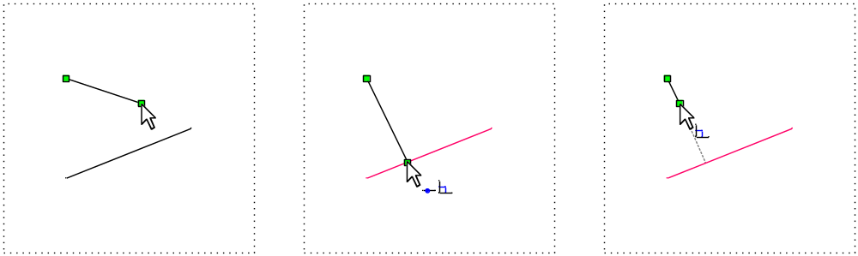
The table below lists the available snapping operations and their cursor symbols:
- Snap to Any Point
- Snap to Mid Point
- Snap to End Point
- Snap to Center
- Snap Tangent to Circle/Arc
- Snap to Perpendicular
- Snap to Vertical
- Snap to Horizontal
- Snap to 45° Angle

Trial Task Description
We would like you to implement one of the three operations below:
- Snap to End Point
- Snap to Perpendicular
- Snap Tangent to Circle/Arc
Segment Highlighting and Reference Line are not required.

Our goal is to see that you understand the coding example and to review an example of your code. If you cannot complete one of the three operations, then please send us whatever code you were able to complete and the time you were able to apply to this Trial Task.

