Weekly Report 13
What was accomplished this week?
The final documentation was finished and we received our report from the Writing Center. The last few cosmetic tweaks we wanted for our home page on the website has been completed.

What problems were encountered?
There were no major issues encountered during this stage.

If solved, what were their solutions?
N/A.

How does our team progress align with our project Gantt chart?
We are still on track, our user manual was completed and now we’re just finishing our last adjustments and turning in the last few requirements before presentation week.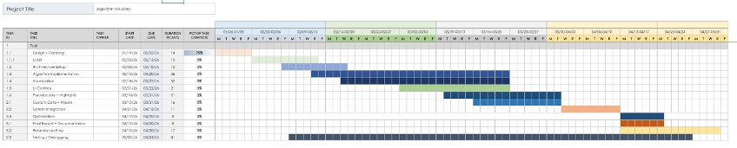

What is the plan for this next week?
Our plan is to hand in the last bit of documentation we need and get ready for the final presentations.

Each member’s contribution
Jasper Martin - user manual documentation, final home page adjustments
Cara Antonucci - editing user manual, weekly report documentation

