Weekly Report 3
What was accomplished last week?
Last week, the menu was updated and made cleaner. Several page files were made that will allow for multiple different pages within the website, the official about me and downloadable weekly reports were added so users will be able to see how the project evolved on a weekly basis throughout our development. We added the starting foundations for algorithm visualization and completed a working example of how data may be visualized. The files were also organized and the animation example was completed.

What problems were encountered?
One problem that occurred was, Github wasn’t accurately updating changes made to the website. For instance, text colors were modified but when we tried checking to see how it looked on the page it didn’t display. We also found out that GitHub Pages was taking a while to refresh.

If solved, what were their solutions?
We found that we have to save in order for changes to commit and push to GitHub. As for the issue with refreshing, since the repository was made public, we have not had that problem.

How does our team progress align with our project Gantt chart?
As seen in the Gantt Chart provided, this week is centered around Architecture setup and starting the algorithm implementation phase. We have added the foundations for algorithm visualization and have gotten relatively familiar with SVG so we’re ready to go with the algorithm implementation phase. We also refined our UI, which we set out to do last week.

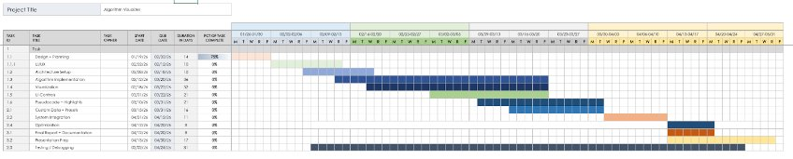

What is the plan for this week?
Next week, our team plans to move into algorithm implementation.

Each member’s contribution
Jasper Martin - UI/UX development/menu refinement
Cara Antonucci - Documentation/visualizer foundation

