Weekly Report 10
What was accomplished this week?
We added the Depth First search algorithm and accompanying pseudocode. We have also completed the Algorithms page, adding operational links for additional resources and complete natural language descriptions for each algorithm we currently have visualized.

What problems were encountered?
There were no major issues during implementation, though there was a small problem with the link color in the Additional Resource page. When the user clicked on a link, it changed the color to purple, upon closing the web page and reopening it, the color stuck (link stayed purple) because the browser remembered the user visiting that link.

If solved, what were their solutions?
Upon researching, we found that the only way to reset the color after the user closes the page, we’d have to clear their cache/browser history upon exit. This was not a viable solution because basic HTML didn’t allow us to do that because it was a security risk for their program to access the user’s browser in that way. Instead, the color was changed to be the same as the initial color so the link color doesn’t change when the user clicks them.

How does our team progress align with our project Gantt chart?
As seen in the Gantt Chart provided, our team is on track. As discussed last week, these were the last visual/logistical changes we wanted to make. If any other changes are requested, we can implement them but we are technically “done”.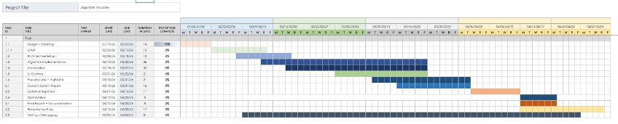

What is the plan for this next week?
Our plan is to receive feedback at the weekly review, if any other tweaks need to be made we will implement them next week but at the point of time of writing this report, the project is technically “done”. We would like to start preparing for our final presentation as soon as we are able to.

Each member’s contribution
Jasper Martin - final pseudocode implementation/final algorithm development
Cara Antonucci - documentation/Algorithm page completion

