Weekly Report 11
What was accomplished this week?
The Depth-First Search node assignment has been fixed so the program assigns nodes based off of level instead of randomly. The Depth-First-Search is now searching instead of just traversing, and the user is able to pick a target node to search for within the tree.

What problems were encountered?
There were no major issues encountered during the current bug patches.

If solved, what were their solutions?
No major bugs reporting during bug patches/implementation.

How does our team progress align with our project Gantt chart?
As seen in the Gantt Chart provided, our team is on track. As discussed last week, we are essentially “done” with our project. We have finished the final tweaks and will now move on to the final phase of the project, which is developing the user manual and getting our presentation ready for the end of the semester.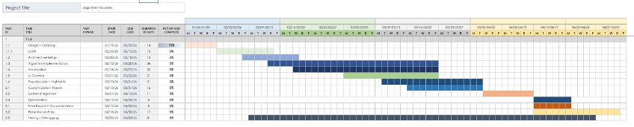

What is the plan for this next week?
Our plan is to start on the user manual and start preparing for our presentation at the end of this semester.

Each member’s contribution
Jasper Martin - final bug fixes
Cara Antonucci - documentation

