Weekly Report 12
What was accomplished this week?
The first 10 pages of the user manual have been written as part of our final preparations for this course.

What problems were encountered?
There were no major issues encountered when writing but there were a few questions we had about the user manual that will be addressed in the weekly meeting, namely the proper page length and if there are any other requirements we aren’t aware of for the document.

If solved, what were their solutions?
We plan to ask our questions during the weekly meeting and go from there.

How does our team progress align with our project Gantt chart?
We are still on track, our program is completed and we’re now working on the document requirements to finish out the course.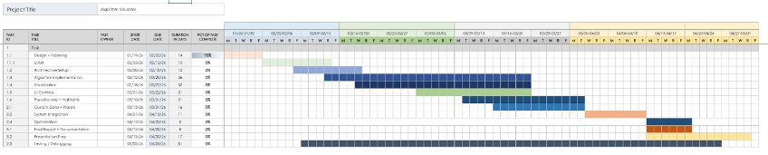

What is the plan for this next week?
Our plan is to get a meeting with the Writing Center and finish up our user manual by next Thursday, we will also be fulfilling the other requirements specified in Dr. Chen’s list by next Friday. Namely, sending the email about our program, completing the final peer evaluation, delivering the hard copy user manual, submitting the source code, and submitting our finished user manual.

Each member’s contribution
Jasper Martin - user manual documentation
Cara Antonucci - weekly report documentation

