Weekly Report 1
What is the Project?
Our project is called the Algorithm Visualizer. It will be a tool used primarily in academic settings, students will be able to choose an algorithm from a list of three categories (sorting algorithms, searching algorithms, and graphing algorithms). There will be at least one algorithm available for visualization in each algorithm category (bubble sort in the sorting category, linear search in the searching category, etc.) Once chosen, the user can either enter preset data or input their own custom data, this will allow the user to see how different data sets affect the algorithm’s operation. Each step of the algorithm will display to the screen in detail along with pseudocode of how the algorithm works in a panel on the left hand side. The user will be able to pause, play, or step through algorithm visualization as well. This tool will not only be useful to students who are just learning how different algorithms function, professors will benefit from it as well as they can use it to demonstrate different algorithms in class and talk through it step by step. Our primary goal with this project is to make a learning tool that’ll help professors and students alike demonstrate/understand various algorithms more easily.

Progress
This project will be written using JavaScript, CSS, and HTML. We’ve established our website for documents using a Github repository, the project will be accessible via that same repository once it’s complete. We have all necessary developer tools needed to code in JavaScript installed, and we’ve created a basic GUI as a starting point for the project ahead.

Planning
Gantt Chart:

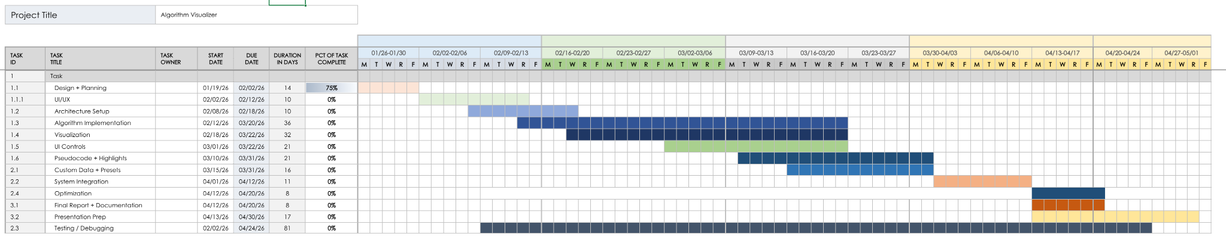
Website: The website we are using is Github, we plan to host the final project through Github Pages. The documentation is available through the README file of the repository, currently the repository is private because we’re still developing the project but once it’s finished it’ll be made public for anyone to access. The link is: https://github.com/Cara-A/Senior-Project-2026.git

Current Challenges: The primary challenge we’re facing right now is that JavaScript has a bit of a learning curve. We decided this project would be a good opportunity to learn another programming language to further expand our skillsets so we’re starting with little prior knowledge of JavaScript, and while it requires a lot of research, we are making progress. Github is a similar matter, we’re learning how to best utilize that as well as we’re not entirely familiar

with Github Pages but research has been helping greatly. In the next few weeks, we would like to continue to build the GUI and work on building the algorithms/graphics. Since the visualization component is directly tied to the algorithm’s function, we intend to work on both aspects in tandem.

Leader of the Implementation Phase: Cara Antonucci

