Weekly Report 4
What was accomplished this week?
Last week, the bubble sort algorithm visualization was moved from the home page and put back in the visualization section of the website. A pause/play button was implemented and refined into two separate pause and play buttons, a reset button was also added. Development has begun on pseudocode panel and step button.

What problems were encountered?
The only problems faced were small errors when resizing various elements in our UI.

If solved, what were their solutions?
We were able to work around the sizing error issue and eventually get it to properly display after some tweaking.

How does our team progress align with our project Gantt chart?
As seen in the Gantt Chart provided, this week is centered around beginning our Algorithm Implementation phase. So far, we have the bubble sort up and running and are working to make it more refined and customizable for the user, once this is finished we can move on to visualizing the next two algorithms with a better understanding of how data visualizations and menus can be created in our program.
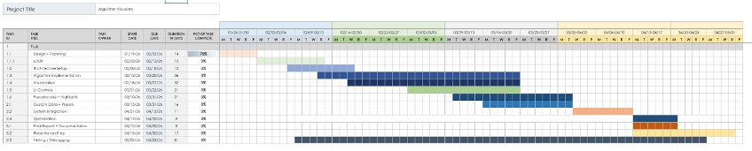

What is the plan for this next week?
Next week, our team plans to continue algorithm implementation.

Each member’s contribution
Jasper Martin - UI/UX development/menu refinement
Cara Antonucci - UI/UX development/documentation

