Weekly Report 5
What was accomplished this week?
We added a reset button and a new data button so the user can get a new array of data, and they can use the reset button to see the current array be reset to its original unorganized state and they can watch it work through the array as many times as they’d like. We also finished our pseudocode section, so now as the algorithm works through the data, the user is able to see what actions the algorithm is currently performing on the given data. Resize issues were also fixed this week.

What problems were encountered?
The main issue we are now running into is the default speed is a little too fast, especially when the pseudocode is changing with each action the algorithm is performing.

If solved, what were their solutions?
The speed has been tweaked and we’re going to continue to adjust as we add algorithms to make sure the default is a comfortable speed for that given algorithm.

How does our team progress align with our project Gantt chart?
As seen in the Gantt Chart provided, this week is centered around our Algorithm Implementation phase. So far, we have the bubble sort itself finished and most of our menu items are close to being finished if not finished already. Our plan was, once the menu items are finished we can continue to move on and apply that same menu logic to the other algorithms so we don’t have to worry too much about the menu stuff and focus more on algorithm logic/drawing it to the screen. We’ve accomplished this, with a few more minor things left to complete before we move on fully to creating the search and graphing (pathfinding) algorithm.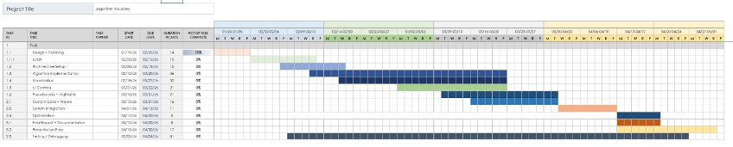

What is the plan for this next week?
Next week, our team plans to continue algorithm implementation.

Each member’s contribution
Jasper Martin - UI/UX development/menu refinement
Cara Antonucci - UI/UX development/documentation

