Weekly Report 7
What was accomplished this week?
We refined the pseudocode and added step by step highlighting while the algorithm is running so the user can see exactly what step of the pseudocode the algorithm is on as it processes. The linear search box was updated as well.

What problems were encountered?
One problem while adjusting the pseudocode was needing to refactor the linear search algorithm, the highlighting was overwriting itself because of how the animation was flowing so when it played it never showed the yellow color, it only showed orange and purple for completion. Another issue was the linear search box being present during the bubble sort when it should’ve only been there for the linear search.

If solved, what were their solutions?
The highlighting issue was resolved much like how a similar issue with the bubble sort was solved, by adding more separation between the linear search steps and the highlighting animation so when it flows through the animation doesn’t overwrite itself. The search box was resolved by tweaking the change listener so it can check what algorithm the user is on and display properly.

How does our team progress align with our project Gantt chart?
As seen in the Gantt Chart provided, this week is centered around our Algorithm Implementation phase. Our linear search and bubble sort are essentially down, as are our menu items going forward, we’re going to focus on the graphing algorithm which aligns exactly with what our Gantt Chart describes.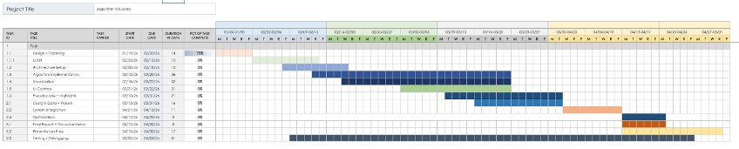

What is the plan for this next week?
Next week, our team plans to continue algorithm implementation and focus fully on completing the next algorithm we intend to implement, the graphing algorithm.

Each member’s contribution
Jasper Martin - UI/UX development/menu refinement
Cara Antonucci - UI/UX development/documentation

