Weekly Report 9
What was accomplished this week?
We added the Dijkstra’s algorithm visualization using a matrix as well as a graph panel, we also added edge customization so the user can alter the edges of the graph. The pseudocode highlighting issue has also been fixed so color doesn’t stick after the user hits the reset button or new data button.

What problems were encountered?
There was an issue with customizing the edges, initially it would allow you to click on the edges as if you were able to customize it but it wouldn’t actually allow any editing.

If solved, what were their solutions?
The customization issue was resolved by adding a hitbox and adjusting the click handler, after those tweaks we were able to customize the edges while the visualization was paused.

How does our team progress align with our project Gantt chart?
As seen in the Gantt Chart provided, our team is still on track. This was technically the last requirement as specified in our previous documents so on a technical level our project is considered “complete”. There are still adjustments we would like to make, including visual/logistical tweaks as needed, we would also like to add another search algorithm if time permits. At this point, we are on track and technically “done”.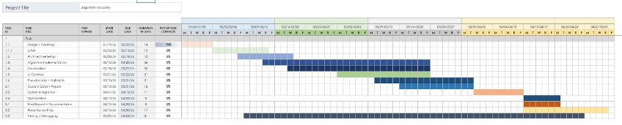

What is the plan for this next week?
Next week, our team plans to continue algorithm implementation and visual/logical refinement to further improve the project.

Each member’s contribution
Jasper Martin - UI/UX development/final algorithm development
Cara Antonucci - documentation/pseudocode debug

