**Business Requirement for Blur Corp System**

Contents

1. System Overview 2

2. Requirements Scope 2

2.1 In Scope 2

2.2 Out of Scope 2

3. Functional Requirements 3

3.1 UML Use Case Diagram 4

3.1 UML Use Case Specifications 5-15

4. Non-Functional Requirements 15

5. Data Model 5

6. UI Screen Mockups 6

**Table of Figures**

Figure 1 - UML Use Case Diagram 4

Figure 2 - Data Model Diagram 17

Figure 3 - View order 18

Figure 4 - View items 19

Figure 5 – View cart 20

Figure 6 – Make purchase 21

Figure 7 – Login/register 22

Figure 8 –Add/remove product 23

## System Overview

The system will be a website that allows customers to add and remove items from their shopping cart, then purchase them once they are satisfied with their selection. Customers will be required to register with an email address before they can use this service. System administrators will also be able to add and remove items that are for sale, while their stock amounts are automatically managed by a database.

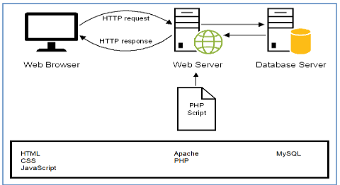

## Requirements Scope

### In Scope

- The client must be able to add products to the web site

- Must be able to display products by categories

- Customers must register to place orders

- Display the current items in the cart

- Add selected products to the cart

- Delete products (individually or all) from their cart

-Adjust the quantity of a selected product currently in the cart

-Preserve the contents of the cart if the user’s session is disconnected

-Have the cart accessible regardless from any machine the customer is logging in

-Provide a confirmation email sent to the client after they place their order

-Include a secure, online payment process

-Allow customers to view their order history

-Provide intuitive, consistent look and feel to the user interface

-Use free open source software

-Have the system fully tested and up and running in 8 weeks

### 2.2 Out of Scope

- Must provide a search facility

- Allow customers to change their order after they have created it

- Allow customers to search their order history

- Allow customers to view the status of their orders

- Allow customers to provide reviews for any of the products they have purchased

- Provide customers with appropriate product recommendations when they look at a particular product

- Provide customers with appropriate product recommendations when they log in

## Functional Requirements

R01 – The client must be able to add products to the web site

R02 – Must be able to display products by categories

R03 – Customers must register to place orders

R04 – Display the current items in the cart

R05 – Add selected products to the cart

R06 – delete products (individually or all) from their cart

R07 – adjust the quantity of a selected product currently in the cart

R08 – Preserve the contents of the cart if the user’s session is disconnected

R09 – Have the cart accessible regardless from any machine the customer is logging in

R10 – Provide a confirmation email sent to the client after they place their order

R11 – Include a secure, online payment process

R12 – Allow customers to view their order history

### 

### 3.1 UML Use Case Diagram

Figure 1 - UML Use Case Diagram

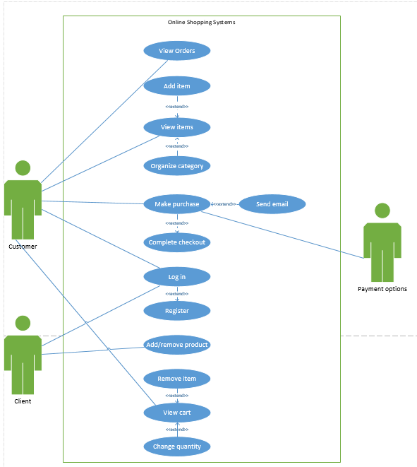

### 3.1 UML Use Case Specifications

*3.1.1 Customer views orders*

|  |  |  |  |
| --- | --- | --- | --- |
| **Use Case Name:** | Customer views orders | **Use Case ID:** | **UC01** |
| **Primary Actor:** | Customer | | |
| **Description:** | The customer views their previous orders. | | |
| **Triggering Event:** | The customer wishes to view their orders. | | |
| **Steps Performed (Main Path)** | | | |
| 1)Customer selects the ‘View Orders’ Button | | | |
| 2)All previous orders are displayed | | | |
| 3)The system allows the customer to return to the home page from the view orders page | | | |
|  | | | |
|  | | | |
| **Extensions or Alternate Scenarios** | | | |
| 2a) The customer has no previous orders. The system alerts the customer of this and prompts them to return to the previous page. | | | |
|  | | | |
|  | | | |
|  | | | |
| **Pre-Conditions:** | 1)The customer is registered and connected to the system | | |
| **Post-Conditions:** | 1)The customer has viewed their order history | | |
| **Assumptions:** | 1)The customer is a current user in good standing with the system. | | |
| **Success Guarantee:** | 1)The customer has viewed their previous orders. | | |
| **Outstanding Issues:** | 1)Does the system store previous orders indefinitely? | | |
| **Priority:** | High | | |

* + 1. *Add item*

|  |  |  |  |
| --- | --- | --- | --- |
| **Use Case Name:** | Customer adds an item to cart | **Use Case ID:** | **02** |
| **Primary Actor:** | Customer | | |
| **Description:** | A photo selection is added to the customers shopping cart. | | |
| **Triggering Event:** | Customer viewing photo adds it to shopping cart. | | |
| **Steps Performed (Main Path)** | | | |
| 1)The Customer selects a photo to add to the cart. | | | |
| 2)The Customer can select the quantity of the picture to add to the cart. | | | |
| 3)The system saves all items added to the cart. | | | |
|  | | | |
|  | | | |
| **Extensions or Alternate Scenarios** | | | |
| 2a) The Customer adds a selection of photos with duplicates already in the cart, the quantity is updated. | | | |
| 3a) If the item is not available, it cannot be added to the cart. | | | |
|  | | | |
|  | | | |
| **Pre-Conditions:** | 1)The Customer must be connected to the system.  2)The system contains catalogue of photos. | | |
| **Post-Conditions:** | 1)The Customers shopping cart is updated with the added photos. | | |
| **Assumptions:** | 1)The Customers account is in good standing with the website | | |
| **Success Guarantee:** | 1)The Customer shopping cart is updated with the added photos. | | |
| **Outstanding Issues:** | 1)Errors within the shopping cart selection, appropriate course of action? | | |
| **Priority:** | High. | | |

* + 1. *View items*

|  |  |  |  |
| --- | --- | --- | --- |
| **Use Case Name:** | Customer views items | **Use Case ID:** | **UC03** |
| **Primary Actor:** | Customer. | | |
| **Description:** | The customer views items available for purchase within the system. | | |
| **Triggering Event:** | The customer wishes to view items on the system. | | |
| **Steps Performed (Main Path)** | | | |
| 1)The customer views items available for purchase. | | | |
| 2)The customer can selected different categories. | | | |
| 3)The customer may add items to their cart. | | | |
|  | | | |
|  | | | |
| **Extensions or Alternate Scenarios** | | | |
| 2a) The selected category has no items available for purchase. The system prompts the customer to return to the home page. | | | |
| 3a) The item is out of stock. The system informs the customer the item is out of stock. | | | |
|  | | | |
|  | | | |
| **Pre-Conditions:** | 1)The customer must be connected to the system.  2)The system contains items that may be viewed. | | |
| **Post-Conditions:** | 1)The customer has viewed and optionally added items to their cart. | | |
| **Assumptions:** | 1)The customer is a current user in good standing with the system. | | |
| **Success Guarantee:** | 1)The customer has viewed and optionally added items to their cart. | | |
| **Outstanding Issues:** | 1)How does the system display items that are out of stock? | | |
| **Priority:** | High | | |

* + 1. *Remove item*

|  |  |  |  |
| --- | --- | --- | --- |
| **Use Case Name:** | Customer removes items from their cart. | **Use Case ID:** | **UC04** |
| **Primary Actor:** | Customer | | |
| **Description:** | The customer removes an item from their cart. | | |
| **Triggering Event:** | The customer wishes to remove an item from their cart. | | |
| **Steps Performed (Main Path)** | | | |
| 1)The customer views their cart and wishes to remove an item. | | | |
| 2)The customer selects the X icon next to an item and confirms the cancellation. | | | |
| 3)The item is removed from their cart. | | | |
|  | | | |
|  | | | |
| **Extensions or Alternate Scenarios** | | | |
| 2a) The system is unable to remove the item for some reason. A system error message is generated, displayed to the customer, and sent to the appropriate authority. | | | |
|  | | | |
|  | | | |
|  | | | |
| **Pre-Conditions:** | 1)The customer must be connected to the system.  2)The customer’s cart contains at least 1 item. | | |
| **Post-Conditions:** | 1)The item was successfully removed from the cart. | | |
| **Assumptions:** | 1)The customer is a current user in good standing with the system. | | |
| **Success Guarantee:** | 1)The item was successfully removed from the cart. | | |
| **Outstanding Issues:** | 1)Does the system allow customers to undo the removal? | | |
| **Priority:** | High | | |

* + 1. *Complete checkout*

|  |  |  |  |
| --- | --- | --- | --- |
| **Use Case Name:** | Complete Checkout | **Use Case ID:** | UC05 |
| **Primary Actor:** | Customer | | |
| **Description:** | The customer moves to checkout and reviews the product(s) in the cart. | | |
| **Triggering Event:** | When the customer clicks the checkout button. | | |
| **Steps Performed (Main Path)** | | | |
| **1)**The customer clicks the checkout button and moves to the complete checkout. | | | |
| **2)**The customer reviews the product(s) in the cart. | | | |
| **3)**The customer reviews shipping/billing information and can make any appropriate changes. | | | |
| **4)**The customer clicks the purchase button to purchase the products. | | | |
|  | | | |
| **Extensions or Alternate Scenarios** | | | |
| **2a)**The customer may change the quantity within the complete checkout use case. | | | |
| **3a)**The customer may choose to purchase it as a gift. | | | |
| **4a)**One or more of the products can’t be purchased. Customer returns to step 2. | | | |
|  | | | |
| **Pre-Conditions:** | 1)The customer is in the checkout page. | | |
| **Post-Conditions:** | 1)The customer is ready to purchase the products. | | |
| **Assumptions:** | 1)The customer is viewing the cart and is ready to complete the checkout. | | |
| **Success Guarantee:** | 1)The checkout process is completed. | | |
| **Outstanding Issues:** | 1)Are one or more of the products unable to be purchased?  2)Does the cart contain any products? | | |
| **Priority:** | High | | |

* + 1. *Purchase product*

|  |  |  |  |
| --- | --- | --- | --- |
| **Use Case Name:** | Purchase Product | **Use Case ID:** | UC06 |
| **Primary Actor:** | Customer | | |
| **Description:** | The customer decides to purchase the product(s) from the website. | | |
| **Triggering Event:** | Customer would like to purchase the product(s) that are currently in the cart after completing the checkout. | | |
| **Steps Performed (Main Path)** | | | |
| **1)**The customer completes the checkout. | | | |
| **2)**The customer is ready to purchase the product(s) currently in the cart. | | | |
| **3)**The customer decides which payment method they will use. | | | |
| **4)**The system accepts the payment. | | | |
| **5)**Customer receives a receipt of their purchase. | | | |
| **Extensions or Alternate Scenarios** | | | |
| **2a)** The customer moves to the complete checkout use case. | | | |
| **4a)** The system is unable to complete the purchase.  The customer returns to step 2 if there was an error within the system or returns to step 4 if the payment method was invalid. | | | |
|  | | | |
|  | | | |
| **Pre-Conditions:** | 1. The customer already has products within the cart. | | |
| **Post-Conditions:** | 1. The customer has purchased the product(s). | | |
| **Assumptions:** | 1. The customer already has an account. | | |
| **Success Guarantee:** | 1. The customer has purchased one or more products. 2. The customer has received a receipt showing what they have purchased. | | |
| **Outstanding Issues:** | 1. If there is an error purchasing a product, how will this issue be handled? Any risks when the customer attempts to purchase an item? | | |
| **Priority:** | High | | |

* + 1. *Login*

|  |  |  |  |
| --- | --- | --- | --- |
| **Use Case Name:** | Login | **Use Case ID:** | **UC07** |
| **Primary Actor:** | Customer or Admin | | |
| **Description:** | Customer is required to login in order purchase items in the cart. Admin can login to Add/remove products from storefront. | | |
| **Triggering Event:** | Customer wishes to login into account to perform cart and order interaction. | | |
| **Steps Performed (Main Path)** | | | |
| 1) The Customer/Admin is presented with a Login Screen. | | | |
| 2) The Customer/Admin enters their email or username, with their password. | | | |
| 3) The Customer/Admin submits and is now logged into the site. | | | |
| 4) The system now lets the Customer add items to the cart, see their previous orders and order status, and make purchases. | | | |
| 4b)The system now lets the Admin add or remove items from the storefront. | | | |
| **Extensions or Alternate Scenarios** | | | |
| 2a)If Customer does not have an Account, they will be prompted to go to the Registration Screen | | | |
| 3a)If email/username + password combo does not match, present error (“Wrong username or password”) and return to step 2. | | | |
|  | | | |
|  | | | |
| **Pre-Conditions:** | 1)The Customer/Admin must be connected to the system.  2)The system contains saved username + password combinations . | | |
| **Post-Conditions:** | 1)Customer/Admin has logged into the system. | | |
| **Assumptions:** | 1)Customer is in good standing within the system.  2)Customer is registered with the system. | | |
| **Success Guarantee:** | 1)Customer/Admin has logged into the system. | | |
| **Outstanding Issues:** | 1)Does the system have access to the registered accounts? | | |
| **Priority:** | High | | |

* + 1. *Register*

|  |  |  |  |
| --- | --- | --- | --- |
| **Use Case Name:** | Register | **Use Case ID:** | **UC08** |
| **Primary Actor:** | Customer | | |
| **Description:** | Customer is registering in the system so they can make a purchase and keep an order history they can look up. | | |
| **Triggering Event:** | Customer wishes to make an account on the system. | | |
| **Steps Performed (Main Path)** | | | |
| 1)The Customer is presented with a list of information to fill in. Required: Full Name, E-mail, Mailing Address, Billing Address, Password. | | | |
| 2)The Customer submits this information to the system, and the system checks that all required boxes are filled in. | | | |
| 3)The system checks that the Customer password is secure enough for the site. | | | |
|  | | | |
|  | | | |
| **Extensions or Alternate Scenarios** | | | |
| 2a)If any required information is missing or invalid, return to step 1 with error(“All * fields required). | | | |
| 3a)If password does not meet site security requirements, return to step 1 with all other info saved in proper text field. | | | |
|  | | | |
| **Pre-Conditions:** | 1)The Customer must be connected to the system.  2)The system can save username/email + password combinations . | | |
| **Post-Conditions:** | 1)The Customer has been added to the system as a registered Customer. | | |
| **Assumptions:** | 1)Customer is in good standing within the system. | | |
| **Success Guarantee:** | 1)The Customer has been added to the system as a registered Customer. | | |
| **Outstanding Issues:** | 1)Does the system store registered account information?  2)Does the system check for duplicate accounts? | | |
| **Priority:** | High | | |

* + 1. *Client add product*

|  |  |  |  |
| --- | --- | --- | --- |
| **Use Case Name:** | The client adds or removes a product. | **Use Case ID:** | **UC09** |
| **Primary Actor:** | Client. | | |
| **Description:** | A product is added or removed to the website through an administrator account. | | |
| **Triggering Event:** | The client wishes to add or remove a product from the system. | | |
| **Steps Performed (Main Path)** | | | |
| 1)The client selects the “add/remove product” button from the administrator account. | | | |
| 2)If adding an item, the client adds a name, price, and optional image for the item they are adding. If removing an item, the client selects the delete option next to an existing item. | | | |
| 3)The client can now view the added/removed products. | | | |
|  | | | |
|  | | | |
| **Extensions or Alternate Scenarios** | | | |
| 1a)The client wants to cancel the addition of an item. The system prompts the client to confirm the cancellation. | | | |
| 1b)The client wants to cancel the removal of an item. The system prompts the client to confirm the cancellation. | | | |
| 2a)No name or price is added with the item. The system gives an error message and prompts the client to add a name or price. | | | |
|  | | | |
| **Pre-Conditions:** | 1)The client is connect to the system with an administrator account. | | |
| **Post-Conditions:** | 1)The client has added or removed items from the system. | | |
| **Assumptions:** | 1)The client has a name, price, and optionally an image for the item they wish to add. | | |
| **Success Guarantee:** | 1)The client has added or removed one or more items from the system. | | |
| **Outstanding Issues:** | 1)Does the system save removed items so they can be re-added later? | | |
| **Priority:** | High | | |

* + 1. *View cart*

|  |  |  |  |
| --- | --- | --- | --- |
| 1. **Use Case Name:** | View Cart | **Use Case ID:** | UC10 |
| **Primary Actor:** | Customer | | |
| **Description:** | Customer is wanting to view their cart in order to review what items and quantity of items in it before purchase | | |
| **Triggering Event:** | Customer clicks on cart and wishes to review that sessions additions. | | |
| **Steps Performed (Main Path)** | | | |
| 1) The Customer is presented with a list of their select item(s) and the quantity of each item, as well as a purchase button.. | | | |
|  | | | |
|  | | | |
|  | | | |
|  | | | |
| **Extensions or Alternate Scenarios** | | | |
| 1a) Cart is empty, Customer is presented with text (“Cart is empty”) | | | |
| 1b) Cart contains items now out of stock. The system produces an error under the item that the item is out of stock. | | | |
|  | | | |
|  | | | |
| **Pre-Conditions:** | 1) The Customer must be connected to the system.  2) The system must present the contents of the Customers session of added items | | |
| **Post-Conditions:** | 1) The Customer can see and edit their cart. | | |
| **Assumptions:** | 1) Customer is in good standing within the system. | | |
| **Success Guarantee:** | 1) The Customer can see and edit their cart. | | |
| **Outstanding Issues:** | 1) Does the system track items and quantity of items in cart?  2) Does the system allow the Customer to remove items? | | |
| **Priority:** | High | | |

* + 1. *Change item quantity in cart*

|  |  |  |  |
| --- | --- | --- | --- |
| **Use Case Name:** | The customer changes item quantity from the cart. | **Use Case ID:** | **UC11** |
| **Primary Actor:** | Customer | | |
| **Description:** | The customer can change the quantity of a selected item within their cart. | | |
| **Triggering Event:** | The customer wishes to change the quantity of an item within their cart. | | |
| **Steps Performed (Main Path)** | | | |
| 1)The customer views their cart and wishes to change the quantity of an item. | | | |
| 2)The customer selects a new quantity for the item. | | | |
| 3)The cart is updated with the new quantity of the item. | | | |
|  | | | |
|  | | | |
| **Extensions or Alternate Scenarios** | | | |
| 2a) If the customer selects 0, the item is removed from the cart. | | | |
|  | | | |
|  | | | |
|  | | | |
| **Pre-Conditions:** | 1)The customer must be connected to the system.  2)The customer’s cart contains at least 1 item. | | |
| **Post-Conditions:** | 1)The customer has changed the quantity of the item within their cart. | | |
| **Assumptions:** | 1)The customer is a current user in good standing with the system. | | |
| **Success Guarantee:** | 1)The customer has changed the quantity of the item within their cart. | | |
| **Outstanding Issues:** | 1)How does the system handle the stock amount of an item when the quantity is changed? | | |
| **Priority:** | High | | |

## 

## Non-Functional Requirements

R13 – Provide intuitive, consistent look and feel to the user interface

R14 – Use free open source software

R15 – Have the system fully tested and up and running in 8 week

## Data Model

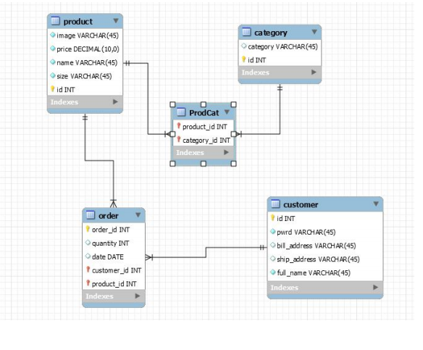

## UI Screen Mockups

View orders

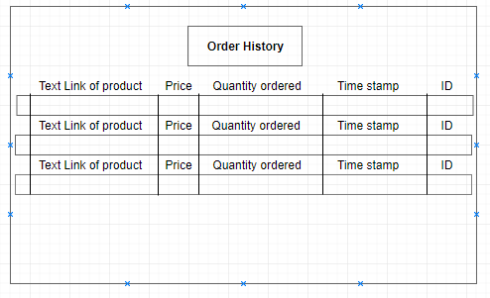

View items – add items - organize category

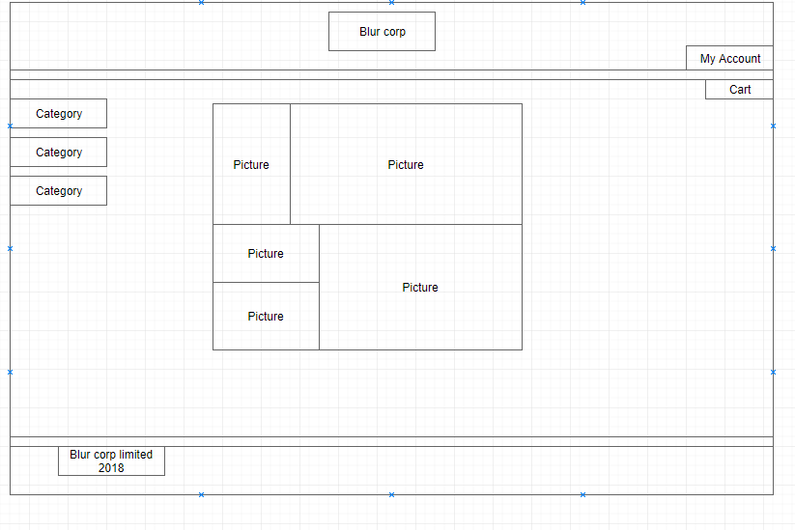

View Cart– remove items-change quantity

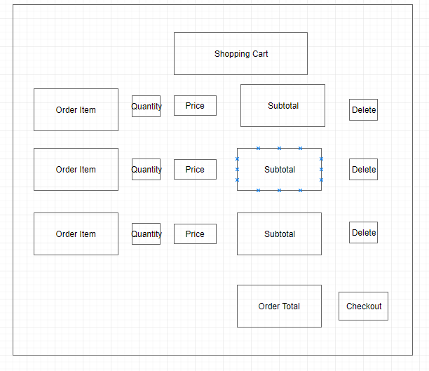

Make purchase – complete checkout

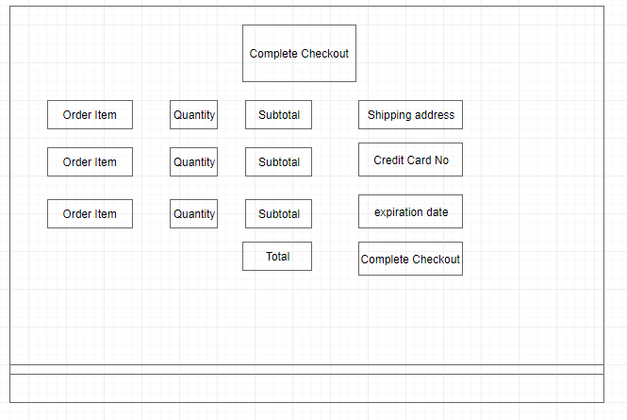

Login/register

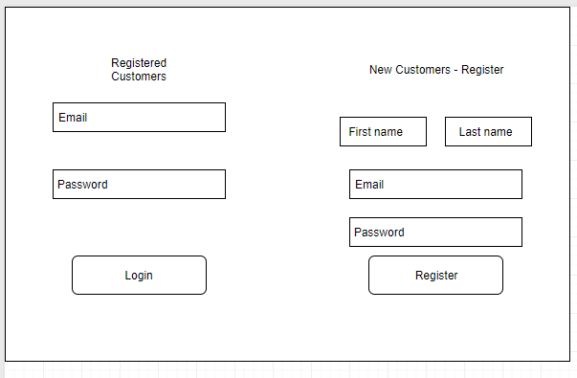

Add/remove product

