## Major non-functional defect in the program

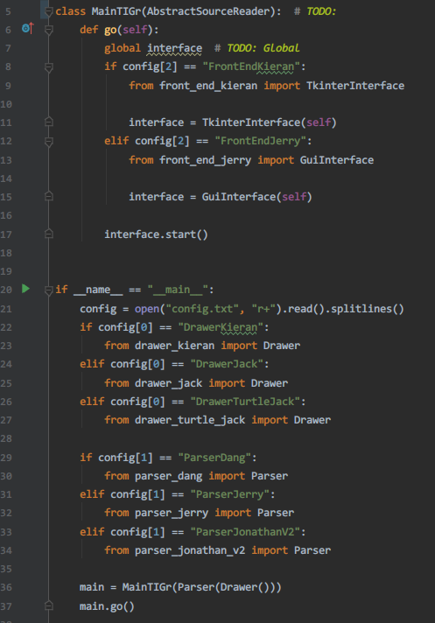

The MainTIGr inherits inappropriate parent class and twist the responsibility of the function in the class. As shown in the screenshot, the MainTIGr inherits the AbstractSourceReader. In assignment 1, the responsibiliteis of provided abstract class AbstractSourceReader are reading source and handing over the result to its parser for further process. However, MainTIGr is used as the entry point of the system. The inheritance is misused in this case.

## Worst bad smells before refactoring

* Inappropriate Intimacy in frontend, parser, drawer
* Alternative Classes with Different Interfaces in two Frontend
* Shotgun Surgery in the drawers
* Switch statement in the drawers and the parsers
* Refused-bequest in MainTIGr
* Temporary Field: drawer_jack -> self.des_x

## Refactoring 1

### Name

Inappropriate Intimacy in frontend, parser, drawer

### Location

* refactored_code
  + front_end_jerry.py
    - GuiInterface draw() line 81~83
  + front_end_kieran.py
    - TkinterInterface draw() line 90~92

### Reasons

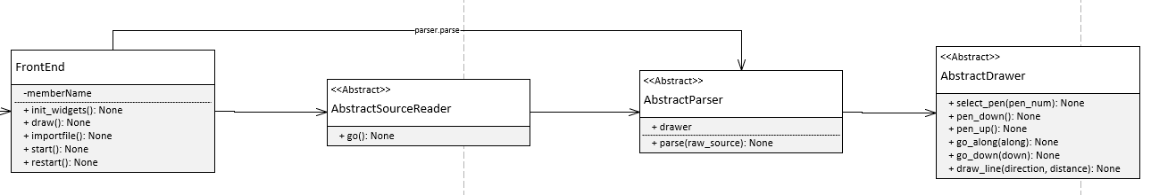





The draw() function in both TkinterInterface and TkinterInterface uses the parse() function in the AbstractParser directly and skips the AbstractSourceReader completely. The tangled relationship creates **high coupling** between these three classes, makes the program hard to maintain and creates confusion for other developer.

### Strategies/ approaches

1. Extract Superclass: Create an AbstractFrontEnd super class inherited by two front end classes to ensure that they have the same properties and functions.
2. Hide delegate: To remove the relationship between FrontEnd

### Result Evaluation

#### Has the bad smell been removed?

#### Did you bring new bad smells into the program?

#### How well is your program now in terms of software quality?

## Refactoring

### Name

Duplicate code

### Location

### Reasons

placeholder

placeholder

### Strategies/ approaches

## Refactoring

### Name

Inappropriate Intimacy

### Location

### Reasons

placeholder

placeholder

### Strategies/ approaches