

As part of the recycling process MobileMuster breaks down mobile phones into components for recycling. This highly efficient process means that over 96% of the materials used in mobile phones and accessories can be recovered and used to make new products.



**Microphones & Speakers** Lead, iron copper, samarium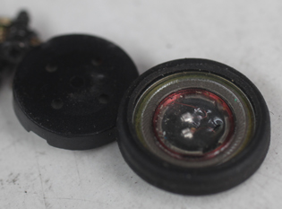

**Capacitors** Nickel, Tantalum, Palladium

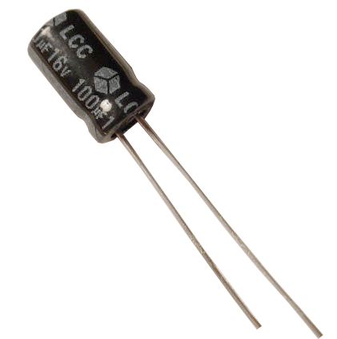

**Battery**

Lithium oxide, Nickel cadmium or Nickel metal hydride.

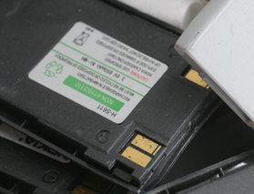

**Wires** plastic, copper



**Antennae & transmitter**

Lead, plastic, copper, nickel, iron

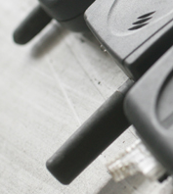

**SIM card**

plastic, copper iron, tin, nickel

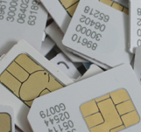

**Mobile phone accessories**

plastic, aluminium, copper

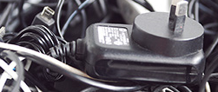

**Display Screen**

silicon dioxide, aluminium silicate, potassium, europium, sodium, yttrium, phosphorous, neodymium, zinc 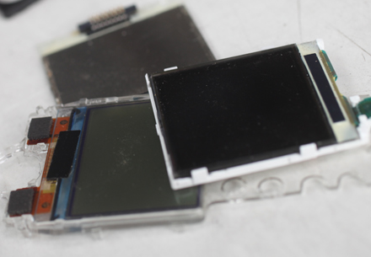

**Keypad** plastic

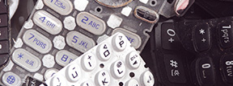

**Casing & Frames**

plastic, aluminium, scandium

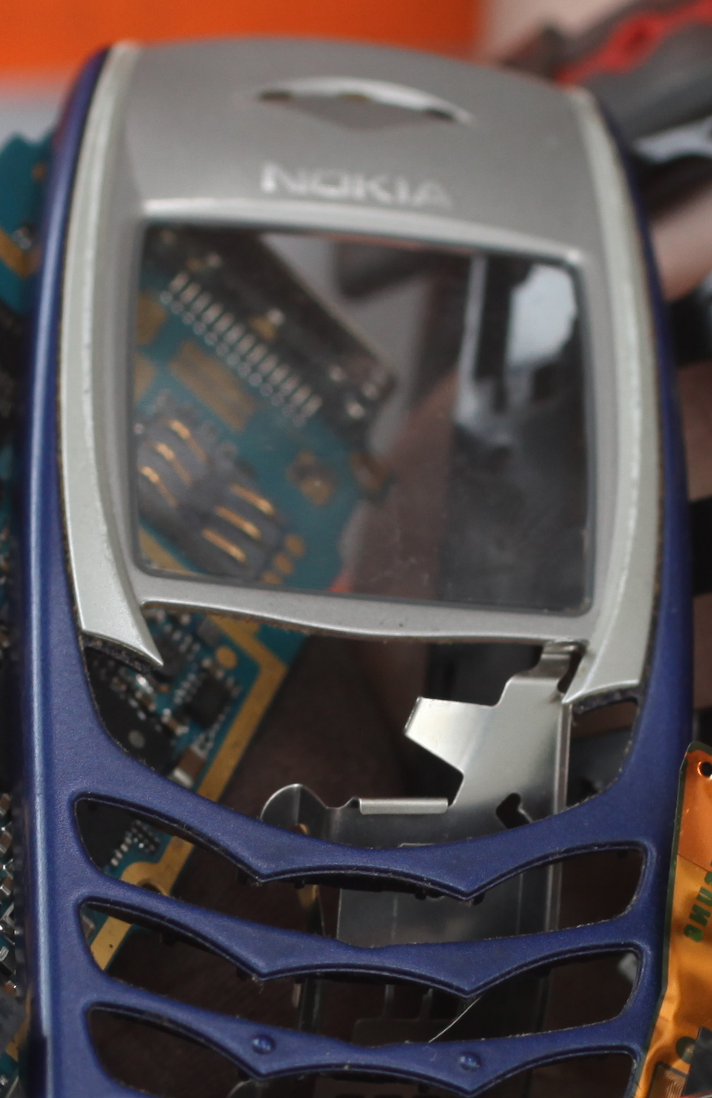

**Circuit Board**

plastic, copper, zinc, gold, tin, iron, platinum, cobalt manganese, silver, nickel, epoxy resin

