

## FACULTY OF COMPUTING AND INFORMATICS

**TGD2251 Game Physics**

**TRIMESTER 2 2019/2020**

**PROJECT #1**

**Report**

**Lecture Section : 01**

**Tutorial Section : 01**

**for:**

**Dr. Wong Ya Ping**

**from:**

|  |  |  |  |
| --- | --- | --- | --- |
| **Student ID** | **Name** | **Email Address** | **Phone No.** |
| 1151104798 | Ch’ng Hao Yuan | Haoyuan2801@gmail.com | 0164966076 |

**Introduction**

This game is a 10 seconds escape game. Player need to escape to the exit by jumping on the shape created and try to reach the goal before the water flows up.

**User Manual**

1. Open Command Prompt, and type this “g++ --version” to check that whether MinGW is settled up.
2. Type “cd “ plus the location you extract the files
3. Type “compile”
4. Type “setenv”
5. Run the program
6. To play the game, Left Arrow to move left, Right arrow to move to the right, press Spacebar to jump

**Screen shots**

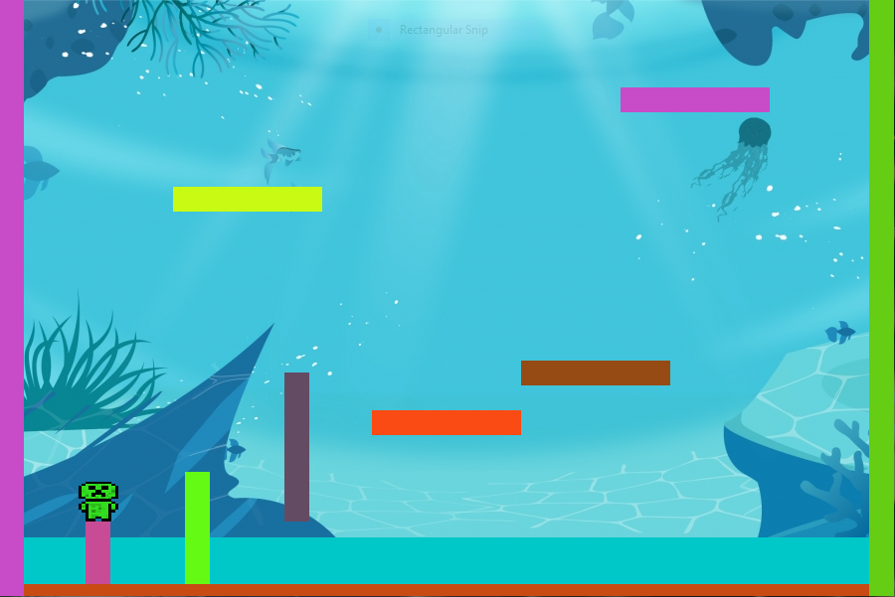

Player at the start of the game

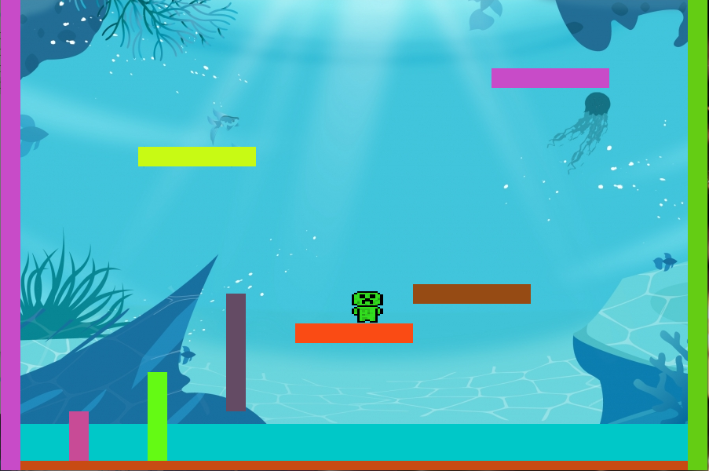

Player need to jump up to reach the goal

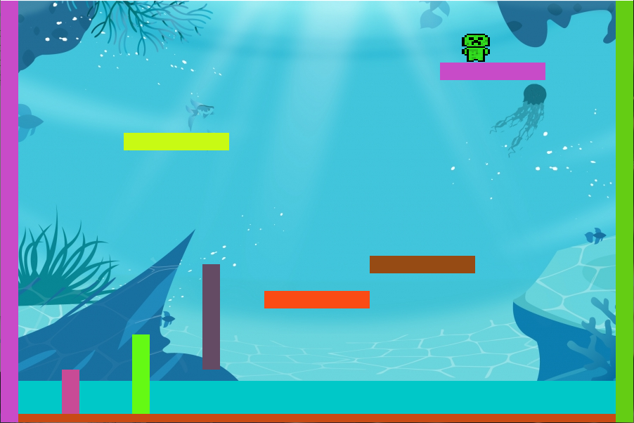

Player reached the goal

**Acknowledgment and References**

I would like to thank my friend Marcus Loo who helped in this assignment.