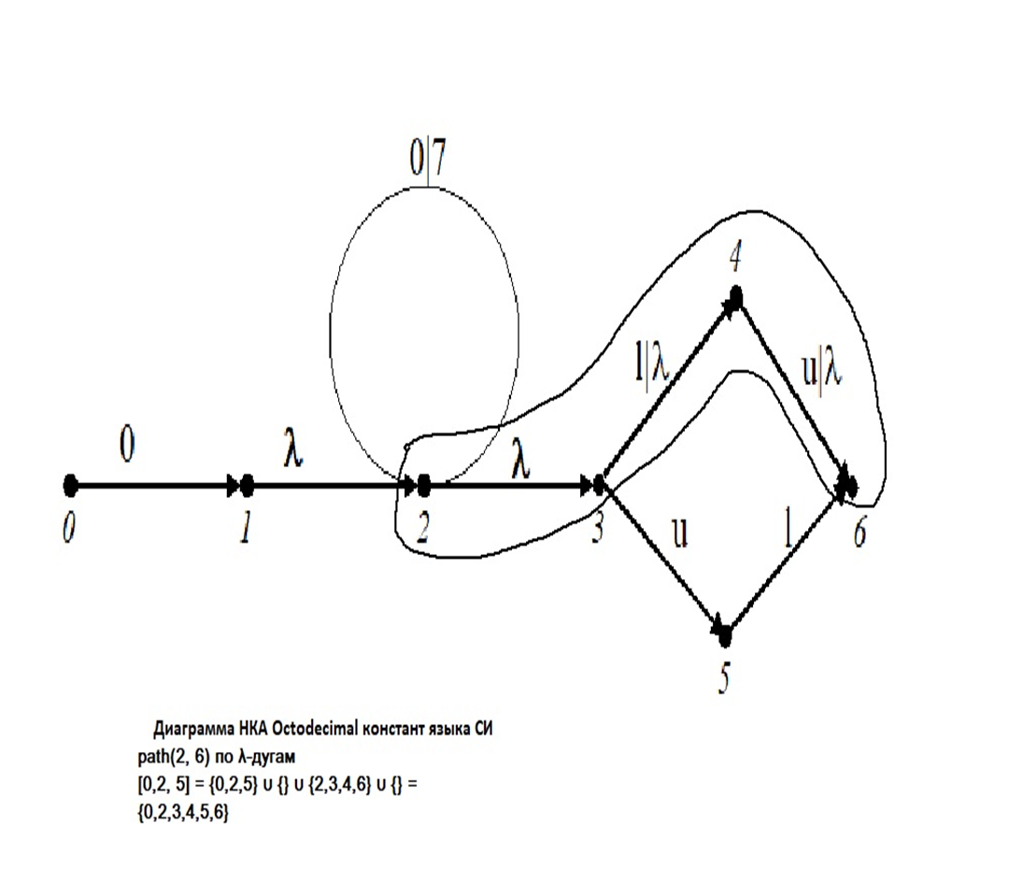

Замыкание: [{0,2,5}] = [0,2,5] = [**0**]⋃[**2**]⋃[**5**] = {**0**} ⋃ {**2**, 3, 4, 6} ⋃ {**5**} = {**0**, **2**, 3, 4, 6, **5**}

[[{0,2,5}]] = [{0,2,5}] = [{**0**, **2**, 3, 4, 6, **5**}] = {**0**, **2**, 3, 4, 6, **5**} – замкнутое множество.

μ({**0**, **2**, 3, 4, 6, **5**}, 0) = {1,2}

μ({**0**, **2**, 3, 4, 6, **5**}, u) = {5, 6}

[1, 2] = {1,2, 3, 4, 6}

[5, 6] = {5, 6}

g({1,2, 3, 4, 6}, 7) = [μ({**1**, **2**, 3, 4, 6}, 7)] = [{2}] = [2] = {2, 3, 4, 6}

g({1,2, 3, 4, 6}, u) = [μ({**1**, **2**, 3, 4, 6}, u)] = [{5, 6}] = {5, 6}