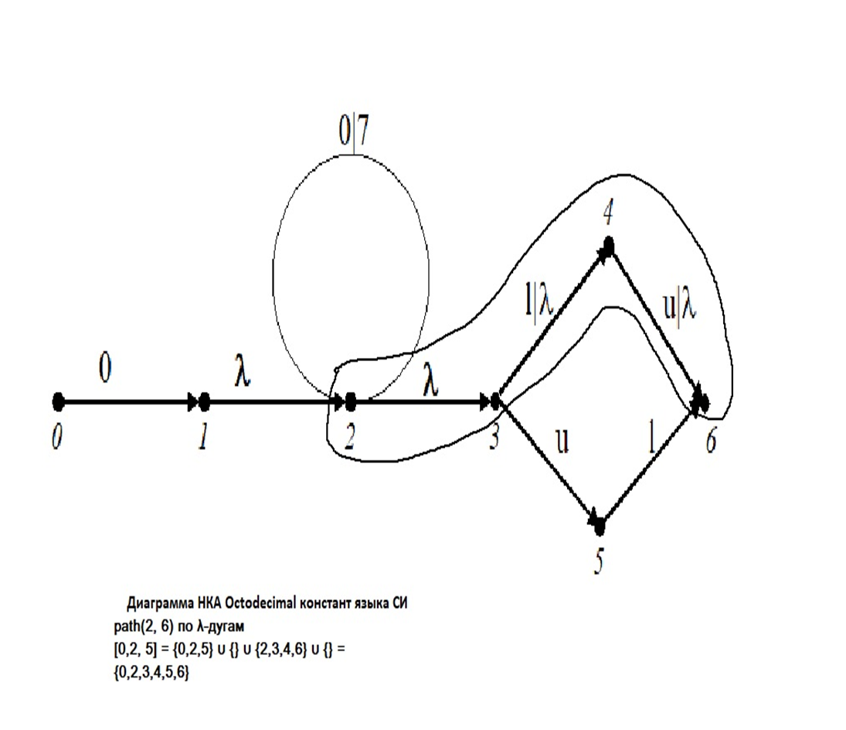

Замыкание: [{0,2,5}] = [0,2,5] = [0]⋃[2]⋃[5] = {0} ⋃ {2, 3, 4, 6} ⋃ {5} = {0, 2, 3, 4, 6, 5}
[[{0,2,5}]] = [{0,2,5}] = [{0, 2, 3, 4, 6, 5}] = {0, 2, 3, 4, 6, 5} – замкнутое множество.

μ({0, 2, 3, 4, 6, 5}, 0) = {1,2}
μ({0, 2, 3, 4, 6, 5}, u) = {5, 6}

[1, 2] = {1,2, 3, 4, 6}
[5, 6] = {5, 6}

g({1,2, 3, 4, 6}, 7) = [μ({1, 2, 3, 4, 6}, 7)] = [{2}] = [2] = {2, 3, 4, 6}
g({1,2, 3, 4, 6}, u) = [μ({1, 2, 3, 4, 6}, u)] = [{5, 6}] = {5, 6}

