C++ fundamentals and Type conversion
Student ID 2017141463415
Student Name 龙行超
Start Time 2019.09.03
Finish Time 2019.09.08

1. Objectives:
To write simple C++ programs covering:
- Understand how a character is stored in memory;
- Understand how an integer is stored in memory;
- Understand array and pointer; and
- Perform conversion from eight bits (character) to eight bytes to be displayed on screen.

2. Type and Format in memory – character, integer, short and float

2.1
This exercise is to determine the memory size of different type.

lab1_1.cpp
//Determine the memory size of declaration and variable type
#include <iostream.h>
#include <stdio.h>
#include <ctype.h>
#include <conio.h>
#include <string.h>
#include <stdlib.h>

void main()
{
char c;
char s[128];
short i;
short n[64];
printf("%3d %3d\n", sizeof(c), sizeof(char));
printf("%3d %3d\n", sizeof(s), sizeof(char[128]));
printf("%3d %3d\n", sizeof(i), sizeof(short));
printf("%3d %3d\n", sizeof(n), sizeof(short[64]));
}

The display is:

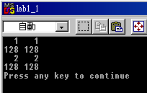

Now execute the above program and fill in the following:

Type | Size in byte | Size in bit
Short | 2 | 16
Char | 1 | 8
Short[32] | 64 | 512
Char[64] | 64 | 512

2.2
Use the approach of the above, determine the memory size of integer, float, integer[128], float[16] (lab1_2.cpp)

Write a program to verify your answer and fill in the following: [hint, use sizeof(…) ]
Type | Size in byte | Size in bit
Int | 4 | 32
Float | 4 | 32
Int[128] | 512 | 4096
Float[16] | 64 | 512

Write down your codes below:
void week01::lab1_2()
{
printf_s("%3d\n", sizeof(int));
printf_s("%3d\n", sizeof(float));
printf_s("%3d\n", sizeof(int[128]));
printf_s("%3d\n", sizeof(float[16]));
}

2.3
This exercise is to display the decimal and octal values so that you know how it is stored in memory.

lab1_3.cpp
//Determine the memory size of declaration and variable type
#include <iostream.h>
#include <stdio.h>
#include <ctype.h>
#include <conio.h>
#include <string.h>
#include <stdlib.h>

void main()
{
for (char i = 30; i <41; ++i)
printf("i: dec=%d oct=%o \n", i, i);
}

the output is:
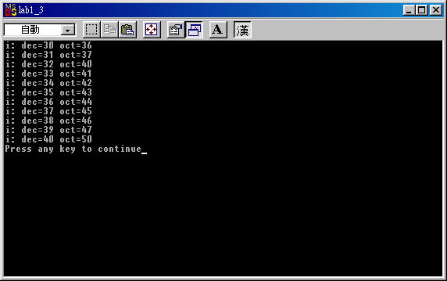

Now modify the above programme to display decimal, octal, hex and unsigned as well. (Hints: hex, %x, unsigned %u)

Write down your codes below:
void week01::lab1_3()
{
for (char i = 30; i < 41; ++i)
printf("i: dec=%d hex=%x unsigned=%u \n", i, i, i);
}
Write down the output of the first 4 lines so that you understand the difference among them.
i: dec=30 hex=1e unsigned=30
i: dec=31 hex=1f unsigned=31
i: dec=32 hex=20 unsigned=32
i: dec=33 hex=21 unsigned=33

2.4
This exercise is to dump the content of memory of different type so that you know how it is stored in memory.
lab1_4.cpp
//Determine the memory size of declaration and variable type
#include <iostream.h>
#include <stdio.h>
#include <ctype.h>
#include <conio.h>
#include <string.h>
#include <stdlib.h>

void main()
{
char a = '0'; // in hex 0x30, not 0
int i = 0x00000013; //in decimal is (1 x 16 + 3) = 19
short j = 18; //occupies two bytes,
float f = 1.25; //occupies 4 bytes
}

In order to display, you have to set a break point by pressing “F9” beside the line, the program will display a red circle as follows:
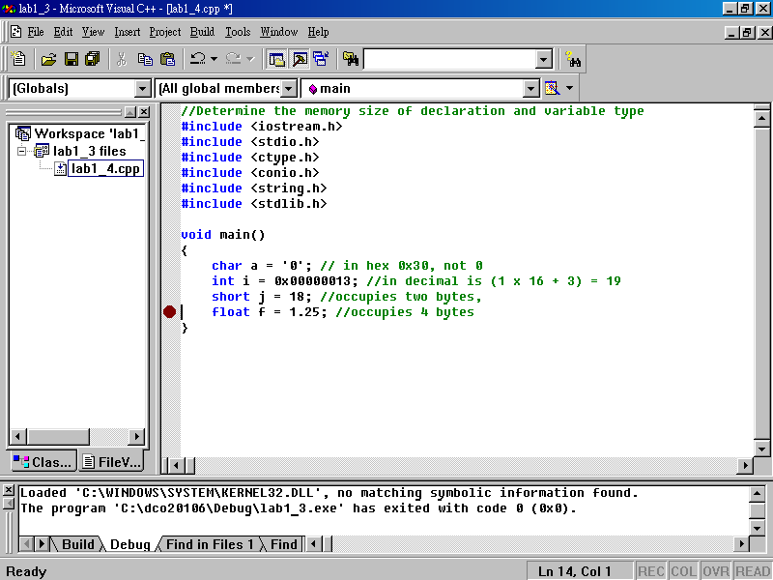

Now, type the address of each variable as shown in the left-bottom frame to locate whether they are. Here, we dump the address of variable ‘a’. Since, visual C++ reserves 4 bytes but char c uses one byte, you can see that the rest three bytes are set to CC CC CC (means 10101010 10101010 10101010 in binary, the default setting).
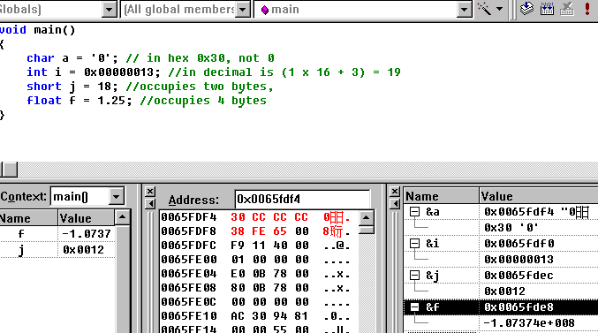

  - memory location of a is 0x0065fdf4, you have to type &a
  - then in the Address, key in 0x0065fdf4,
  - it displays 30 CC CC CC

0x0065FDF4, the hexadecimal is 0x30 (ASCII)

Now, type and execute the above program and fill in the following, note that your addresses might be different from what I have below.

Variable | Memory address | Hexadecimal value
a | 0x006FF647 | 0x30
i | 0x006FF638 | 0x00000013
j | 0x006FF62C | 0x0012
f | 0x006FF620 | 1.25000000

3. Array and Pointer

3.1

The following is a very simple array definition. It defines an array called char a[4] which occupies 4 bytes, the value is 0x30 0x31 0x32 0x00. Note that 0x30 (ASCII) is 0 in decimal. The last character must be terminated by 0x00 or is called null. (ref. lab1_5.cpp)

lab1_5.cpp
#include <conio.h>
#include <string.h>
#include <stdlib.h>

void main()
{
char a[4] = "012";
}

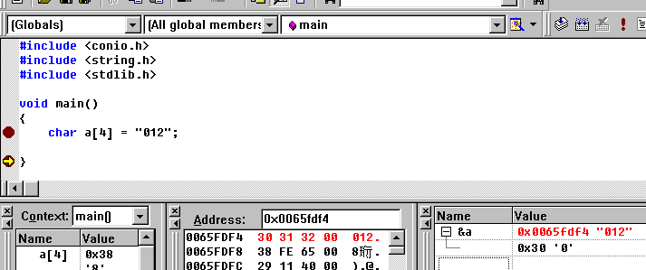
0x30 or 0
Null, 0x00

Based on the above, note that the address of array a is 0x0065fdf4. Now fill in the following:

Address | Type | Value
0x00DFFB1C | a[0] | 0x30
0x00DFFB1D | a[1] | 0x31
0x00DFFB1E | a[2] | 0x32
0x00DFFB1F | a[3] | 0x00

3.2
The following program will display the content of an array a[11].

#include <ctype.h>
#include <conio.h>
#include <string.h>
#include <stdlib.h>

void main()
{
char a[11] = "0123456789";
for (int i = 0; i <10; ++i)
printf("The value of %d is %c in hex %x \n", i, a[i], a[i]);

}
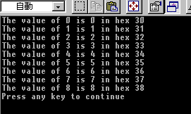

Now modify the above program to display the address of each location in hexadecimal and the value a[12], a[13], explain why you can display a[12] and [13] as you only defined them up to a[10] as follows. (Hint: The address of a[0] is &a[0])

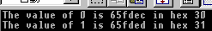 (note that your value might be different.)
Write down the program
void week01::lab1_6()
{
char a[11] = "0123456789";
for (int i = 0; i < 10; ++i) {
printf_s("The position of %d is %x \n", i, &a[i]);
}
printf_s("%d\n", a[12]);
printf_s("%d\n", a[13]);
}
Write down your explanation (hint: dump the memory location and look at the location of a[11], a[12] and a[13] etc. you then realise why?)
栈在内存中是倒置放置，从高位到低位，最先进入栈中的元素在高位，数组是顺序存储，由高位到低位存储，也就是a[10]的地址比a[0]要大，而编译器本身是不做数组越界的判断，那么访问下标比定义更长的数组变量，不会报错，实际上就是顺着栈的方向往上找值，返回的是一个不需要的值。此例中，a[9]的地址为0x0057F851，那么访问a[11]、a[12]、a[13]等等，实际上取的是内存地址为0x0057F853、0x0057F854、0x0057F854单元的值。

3.3
#include <iostream.h>
#include <stdio.h>
#include <ctype.h>
#include <conio.h>
#include <string.h>
#include <stdlib.h>

void main()
{
char a[11] = "0123456789";
char *ptr;
ptr = &a[0]; // it can be &a with same effect
for (int i = 0; i <11; ++i, ++ptr)
printf("The value of %d is %x in hex %x \n", i, ptr, *ptr);
}
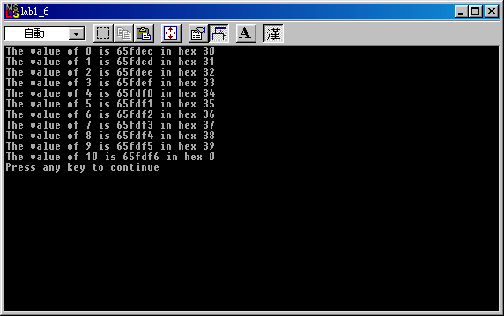
Now explain the meaning of the following of the above program.
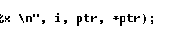
ptr是指针变量，是一个地址，%x是以十六进制的方式打印出该指针所指向的地址信息；*ptr指引用指针所指单元的内容，%x就是以十六进制方式打出ptr所指单元格的内容的信息。

3.4

The following is about the integer array.

#include <iostream.h>
#include <stdio.h>
#include <ctype.h>
#include <conio.h>
#include <string.h>
#include <stdlib.h>

void main()
{
int a[7] = {12, 21, 31, 41, 51, 61};
for (int i = 0; i <6; ++i)
printf("The value of %d is %x in hex %d \n", i, &a[i], a[i]);
}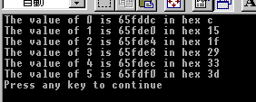
Now explain increment of address is 4 instead of 1.
int占四个字节，需要四个存储单元来存，所以整型数组的每个元素之间的地址差4.

3.5

Modify the above program with the same output with pointer instead of array a[].

Write down the program
void week01::lab1_9()
{
int a[7] = { 12, 21, 31, 41, 51, 61 };
int* p = a;
for (int i = 0; i < 6; ++i, p++)
printf_s("The value of %d is %x in hex %d \n", i, p, *p);
}

Further discussion

You don’t need answer the following question, just think about it.
void main()
{
char a[4];
char b[3];
char c;

}
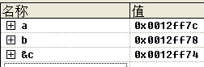

why increment of address is 4 for array b and character c.

