作业提交：仅提交本文件中蓝色标识部分，其余部分请删除。

Laboratory Two – Decoding Lab (Part 1)

- In the address screen: Enter the value of the address of data: 0x63636363. You can see the value of on the right hand side.

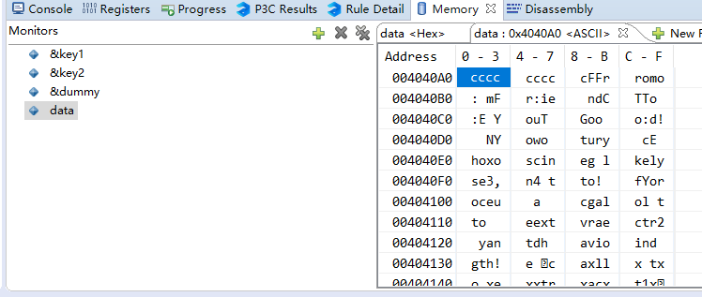

Write down the first 40 characters.
<cccc> <cccc> <cFFr> <romo>
<: mF> <r:ie> < ndC> <TTo >
<:E Y> <ouT >

Start value: in decimal in order to produce the above message is 9

- Write down the address of dummy 0x61FF0C, you have to set a break point beside key1, F9 and Execute debug so that the program goes through the first few lines.

It is an integer: It consists of 4 bytes.

Write down the value of key1：1
Key2 : 0 x start + 0 x stride： 777

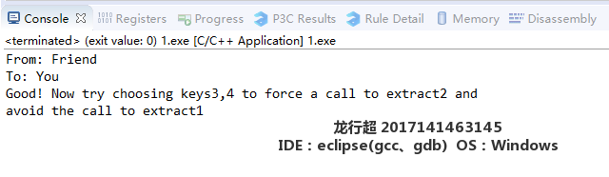

此处提交屏幕截图，截图含学号姓名，IDE平台信息 （比如开启一个写字板，截图时将运行界面和写字板共同截下）

