Laboratory – Decoding Lab (Part 2)

In this laboratory, you have to continue the previous exercise to break the last two secret keys, key3 and key4 together with understanding bit operation. I will guide you to solve the problem. This exercise is extracted from the CTE, SSD6 – Exercise one.

Clues : the realize of pass by pointer will affect the solution of find return address.

Activity 1

Load the secret.cpp from CTE again or load the program from Laboratory 2.

Modify the program and type after msg1 = extract_message1(start, stride);

*msg1 = ‘\0’;
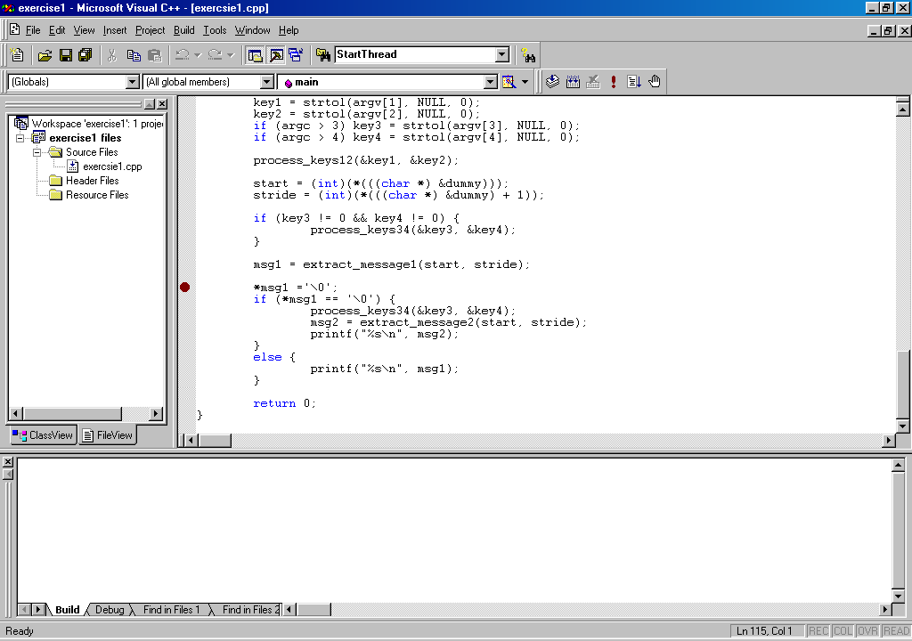

In the project setting, enter the values of key1, key2, key3 and key4, You should choose the appropriate values of key1, key2, but not key3 and key4.

Set a break point beside printf(“%s\n”, msg2);

Start the debug mode (under build, start debug), you will see the following output

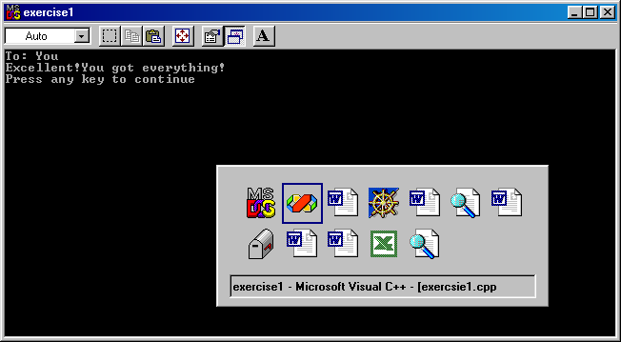

Now you know the message if you choose the appropriate values of key3 and key4.

Now remove the message *msg = ‘\0’; and look at the code.
*key4, integer pointed by key4
void process_keys34 (int * key3, int * key4) {

*(((int *)&key3) + *key3) += *key4;
(int *)&key3, value pointed by address of key3, not key3
}

When we invoke a sub-routine, it will place a return address to the caller, the return address is located in }

key4 = 0x00656463, *key4 = value in address 0x00656463
0x00656463

Key3 = 0x00656467, &key3 address of key3, is the one you passed, might be 0x00650000, (int *)&key3, refers to the value of 0x00650000, not value by 0x00656467

Now, you understand that if you choose key3 properly, you will modify the return address and the meaning of *key4 is to jump to a new location determined by difference

*(((int *)&key3) + *key3) += *key4;
means
*(((int *)&key3) + *key3) = *(((int *)&key3) + *key3) + *key4;

Now, set a breakpoint besides
Hint: there are two meanings, the offset to the address of key3 and the increment of the value. If you have this idea, you know the meaning of key3 and key4.

void process_keys34 (int * key3, int * key4) {

*(((int *)&key3) + *key3) += *key4;
}

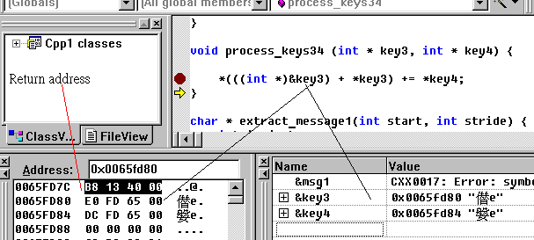

Debug this program and remember to enter an appropriate value of key3 and key 4

Right click the mouse and click the go to disassembly
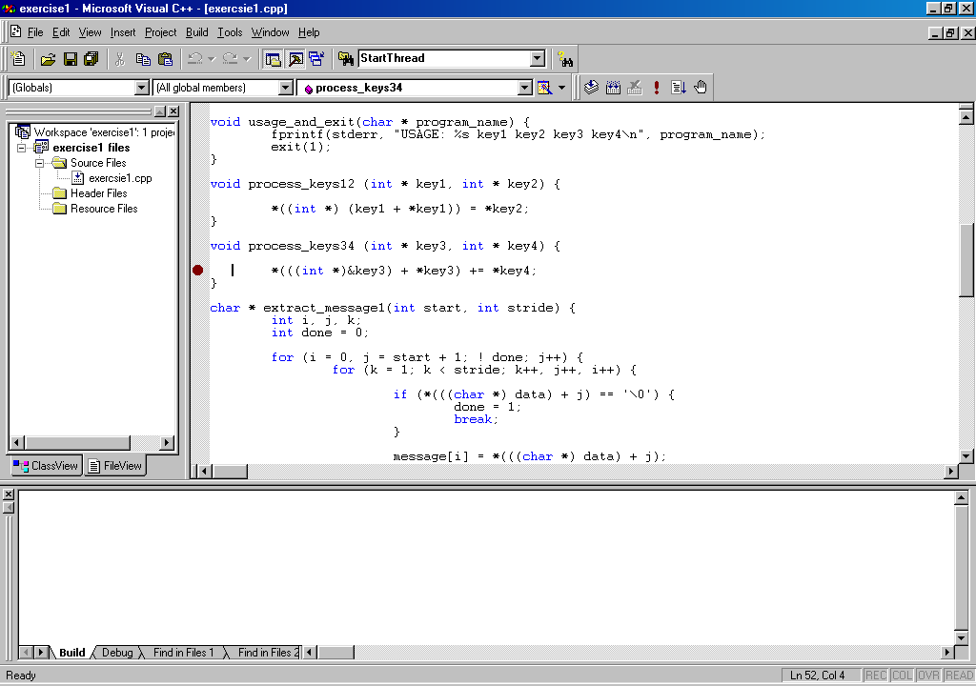

Activity 2

write down the address of } 0x0040_________ before

}
msg1 = extract_message1(start, stride);
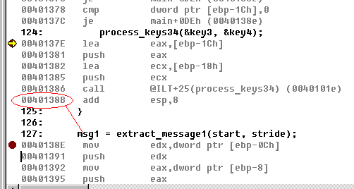

and the address (before) of msg2 = extract_message2(start, stride);
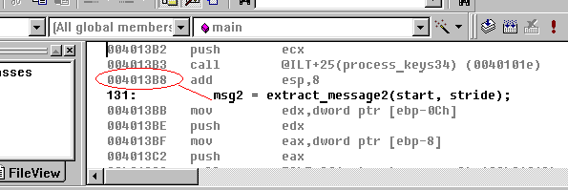

0x0040___________

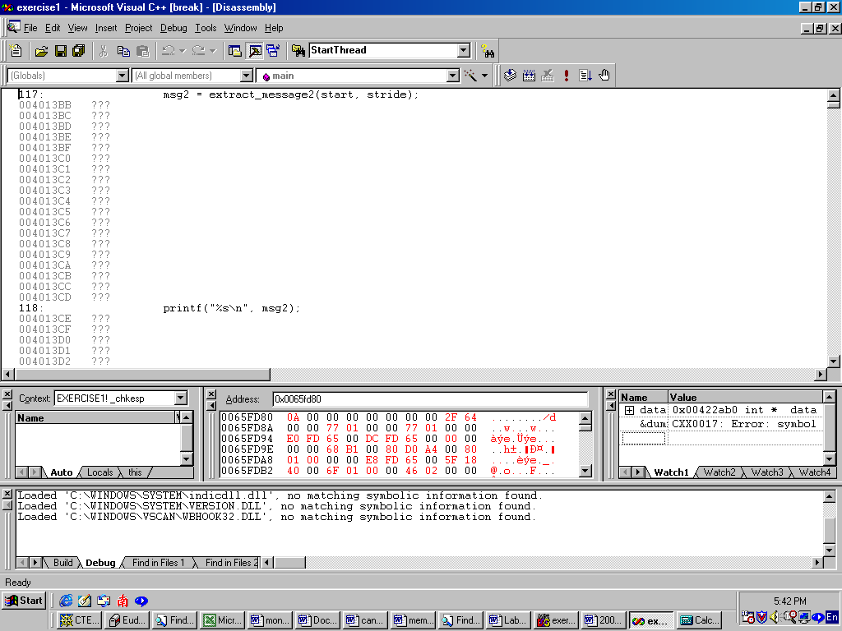
msg2 = extract_message2(start, stride);

The difference between is related to key4

Determine the value in decimal

Activity 3

Demonstrate the key1, key2, key3 and key4.

Key1:___________
Key2:___________
Key3:___________
Key4:___________

Activity 4

Write down your explanation on how to deduce all the keys.

Key1 and Key2

Key3 and Key4

