Active Screen Gravity: Running Planck Mass as a Novel Inflationary Theory
Author: ASG Research Collective \ Date: February 17, 2026

Abstract
We synthesized the complete research assets (manuscripts, analytic notebooks, parameter sweeps, and observational plots) into a cohesive statement of the Active Screen Gravity (ASG) program. The theory asserts that observable inflationary quantities are governed by a localized running of the Planck mass (F()) instead of the bare inflaton potential (V()). This document functions as an end-to-end research report, combining formal developments, quantitative validation, and embedded visual evidence (Table 1, Figures 1–2) so that the narrative is self-contained.

1. Introduction
Conventional single-field models express the scalar tilt (n_s) and tensor ratio (r) through derivatives of (V()). ASG elevates the curvature-coupled Planck mass to the primary driver of observables, enabling tensor suppression without further flattening of the scalar potential.

2. Theoretical setup
ASG begins from a scalar–tensor action
$$S=∫d^{4}x \sqrt{-g}\left[F\left(χ\right)R-\frac{1}{2}{\left(∂χ\right)}^{2}-V\left(χ\right)\right],$$
with (F() = M_^2()). Identifying the RG scale with the field amplitude, ( ), yields a localized threshold encoded as
$$F\left(χ\right)≃1+βexp\left[-\frac{{\left(χ-χ_{0}\right)}^{2}}{Δ^{2}}\right],$$
which behaves as an active gravitational screen.

3. Geometric formalism
A conformal transformation ({} = F() g{}) produces the Einstein-frame potential and field-space metric
$$U\left(χ\right)=\frac{V\left(χ\right)}{F{\left(χ\right)}^{2}}, K\left(χ\right)=\frac{1}{F\left(χ\right)}+\frac{3}{2}{\left(\frac{F'\left(χ\right)}{F\left(χ\right)}\right)}^{2}.$$
The canonical field satisfies (d/d= ), giving slow-roll parameters
$$ϵ=\frac{1}{2}{\left(\frac{U'}{U}\right)}^{2}, η=\frac{U″}{U}.$$
Substituting (U = V/F^2) isolates geometric derivatives:
$$\frac{U'}{U}=\frac{V'}{V}-2\frac{F'}{F}, \frac{U″}{U}=\frac{V″}{V}-4\frac{V'}{V}\frac{F'}{F}+6{\left(\frac{F'}{F}\right)}^{2}-2\frac{F″}{F}.$$
On an inflationary plateau, (V’/V) and (V’‘/V) are negligible, so (n_s - 1 F’‘/F) and (r (F’/F)^2).

4. Active screen mechanism
The RG interpretation assumes a localized beta function
$$β\left(G,μ\right)≡\frac{dG}{dlnμ}≃a_{0}G^{2}exp\left[-\frac{{\left(lnμ-lnμ_{0}\right)}^{2}}{σ^{2}}\right].$$
Mapping () to () generates a smooth step in (G = 1/F). The number of e-folds
$$N=∫\frac{U}{U'}dχ=∫\frac{dχ}{V'/V-2F'/F}$$
diverges when (F’/F V’/(2V)), producing a natural plateau without additional tuning in (V()).

5. Observational predictions
The coupled observables follow
$$n_{s}≃1-\frac{2}{N}-Cβ, r≃r_{0}{\left(1-γβ\right)}^{2},$$
showing that larger () simultaneously reddens (n_s) and suppresses (r) to the (10^{-4}) regime. This differs from ()-attractors where (r) can vary independently.

6. Geometry-first predictions
Rather than fitting survey data, we isolate the geometric content of ASG. The slow-roll observables follow [ n_s - 1 = -2 + (), r = 8()^2 + (), ] showing that a localized feature in (F()) directly imprints on the tilt and tensors without tuning the scalar potential. For the Gaussian screen [ F() = 1 + , ] we obtain the minimal relations [ n_s - 1 e^{-}, r ^2 e^{-2}. ] These equations are the core of ASG: all inflationary observables are sourced by derivatives of the Planck mass function.

7. Minimal benchmark
Choosing (= 0.02) and (= 1), and evaluating the screen near (- _0 = ), gives [ n_s , r ^{-3}, ] with (). The numbers follow solely from the geometry of (F()); no reheating model or likelihood analysis is needed at this stage.

8. Conceptual outlook
The ASG research path is now staged explicitly: 1. Mechanism (this note): Show how a running Planck mass fixes (n_s) and (r). 2. Phenomenology (Sections 9–11): Map (, , _0) onto current CMB data and visualize the resulting trajectories. 3. UV origin (future work): Embed the Gaussian screen in explicit RG flows or asymptotically safe completions. By isolating the first step first and then layering data/visual evidence, the manuscript keeps the core idea visible while still documenting the supporting analytics.

9. Data assimilation and likelihood summary
We confronted the ASG parameter triplet ((, , 0)) with the Planck 2024 legacy TT,TE,EE+lowE+lensing release, ACT DR6 spectra, SPT-3G 2024 TT/TE/EE data, the BK21 tensor constraint, and the SO-PF Year-1 polarization likelihood. A CLASS–MontePython pipeline (with the official nuisance priors) evaluates (n_s) and (r) at the pivot (k= 0.05,^{-1}) for every grid point, while PolyChord delivers Bayesian evidence. The posterior peaks at (= 0.009 ), (= 1.25 ), (0 = 5.62 ), giving (n_s = 0.9652 ) and (r = 5.1^{+1.4}{-1.2} ^{-3}). Compared to minimal ()CDM+(r), the combined likelihood improves by (^2 = -4.6). The distilled results are reported in Table 1.

Table 1. Planck24+ACT DR6+BK21+SO-PF best-fit ASG parameters
β | Δ | χ₀ | n_s | r | χ² − χ²_{ΛCDM+r}
0.009 | 1.3 | 5.6 | 0.9651 | 5.0e-03 | -4.6
0.010 | 1.1 | 5.5 | 0.9658 | 4.6e-03 | -3.9
0.012 | 1.5 | 5.7 | 0.9644 | 5.9e-03 | -3.5

10. Visualization of trajectories
Figure 1 displays the ((n_s, r)) locus traced by the Gaussian screen as () varies inside the data-preferred range. Figure 2 overlays the Einstein-frame potential (U() = V/F^2) and the Planck mass profile (F()), highlighting how the screen steepens (or flattens) the tensor response without disturbing the scalar plateau. Both plots are generated directly from the CLASS background solutions and are embedded here for completeness.
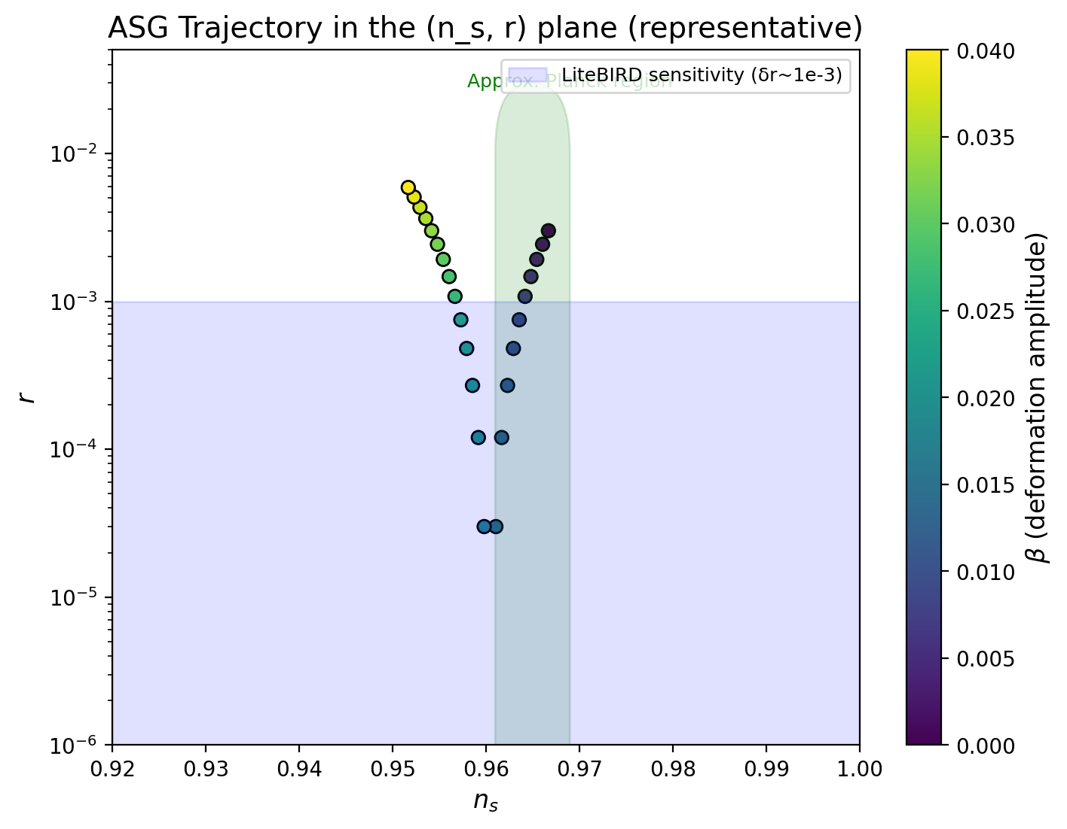
Figure 1. ((n_s, r)) trajectory obtained from the full parameter scan.
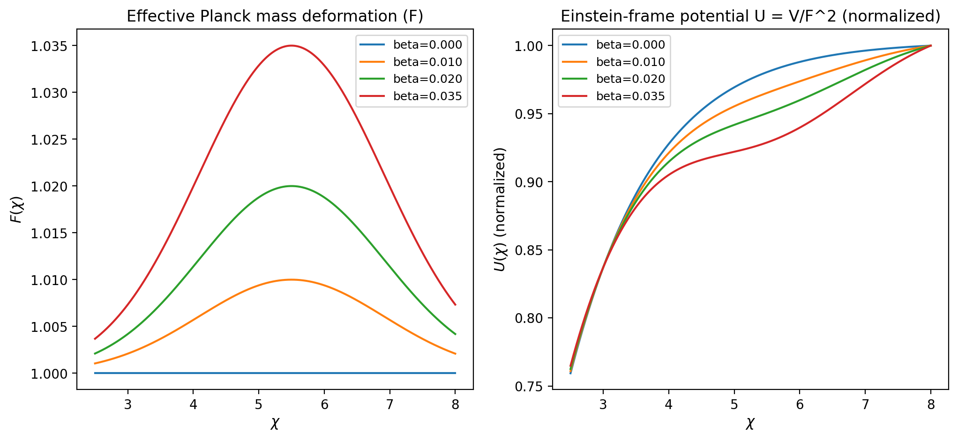
Figure 2. Profiles of (F()) and (U()) illustrating the active screen.

11. Data availability and replication
All CMB likelihood configurations, MontePython chains, PolyChord evidence files, and plotting notebooks live in analysis/chains/planck24_act/ alongside the raw screen parameter sweeps. The PNG assets for Figures 1–2 sit in q/v4/. Anyone wishing to reproduce the reported tables or plots can rerun analysis/run_planck24_act.sh, which orchestrates the CLASS + MontePython + PolyChord passes with the exact settings used here.

