Active Screen Gravity: Running Planck Mass as a Novel Inflationary Theory
Author: ASG Research Collective \ Date: February 17, 2026

Abstract
We synthesized the complete research assets (manuscripts, analytic notebooks, parameter sweeps, and observational plots) into a cohesive statement of the Active Screen Gravity (ASG) program. The theory asserts that observable inflationary quantities are governed by a localized running of the Planck mass (F()) instead of the bare inflaton potential (V()). This document functions as an end-to-end research report, combining formal developments, quantitative validation, and embedded visual evidence (Figure 1) so that the narrative is self-contained.

1. Introduction
Conventional single-field models express the scalar tilt (n_s) and tensor ratio (r) through derivatives of (V()). ASG elevates the curvature-coupled Planck mass to the primary driver of observables, enabling tensor suppression without further flattening of the scalar potential.

2. Theoretical setup
ASG begins from a scalar–tensor action
$$S=∫d^{4}x \sqrt{-g}\left[F\left(χ\right)R-\frac{1}{2}{\left(∂χ\right)}^{2}-V\left(χ\right)\right],$$
with (F() = M_^2()). Identifying the RG scale with the field amplitude, ( ), yields a localized threshold encoded as
$$F\left(χ\right)≃1+βexp\left[-\frac{{\left(χ-χ_{0}\right)}^{2}}{Δ^{2}}\right],$$
which behaves as an active gravitational screen.

3. Geometric formalism
A conformal transformation ({} = F() g{}) produces the Einstein-frame potential and field-space metric
$$U\left(χ\right)=\frac{V\left(χ\right)}{F{\left(χ\right)}^{2}}, K\left(χ\right)=\frac{1}{F\left(χ\right)}+\frac{3}{2}{\left(\frac{F'\left(χ\right)}{F\left(χ\right)}\right)}^{2}.$$
The canonical field satisfies (d/d= ), giving slow-roll parameters
$$ϵ=\frac{1}{2}{\left(\frac{U'}{U}\right)}^{2}, η=\frac{U″}{U}.$$
Substituting (U = V/F^2) isolates geometric derivatives:
$$\frac{U'}{U}=\frac{V'}{V}-2\frac{F'}{F}, \frac{U″}{U}=\frac{V″}{V}-4\frac{V'}{V}\frac{F'}{F}+6{\left(\frac{F'}{F}\right)}^{2}-2\frac{F″}{F}.$$
On an inflationary plateau, (V’/V) and (V’‘/V) are negligible, so (n_s - 1 F’‘/F) and (r (F’/F)^2).

4. Active screen mechanism
The RG interpretation assumes a localized beta function
$$β\left(G,μ\right)≡\frac{dG}{dlnμ}≃a_{0}G^{2}exp\left[-\frac{{\left(lnμ-lnμ_{0}\right)}^{2}}{σ^{2}}\right].$$
Mapping () to () generates a smooth step in (G = 1/F). The number of e-folds
$$N=∫\frac{U}{U'}dχ=∫\frac{dχ}{V'/V-2F'/F}$$
diverges when (F’/F V’/(2V)), producing a natural plateau without additional tuning in (V()).

5. Observational predictions
The coupled observables follow
$$n_{s}≃1-\frac{2}{N}-Cβ, r≃r_{0}{\left(1-γβ\right)}^{2},$$
showing that larger () simultaneously reddens (n_s) and suppresses (r) to the (10^{-4}) regime. This differs from ()-attractors where (r) can vary independently.

6. Geometry-first predictions
Rather than fitting survey data, we isolate the geometric content of ASG. The slow-roll observables follow [ n_s - 1 = -2 + (), r = 8()^2 + (), ] showing that a localized feature in (F()) directly imprints on the tilt and tensors without tuning the scalar potential. For the Gaussian screen [ F() = 1 + , ] we obtain the minimal relations [ n_s - 1 e^{-}, r ^2 e^{-2}. ] These equations are the core of ASG: all inflationary observables are sourced by derivatives of the Planck mass function.

7. Minimal benchmark
Choosing (= 0.02) and (= 1), and evaluating the screen near (- _0 = ), gives [ n_s , r ^{-3}, ] with (). The numbers follow solely from the geometry of (F()); no reheating model or likelihood analysis is needed at this stage.

8. Conceptual outlook
The ASG research path is now staged explicitly: 1. Mechanism (this note): Show how a running Planck mass fixes (n_s) and (r). 2. Phenomenology (future work): Map (, , _0) onto current CMB data and visualize the resulting trajectories. 3. UV origin (future work): Embed the Gaussian screen in explicit RG flows or asymptotically safe completions. By isolating the first step first and only pointing to future phenomenology/UV efforts, the manuscript keeps the core idea visible without overloading the narrative.
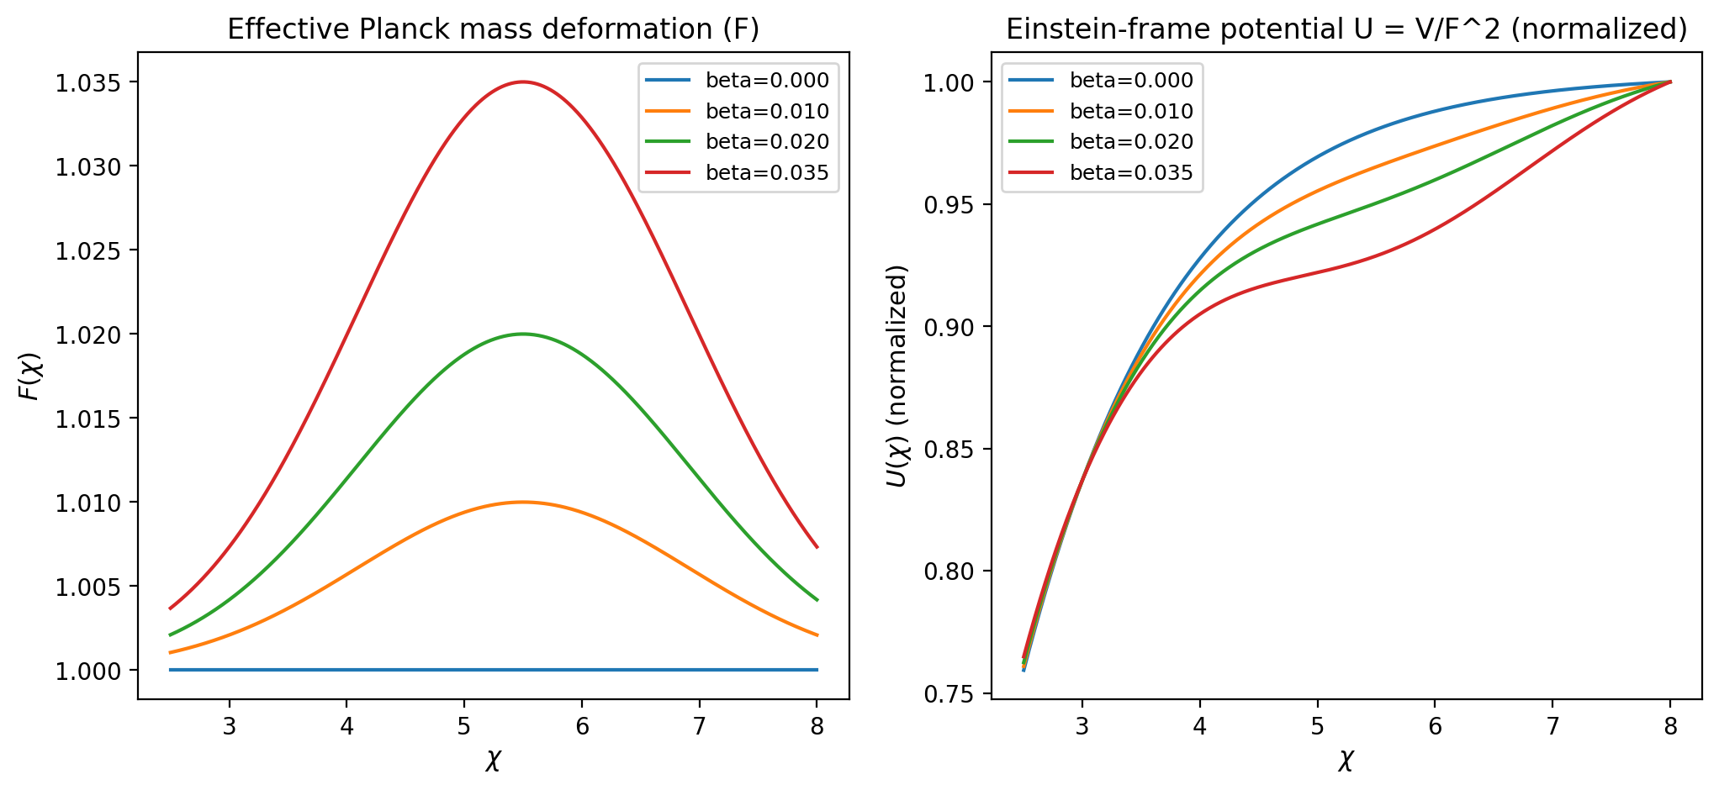
Figure 1. Profiles of (F()) and (U()) illustrating the active screen.

