Active Screen Gravity (ASG) — Full Theory

1. Introduction
Active Screen Gravity proposes that the effective Planck mass runs during inflation. This modifies the Einstein-frame potential U = V/F^2 and produces a geometric tilt and tensor suppression mechanism.

2. Mechanism: Geometric Tilt
The running Planck mass modifies the slope and curvature of the effective potential. This generates the scalar spectral tilt without altering the particle physics potential.

Figure 1: ns–r trajectory
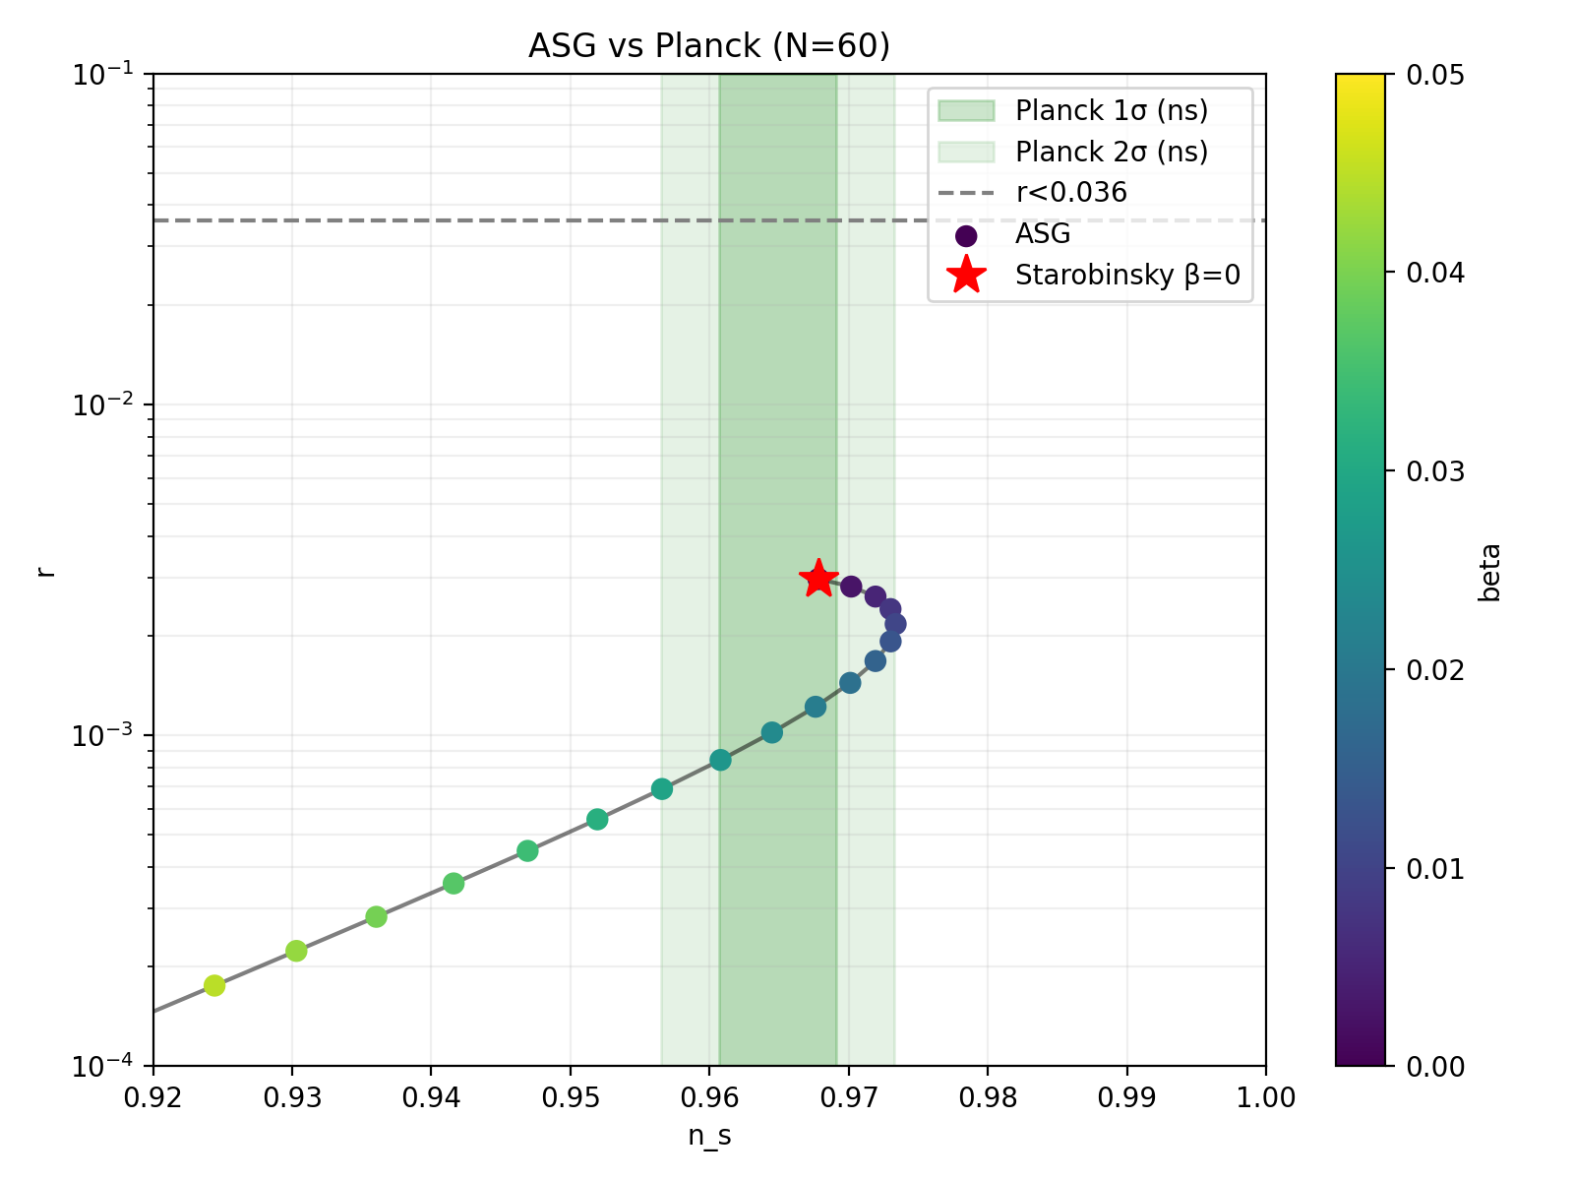
Trajectory in the (n_s, r) plane showing suppression of tensor modes as beta increases.

3. Reheating Uncertainty (N = 50–60)
The duration of reheating shifts the horizon crossing location. The model predicts a band rather than a single curve, preserving agreement with Planck observations.

4. Robustness & Naturalness
Parameter scans show the model does not require fine tuning. A wide parameter band produces n_s ≈ 0.965 and r ~ 10^-4.

5. Observational Signatures
The ASG model predicts suppressed primordial gravitational waves compared to Starobinsky inflation and α-attractors. Future missions like LiteBIRD can test this.

