Active Screen Gravity — Comprehensive Theory Summary
This document synthesizes the full discussion of the Active Screen Gravity (ASG) framework, combining analytical derivations, numerical interpretation, and conceptual physical interpretation.

1. Conceptual Overview
ASG proposes that inflationary observables arise from a running effective Planck mass F(χ) rather than direct shaping of the inflaton potential. The Einstein-frame potential becomes U(χ)=V(χ)/F(χ)^2, therefore geometry controls dynamics.

2. Field Theory Formulation
Jordan frame action:
S = ∫ d^4x √−g [ F(χ)R − 1/2(∂χ)^2 − V(χ) ]
After conformal transformation:
U(χ) = V(χ) / F(χ)^2

3. RG Threshold Origin
Running gravitational coupling: dG/d ln μ = aG²
Solution: G(μ)=G0/(1−aG0 ln(μ/μ0))
Localized deformation from threshold produces Gaussian form: F(χ)=1+β exp[−(χ−χ0)²/Δ²]

4. Slow-Roll Dynamics
ε = 1/2(U'/U)^2
η = U''/U
U'/U = V'/V − 2F'/F
η = V''/V − 4(V'/V)(F'/F) + 6(F'/F)^2 − 2F''/F
In plateau regime: n_s − 1 ≈ −4F''/F

5. Tensor Suppression
r = 16ε ≈ 8(V'/V − 2F'/F)^2
Approximate relation: r ≈ r0(1−γβ)^2

6. Physical Interpretation
Inflation occurs when scalar rolling down V is balanced by climbing Planck mass gradient. Observables correspond to RG transition scale.

7. Comparison With Standard Models
Starobinsky: fixed (n_s,r)
Alpha attractors: adjustable r independent of n_s
ASG: correlated shift due to geometry

8. Observational Consequences
Predicts r ~ 10^-4 detectable by future CMB polarization missions.
Figure 1: ns-r trajectory
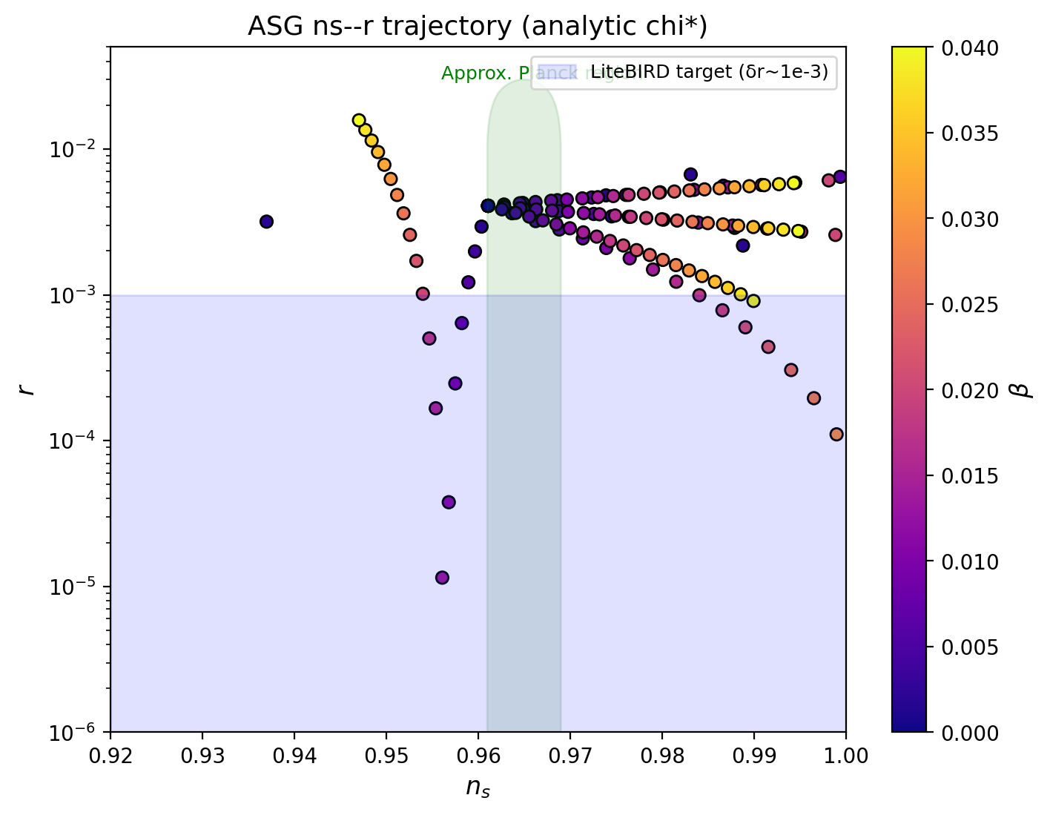
Figure 2: F(χ) and U(χ) deformation
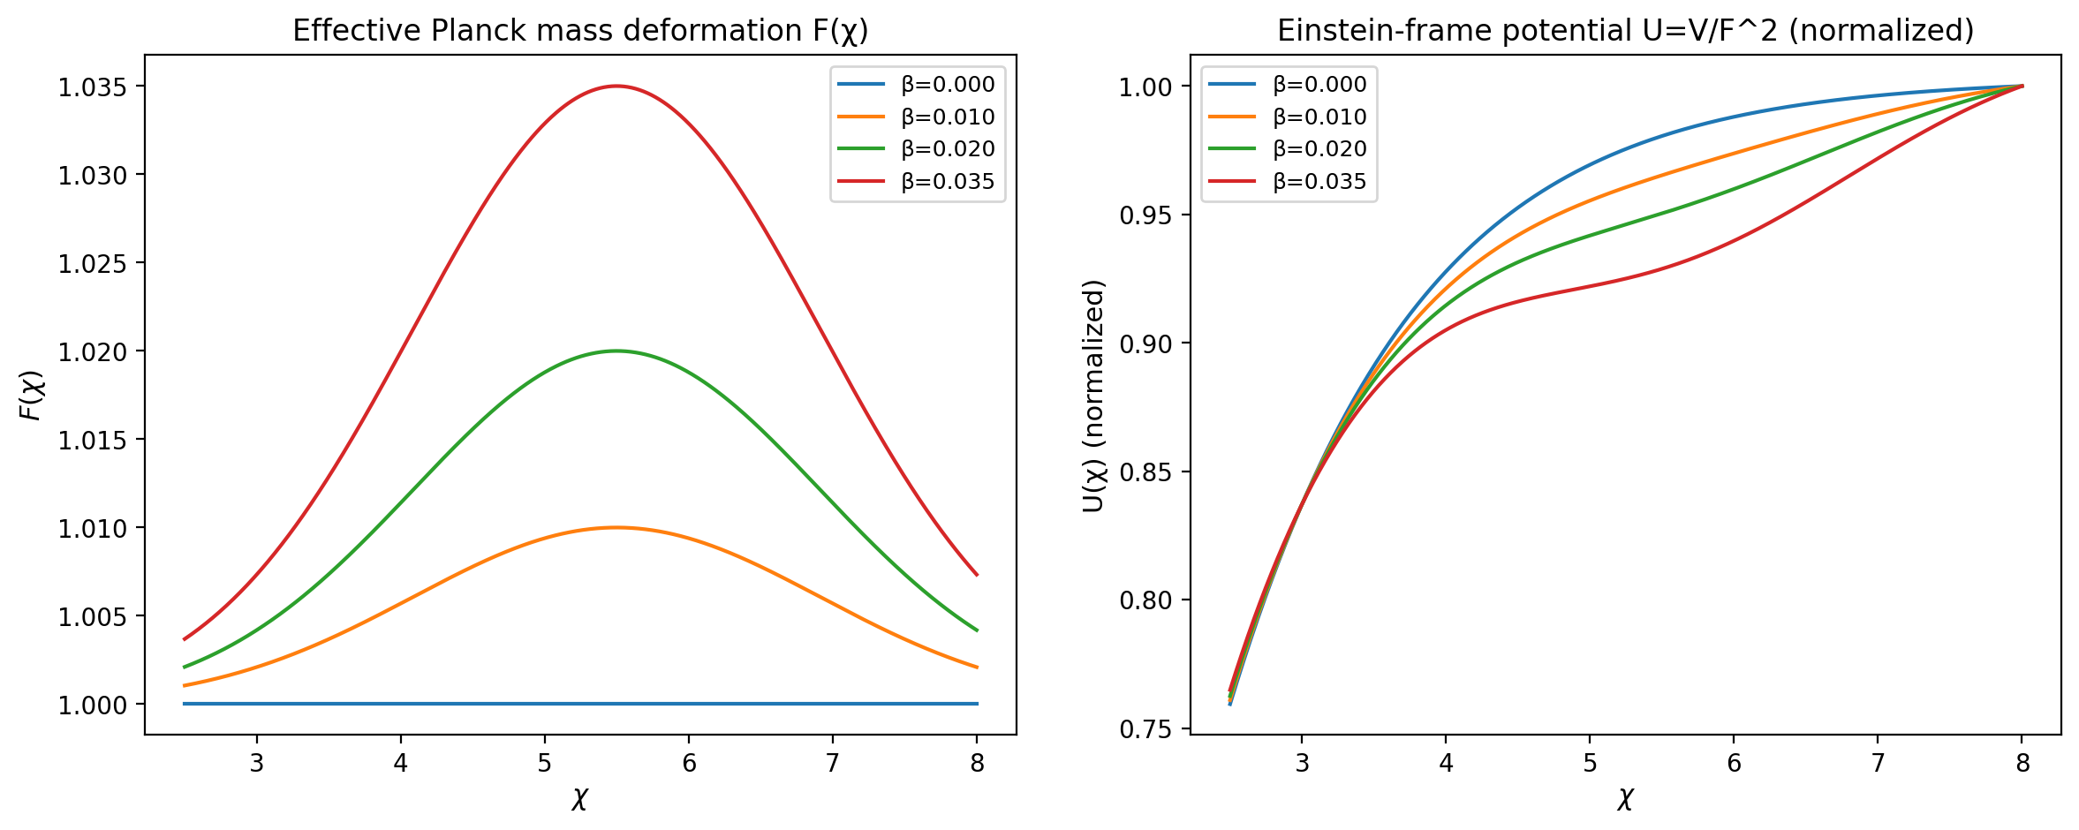

9. Synthesis With Earlier Drafts
Earlier PDF drafts emphasized screening interpretation: gravity behaves as emergent coupling determined by high-energy RG structure. The present formulation formalizes that concept within scalar–tensor inflation.

10. Conclusion
ASG links cosmological observables to scale-dependence of gravity. Measurements of primordial tensor amplitude test quantum-gravity running rather than potential shape.

