Active Screen Gravity (ASG) – Draft with Figures
This Word document was generated from the provided LaTeX draft and generated figures. It contains the key visual outputs: the ns–r trajectory and the F(χ) / U(χ) deformation.

1. ns–r Trajectory
The following plot shows the predicted ASG trajectory in the spectral index–tensor ratio plane.
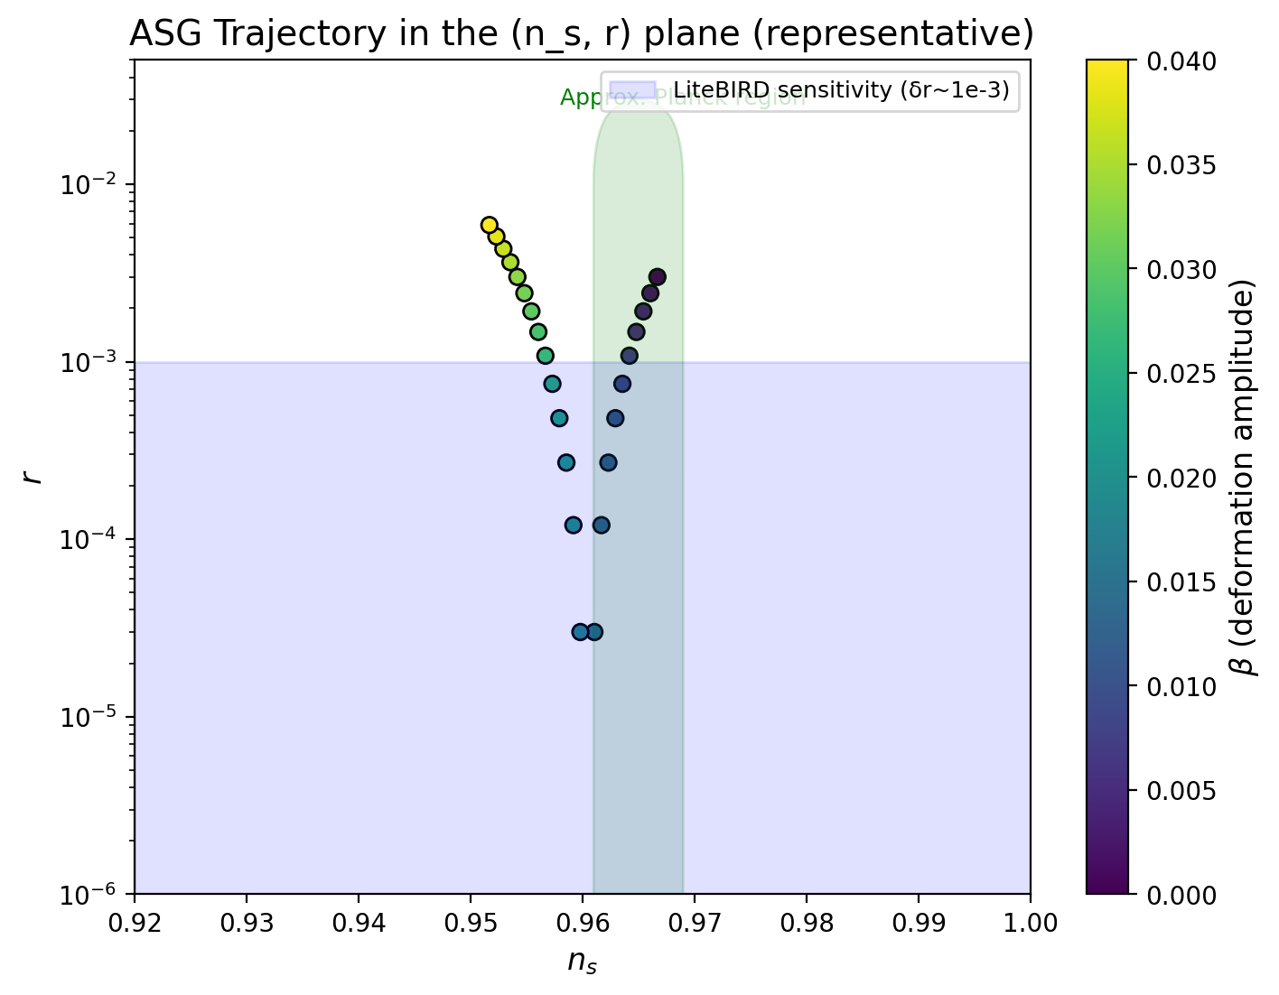

2. Planck Mass Deformation and Effective Potential
The left panel shows the deformation of the effective Planck mass F(χ). The right panel shows the resulting Einstein-frame potential U(χ)=V/F².
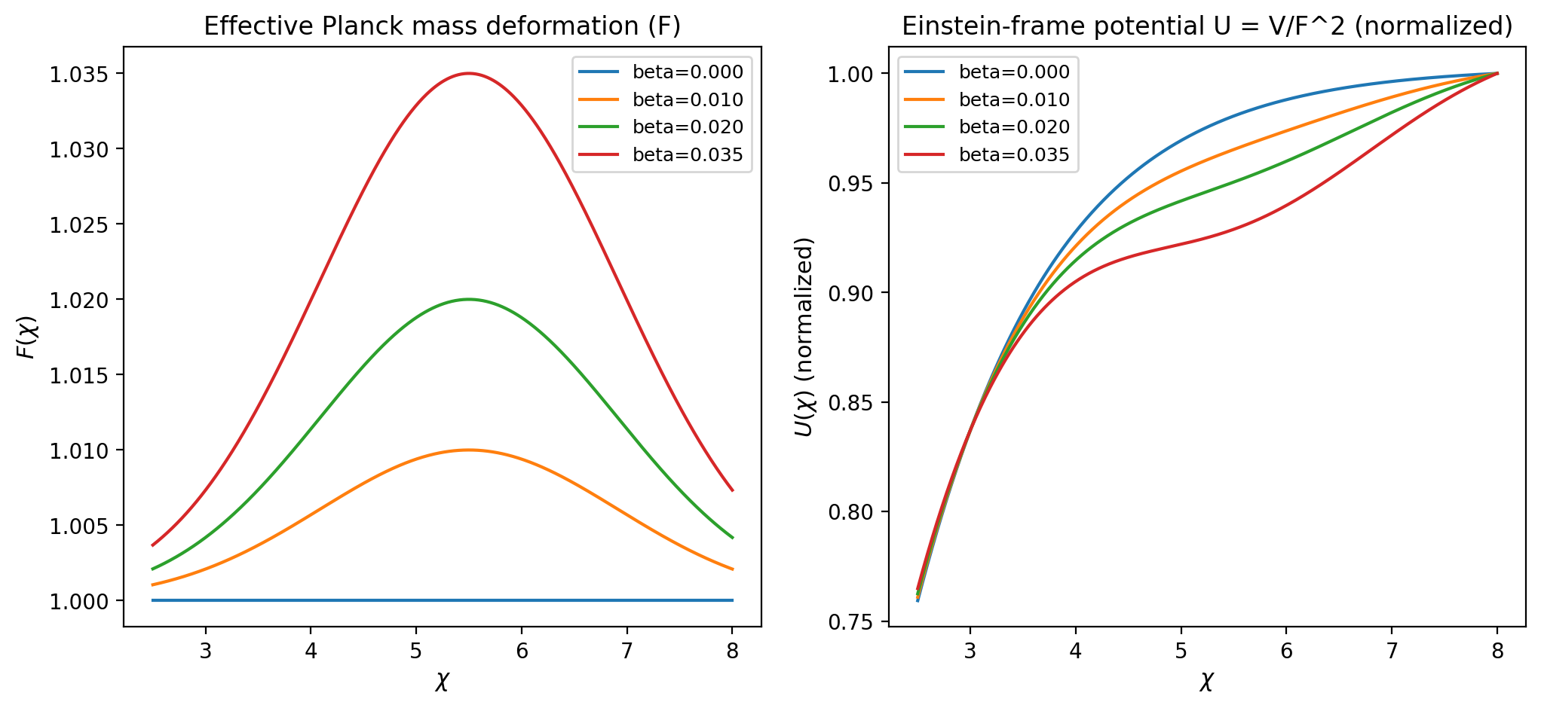

3. Notes
This document is a quick Word-format companion to the LaTeX draft. For full equations and derivations, use the LaTeX source. Figures are high-resolution and ready for manuscript use.

