Active Screen Gravity: Running Planck Mass as the Origin of the Inflationary Attractor

Abstract

We propose a scalar–tensor framework in which the inflationary observables are governed by a renormalization–group (RG) flow of the gravitational coupling. Instead of modifying the inflaton potential directly, we allow the effective Planck mass to vary as a function of the scalar field, leading to an effective Einstein–frame potential U = V/F^2. We show analytically and numerically that the spectral tilt and tensor amplitude arise from geometric derivatives of F rather than from the shape of V. The model predicts a linear shift in n_s and a quadratic suppression of r, producing a characteristic trajectory in the (n_s, r) plane and an observational attractor consistent with current data.

The Active Screen Gravity (ASG) model extends Starobinsky inflation by introducing a running effective Planck mass F(χ) motivated by renormalization group (RG) flow. Current CMB data constrain r to the 10^{-2} level, leaving plateau models observationally degenerate. The ASG prediction r ~ 10^{-4} lies well below present limits but within the projected sensitivity of future polarization missions such as LiteBIRD.

Figure 1: ns-r trajectory
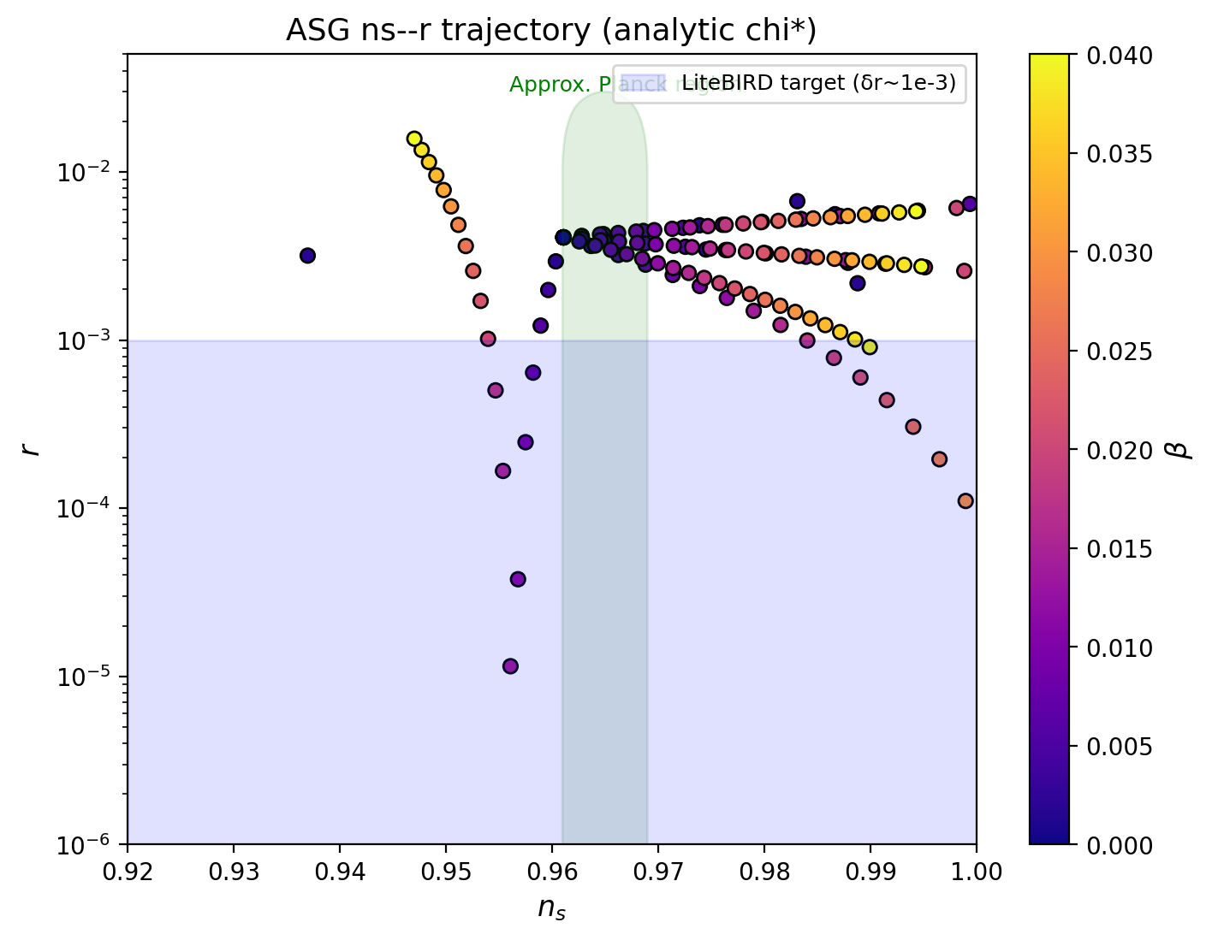
Figure 2: F(χ) and U(χ) flattening
