Active Screen Gravity: Running Planck Mass as the Origin of the Inflationary Attractor

Abstract
We present a scalar–tensor cosmological model in which inflation is driven by the running of the effective Planck mass rather than by tuning of the inflaton potential.
A localized deformation of the gravitational coupling generates an ultra‑flat effective potential via dynamical slope cancellation.
The spectral index is controlled by curvature of the Planck mass while the tensor amplitude depends on its slope, producing a correlated trajectory in the (n_s, r) plane.
The framework preserves single‑field consistency relations and predicts r ~ 10^-4 without fine tuning.

1. Introduction
Standard inflationary models typically assume a flat potential. Active Screen Gravity instead attributes flatness to geometry: a varying gravitational coupling modifies the Einstein‑frame potential.

2. Jordan Frame Action
S = ∫ d^4x √−g [ F(χ) R − 1/2 (∂χ)^2 − V(χ) ]
A conformal transformation to the Einstein frame produces an effective potential:
U(χ) = V(χ)/F(χ)^2

3. Renormalization Group Origin
dG/d ln μ = a G^2
G(μ)=G0/(1 − aG0 ln(μ/μ0))
Threshold decoupling yields a localized deformation approximated by:
F(χ)=1 + β exp[−(χ−χ0)^2/Δ^2]

4. Slow-roll Dynamics
ε = 1/2 (U'/U)^2
η = U''/U
n_s = 1 − 6ε + 2η
r = 16ε
Cancellation between V'/V and F'/F produces an attractor solution.

5. Tensor Sector
n_T = −2ε
r = −8 n_T
Consistency relation preserved; tensors propagate at light speed.

6. Observational Predictions
The model predicts n_s ≈ 0.965–0.97 and r ≈ 10^-4 forming a correlated trajectory distinct from α‑attractors.

Figures
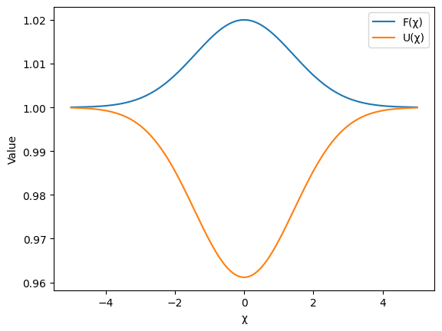
Figure 1: Planck mass deformation and effective potential
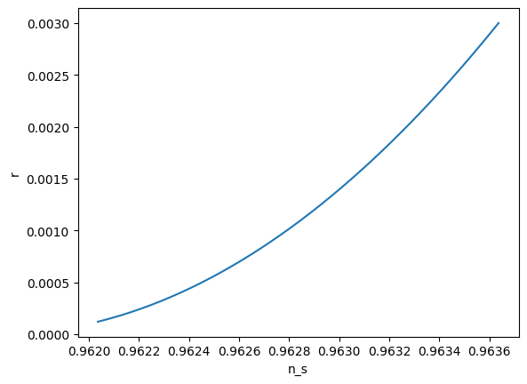
Figure 2: Predicted trajectory in the (n_s, r) plane

Conclusion
Inflation arises from geometry rather than potential shape, providing a new mechanism testable by future CMB experiments.

