Active Screen Gravity: Running Planck Mass as the Origin of the Inflationary Attractor
We present a scalar–tensor framework in which inflationary observables arise from a running effective Planck mass. The model produces a correlated trajectory in the (n_s, r) plane and predicts r ~ 10^-4 without fine tuning.

Planck Mass Deformation
Example Gaussian deformation F(χ) and resulting effective potential U(χ):
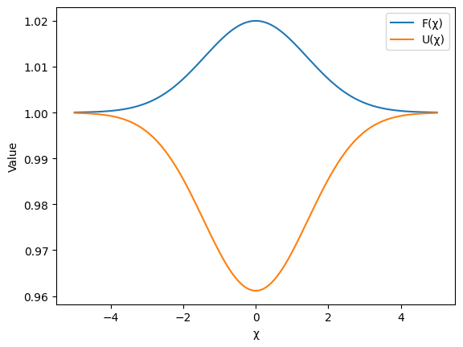

Predicted Observational Trajectory
Predicted correlated trajectory in the (n_s, r) plane:
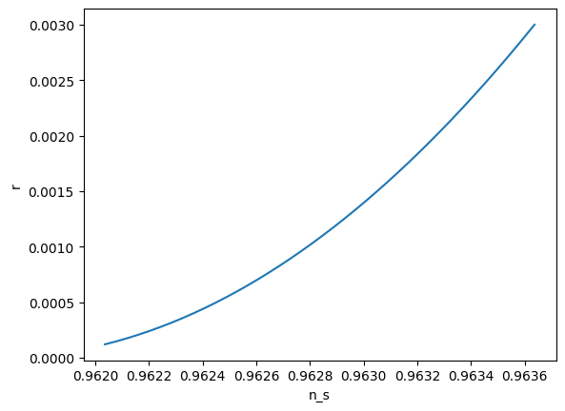

Conclusion
The model modifies geometry rather than potential shape and preserves the single-field consistency relation.

