- ReLU activation: output(x) = max(0, a + w·x). Logistic activation: output(x) = (1 + exp(−a − w·x))−1.
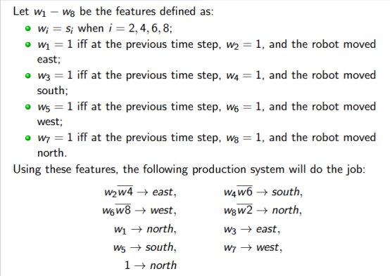
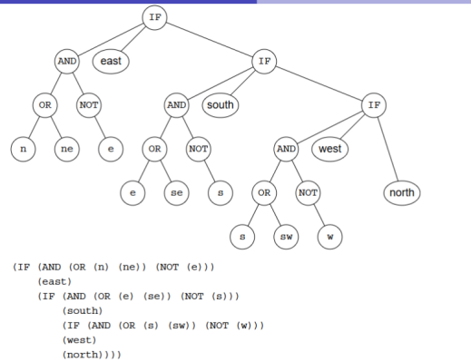

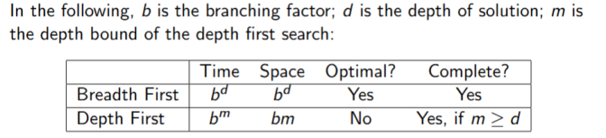

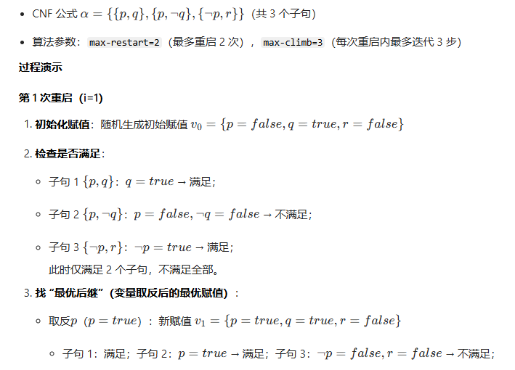
- Iterative Deepening Search 迭代DFS,适用于状态空间为树状、且目标深度未知的场景如迷宫/路径规划
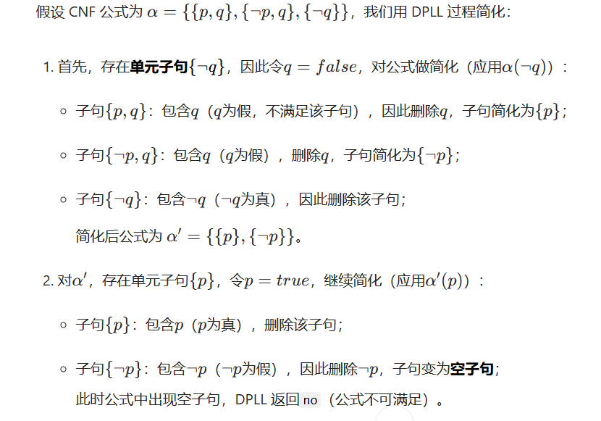

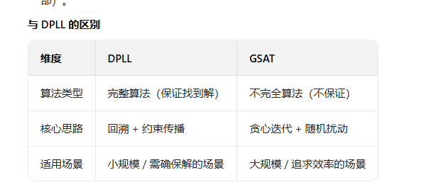

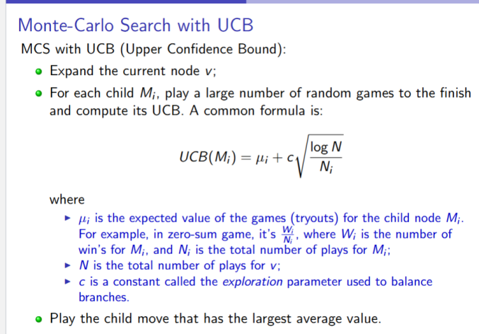

- A MDP consists of: ①A set of states.②A starting state.③A set of actions modeled by a global probabilistic transition relation: T (s, a, s′) - the probability of reaching state s′ from s by taking action a. ④Reward function: Reward(s, a, s′) - the reward for ending in s’ when taking action a in s. ⑤Goal (terminating) condition: End(s). ⑥A discount factor 0 ≤ γ ≤ 1

- RL ①Goal: Learn a policy to maximize the rewards. ②Given: a set of actions to do in a state.
③Assuming: know the states and have unlimited memory and computational resource;
④Question 1: how is a policy represented? ⑤Question 2: which action to try in the present state?
⑥Question 3: once an action is done and a reward received, how toupdate the current policy?
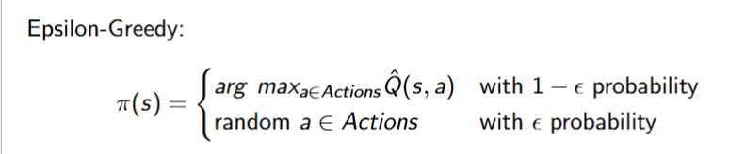

Representation:①Tabular representation: transition relations, rewards, values, Q-values, policies are all represented by tables.②Approximation: approximated by efficient functions such as neural networks
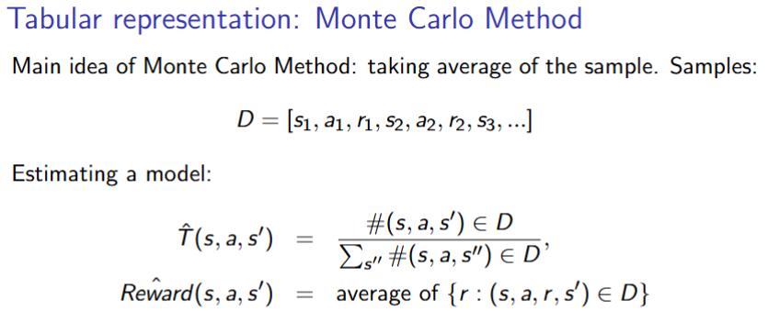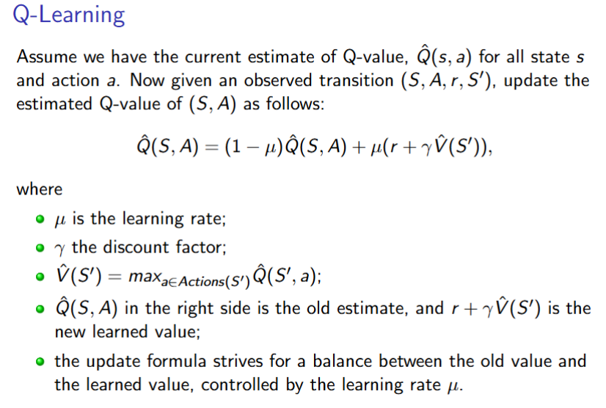

- Multi-Agent Systems (MASs) Game Theory
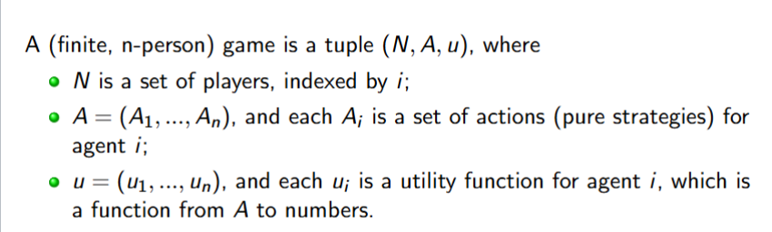

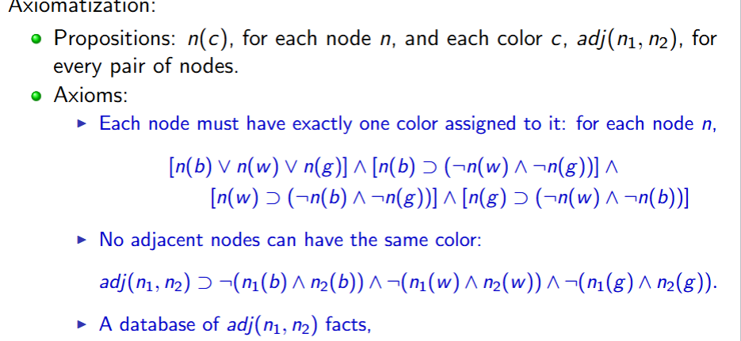
- Knowledge Representation and Reasoning
- Language
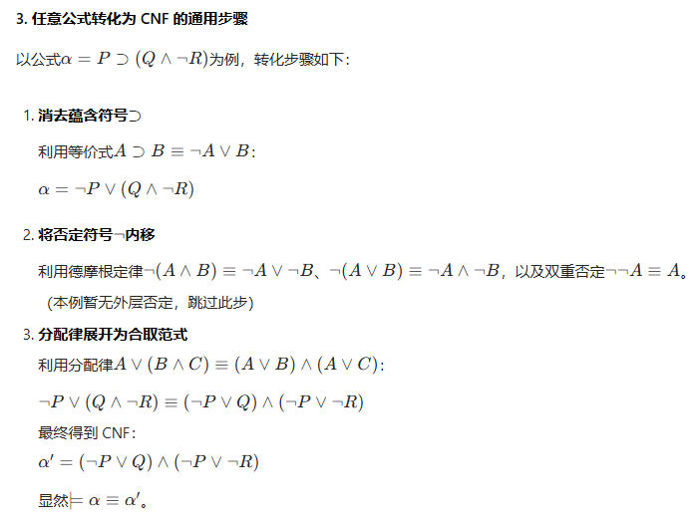
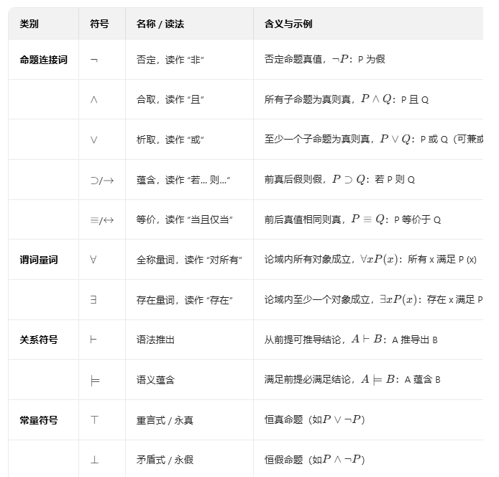
文字：单个变元或否定
子句Clause：文字的析取
单个子句也是CNF
项Term：文字的合取
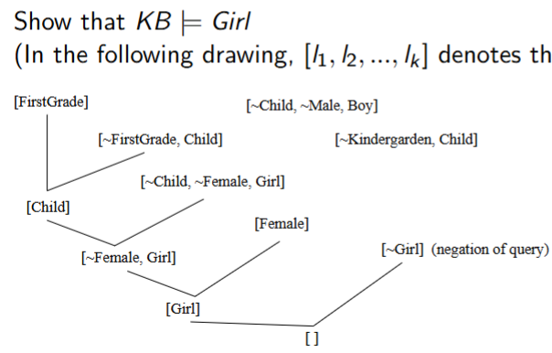
- Resolution
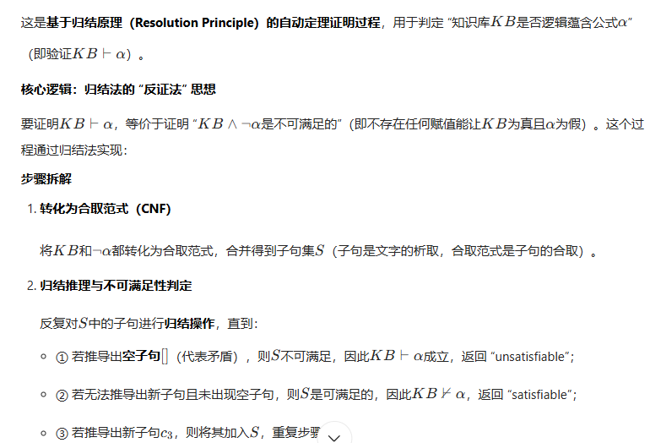

- FOL(First-Order Logic)
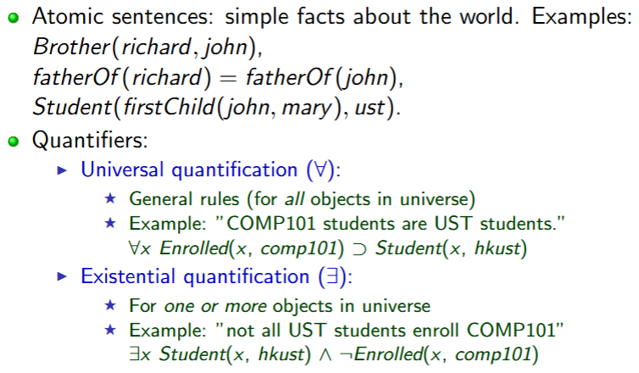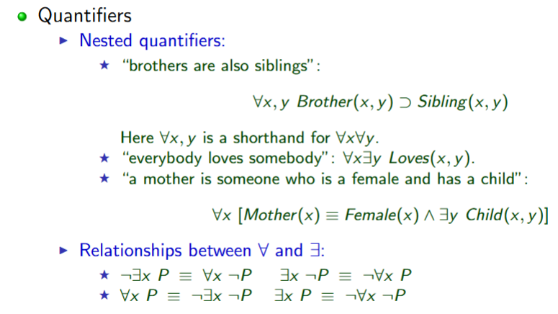

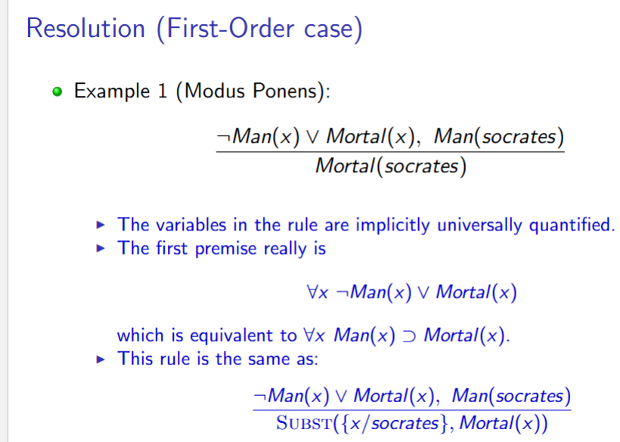
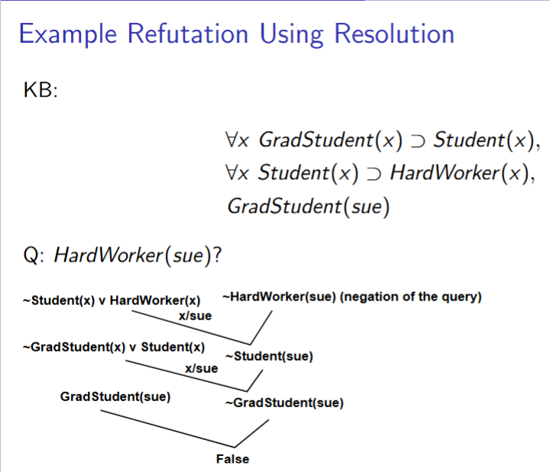
- Resolution and Refutation

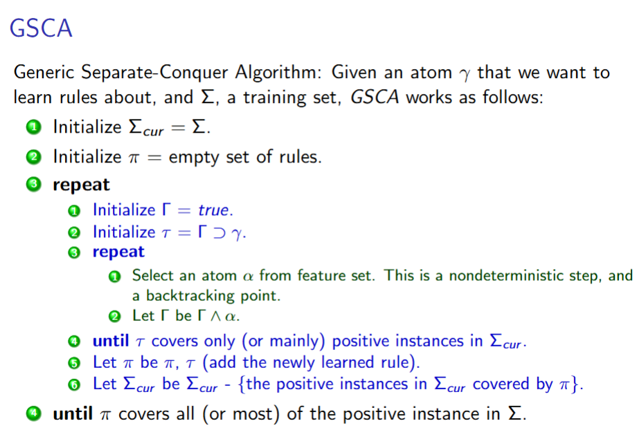
- Rule-Based Expert Systems

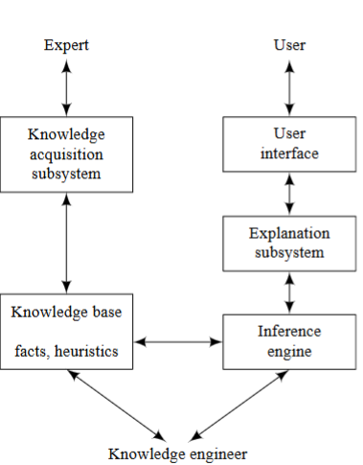
- Uncertainty Probability Prior and Posterior Probabilities
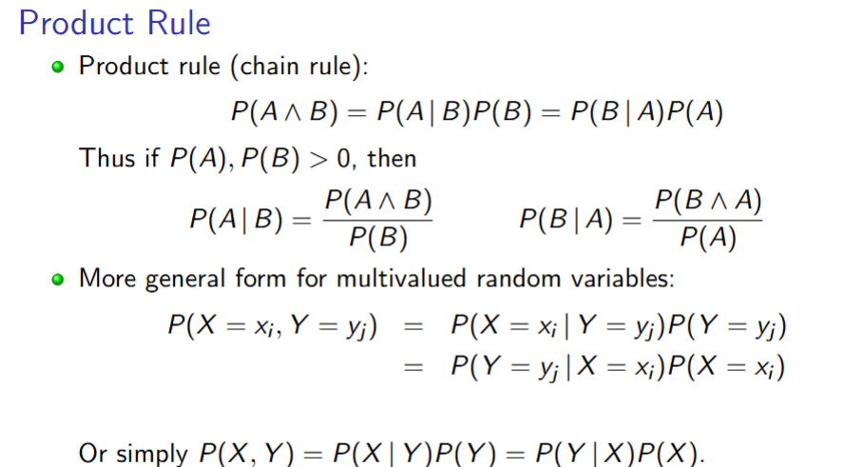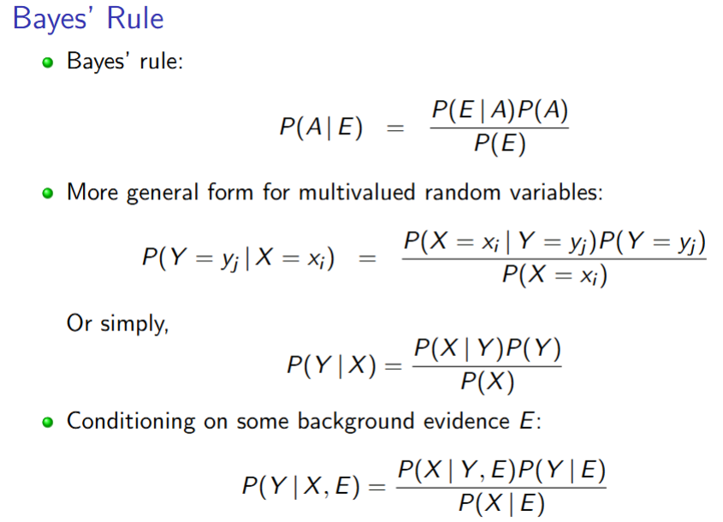
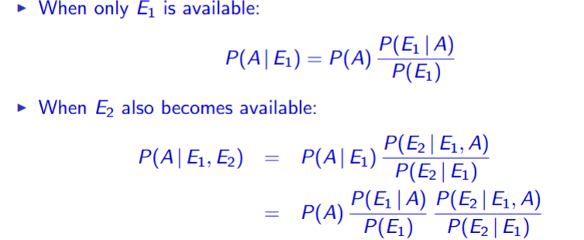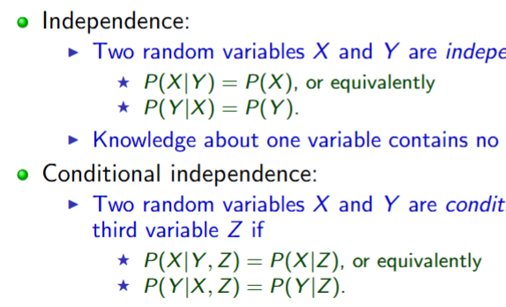
- Belief Networks/Bayesian networks
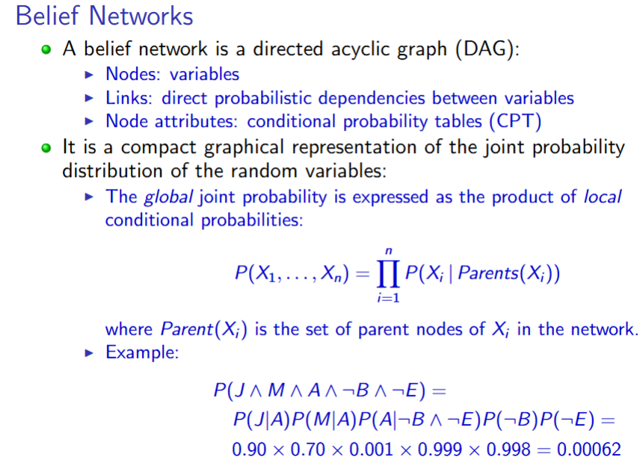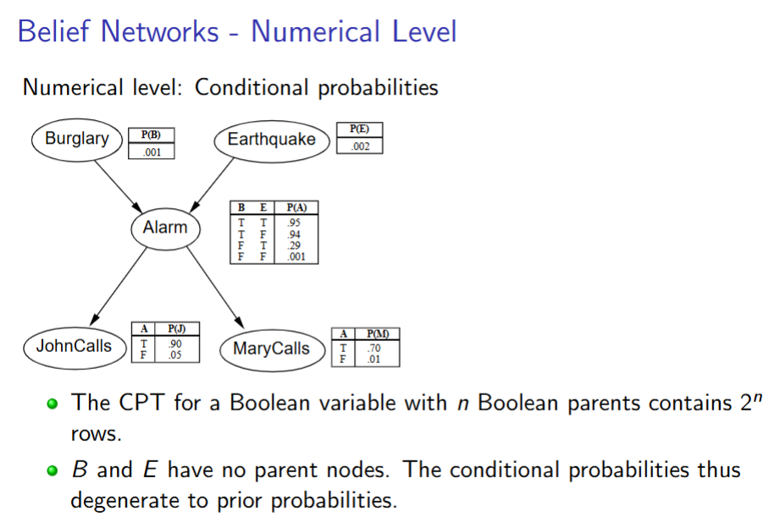
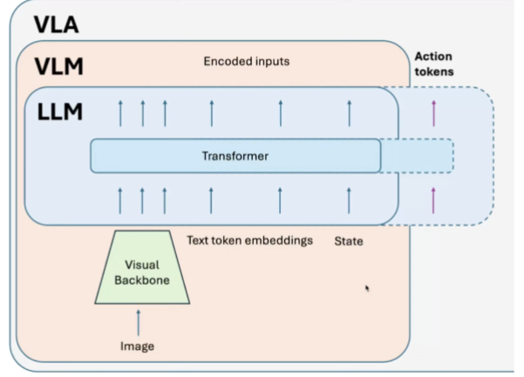
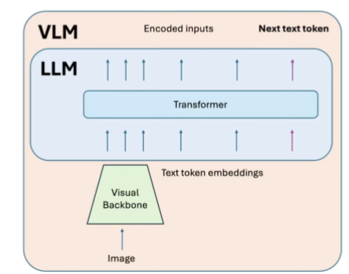
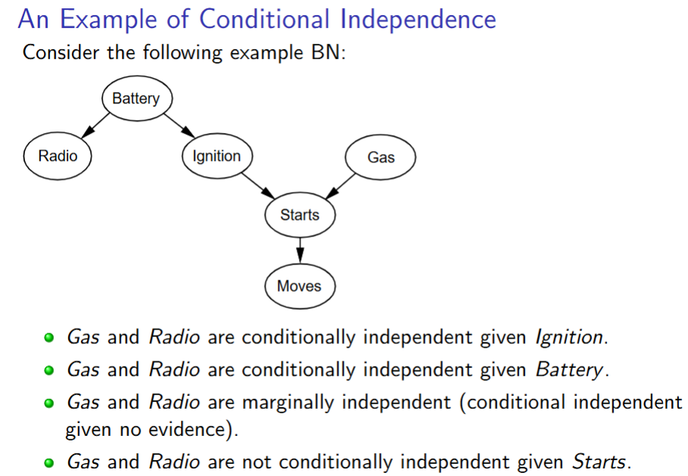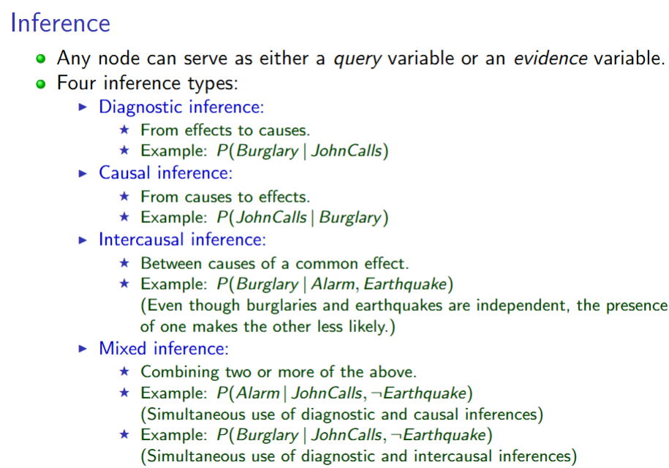

- LLM/VLMs

