Ethical Analysis of a AI-Related App

called Reddit

prepared by Yang,Fengshuo

AI Usage Declaration
In the creation of this article, I did not use artificial intelligence to generate any key content or replace my own thought process. All personal reflections, research findings, ethical arguments, and solutions presented are original. This article only used automatic translation tools for grammar checking and sentence polishing.
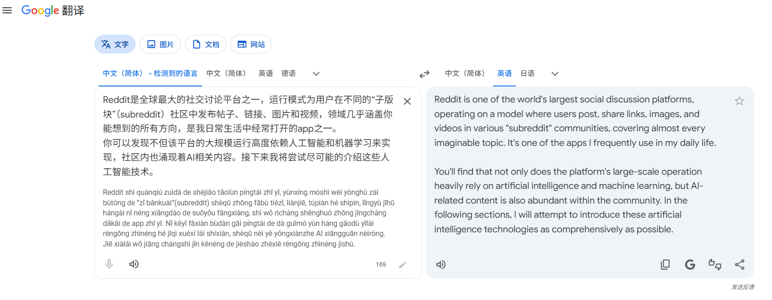

Words:1914 without declaration

Description of the App: Reddit
Reddit is one of the world's largest social discussion platforms, operating on a model where users post, share links, images, and videos in various "subreddit" communities, covering almost every imaginable topic. It's one of the apps I frequently use in my daily life.

You'll find that not only does the platform's large-scale operation heavily rely on artificial intelligence and machine learning, but AI-related content is also abundant within the community. In this section, I will attempt to introduce these artificial intelligence technologies as comprehensively as possible.
- AI-Driven Personalized Recommendation Systems
These systems collect user behavior data, including browsing history, clicks, like-votes, dislike-votes, search keywords, time spent on posts, and even device and location information. Using collaborative filtering and deep learning models¹, the platform predicts user interests and pushes highly relevant content( not only from other users but even commercial ads) to the top of the homepage. This is why users often see content they care about without actively searching for it.

- Reddit applies AI-based content popularity algorithms
These kinds of algorithms help to rank posts. Instead of relying purely on time or raw like-votes, the algorithm evaluates engagement rate, comment velocity, community feedback, and user retention to determine which posts rise to the top of a subreddit or the homepage. This dynamic sorting directly shapes what millions of users see each day.

- Increasingly AI-generated contents (AIGC)
These AIGC include AI-created images, music, videos, poems, and stories. Many communities now specialize in sharing AI art, deepfakes, AI parodies, and synthetic media. While some are creative, others are misleading or deceptive.

- Reddit offers a premium AI auto-reply service for paid subscribers
When users pay for a membership plan, their posts receive automated, context-matching replies from AI bots². These fake comments artificially inflate engagement metrics, making posts appear more popular and thus more likely to be promoted by the algorithm.

- Reddit also includes an AI summarization tool
This feature condenses long posts, comment threads, and articles into short readable paragraphs, which improves user efficiency but also reduces deep reading and critical engagement.

Together, these AI technologies make Reddit convenient, dynamic, and highly personalized. However, they also create serious ethical risks related to privacy, authenticity, fairness, and trust.

My Experience with Reddit
My daily use of Reddit reveals both the convenience and harm of its AI systems.

On the positive side, Reddit’s recommendation algorithm has genuinely saved me time and matched my interests accurately. Recently, I became highly interested in a professional sports team. Over several days, I repeatedly searched and browsed related posts, game statistics, and fan discussions without explicitly following the team’s subreddit or linking my account to any related topics. Remarkably, on the exact day the team had a scheduled match, Reddit’s homepage immediately pushed real-time game data, pre-match analysis, and live discussion threads. This personalized delivery let me catch up with urgent news quickly and effortlessly, showing how AI can improve user experience when used properly.

However, negative experiences are equally noticeable. One major issue is repetitive and intrusive advertising. Reddit’s AI ad system collects information about other apps installed on my device and my usage patterns. As a result, advertisements I have already seen on other social media platforms reappear frequently on it, creating a tedious and invasive experience.
Another problem is AI-enabled misinformation and fraud.Once in a fan communities dedicated to specific celebrities, I have seen users sell autographed photos and collectibles at low prices. Buyers later discover the items are completely fake and digitally manipulated, leading to financial loss and disappointment. This shows how Reddit’s AI-friendly environment can enable unethical and even illegal behavior.

Overall, Reddit’s AI features bring efficiency and personalization, but they also erode privacy, spread misinformation, and undermine the authenticity of community.

User Attitudes Toward AI on Reddit
To understand public opinion, I conducted a small-scale survey by posting questions in several general and tech-focused subreddits. Here are some user opinions and my analyses to that.
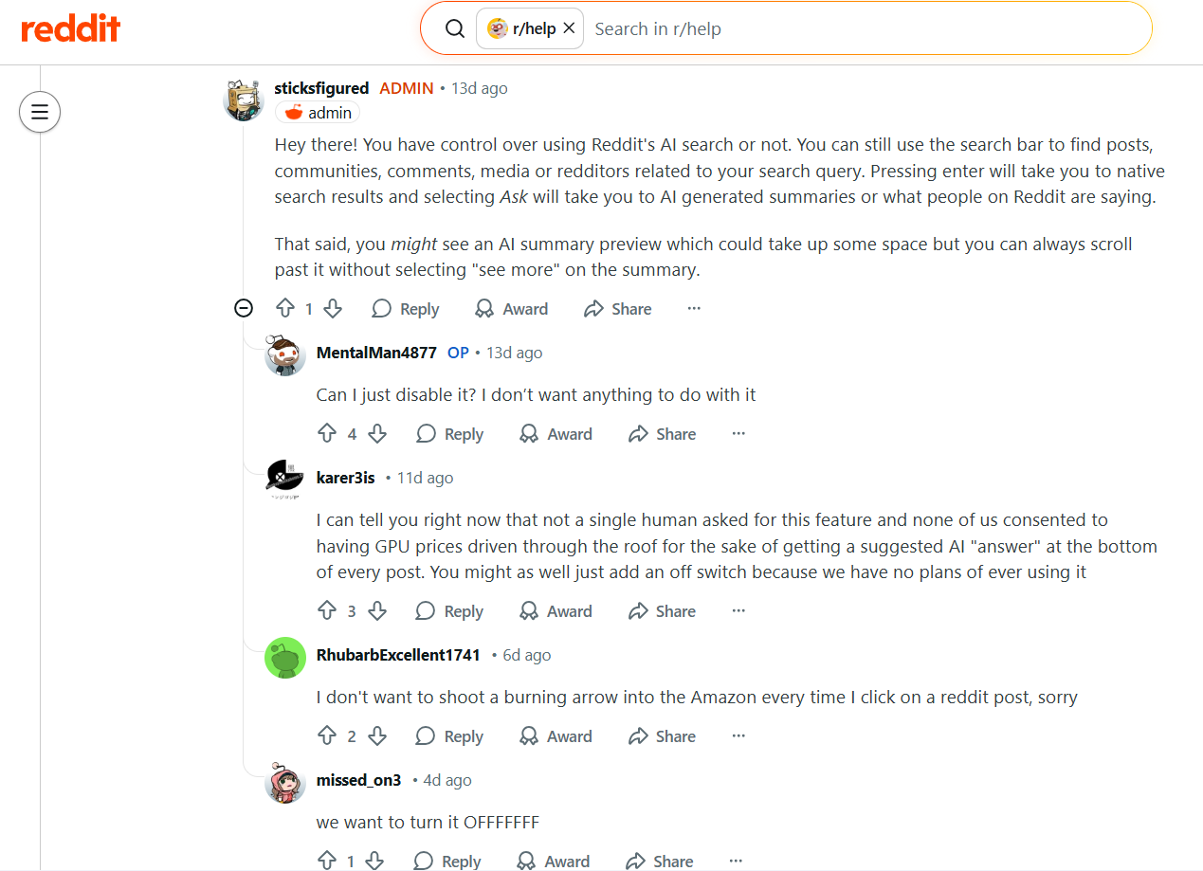
- Picture: obvious dissatisfaction and opposition to AI functionality.
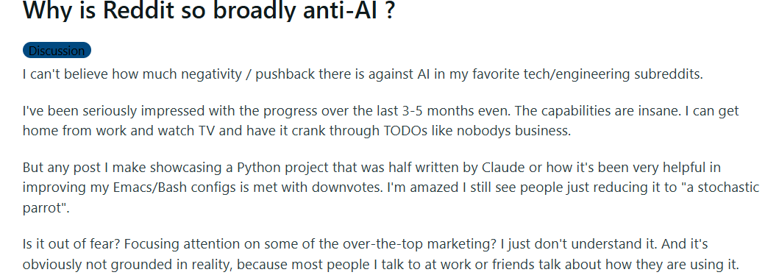
- Picture:user’s question regarding anti-AI sentiment

We may extract these facts:
- Most users dislike excessive AI integration, especially fake auto-replies and AI-generated preview or summary.
- Many users worry about their privacy leaks and do not trust Reddit’s data practices. But they actually do not know exact Reddit’s data collection policies.
- Users strongly oppose AI forgery and fraud, especially in trading and fan communities.
- However some users believe that the resistance to AI in real-person communities is excessive. They are well aware that AI is inevitably entering people's lives and unavoidable.

This survey shows that users hold ambivalent attitudes: they reject meaningless AI practices but recognize AI’s practical value. This indicates the community expecting better governance rather than full rejection.

Ethical Concerns and Analysis
- Privacy Violations and Data Exploitation
Reddit collects massive amounts of personal data, including location, device information, browsing history, and even usage of other apps. Although users agree to a privacy policy, the explanations are vague, legalistic, and difficult for ordinary users to understand³. Many users do not know Reddit monitors other applications on their phones. This practice violates the principle of informed consent⁴. From a deontological perspective, collecting non-necessary data without clear permission is inherently wrong, regardless of benefits. Legally and ethically, this overreach violates user privacy rights and may violate data protection regulations such as GDPR or CCPA.

- AI Forgery and Misinformation
AI-generated images, videos, and fake testimonials on Reddit pose severe risks. Malicious users can create deepfakes to defame individuals, spread false rumors, or forge evidence⁵. In celebrity communities, AI-manipulated photos harm both fans and the public figures themselves. Such content erodes trust in digital media and may cause real-world harm, including career damage, harassment, and public panic. This violates virtue ethics by promoting dishonesty, harm, and irresponsibility.

- Unfairness and Manipulated Visibility
Reddit’s paid AI auto-reply service creates unfair competition. Users who pay for membership can boost their contents’ visibility. Meanwhile, high-quality posts from ordinary users receive less attention because they lack artificial engagement. This system rewards payers rather than creators, undermining fairness, transparency, and the community’s original value of meaningful discussion. This contradicts utilitarianism because it reduces overall community well-being for the benefit of a small group and the platform.

- Erosion of Authentic Human Interaction
As AI replies, AI posts, and AI summaries become more common, Reddit risks losing its identity as a “real human community.” Future risks include echo chambers, algorithmic manipulation, widespread disinformation, and the gradual replacement of real voices with automated content. This threatens the emotional and social value of public discussion online.

Ethical Solutions for AI Issues
To address the ethical problems identified above, I propose targeted mitigation strategies justified by utilitarian ethics, deontological ethics, and virtue ethics.

- Deontological Ethics: Transparent Data Consent
From a deontological perspective, users have a moral right to know and control their data.
Reddit should redesign its permission interface to use simple, clear language. It must separately ask for consent to collect location, app usage, and browsing history.Add one-tap buttons to “allow limited data” or “allow full data.” Users should easily disable ad tracking and cross-app monitoring. If a user wants to use Reddit but refuses to share other app data, the platform still allows full access but only uses on-platform behavior for recommendations. This respects individual rights⁶.

- Virtue Ethics: Ban AI-Enabled Fraud
Virtue ethics emphasizes honesty, fairness, and responsibility.
It’s important to use auto-detectors to identify AI-forged images, videos, and fake merchandise. Enforce strict rules against deceptive AI content. Require clear labels for all AI-generated posts.If a user tries to sell an AI-generated fake autograph, the system will detect manipulation, and label it as synthetic, warn buyers. This protects the community and upholds virtuous behavior.

- Utilitarianism: Prohibit Paid AI Auto-Replies to Ensure Fairness
Utilitarianism aims to maximize overall happiness and benefit for the community.
The app should eliminate the paid AI auto-reply service and penalize accounts that use bots to inflate engagement. Redesigning the popularity algorithm to value meaningful human comments over fake ones is also a better system than now.During this method, using machine learning to detect repetitive, low-quality, or bot-generated comments may be a promotion. Judging different posts rely on fake engagement detection, which is combined with second solution before.
We can imagine when a paid user’s post stops receiving fake AI replies, then its visibility can drop to a natural level. After that, genuine posts will rise based on real user interest. This improves overall community quality and satisfaction.

- Combined Framework: Explainable Recommendations and User Control
Let users view and adjust their interest profiles. It is necessary for the app to explain why a post or ad was recommended.It’s a better way to add a “Why this ad?” and “Why this post?” button for users who can remove interests or reset recommendations⁷.

Reflection and Conclusion
In conceiving this article and collecting community feedback, I gradually realized the deeper ethical problems that arise when comparing personal, unique human ideas with AI-generated content. At least within the current AI technological landscape, it is still extremely difficult for AI to fully replace humans in tasks closely related to human society, culture, emotion, and creative expression. This is because although AI can generate outputs that appear comprehensive and precise, it fundamentally relies on existing data, fixed models, and patterned algorithms rather than genuine experience or subjective insight. Such formulaic content is often repetitive and lacks authentic human context, which can easily lead to widespread information overload and redundancy across digital platforms.

I firmly believe that over-reliance on artificial intelligence gradually weakens individual critical thinking, independent judgment, and genuine personal expression. To prevent this erosion of human agency, we must consciously prioritize and preserve our personal perspectives in creative and academic work. A practical approach is to draft key sections manually first, then use AI only for minor polishing and language refinement. The ultimate goal is to ensure that the final work truly reflects our own understanding, values, and voice as users. Maintaining independent thinking is particularly vital in the field of AI ethics, since our core mission is to evaluate technology responsibly, ethically, and from a human-centered perspective.

Bibliography
- Zuckerberg, M., et al. (Reports on social media algorithms). This report explains how recommendation systems shape user behavior and create ethical risks. It supported my analysis of Reddit’s homepage algorithm.

- Reddit’s public policy blog and user terms. Official documents revealed Reddit’s actual data practices and paid services, ensuring my essay is factually accurate.

- Floridi, L., & Cowls, J. (2019). AI Ethics: Four Principles and Their Applications. This source provides a classic framework for AI ethics: transparency, justice, non-maleficence, and autonomy. It helped me structure the ethical analysis of privacy and fairness.

- Tufekci, Z. (2018). Engineering the public: Big data, surveillance and computational politics.This book discusses how social media platforms collect user data to shape content distribution and influence public opinion. It provides theoretical support for analyzing Reddit’s privacy violations and algorithmic manipulation, helping clarify the ethical risks of data exploitation in social platforms.

- Research on synthetic media and deepfake harms. Academic studies on misinformation and reputation damage supported my section on AI forgery risks.

- Data Protection authorities. Guidelines on AI and data consent. These rules emphasize informed and specific consent. They justified my strategy of improving Reddit’s permission design.

- Wachter, S., Mittelstadt, B., & Floridi, L. (2017). Why a right to explanation matters in automated decision-making.This paper emphasizes the importance of transparency and explainability in AI systems. It informed my mitigation strategy of adding “Why this post?” and “Why this ad?” explanations to enhance user autonomy.

