ARIN 5305 (Fall 2025) Programming Assignment
Stage1 Task1.2 CodeBLEU

Yang,Fengshuo/21216054

Ⅰ.As the introduction from the official website(https://github.com/k4black/codebleu.git) ,the final results we calculated for each comparison come from a specific formula.(Note:Four default weight parameters are all 1/4, and we will not change them at present.)

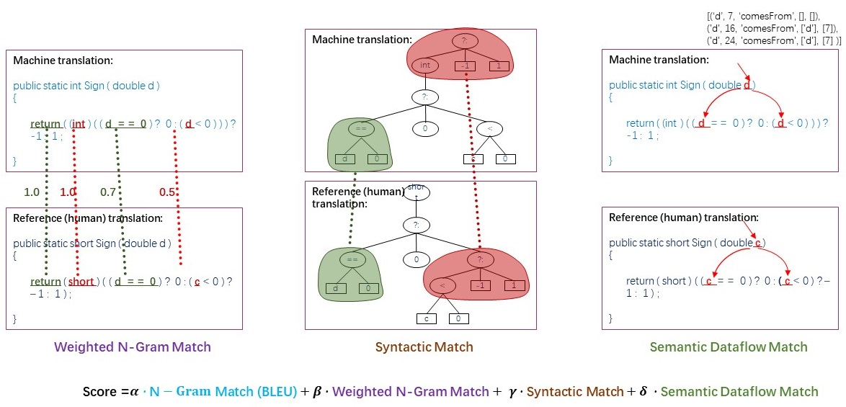

Ⅱ.Here we get the scores table:
 | Correct code vs. LLM-Reproduced code |  |  |  |  | Correct code vs. Faulty code
 | Ngram | Weighted Ngram | Synt-ax | Data  -flow | Code  -bleu | Ngram | Weighted  Ngram | Synt-ax | Data  -flow | Code  -bleu
basic-  calculator | 0.31 | 0.32 | 0.61 | 0.34 | 0.40 | 0.97 | 0.98 | 1.0 | 0.53 | 0.87
count-the-  number-of-  special-  characters-ii | 0.37 | 0.41 | 0.89 | 0.71 | 0.59 | 0.92 | 0.95 | 1.0 | 1.0 | 0.97
minimum-  cost-good-  caption | 0.25 | 0.26 | 0.73 | 0.55 | 0.45 | 0.97 | 0.97 | 0.98 | 1.0 | 0.98
robot-  collisions | 0.34 | 0.35 | 0.79 | 0.34 | 0.45 | 0.97 | 0.98 | 1.0 | 0.88 | 0.96
sum-of-  largest-prime-substrings | 0.11 | 0.22 | 0.61 | 0.25 | 0.36 | 0.86 | 0.91 | 1.0 | 1.0 | 0.94

Ⅲ.Based on this result, there are several notable facts(Using S means different CodeBLEU Scores):
①S _{Correct code vs. Faulty code} are always much higher than S Correct code vs. LLM-Reproduced code actually in every dimension and every problem.
②Between Correct code vs. LLM-Reproduced code, we often get higher scores in Syntax and Data-flow match relative to Ngram and Weighted Ngram match.And the scores in Ngram and Weighted Ngram match are usually as low as 0.3,which results in low final CodeBLEU Scores.
③Between Correct code vs. Faulty code, things are different that scores in all matches are always above 0.9,and in Syntax they are all perfectly matched.

Ⅳ.Here is the extended analysis:
①The faculty codes are the simply-changed version of the correct codes(change of a single number or a single keyword,etc.),so the CodeBLEU similarity obviously shows they are similar not only in text content but also in code structure,so we can easily assume that they are cloned codes.But there is also a slight difference worth noting here which is about Data-flow in codes.When we change the initial value of a key variable in code and thus affect the way that code loops(like the following left pic1),the score in Data-flow match has the ability to show us the difference while others do not.But when we only change the data type of the variable in code(like the following right pic2), the CodeBLEU metric only knows the syntax difference.
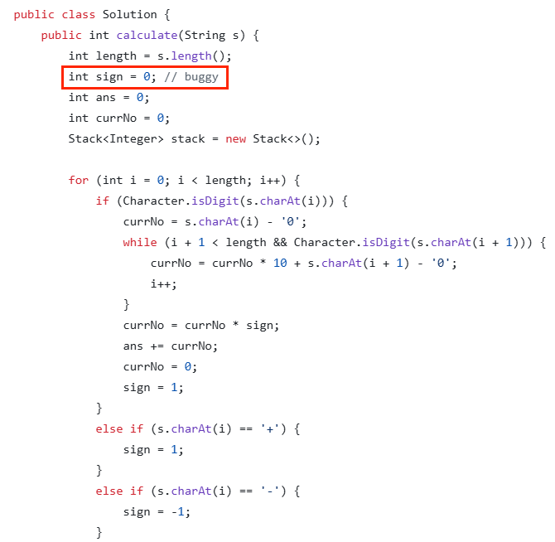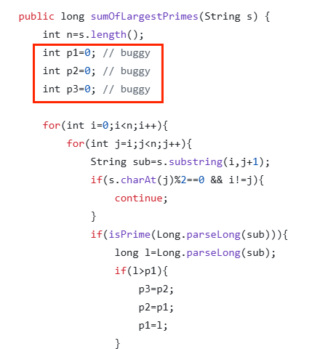
Picture1 Picture2
②As for the reproduced codes by LLM,the CodeBLEU similarity has exactly told us the LLM used many different words in reproducing a code,but it still tried to reproduce a similar code with a similar code structure(including how variables and values flow in the code) by the natural language descriptions actually summarized by itself!Although the CodeBLEU intuitively shows the difference between codes generated by the Large Language Model and the original version,it is hard to evaluate the quality of generated codes solely based on this.On one hand,the reproduced codes could be accepted for its useful function(they do work well on the problem),while at the same time we have to admit they are far away from the original ones just experiencing a translation and reproduction.
③An extra fact we should emphasis is that this method cannot help us to find whether two similar codes are the equal solutions to one problem,easily to know.

Ⅴ.Conclusion:
The CodeBLEU method is indeed effective in evaluating code textual and structural similarity (except for code correctness), which is consistent with the semantic consistency from a machine perspective, rather than a human perspective. In fact, when we manually observe different codes, factors such as variable names are not important criteria for our evaluation. Based on this, how to correctly assess the quality of LLM-generated code may require more parameter indicators.Even though,in many other fields like plagiarism detection, or clone analysis,it helps.

