Procedures for Zoom Classes

Overview
Note that this does not apply to Fiberside Chats, which are not handled by staff members in the shop
The general procedure for Zoom classes is as follows:
- The working day before the class, send the Zoom link and any related materials (e.g. handouts) to the students and instructor, as well as the roster to the instructor and change the calendar color to green
  - If students sign up after the materials are sent, send the materials to each additional student individually and note in the daily recap and Task List that an updated roster will need to be sent on the day of the class
- The day of class, continue sending the Zoom link and related materials individually as additional students sign up, if any
- Open the Zoom room 15 minutes before the class starts and assign the teacher the co-host role once they join
- Send an updated roster to the instructor if noted in the Task List or if additional students have signed up on the day of
  - If there is no time between the last sign up and the start of the class (busy in the shop, last sign up was very close to the start of class, etc.), make a note in the daily recap and the Task List to send the updated roster on the day following the class
- The day following the class, send the Zoom recording to the students and instructor, as well as the final roster to the instructor if noted in the Task List. Also change the color of the calendar to yellow
This guide covers the above tasks in detail, followed by instructions for tasks that occur less frequently such as logging in to the Zoom accounts and creating Zoom events

Sending the Zoom Link to the Students and Instructor
Get the handout
Check to see if a handout is associated with the class
- Double-click the class event in the calendar to open it
- Check the event title and description for a handout
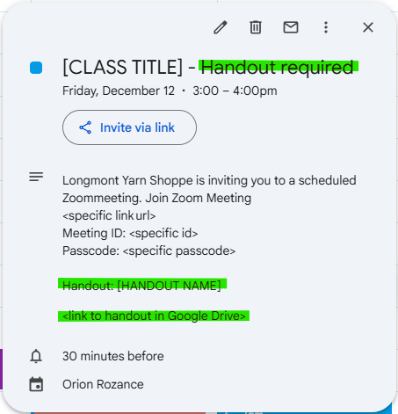
If the class requires a handout, download it now
- Navigate to the handout in the Google Drive
  - Click on the link to the handout in the calendar description
  - Locate general classes by season/year. Locate Fiber Friday handouts in the Fiber Fridays folder under the instructor for relevant class
- The correct handout will be labeled with the class name like so: <Class Name.pdf>
  - If the class has more than one handout, the handout will be named with the class name and document name like so: <Class Name - Document Name.pdf>
- Double-click the correct document to open it
- Click the vertical 3 dot menu in the upper right, immediately to the left of the “Share” button
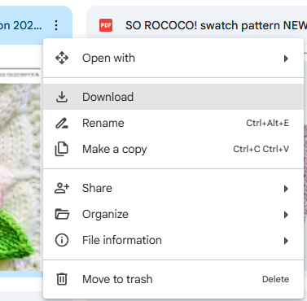
- Click the “Download” option in the menu
- The Downloads folder should open automatically in a new window
  - If a folder other than Downloads opens automatically, navigate to Downloads by clicking on “Downloads” in the left column of the new window. You may have to scroll to find it
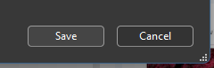
- Click the “Save” button in the bottom right corner. Do not change the name of the file
  - If a warning appears saying the file already exists, click “Yes” to replace the older file with the current version
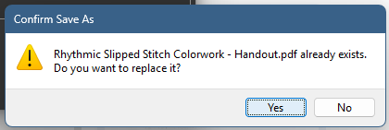

Locate the Zoom link
Most of the time, the Zoom link will be in the calendar event description for the class. If the Zoom link is present, continue. If the Zoom link is not present, complete the steps in Creating a Zoom Event before continuing

Download the roster
- Click on Reports from the lefthand menu to open the Reports page
- Click on Services > Classes to open the list of class reports
- Click on the name of the relevant class to open its report
- Click the “Export” option on the right
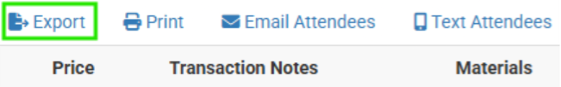
- The Downloads folder should open automatically in a new window.
  - If the Downloads folder does not open automatically, navigate to it by clicking on “Downloads” in the left column of the new window. You may have to scroll down to find it.
- Save the file in the Downloads folder as “<Name of Class> Roster”

If there is no handout
The Zoom link can be sent through Rain if there are no additional materials to send
- Click on Reports from the lefthand menu to open the Reports page
- Click on Services > Classes to open the list of class reports
- Click on the name of the relevant class to open its report
- Click the “Email Attendees” option on the right
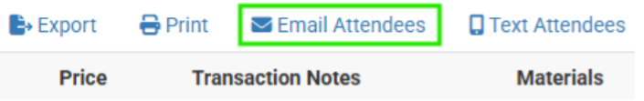
- Enter “<Name of Class> Zoom Link” in the Email Subject field
- Copy the Zoom link and passcode from the calendar event
- Write a short message with the pasted Zoom link in the Email Body field. Template provided. The entire block of highlighted text can be copied from the calendar event. If class takes place on a Tuesday, change “tomorrow” to be more appropriate:
Hello,
Here is the Zoom link for [Class Name] at [Time of Class] tomorrow:
Longmont Yarn Shoppe is inviting you to a scheduled Zoom meeting. Join Zoom Meeting
<specific link url>
Meeting ID: <specific id>
Passcode: <specific passcode>
See you there!
LYS Team [or your name]
- Click the “Send Email” button to send

The roster must then be sent separately to the instructor
- If the Zoom class is a Fiber Friday, the instructor’s email can be found in the Google Drive at My Drive > Classes @ LYS > Fiber Friday Handouts > Fiber Friday Teacher Contact Info
- If the Zoom class is not a Fiber Friday, the instructor’s email can be found in the Google Drive at My Drive > LYS Contact List
- Select the correct email and press Ctrl+C to copy it
- Open the Zoho email (info@longmontyarn.com) in a new tab
- Create a new email
- Select the “To” field and press Ctrl+V to paste the instructor’s email
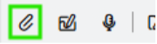
- Set the subject as “<Name of Class> Zoom Link and Roster”
- Click the Attachment icon on the toolbar
- Click “Upload Files” to open the File Explorer
- Navigate to the Downloads folder and select the roster downloaded above
- Click the “Attach” button in the lower left corner
- Write a short message with the pasted Zoom link in the Email Body field. Template provided. The entire block of highlighted text can be copied from the calendar event. If class takes place on a Tuesday, change “tomorrow” to be more appropriate:
Hello <Instructor Name>,
Here is the Zoom link and handout for [Class Name] at [Time of Class] tomorrow:
Longmont Yarn Shoppe is inviting you to a scheduled Zoom meeting. Join Zoom Meeting
<specific url>
Meeting ID: <specific id>
Passcode: <specific passcode>
We’ll open the Zoom room for you about 15 minutes before the class starts in case we need time to troubleshoot.
I’ve also attached the roster to this email, and we will send an updated roster if anyone signs up between now and the class.
See you then!
LYS Team [or your name]
- Send the email after verifying that the roster uploaded fully
- After all emails are sent, navigate back to the calendar event
- Right click the calendar event to open the color menu
- Click the green option to indicate the recording is sent
If there is a handout
The Zoom link and handout must be sent through email
- Open the roster that you downloaded above
- Click on the first email in the “Emails” column and drag down to the end of the list to select all of the emails
- Press Ctrl+C to copy the list of emails
- Open the Zoho email (info@longmontyarn.com) in a new tab
- Create a new email
- Click the “Bcc” on the right side of the “To” line
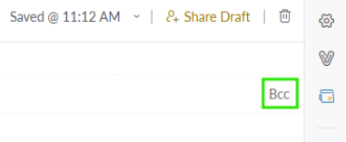
- Press Ctrl+V to paste the email list into the “Bcc” field
- Press Enter to automatically separate the emails

- Set the subject as “<Name of Class> Zoom Link and Handout”
- Click the Attachment icon on the toolbar
- Click “Upload Files” to open the File Explorer
- Navigate to the Downloads folder and select the handout downloaded above
- Click the “Attach” button in the lower left corner
- Copy the Zoom link and passcode from the calendar event
- Write a short message with the pasted Zoom link in the Email Body field. Template provided. The entire block of highlighted text can be copied from the calendar event. If class takes place on a Tuesday, change “tomorrow” to be more appropriate:
Hello,
Here is the Zoom link and handout for [Class Name] at [Time of Class] tomorrow:
Longmont Yarn Shoppe is inviting you to a scheduled Zoom meeting. Join Zoom Meeting
<specific url>
Meeting ID: <specific id>
Passcode: <specific passcode>
See you there!
LYS Team [or your name]
- Send the email after verifying the handout uploaded fully

Next we send everything to the instructor.
- If the Zoom class is a Fiber Friday, the instructor’s email can be found in the Google Drive at My Drive > Classes @ LYS > Fiber Friday Handouts > Fiber Friday Teacher Contact Info
- If the Zoom class is not a Fiber Friday, the instructor’s email can be found in the Google Drive at My Drive > LYS Contact List
- Select the correct email and press Ctrl+C to copy it
- Back in the email tab, open the “Sent” email folder
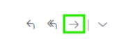
- Select the email you just sent to the students
- Select the “Forward” option from the right menu
- Press Ctrl+V to paste the instructor’s email in the “To” field

- Set the subject as “<Name of Class> Zoom Link and Roster”
- Click the Attachment icon on the toolbar
- Click “Upload Files” to open the File Explorer
- Navigate to the Downloads folder and select the roster downloaded above
- Click the “Attach” button in the lower left corner
- Write a short message in the Email Body field. Template provided:
Hello <Instructor Name>,
Here is the email I just sent to your students with the Zoom link and handout. I’ve attached the roster to this email, and we will send an updated roster if anyone signs up between now and the class.
We’ll open the Zoom room for you about 15 minutes before the class starts in case we need time to troubleshoot.
See you then!
LYS Team [or your name]
- Send the email after verifying that the roster uploaded fully
- After all emails are sent, navigate back to the calendar event
- Right click the calendar event to open the color menu
- Click the green option to indicate the recording is sent

Starting the Class
The Zoom room needs to be opened 15 minutes before the class starts on the HP laptop (Ravelry station)
- Open a new tab in the browser
- Click the search bar at the top of the window and type “zoom.us” then hit “Enter”
You will likely need to log in to Zoom. If you are automatically logged in, continue to step 7
Most classes take place on Zoom 1. If a class takes place on Zoom 2, it will be labeled as such in the calendar. This happens if Zoom 1 is being used for a different event at the same time
- Locate the login information for the correct Zoom account with the logins in the back of the Staff Resources binder
  - There is one binder located in by the back computer and one located in a drawer at the front computer
- Click the “Sign In” button in the top right of the Zoom home page

- Type the email for the correct Zoom account in the Email/Phone number field
  - Zoom 1 uses the info@longmontyarn.com email; Zoom 2 uses business@longmontyarn.com
- Type the correct password in the Password field and hit “Enter” to sign in
- Click “Meetings” in the menu on the left
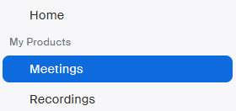
- Hover over the correct Zoom event and click the “Start” button that appears
- Click the “Participants” button on the left of the center menu to open the participants list
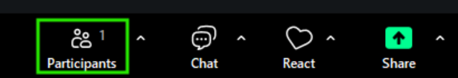
- When the instructor joins, click the “Admit” button that appears next to their name
- After greeting the instructor, make them co-host by clicking on the three dot menu in the upper corner of their video and selecting the “Make Co-host” option
- In the participants window, click the three dot menu in the lower corner and ensure the following:
  - “Mute participants upon entry” is on
  - “Play sound when someone joins or leaves” is off
- Help the instructor with anything they may need regarding cameras, screenshare, etc. Normally they don’t need help
- When the time comes (either at the start time of the class or a few minutes before, at the instructor’s discretion), click the “Admit All” button in the participant window to let everyone from the waiting room in
- Click the “Record” button toward the right of the center menu, then select “Record to cloud”
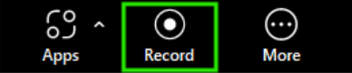
- Wait a few minutes into the class while watching the participant list to admit any late arrivals using the same method as above
- Leave the meeting by clicking the “Leave” button on the bottom right
  - It is important to click “Leave” and not “End Meeting for All” so that the meeting can continue once you leave. Since the instructor was made co-host, they will become host when you leave the meeting

Sending the Recording
Send the recording to the students and instructor the next working day after the class takes place.
- Open a new tab in the browser
- Click the search bar at the top of the window and type “zoom.us”
If the calendar event indicates Zoom 2, use the Zoom 2 login information for the steps below. Else, use the Zoom 1 login information
- Locate the login information for the correct Zoom account with the logins in the back of the Staff Resources binder
  - There is one binder located in by the back computer and one located in a drawer at the front computer
- Click the “Sign In” button in the top right of the Zoom home page

- Type the email for the correct Zoom account in the Email/Phone number field
  - Zoom 1 uses the info@longmontyarn.com email; Zoom 2 uses business@longmontyarn.com
- Type the correct password in the Password field and hit “Enter” to sign in
- Click “Recordings” in the menu on the left
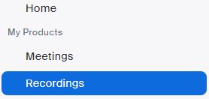
- Click on the recording for the relevant class, which should be labeled with the class name
- Click the “Share” button
- Open the share settings
- Set the expiration date to 7 days from the current date
- Set the password to something relevant to the class topic
- Save the share settings
- Copy the recording link and password from the share information
Sending the recording to students
- Open a new tab and go to Rain
- Click on Reports from the lefthand menu to open the Reports page
- Click on Services > Classes to open the list of class reports
- Click on the name of the relevant class to open its report
- Click the “Email Attendees” option on the right

- Enter “<Name of Class> Recording” in the Email Subject field
- Write a short message with the pasted Zoom link in the Email Body field. Template provided. The entire block of highlighted text is copied and pasted from the Zoom recording share information
Hello,
Thanks for joining us for yesterday’s class! Below is the link to the recording, which will be available for 7 days.
Recording link: <specific link url>
Passcode: <specific passcode>
Best,
LYS Team [or your name]
- Click the “Send Email” button to send
Sending the recording to the instructor
- Open a new tab and go to the Zoho email
- In the “Sent” folder, locate the email with the zoom information sent to the instructor
- Click the “Reply” button to start a new email to the instructor on the same email thread
- Write a short message with the pasted Zoom link. Template provided. The entire block of highlighted text is copied and pasted from the Zoom recording share information
Hello <instructor name>,
Here’s the Zoom recording of yesterday’s class if you want to watch it, it’s available for the next 7 days.
Recording link: <specific link url>
Passcode: <specific passcode>
Thanks for a great class!
LYS Team [or your name]
- If the Task List mentions that an updated roster should be sent, follow the steps from Download the Roster to get the updated roster for the class

- Back in the email tab, click the Attachment icon on the toolbar
- Click “Upload Files” to open the File Explorer
- Navigate to the Downloads folder and select the roster downloaded above
- Click the “Attach” button in the lower left corner
- Send the email after verifying that the roster uploaded fully
- After all emails are sent, navigate back to the calendar event
- Right click the calendar event to open the color menu
- Click the yellow option to indicate the recording is sent

Creating a Zoom Event
- Open a new tab in the browser
- Click the search bar at the top of the window and type “zoom.us” then hit “Enter”
You will likely need to log in to Zoom. If you are automatically logged in, continue to step 7
Most classes take place on Zoom 1. If there is already a Zoom event taking place during the class time, use Zoom 2.
- Locate the login information for the correct Zoom account with the logins in the back of the Staff Resources binder
  - There is one binder located in by the back computer and one located in a drawer at the front computer
- Click the “Sign In” button in the top right of the Zoom home page

- Type the email for the correct Zoom account in the Email/Phone number field
  - Zoom 1 uses the info@longmontyarn.com email; Zoom 2 uses business@longmontyarn.com
- Type the correct password in the Password field and hit “Enter” to sign in
- Click “Meetings” in the menu on the left

- Double check that the class is not listed in the meetings list
- Click the “Schedule a Meeting” button in the top right
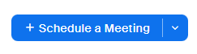
- Type the name of the class in the “Topic” field
- Set the date and time accordingly
- Click the “Save” button in the bottom left
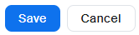
- Click “Copy Invitation” to open the Zoom meeting information
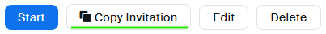
- Click “Copy Meeting Information” to copy everything
- Go to the Google calendar and double-click the calendar event
- Paste the Zoom meeting information into the description
- Click the “Save” button

