|  |
| --- |
| Министерство образования Российской Федерации  Пензенский государственный университет  Кафедра «Вычислительная техника» |
| Отчет  по лабораторной работе №6  по курсу «Логика и основы алгоритмизации в инженерных задачах» на тему «Поиск расстояний в графе» |
|  |
|  |
| Выполнила студентка группы 19ВВ3:  Ланцов А.С.  Принял:  Митрохин М. А. |
| Пенза  2020 |

## Поиск в ширину

### **Для матричной формы**

Листинг:

#define _VALUE_OF(type,pointer) *((type*)pointer)  
#define new(type) malloc(sizeof(type))  
#define new_const(type,value) &((type){value})  
#define new_block(type,how_much) malloc(sizeof(type)*how_much)  
#define del(ptr) free(ptr)  
  
#define _FOR_(index,range) for(int index=0;index<range;index++)

typedef struct numbers_s {  
 int* data;  
 size_t size;  
}numbers_t;

numbers_t* numbers(int size){  
 numbers_t* arr = new(numbers_t);  
 arr->data = new_block(int,size);  
 arr->size = size;  
  
 return arr;  
}

void fill_num(numbers_t* arr,int value){  
 _FOR_(i,arr->size){  
 arr->data[i]=value;  
 }  
}

void test_bfs_matrix(int SIZE,int vrtx){  
 printf("\nBFS distances, matrix graph\n");  
 mtrx_grph_t* matrix_graph = matrixGraph_create(SIZE);  
  
 srand( time(NULL) );  
 init_random_symetric_matrix(matrix_graph->matrix,SIZE,0.2);  
 row(matrix_graph->vertexes,SIZE,0);  
  
 print_graph(matrix_graph);  
  
 numbers_t* distances = numbers(SIZE);  
 printf("Breadth-first search from '%d'\n",vrtx);  
 clock_t start_time, finish_time;  
  
 bfs_matrix(matrix_graph,vrtx,distances);  
  
 double wait_time = (double)(finish_time - start_time) / CLOCKS_PER_SEC;  
 printf("Time:%f s\n",wait_time);  
  
 dist_log(matrix_graph->vertexes,vrtx,distances);  
  
 free(distances->data);  
 free(distances);  
}

void bfs_matrix(mtrx_grph_t* graph,int vertex_index,numbers_t* dist){  
 //every i in dist = -1  
 fill_num(dist,-1);  
  
 lim_queue* vertexes_queue = lim_queue_create(graph->size);  
 lim_queue_push(vertexes_queue,vertex_index);  
   
 int v;//next vertex  
 int* front;  
 dist->data[vertex_index] = 0;  
  
 printf("%d,",vertex_index);  
 while (vertexes_queue->length > 0){  
 v = lim_queue_pop(vertexes_queue);  
   
 _FOR_(i,graph->size){  
 if (graph->matrix[v][i] && dist->data[i]==-1) {  
 lim_queue_push(vertexes_queue,i);  
   
 dist->data[i]=dist->data[v]+1;  
 printf("%d,",i);  
 }  
 }  
 }  
 printf("\n\n");  
 lim_queue_free(vertexes_queue)  
}

Результат:  
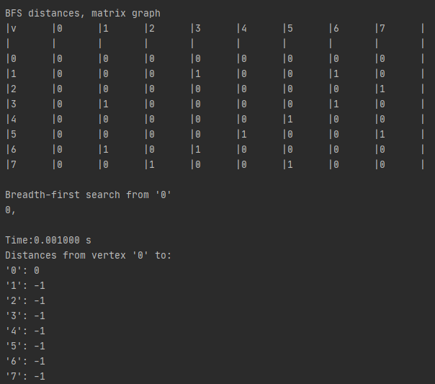

### **Для листовой формы**

Листинг:

void bfs_lists(list_graph_t* graph,int vertex_index,numbers_t* dist){  
 fill_num(dist,-1);  
 list_t* vertexes_queue = list_create();  
 que_insert(vertexes_queue,new(int));  
 _VALUE_OF(int,vertexes_queue->tail->value) = vertex_index;  
  
 int v,u;//next vertex  
 node_t* next_vrtx;  
 dist->data[vertex_index] = 0;  
 int* front;  
  
 print_vertex("%v,",graph->vertexes[vertex_index]);  
 while (!que_isempty(vertexes_queue)){  
 front = que_remove(vertexes_queue);  
 v = _VALUE_OF(int,front);  
 del(front);  
  
 next_vrtx = graph->lists[v]->head;  
  
 while(next_vrtx->next){  
 next_vrtx = next_vrtx->next;  
 u = get_vertex_index(graph->vertexes,get_vrtx_name(next_vrtx->value),graph->size);  
 if(dist->data[u]==-1){  
 que_insert(vertexes_queue,new(int));  
 _VALUE_OF(int,vertexes_queue->tail->value) = u;  
 dist->data[u]=dist->data[v]+1;  
  
 print_vertex("%v,",graph->vertexes[u]);  
 }  
  
 }  
  
 }  
 printf("\n\n");  
 free(vertexes_queue);  
}

void test_bfs_lists(int SIZE,int vrtx_index){  
 printf("\nBFS distances, lists graph\n");  
 mtrx_grph_t* matrix_graph = matrixGraph_create(SIZE);  
  
 srand( time(NULL) );  
 init_random_symetric_matrix(matrix_graph->matrix,SIZE,0.2);  
 row(matrix_graph->vertexes,SIZE,0);  
  
 list_graph_t* list_graph = matrix_to_list(matrix_graph);  
 print_list_graph(list_graph);  
  
 numbers_t* distances = numbers(SIZE);  
 printf("Breadth-first search from ");  
 print_vertex("'%v'\n",list_graph->vertexes[vrtx_index]);  
 bfs_lists(list_graph,vrtx_index,distances);  
 dist_log(matrix_graph->vertexes,vrtx_index,distances);  
}

Результат:  
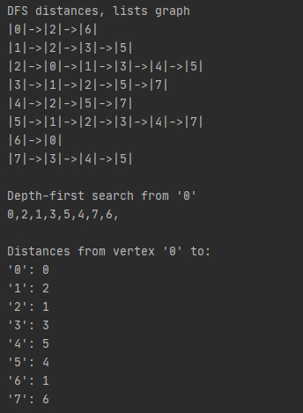

## Поиск в длину

### **Для матричной формы**

Листинг:

void hardStack_matrix_dist(mtrx_grph_t* graph, int v_index, numbers_t* dist){  
 printf("%d,",graph->vertexes[v_index]);  
 for (int i=0; i<graph->size; i++){  
 if (graph->matrix[v_index][i] && dist->data[i]==-1){  
 dist->data[i] = dist->data[v_index]+1;  
 hardStack_matrix_dist(graph,i,dist);  
 }  
 }  
}

void dfs_matrix(mtrx_grph_t* graph, int v_index, numbers_t* dist){  
 fill_num(dist,-1);  
 dist->data[v_index] = 0;  
 hardStack_matrix_dist(graph,v_index,dist);  
 printf("\n\n");  
}

void test_dfs_matrix(int SIZE, int vrtx){  
 printf("DFS distances, matrix graph\n");  
 mtrx_grph_t* matrix_graph = matrixGraph_create(SIZE);  
 srand( time(NULL) );  
  
 init_random_symetric_matrix(matrix_graph->matrix,SIZE,0.5);  
 row(matrix_graph->vertexes,SIZE,0);  
  
 print_graph(matrix_graph);  
  
 numbers_t* distances = numbers(SIZE);  
  
 printf("Depth-first search from '%d'\n",vrtx);  
 dfs_matrix(matrix_graph,vrtx,distances);  
 dist_log(matrix_graph->vertexes,vrtx,distances);  
}

Результат:

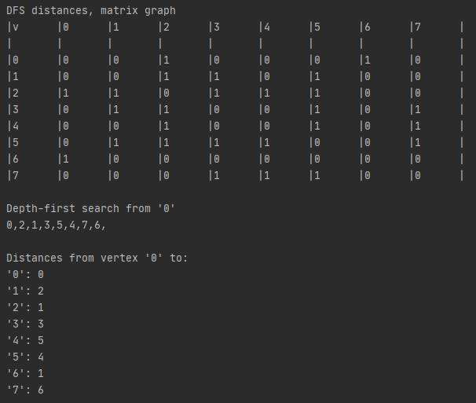

### **Для листовой формы**

void hardStack_lists_dist(list_graph_t* graph,int v_index, numbers_t* dist){  
 node_t* next = graph->lists[v_index]->head;  
 int next_index;  
  
 printf("%d,",graph->vertexes[v_index].name);  
 for (int i=0; i<graph->lists[v_index]->depth; i++){  
 next_index=get_vertex_index(graph->vertexes,get_vrtx_name(next->value),graph->size);  
 if (dist->data[next_index]==-1) {  
 dist->data[next_index] = dist->data[v_index]+1;  
 hardStack_lists_dist(graph, next_index,dist);  
 }  
 next = next->next;  
 }  
}

void dfs_lists(list_graph_t* graph, int v_index, numbers_t* dist){  
 fill_num(dist,-1);  
 dist->data[v_index] = 0;  
 hardStack_lists_dist(graph,v_index,dist);  
 printf("\n\n");  
}

void test_dfs_lists(int SIZE, int vrtx){

printf("\nDFS distances, lists graph\n");  
 mtrx_grph_t* matrix_graph = matrixGraph_create(SIZE);  
  
 srand( time(NULL) );  
 init_random_symetric_matrix(matrix_graph->matrix,SIZE,0.5);  
 row(matrix_graph->vertexes,SIZE,0);  
  
 list_graph_t* list_graph = matrix_to_list(matrix_graph);  
 print_list_graph(list_graph);  
  
 numbers_t* distances = numbers(SIZE);  
 printf("Depth-first search from '%d'\n",vrtx);  
 dfs_lists(list_graph,vrtx,distances);  
 dist_log(matrix_graph->vertexes,vrtx,distances);

}

Результат:

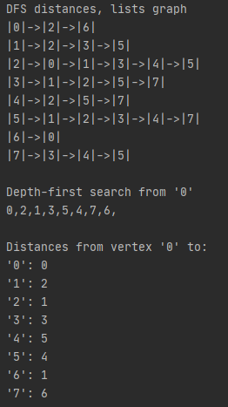

## Приложение

Структуры:  
typedef struct node{  
 uint8_t* value;  
  
 struct node* last;  
 struct node* next;  
}node_t;  
  
typedef struct list{  
 node_t* head;  
 node_t* tail;  
  
 int depth;  
  
}list_t;

typedef struct matrix_graph{  
 int** src;  
  
 int** matrix;  
 char** vertexes;  
 int size;  
  
}mtrx_grph_t;

typedef struct list_graph{  
 list_t** lists;  
 uint8_t** vertexes;  
  
 int size;  
}list_graph_t;

typedef struct vertex_s{  
 int name;  
 char color;  
}vertex;  
  
#define get_vrtx_color(pointer) (*((vertex*)pointer)).color  
#define get_vrtx_name(pointer) (*((vertex*)pointer)).name

Очередь:

int que_isempty(list_t* queue){  
 if(queue->head==0)  
 return 1;  
 else  
 return 0;  
}

void que_insert(list_t* queue, void* value) {  
 queue->tail = push(queue->tail,value);  
 if(queue->head==0) {  
 queue->head = queue->tail;  
 }  
  
 queue->depth ++;  
}  
  
void* que_remove(list_t* queue) {  
 if(que_isempty(queue)) {  
 return 0;  
 }  
 else{  
 node_t* temp;  
 void* head_value;  
  
 head_value = queue->head->value;  
 temp = queue->head;  
 queue->head = queue->head->next;  
  
  
 if(!queue->head){//if queue is empty now  
 queue->tail=NULL;  
 }  
 else{  
 queue->head->last = NULL;  
 }  
  
 free(temp);  
  
 queue->depth --;  
 return head_value;  
 }  
  
}

typedef struct limited_queue_s {  
 int* data;  
 size_t first;  
 size_t last;  
 size_t value_size;  
 size_t length;  
 size_t limit;  
  
}lim_queue;  
  
#define lim_queue_free(q) \  
free(q->data);\  
free(q);

lim_queue* lim_queue_create(size_t limit){  
 lim_queue* queue = malloc(sizeof(lim_queue));  
  
 queue->data = malloc(sizeof(int)*limit);  
 queue->limit = limit;  
 queue->length = 0;  
 queue->first = 0;  
 queue->last = -1;  
  
 return queue;  
}  
  
int lim_queue_push(lim_queue* queue,int value){  
 queue->length ++;  
  
 if (queue->length <= queue->limit){  
 queue->last++;  
 queue->data[queue->last]=value;  
 return 1;  
 }  
 else{  
 return 0;  
 }  
}  
  
int lim_queue_pop(lim_queue* queue){  
 queue->length --;  
  
 if (queue->length >= 0){  
 queue->first++;  
 return queue->data[queue->first-1];  
 }  
 else{  
 return NULL;  
 }  
}