A Novel Approach to achieve ignition locking on detection of Drunk Driving

Yashna Jha Karthik Shivaram

Information Science Engineering Computer Science Engineering

PES Institute of Technology-Bangalore South Campus, PES Institute of Technology-Bangalore South Campus,

Bangalore-560100, Karnataka, India Bangalore -560100, Karnataka, India

yashnajha@gmail.com karthik.shivram96@gmail.com

Pratibha Agarwal

Information Science Engineering

PES Institute of Technology-Bangalore South Campus,

Bangalore-560100, Karnataka, India

pagarwal2610@gmail.com

*ABSTACT —The number of cases of drunken driving is growing. This article proposes a cheap and effective setup integrated into the vehicles interlock system and the ignition. The setup requires a breath sample of the driver before turning the key in the ignition. The decision to allow the vehicle to start depends to the blood alcohol content of the driver*

*Index Terms*—Drunk Driving, Blood Alcohol Content (BAC), ignition.

# Introduction

Driving while either intoxicated or drunk is dangerous and drivers with high blood alcohol content are at increased risk of car accidents, highway injuries and vehicular deaths. Prevention measures attempted so far include license suspension or revocation, impounding or confiscating vehicle plates, increasing fine penalties and even imprisonment for serious cases of negligence.

This paper discusses the design of an Automatic Alcohol Detector integrated with the vehicles on board media system and the interlock system, along with a hardwired connection to the vehicle’s ignition motor. An alcohol breathalyzer is used to monitor the drivers BAC level. The alcohol sensor requires a sample from the driver. The detection of an alcoholic breath disallows the driver to turn on the ignition. The sensor further collects data over the drive travel time to ensure no inebriation occurs while at the wheel. This project is aimed to increase safety of passengers and innocent bystanders.

# Past statistics

In the World Health Organization’s Global Status Report on road safety [1-3]. The report results suggests that 90% of the deaths due to road accidents occur in low and middle income countries(21.5 and 19.5 per lakh of population, respectively) but having only 48% of all registered vehicles. As far as India is concerned, it has the second largest road network in the world which majorly contributes to its economy and expands over 3 million km out of which only 60% is paved. According to a Government survey, road accidents in 2010 caused about 1,34,000 deaths in India which is an average of 336 deaths per day [4].

Drunken driving has been identified as the major cause of road accidents in India. Due to lack of good quality research data, the problem has been largely unacknowledged. Alcohol and Drug Information Centre (AIDC), India [5] has revealed the results of a recent study which states that influence of alcohol is responsible for about 40% of the occurred road accidents.

In a multi-Centre, collaborative study- ‘Injury and Alcohol’ [6] atNational Institute of Mental Health and Neuro Sciences (NIMHANS) Bangalore, a report initiated by WHO suggestedthat the proportion of injuries ‘linked’ to alcohol use was 58.9% of all injuries with 24% due to personal consumption of alcohol and 35% due to others drinking. It has been revealed that on the type of injuries amongst alcohol consumers, 46% were due to road accidents. In a study conducted in the Kerala state [7] by the Alcohol and Drug Information Centre, around 40% of the road accidents have occurred due to the driver being under the influence of alcohol. In case of National Highways [8], more than 72% of the road accidents have occurred due to drunken driving. In a survey conducted by Directorate of Prohibition [9], it was projected that 45% of the drivers in Delhi have driven under the influence of alcohol at least once. One of the most common scenarios includes car owners who attend dinners and parties and get drunk thereby indulging in rash driving. The drunken drivers of cars and two wheelers have been a cause of about60% and 65% of accidents caused during night and early hours of the morning.

# The setup

To emulate the system, the components used are

* Atmega 2560 MCU housed in an Arduino Mega
* a MQ-3 breathalyzer
* a DC motor to emulate the ignition motor
* a breadboard to connect the components
* an OLED display to emulate the Media Center of the vehicle
* a Bluetooth module HC-05 to provide Bluetooth connectivity to the system.

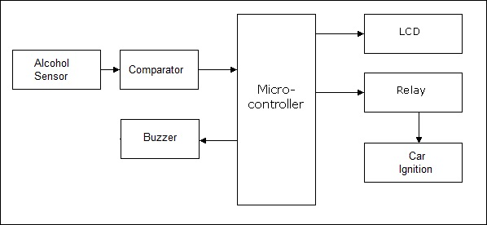

Figure1. Block Diagram of the proposed system [10]

A. MQ-3 Breathalyzer

MQ3 is an analog gas sensor (fig. 2) which can be used as a low-end breath analyzer. It is highly sensitive to alcohol but slightly sensitive to benzene. Its sensitivity can be adjusted using the potentiometer. SnO2 is the sensitive material in this sensor which has a lower conductivity in clean air. When a target alcohol gas exists, the sensor has higher gas conductivity along with rise in gas concentration. The change of conductivity is converted to corresponding output signal of gas concentration.

Figure 2. MQ-3 Alcohol Sensor [12]

Thus the sensitivity adjustment is very important. The detector must be calibrated for 0.04g/100ml of alcohol concentration in air and use a load resistance of about 200 KΩ.

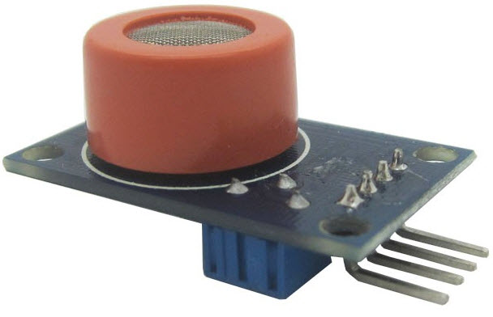

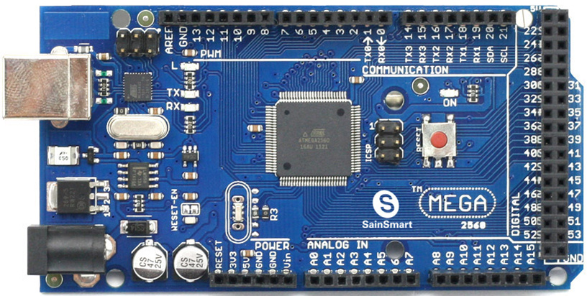

Figure 3. Arduino Mega 2560 [11]

1. Arduino Mega 2560 with the Atmega 2560 MCU (fig. 3)

The MCU has an operating voltage of 5V for the purpose of the emulation. It has 14Digital I/O Pins (of which 6 provide PWM output) and 6Analog Input Pins. It has 256 KB of flash memory of which 8 KB is used by bootloader.

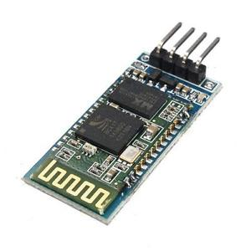

Figure 4. Bluetooth module HC-05[13]

Other components including the Bluetooth module HC-05(fig. 4) is a straight up shield for the Arduino range of boards with attached header files and built in functions to support it. The DC motor used is a simple 5V DC motor.

# Working

The system is powered by the battery within the vehicle. It requires a sample from the driver in order to turn the car on. If the BAC level registered by the sensor crosses a certain threshold, the driver will not be able to turn the ignition. The onboard MCU via the Bluetooth module will relay the statistics to a packaged app. The user will see an appropriate message and will be given further options to:

1. Call a trusted contact.
2. Send a message along with the user’s location.
3. Book a cab from the location.

The app will redirect the user to the appropriate screen. An appropriate message will also be displayed on the onboard media center screen if the system supports it.

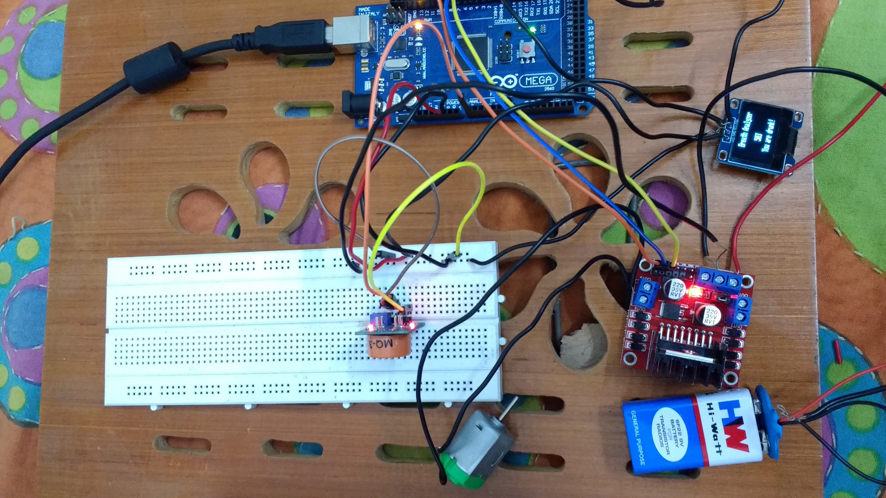

Figure 5. Circuit connections

This setup can further be coded to take readings at certain intervals throughout the drive to continuously tackle drinking while driving. On encountering such a case the vehicles interlock system will be activated which causes the vehicle to respond using audio alerts or vibrations, thus forcing the driver to slow down and stop his car. This approach appears much better rather than a misconceived idea of shutting down the engine instead which could lead to even more road disturbances.

# Impact and further development

With Financial support backed by governmental agencies and with further laws in place to support this, a record system that maintains a database containing the history of the offender’s vehicle number can be created. This can be extended to allow tracking by a monitoring agency that is linked to registered user’s license to avoid repeat offenders from attempting this task. This system can provide an impartial judgment towards the entire spectrum of offenders.

# ACKNOWLEDGEMENT

The authors gratefully acknowledgethe management of PES Institute of Technology-Bangalore South Campus(PESIT-BSC)for their support and encouragement towards carrying out this work.

# References

1. WHO-Road Safety Status 2015

http://www.who.int/violence_injury_prevention/road_safety_status/2015/en/

1. Alcohol Control Policies in South East Asia Region, Selected issues, WHO Alcohol Control Series3.
2. Benegal et al. *Alcohol and injury in emergency departments*: *summary of the report from the WHO collaborative study on alcohol and injuries* (in press). by the WHO Collaborative Study Group on Alcohol and Injuries.
3. MORTH (Ministry Of Transport and Highways) Annual report on road accidents in 2015

http://morth.nic.in/showfile.asp?lid=2143

1. http://www.adicindia.org/
2. Knowledge, Attitude and Social Behavior about the Use of Disposable Breath Analyzers for Preventing Road Accidents Due to Drink and Drive - A Cross-Sectional Study in Delhi-NCR- IRACST-International Journal of Research in Management& Technology (IJRMT), ISSN: 2249-9563 Vol. 4, No.5, October 2014 232
3. National Mental Health Survey of India, 2015-16

http://www.nimhans.ac.in/sites/default/files/u197/NMHS%20Report%20%28Prevalence%20patterns%20and%20outcomes%29%201.pdf

1. http://www.iracst.org/ijrmt/papers/vol2no42012/7vol2no4.pdf
2. From Delhi Police, under the list of the causes of accidents , https://delhitrafficpolice.nic.in/public-interface/traffic-offence/

[10] Block Diagram - http://www.projectsof8051.com

[11] Arduino mega 2560 - http://www.robotpark.com/Arduino- MEGA-2560-En

[12] Alcohol Sensor MQ3-

https://www.sparkfun.com/products/8880

[13] Bluetooth Module-

https://www.sparkfun.com/products/8880