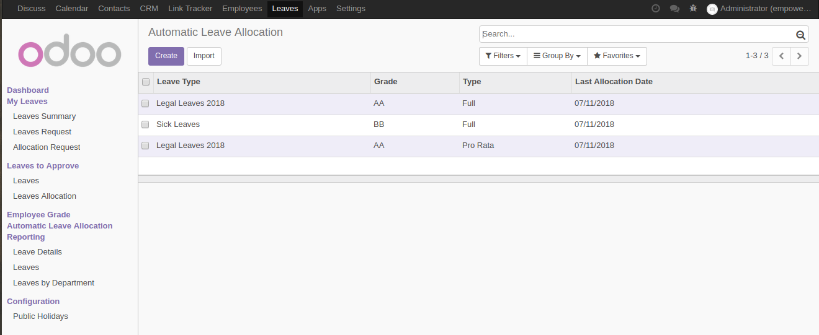

Configuration for automatic leave allocation.
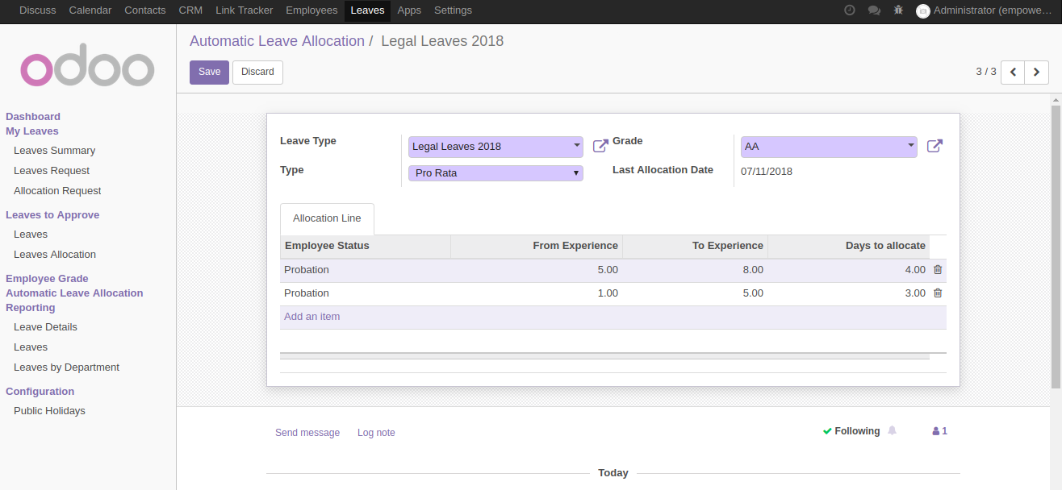
Set the Leave type and Allocation type and defind experience range with status in Allocation line.

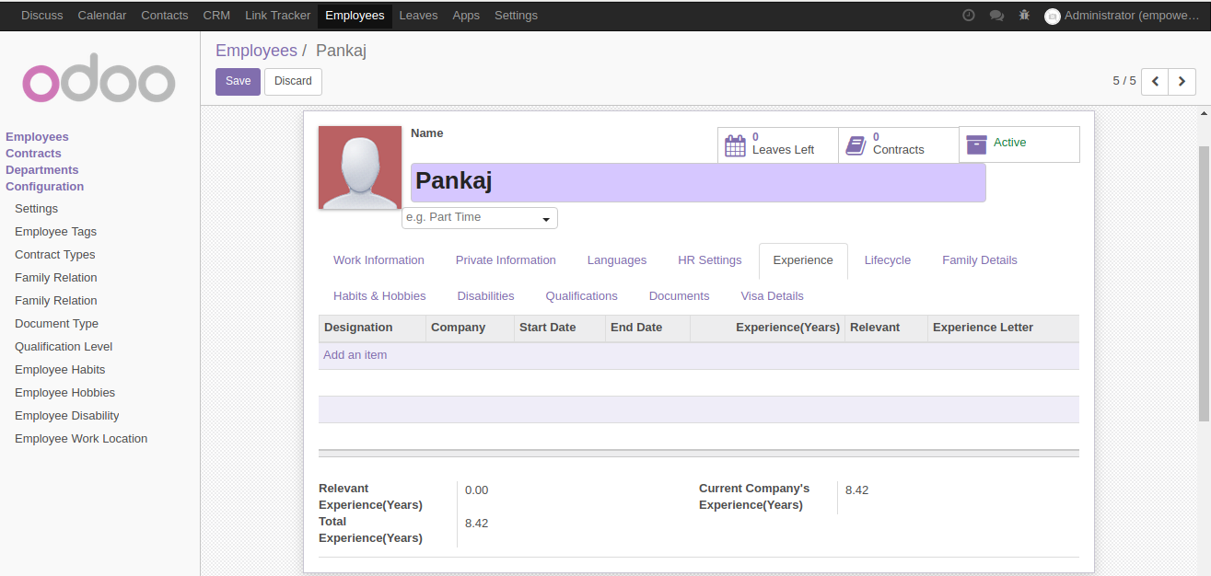
Based on Employee’s Status and his/her experience leave will be allocated to him/her.

Pro-rata leave will be allocated monthaly bases and Full leave will be allocated yearly.
