**Introduction:**

JustSnap is a Web-Application created for a user to take his/her physical money online and to do digital transactions giving him an extra feature of having a bank account.

**Functional Requirements:**

The functional requirements of the project are:

**For the User:**

* Login/Register
* Show Balance
* Deposit Money
* Withdraw Money
* Transfer Money
* Print Transactions
* Edit Profile
* Delete Account

**Micro-Services**

The different micro-services in which this project is divided into are:

* **User Service:** Register a new account and login as a user
* **UserMoeny Service:** Create a user account with wallet, bank, and card details
* **Transaction Service:** Stores the details of every transaction made my a user each time.

**Overall Architecture Diagram:**

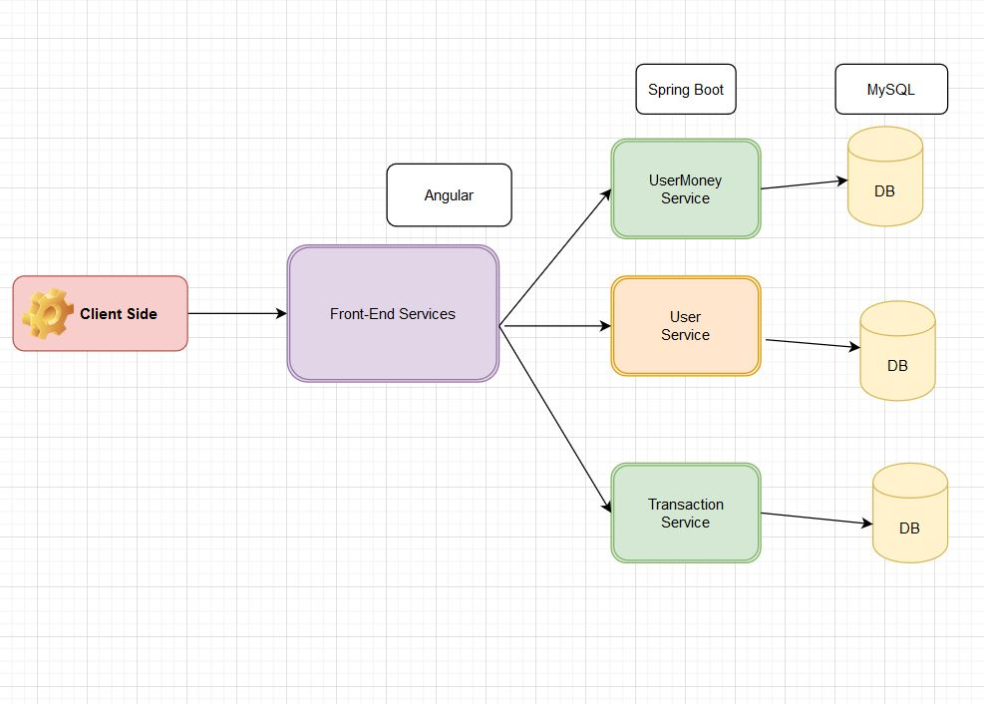

**Overall Entity Relationship Diagram:**

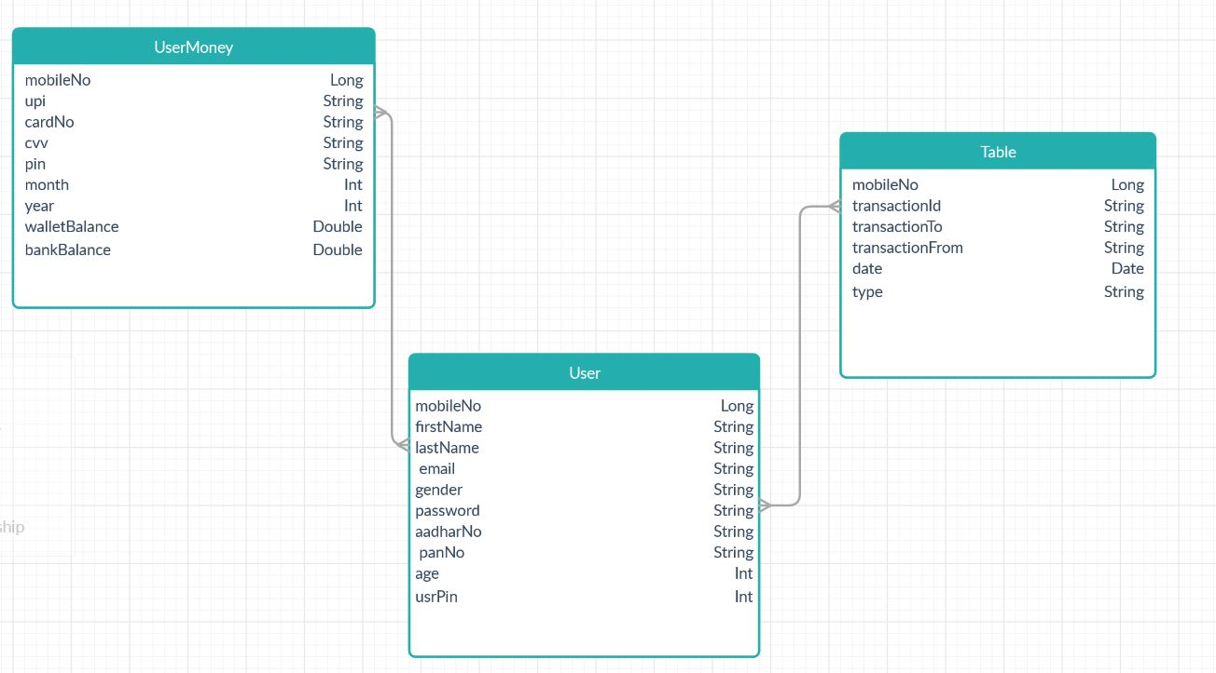

ACTIVITY DIAGRAMS

1. Register-

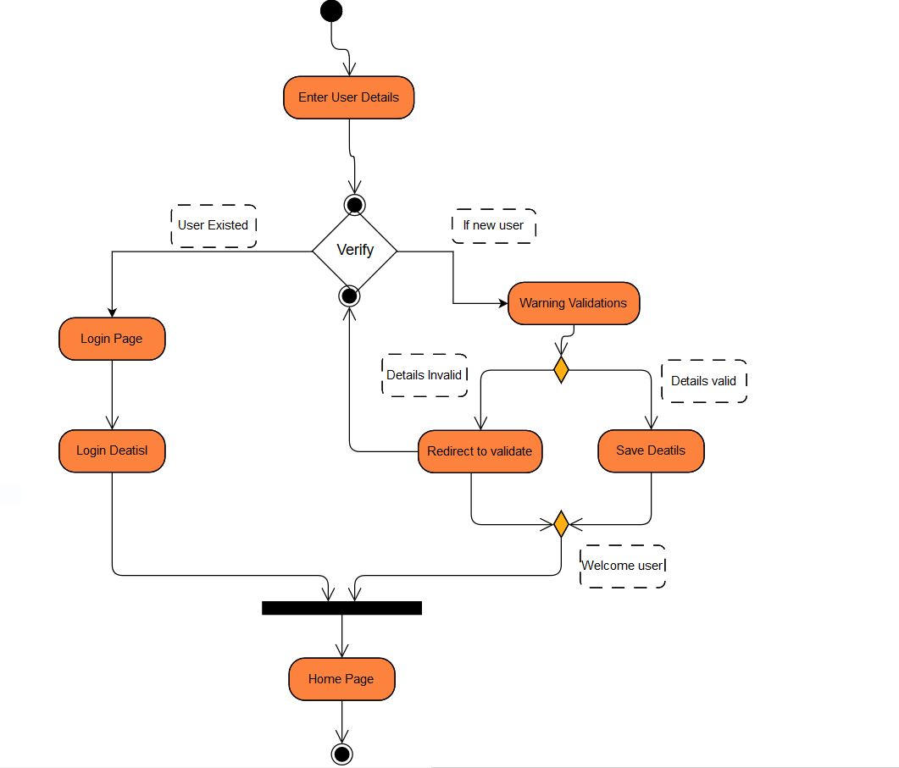

1. Login –

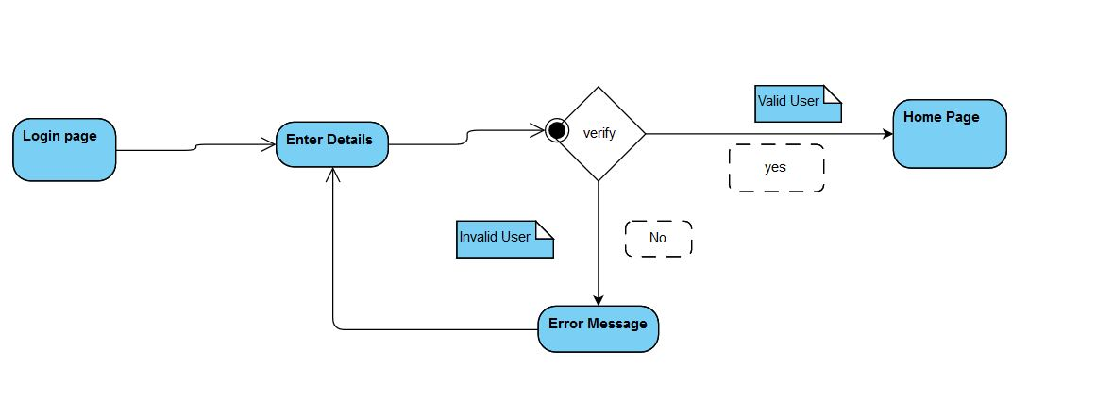

1. Deposit –

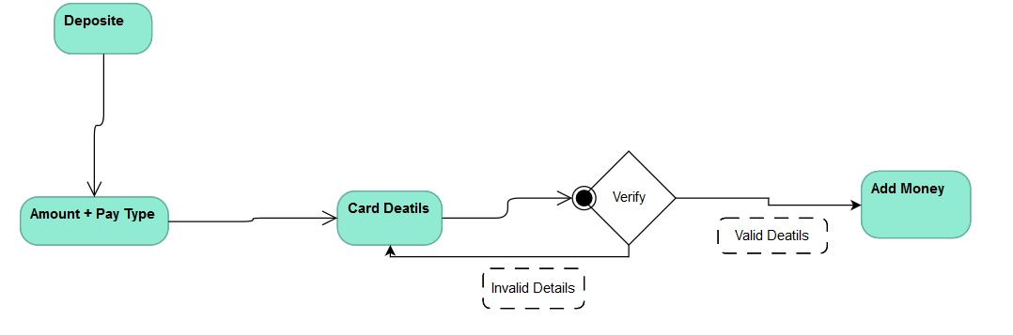

1. Withdraw –

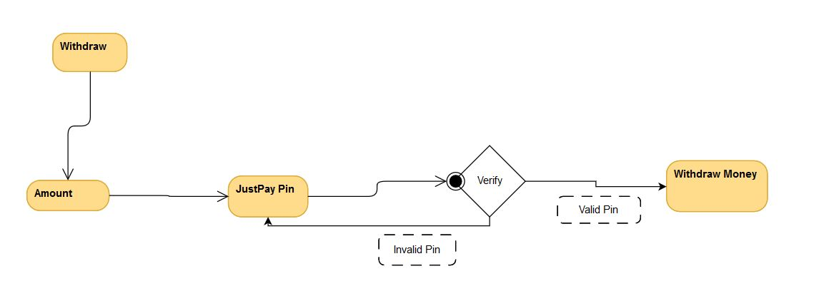

1. Transfer -

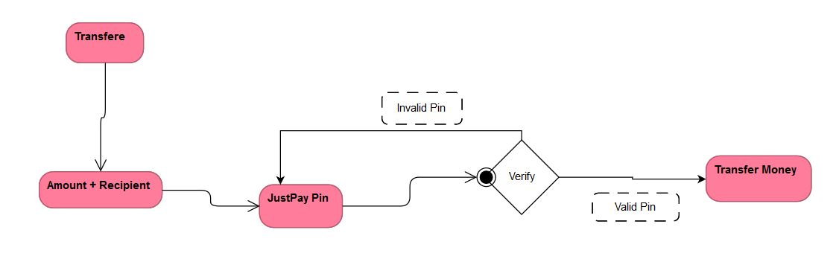

1. Delete –

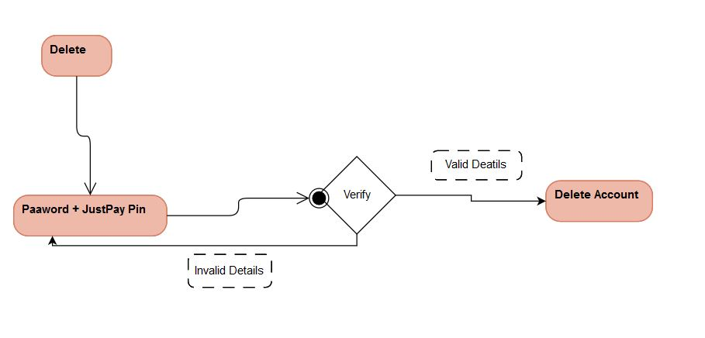

WIREF-RAMES

**User Service:**

1. Login –

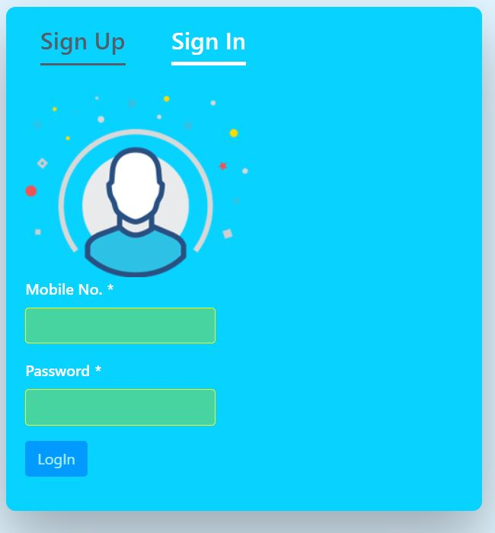

1. Register –

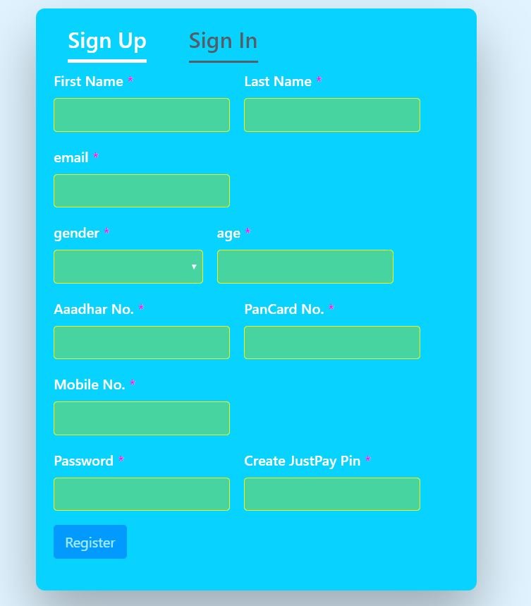

1. Show balance -

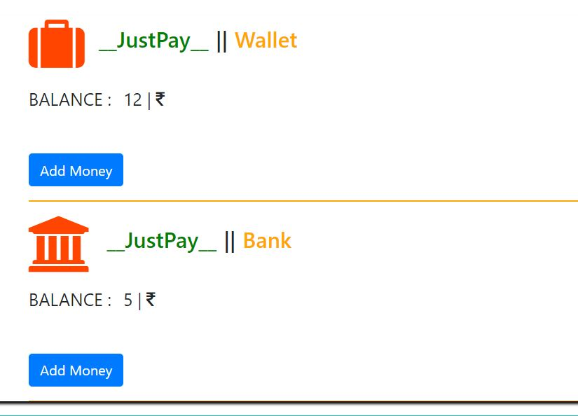

1. Deposit -

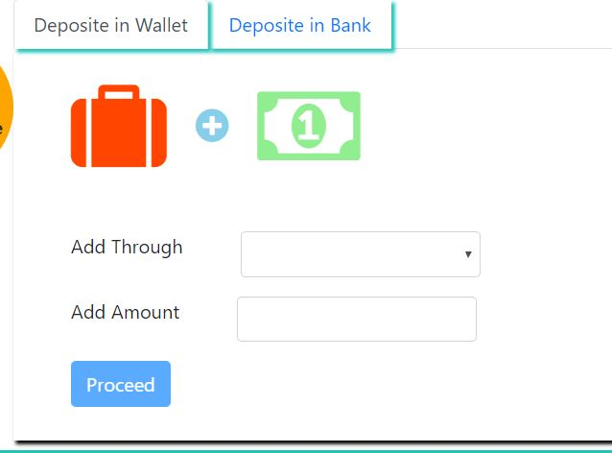

1. Withdraw -

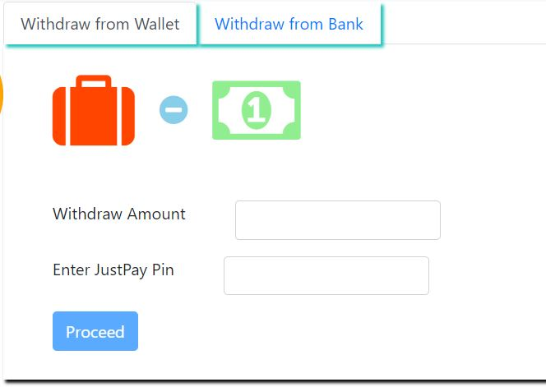

1. Transfer -

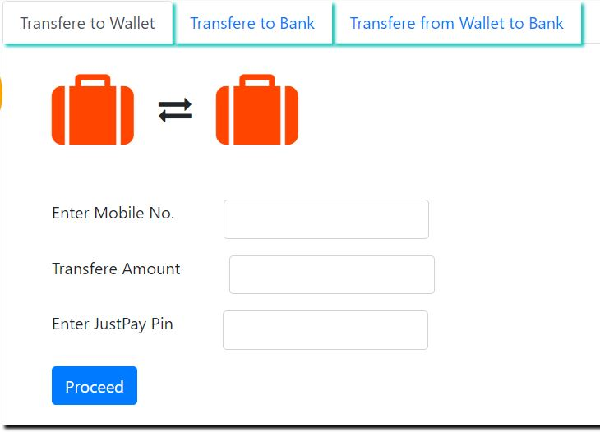

1. Transactions –



1. Profile

