University of Dhaka
Department of Computer Science & Engineering

Topic: Comparative Performance Analysis of Go-Back-N and Selective Repeat ARQ Mechanisms

Submitted by:
- Kashob Kumar Roy(Roll : 01)
- Syeed Abrar zaoad (Roll: 23 )
Submitted to:
Dr. Rezaul Karim
Professor, Department of Computer Science and
Engineering
University of Dhaka

Iffat Anjum
Lecturer, Department of Computer Science and Engineering
University of Dhaka
Submission Date: 09-11-17

INDEX

1. Problem definition:

2. Theoretical background
a. Definition of Go-Back-N ARQ
- History
- Operational principles
- Advantages

b. Definition of Selective Repeat ARQ
- History
- Operational principles
- Advantages

c. Key Differences between Go-Back-N and Selective Repeat
d. Comparison Chart

3. Working principle
a. Go-back-N and Selective Repeat Request protocols.
b. pseudo code
c. Main challenges and their solutions

4. Applications:

5. Comparative analysis

6.Graph
7. Observation
8. Conclusion

1. Problem definition
In this experiment, we have to implement both Go-Back-N and Selective Repeat ARQ mechanisms. Each of the implementations should have the
Window size n which will be taken from the user and sender should read data from a file (size >5MB) into 8 byte segments. We should also enclose our data (8 byte) within a defined structure with header, trailer and other flag information. CRC-16 computation should be done for frame structure.
Acknowledgements, negative acknowledgements should also follow similar
frame structure.We are told to create separate thread for each data frame sent.Timeout should be implemented for each data frame. Therefore each
frame should have its own thread which will die when the frames
acknowledged.
The receiver can send:
a) Both single and cumulative acknowledgements.
b) Negative acknowledgement is sent when an erroneous packet is
received.
c) There should be timer for both positive and negative
Acknowledgements.

For Go-Back-N ARQ and Selective Repeat ARQ: Window will slide and adjust on each in-order successful transmission. Situations like packet loss, error in packet, acknowledgement loss, error in acknowledgement, negative acknowledgement loss and error in negative acknowledgement should be considered.Upon receiving a packet we should perform CRC check and reconstruct the source file.

Input:
a)Window size n
b)File size greater than 5MB containing data
Output:
Reconstruction of the source file in receiver side.

Equipment required
- JDK latest version
- Java
3. Complete knowledge of Go-Back-N and Selective Repeat ARQ
4. netbeans IDE

2. THEORETICAL BACKGROUND:

a)Go-back-N ARQ

Go-Back-N ARQ is a specific instance of the automatic repeat requestr(ARQ) protocol, in which the sending process continues to send a number of frames specified by a window size even without receiving an acknowledgement (ACK) packet from the receiver. It is a special case of the general sliding window protocol with the transmit window size of N and receive window size of 1. It can transmit N frames to the peer before requiring an ACK.
The receiver process keeps track of the sequence number of the next frame it expects to receive, and sends that number with every ACK it sends. The receiver will discard any frame that does not have the exact sequence number it expects (either a duplicate frame it already acknowledged, or an out-of-order frame it expects to receive later) and will resend an ACK for the last correct in-order frame. Once the sender has sent all of the frames in its window, it will detect that all of the frames since the first lost frame are outstanding, and will go back to the sequence number of the last ACK it received from the receiver process and fill its window starting with that frame and continue the process over again.

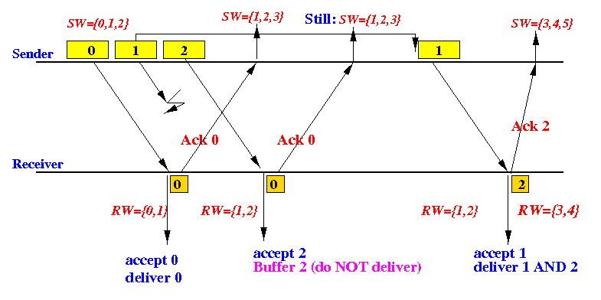

Advantages:
There are some advantages of Go-Back-N ARQ. They are given below
- No receiver transport buffering with discard
- Receive window size in only 1. So resources needed at receiver is limited.
- It avoids large bursts of packet delivery to higher layers
- Buffering and protocol processing at sender and receiver is simple and less complex.
So in less noisy channel , this mechanism serves great.

a)Selective Repeat ARQ
it may be used as a protocol for the delivery and acknowledgement of message units, or it may be used as a protocol for the delivery of subdivided message sub-units.
When used as the protocol for the delivery of messages, the sending process continues to send a number of frames specified by a window size even after a frame loss. Unlike Go-Back-N ARQ, the receiving process will continue to accept and acknowledgement frames sent after an initial error; this is the general case of the sliding window protocol with both transmit and receive window sizes greater than 1.
The receiver process keeps track of the sequence number of the earliest frame it has not received, and sends that number with every acknowledgement(ACK) it sends. If a frame from the sender does not reach the receiver, the sender continues to send subsequent frames until it has emptied its window. The receiver continues to fill its receiving window with the subsequent frames, replying each time with an ACK containing the sequence number of the earliest missing frame. Once the sender has sent all the frames in its window, it re-sends the frame number given by the ACKs, and then continues where it left off.
The size of the sending and receiving windows must be equal, and half the maximum sequence number (assuming that sequence numbers are numbered from 0 to n−1) to avoid miscommunication in all cases of packets being dropped. To understand this, consider the case when all ACKs are destroyed. If the receiving window is larger than half the maximum sequence number, some, possibly even all, of the packets that are resent after timeouts are duplicates that are not recognized as such. The sender moves its window for every packet that is acknowledged.[

c)Key Differences between Go-Back-N and Selective Repeat

Go Back N ARQ | Selective Repeat ARQ
Go Back N ARQ is inefficient for noisy link. | Selective repeat ARQ is efficient for noisy links
Go Back N ARQ is less complicated than Selective repeat ARQ. | Selective Repeat ARQ is complicated
Go Back N ARQ Sender Window Size is 2^ (m)-1 and receiver window size is 1. | .in Sender and receiver Window Size is 2^ (m-1)
Go-Back-N ARQ is a specific instance of the automatic repeat request (ARQ) protocol, in which the sending process continues to send a number of frames specified by a window size even without receiving an acknowledgement (ACK) packet from the receiver. It is a special case of the general sliding window protocol with the transmit window size of N and receive window size of | Selective Repeat ARQ / Selective Reject ARQ is a specific instance of the Automatic Repeat-Request (ARQ) protocol used for communications. It may be used as a protocol for the delivery and acknowledgement of message units, or it may be used as a protocol for the delivery of subdivided message sub-units.

3.Working Principles

In lab 5 and homework ,we did the task using networking.We sent a complete window recieving will ready to receive all data. It is not worried about the acknowledgement .After a sending whole window it set it’s timer.If any acknowledgement arrived , window was slided accordingly. And if any negative acknowledgement arrived, then in case of Go Back N , window was adjusted and all the frames sent after that negatively acknowledged frame were discarded and re-sent. On the other hand, in case of Selective ARQ protocol, only that negatively acknowledged frame was re-sent instead. On the other hand, receiver side received the data, extracted the sequence number from that and checked whether it was expected or not, if it was expected it sent an acknowledgement to the sender , otherwise it did nothing , eventually a timeout happened in sender side and it re-transmitted the data. Another case was, when receiver got the expected frame but it was corrupted, receiver then sent a negative acknowledgement to the sender forcing it to re-transmit that packet. We added random error with a probability of 30%. Again, the frame structure was simpler then , we just send raw data with sequence number without any header and trailer.

we implement this problem .we implement socket for the system more efficient.
When timer set time will ecceded then sender automatic send the file again
In lab 12, we implemented multiple threads to make the system more efficient. We used a timer for each frame sent. The basic principle was the same , window slides when an acknowledgement arrives and in case of negative acknowledgement Go Back N protocol re transmits all the frames following that negatively acknowledged frame and selective just sent that particular frame instead. . Again frame structure is also more realistic this time with header and trailer. We implement CRC error checking mechanism also. In our previous tasks we took a fixed window size but in this lab we ask the user the provide window size and also provide them with a menu to select any of two protocols.

Pseudo code

// Sender side

DatComAclient()
{
getProtcol();
getWindowSize();
startlCorrespondingThreads();
}

Sender extends Thread()
{
readDataFromInputFile();
while(all the data are not being sent )
{
while(window is not filled)
{
FormTheHeader();
takeDataForFrame();
callCRCGenerator();
FormTheTrailer();
FormTheFrame();
sendFrame();
startsTheTimer();
}

if(acknowledgement)
{
stopTimer();
slideWindow();
}
elseIf(negative acknowledgement)
{
//In case of Go back N
adjustWindow();
resendAllTheTrailingFrames();
//In case of selective
sendThatParticularFrame();
}
}
}

Receive extends Thread()
{
receiveFromReceiver();
if(acknowledgement) InformTheSenderThread();
elseIf (negative acknowledgement) InformTheSenderThread();

}

//Receiver side

DatComAServer()
{
receiveSelectedProtocol();
receiveWIndowSize();
startAppropiateThread();
}

Receiver extends Thread()
{
receiveData();
If (sequence number is expected)
{
callCRC();
if(dataIsCorrect)
{
// Go back N
sendAcknowledgement();
// Selective
sendAcknowledgement();
slideWindow();
}
Else
{
sendNegativeAcknowledgement();
}
}
}

Challenges and solutions

Theory was little confusing initially and we had to change our implementation structure several times. Another major challenge was implementing timer. We had problems with synchronizing threads while accessing any shared resource , we solved it using a very primary lock system.

4.Applications in Real Life

Go-Back-N ARQ :

Go-Back-N ARQ is a layer 2 (Data link layer) protocol.This protocol and its variants is widely used in layer 2 when the medium is error prone, e.g. wireless or old POTS. LLC2 or HDLC are examples. It is also used, with some sofistications , in wireless protocols like 802.11 or 802.16. Finally, similar protocols are present in mobile radio protocols.

Selective Repeat:
The Transmission Control Protocol uses a variant of Go-Back-N ARQ to ensure reliable transmission of data over the Internet Protocol, which does not provide guaranteed delivery of packets; with Selective Acknowledgement (SACK) extension, it may also use Selective Repeat ARQ.
The ITU-T G.hn standard, which provides a way to create a high-speed (up to 1 Gigabit/s) Local Area Network using existing home wiring (power lines, phone lines and coaxial cables), uses Selective Repeat ARQ to ensure reliable transmission over noisy media. G.hn employs packet segmentation to sub-divide messages into smaller units, to increase the probability that each one is received correctly.
The “STANAG 5066 PROFILE FOR HF RADIO DATA COMMUNICATIONS” uses Selective Repeat ARQ, with a maximum window size of 128 protocol-data units (PDUs).

5.Comparative Analysis

a)The reasons that Selective Repeat performs better than Go-Back-N:

The basic difference between go-back-n protocol and selective repeat protocol is that the “go-back-n protocol” retransmits all the frames that lie after the frame which is damaged or lost. The “selective repeat protocol” retransmits only that frame which is damaged or lost.

Go-Back-N ARQ simplifies the process at the receiver side. The receiver keeps track of only one frame and there is no need to buffer overflow frames and they are simply discarded. However, this protocol is very inefficient for a noisy link.
In a noisy link a frame has a higher probability of damage, which means the resending of multiple frames. This resending uses up the bandwidth and slows down the transmission. In this case, selective repeat serves a great advantage. It does not resend all the frames when just one frame is damaged rather the damaged frame is resent. It is more efficient for noisy links in the perspective of bandwidth and speed, but the processing at the receiver is more complex.

b)The situations where Go-Back-N is better than Selective Repeat:
Selective Repeat ARQ is more efficient for noisy links, but the processing at the receiver is more complex.But in less noisy channel Go-Back-N serves better. Again in Go-Back-N -
1.No receiver transport buffering with discard
2. Saves resources at receiver
3. Avoids large bursts of packet delivery to higher layers
4. Simplicity in buffering and protocol processing at sender and receiver
There is a tradeoff between buffering/processing complexity and bandwidth in Go-Back-N ARQ. When we are more concerned about the cost and effort, Go-back-N is better.

c. Performance analysis

Throughput
General term of throughput is how much work is completed or how much output is produced over specific period of time.
In data communication, throughput refers to the average data rate of successful data or message delivery over a specific communications link. It is measured in bits per second (bps).
Example:
A communication link that has a maximum transfer rate of 100 Mbps has twice the throughput of a communication link that can only transfer data at 50 Mbps. Similarly, a 54 Mbps wireless connection has roughly 5 times as much throughput as a 11 Mbps connection. However, the actual data transfer speed may be limited by other factors such as the Internet connection speed and other network traffic. Therefore, it is good to remember that the maximum throughput of a device or network may be significantly higher than the actual throughput achieved in everyday use.

Throughput Calculation:
Propagation time, Tp = Distance x bit rate
Transmission time, Tt = bit Transferred / bit rate
So, a = Tp/Tt
Throughput = Utilization x Bandwidth
Now, for Go-Back-N ARQ,
Utilization = Tt / (Tt + 2 x Tp)
= 1 / ( 1 + 2a)
So, Throughput = { 1 / ( 1 + 2a) } x Bandwidth
For, Selective Repeat ARQ,
If, window size = w.
Then, Utilization = w / ( 1 + 2a)
Throughput = Utilization x Bandwidth
= { w / ( 1 + 2a) } x Bandwidth

d) GRAPHS
(y-axis: throughput of the protocols) vs (x-axis: window size) (Line chart)
Go-back-N
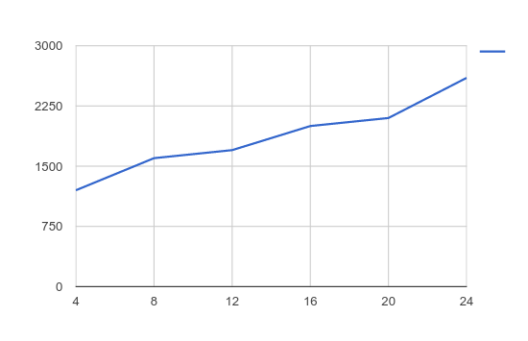

Selective Repeat
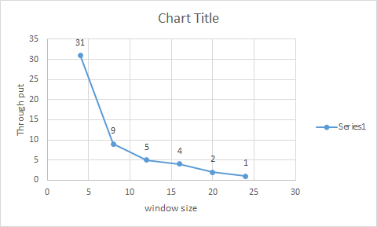

(y-axis: throughput of the protocols) vs (x-axis: packet size) (Column Chart )
Go Back N :

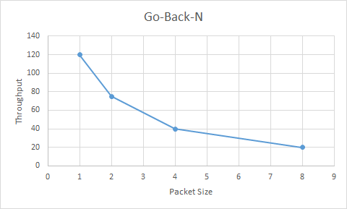

Selective :
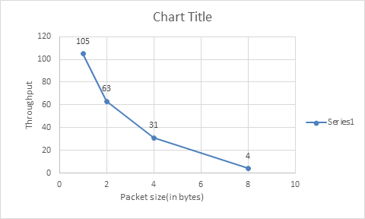

y-axis: throughput of the protocols) vs (x-axis: packet loss rate)
If We consider-
p - Loss probability
t_trans - pkt transmission
time rtt - Round trip time
Then-
Throughput for Go-Back-N = (1-p)/(p x rtt + t_trans)
Throughput for Selective Repeat = (1-p)/t_trans
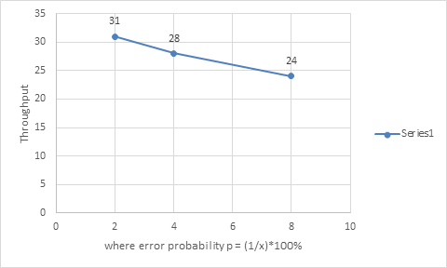

In Go-Back-N , all the packets that follow a corrupted one are discarded, so we have to resend all those packets so overhead is very high and throughput decreases as probability of losing packet increases.
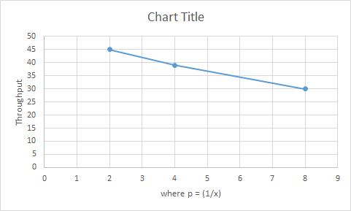

6.Observation
Go Back N ARQ protocol is very much less efficient in extremely noisy channel as it discards all the frames that follow a corrupted . In a noisy channel , error occurs in a higher rate so most of the frames sent will be discarded. On the other hand selective ARQ protocol sends only the corrupted frame, so there is no overhead which makes it way more effective in noisy channel than Go back N. But in noiseless channel or less noisy channel Go Back N performs better than Selective as receiver side of Go Back N is simpler than that of selective. So, in less noisy channel Go Back N does better.

7.Conclusion

This assignment was not a simpler one , it needs a clear understanding of the theory and a solid idea of implementing. We had to go through many challenges while working with this assignment. We had to discuss with each other and overcome those challenges thus it made ourselves more suitable for group projects. Finally, though it was tough enough but really interesting to do.

References:
Data Communications and Networking, 5th Edition (Behrouz A.Forouzan)
http://www.wikipedia.org
http://techdifferences.com/difference-between-go-back-n-and-selective-repeat-protocol.html#Definition
ftp://gaia.cs.umass.edu/cs653-99/rel2.pdf
http://web.mit.edu/modiano/www/6.263/lec3-4.pdf

