**ICS 344**

**COMPUTER INFORMATION DEPARTMENT**

**Phase 1**

**Saad ahmed**

**Vm of Metasploittable**

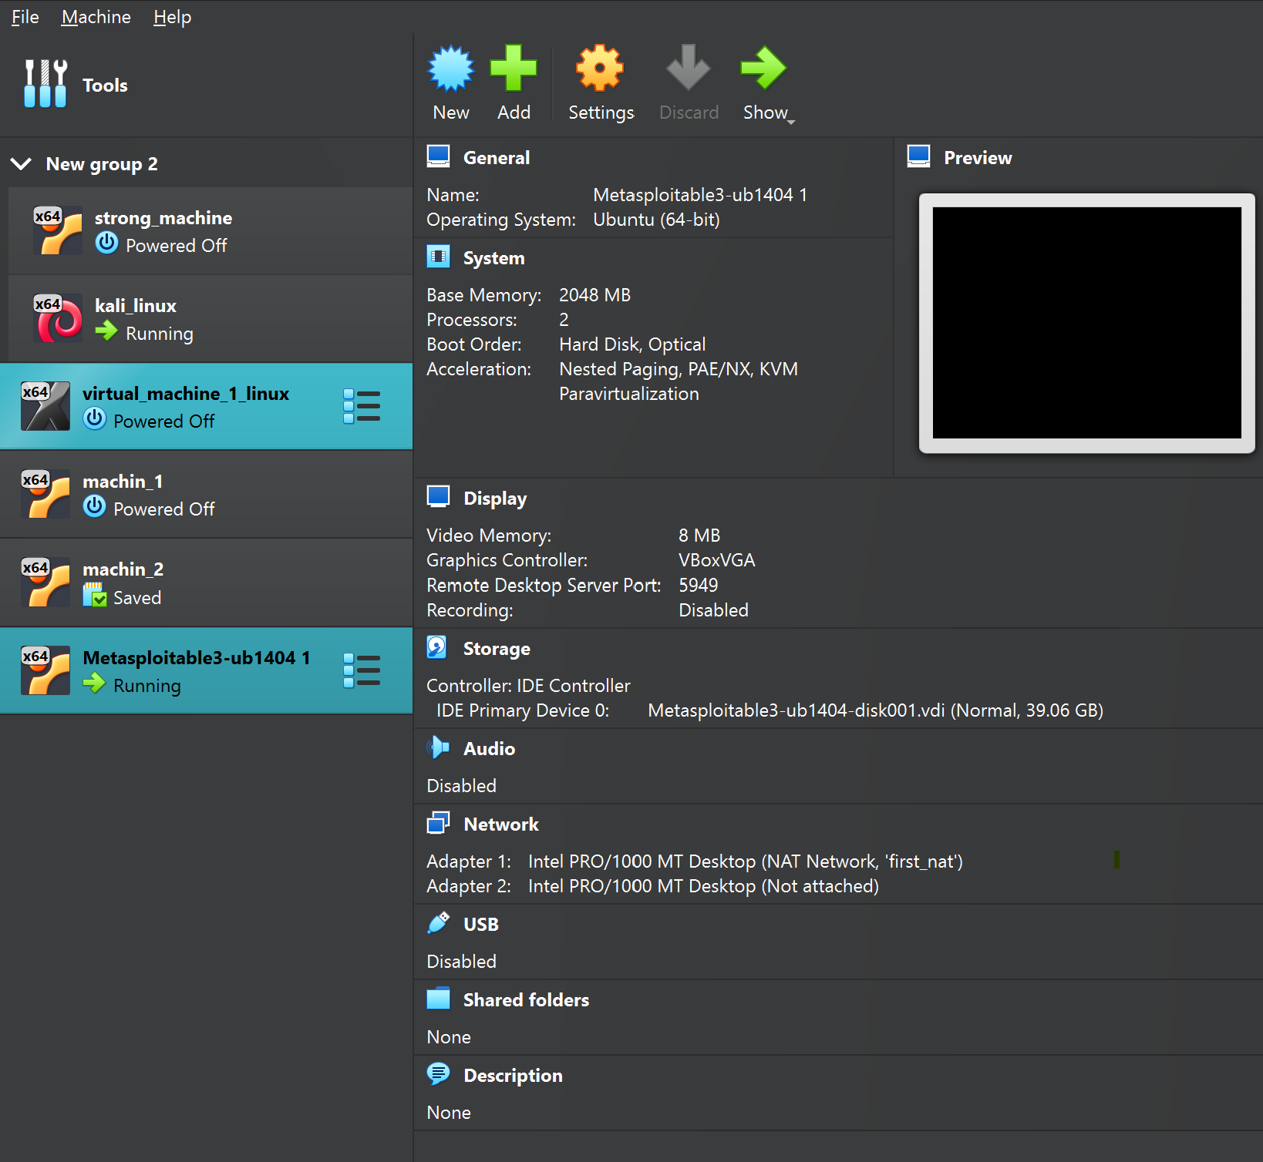

**VM of kali linx :**

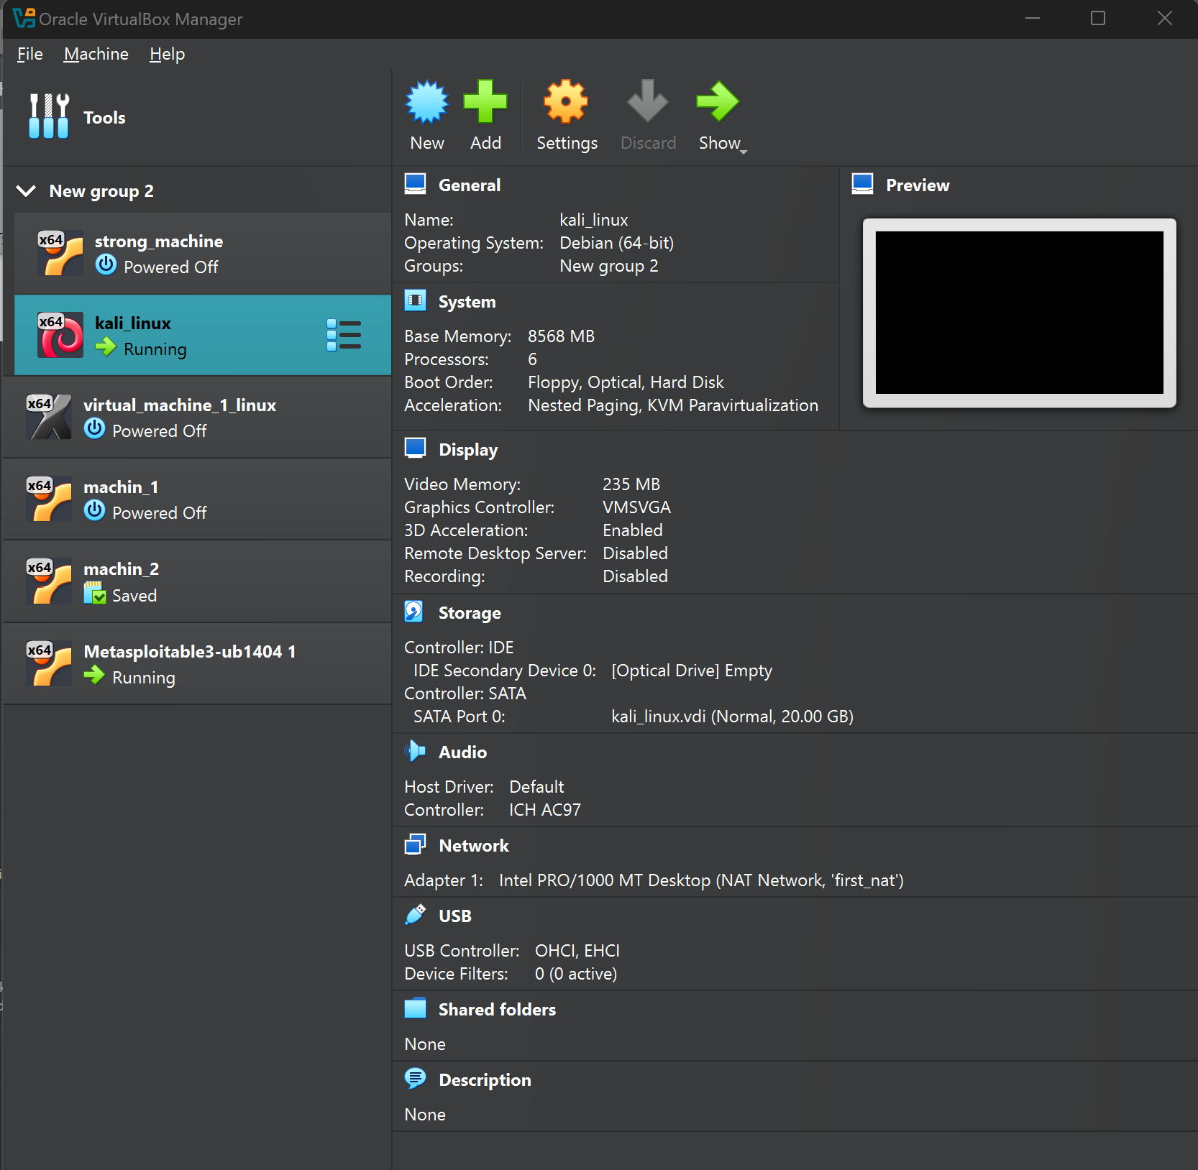

**RUNING NMAP TO SEE ALL PORTS AND DEVICES ON NETWORK**

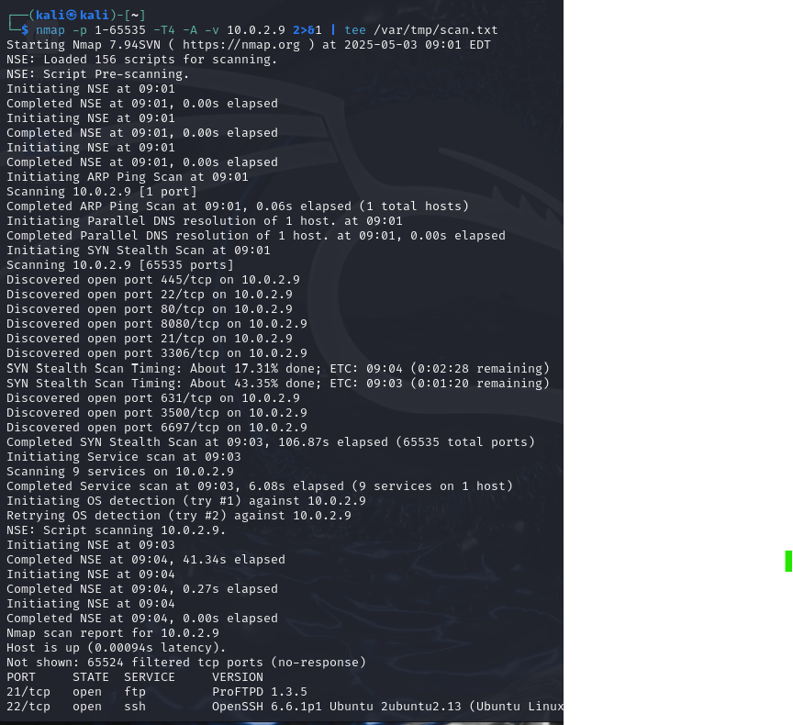

**WE FOUND OUT THAT OPENSHELL USES AN OLD VERSION THUS THERE MIGHT BE A VULNRABILITY**

**SO WE EXPLIOT IT USING METASPOLT , AND AFTER THESE COMMANDS WE**

**HAVE ESTABLISHED A CONNECTION WITH THE VICTIM VM**

**THE PROOF OF CONCEPT IS ‘WHOAMI” -> VAGRANT**

**WE THEN COPY ALL THE COMMANDS WE USED PREVIOUSLY TO MAKE A SCRIPT FILE**

**THAT IS EXCUTED BY SHELL**

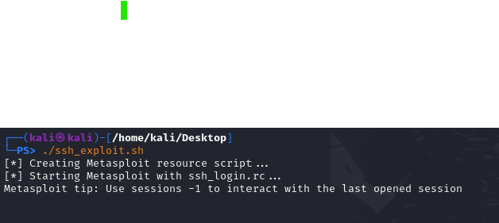

**Here we execute the script file**

**This is the result , same as previous , when we execute the script – this is a continuation picture of the previous picture , cause its long.** 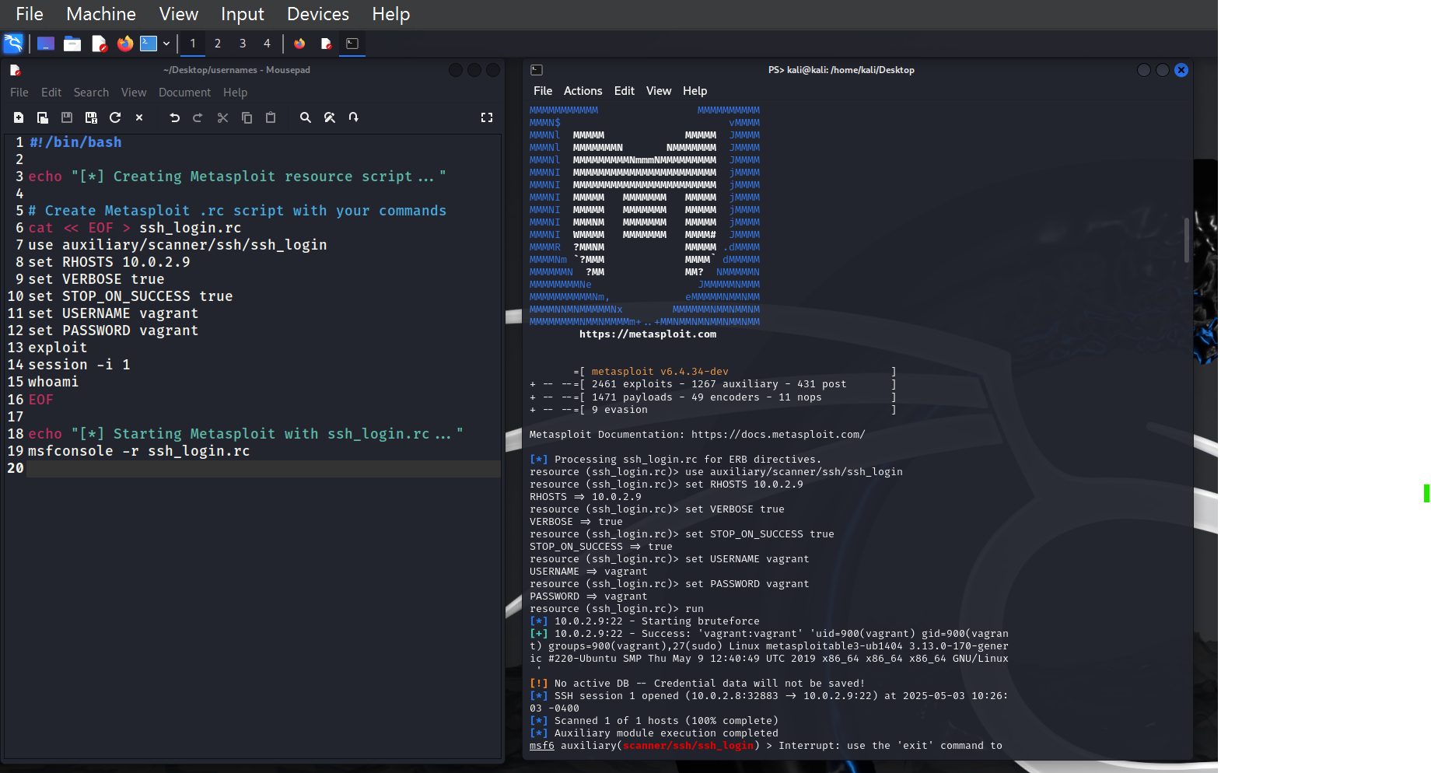f