***ICS 344***

***COMPUTER INFORMATION DEPARTMENT***

***Phase 3***

***Abdulaziz Althukair***

**Our defense strategy will employ alerting the machine when it’s clear that a brute force attack is occuring, and halting connection. We first look for common phrasing in the attacks**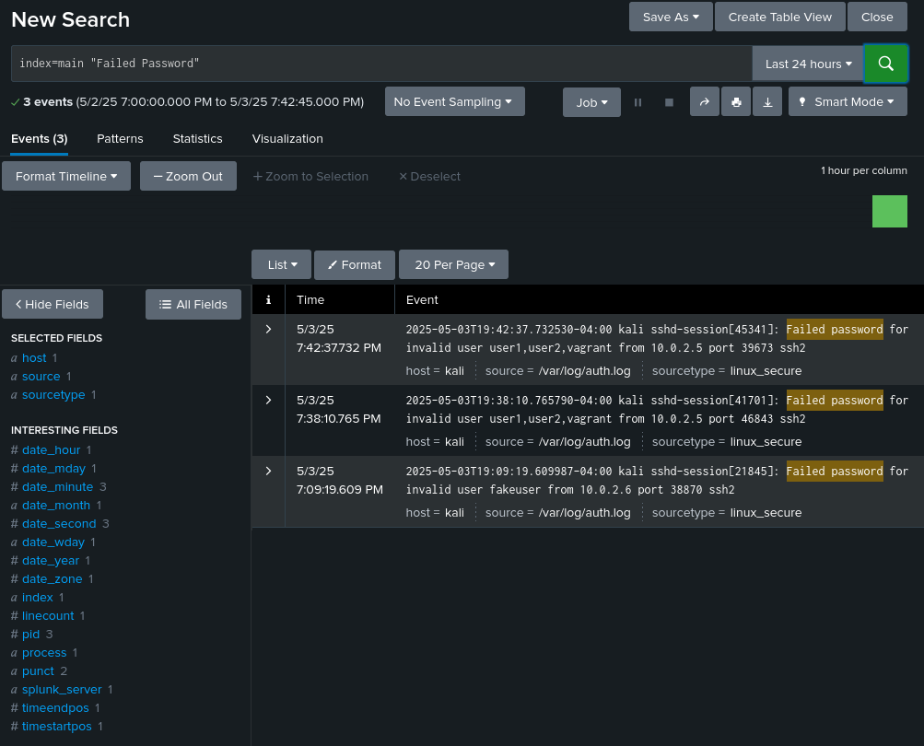

**We establish the alert below**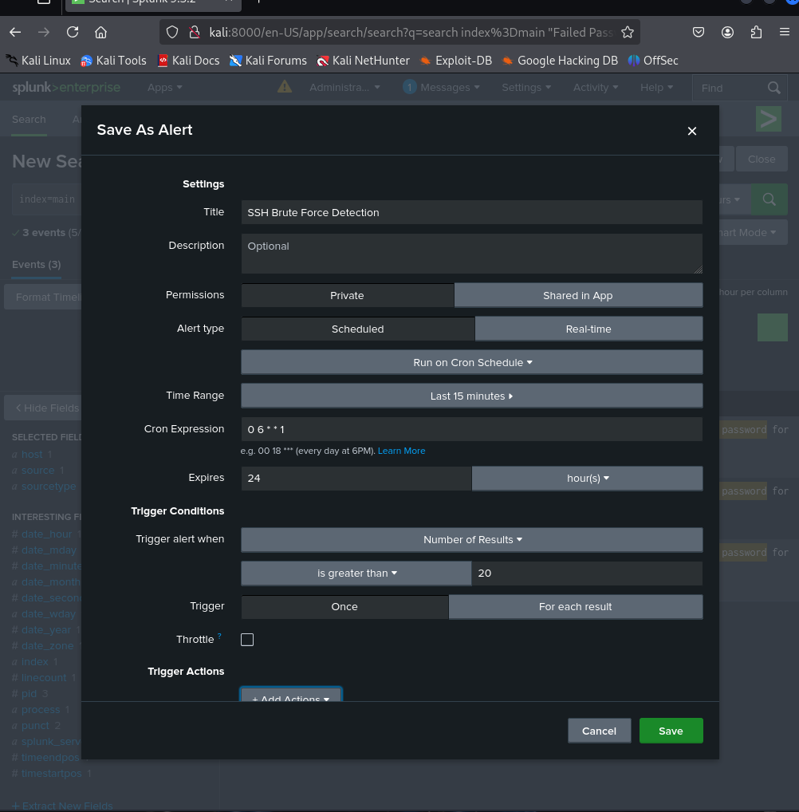

**We can see after a second attack, that the common phrase we used was detected and the alert was triggered, leading to further prevention of the attack**

