# PCB Spec

Layers: 4 layers

Material Details: FR4-Standard Tg

Board Thickness: 1.6mm

Board Dimensions: Width 86.000mm x Height 75.800mm

Surface Finish: Lead Free HASL

Copper Thikness: 1oz (35um)

Soldermask Sides: Both

Soldermask Color: Blue

Silkscreen Sides: Both

Silkscreen Color: White

# Description of the files contained:

*.drl (Drill Data)

*-drl.rpt (Drill Tool List)

*-drl_map.gbr (Drill Map)

*-Edge.Cuts.gbr (Board Outline)

*-top.pos (Top Layer Module Positions)

1st layer

*-F.Adhes.gbr (Gerber Top Layer Adhesives)

*-F.Cu.gbr (Gerber Top Layer)

*-F.Mask.gbr (Gerber Top Solder Mask)

*-F.Paste.gbr (Gerber Top Solder Paste for stencil)

*-F.SilkS.gbr (Gerber Top Silk)

2nd layer

*-In1.Cu.gbr (Gerber 2nd layer)

3rd layer

*-In2.Cu.gbr (Gerber 3rd layer)

4th layer

*-B.Adhes.gbr (Gerber Bottom Layer Adhesives)

*-B.Cu.gbr (Gerber Bottom Layer)

*-B.Mask.gbr (Gerber Bottom Solder Mask)

*-B.Paste.gbr (Gerber Bottom Solder Paste for stencil)

*-B.SilkS.gbr (Gerber Bottom Silk)

BOM file: zturn_adc.xlsx

# Note for Assembly

All the parts are mount on the TOP SIDE.

Do not load R15, R29, R30 (and NO SOLDER).

4 center pads of U1, U6 should also be soldered.

CN1, CN2, CN3 are towards OUTSIDE of the PCB.

Orientation of U1:

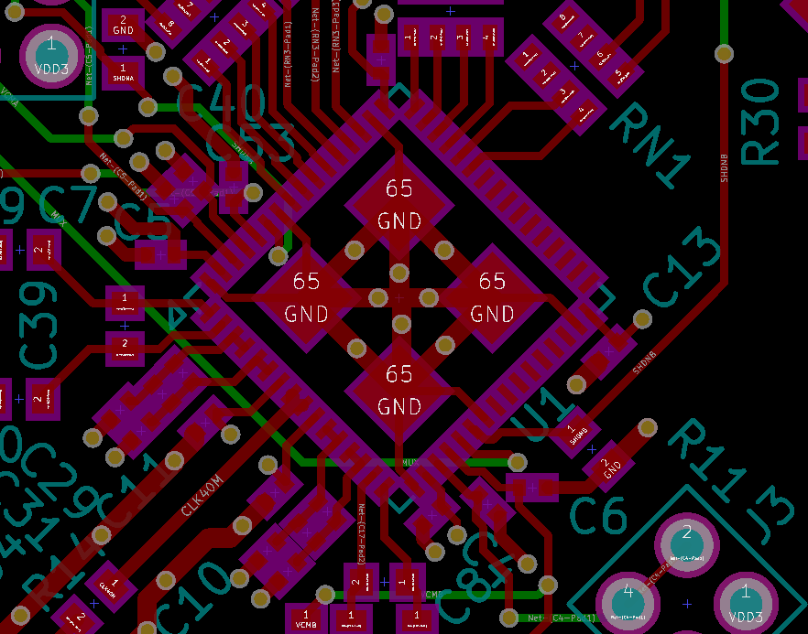

Pin1

Pin64

Orientation of X1:

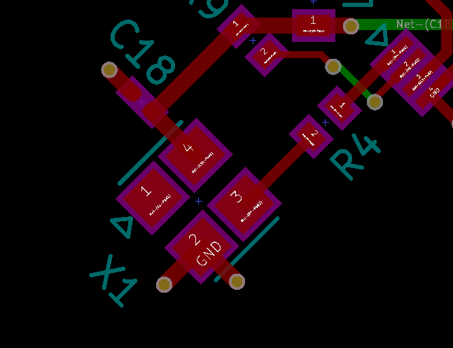

Pin1

Orientation of U5:

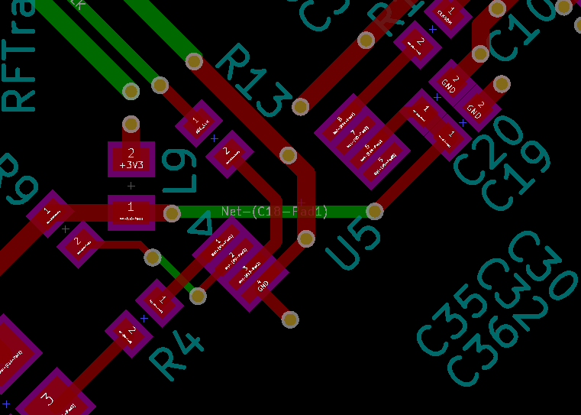

Pin8

Pin1

Orientation of U3:

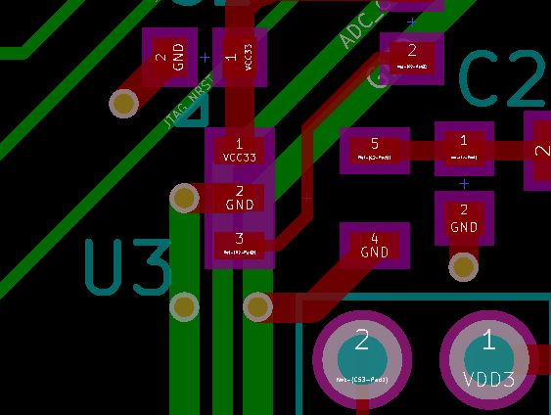

Pin1

Orientation of U7:

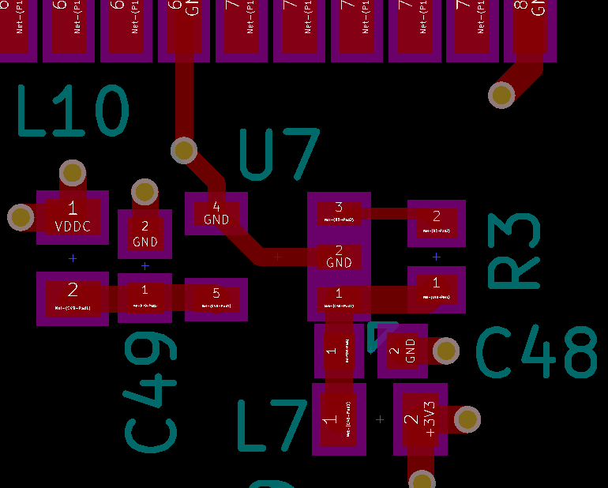

Pin1

Orientation of U6:

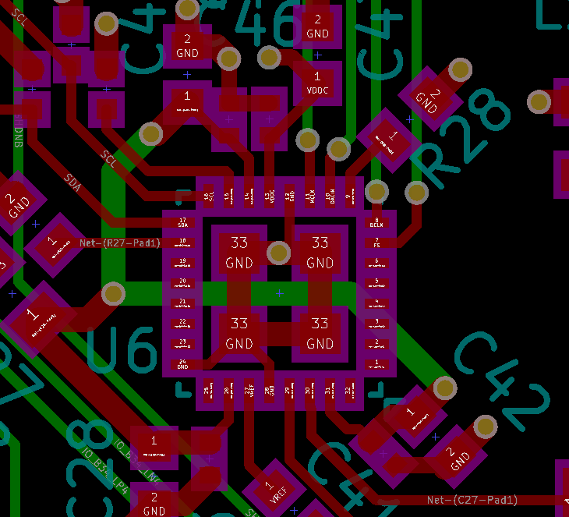

Pin32

Pin1