The Formera socketplug uses esp8266-12f as mcu

Here is pinout

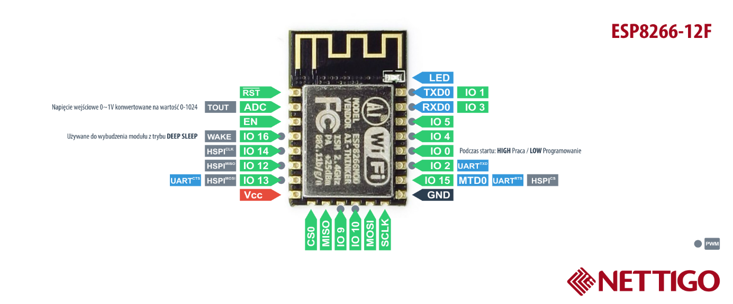

Firmware support sensors. To be able to use it a sensor has to be connected. IO 4 is used for sensors data pin as per default. To choose other just change this in firmware, socketplug.cpp

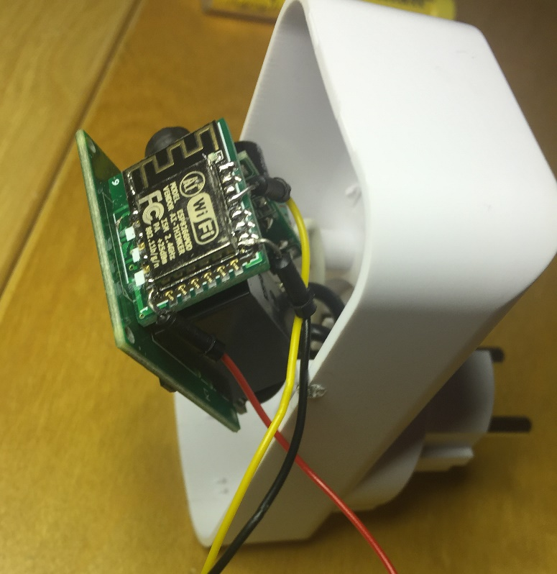 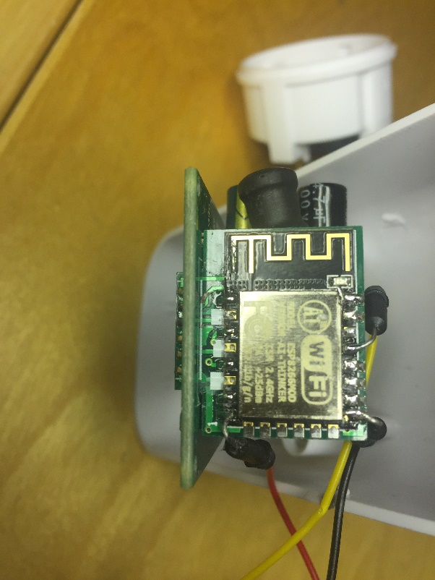

With firmware 1.0.8 DHT22 and ds18b20 is supported

DHT22 – Temerature and humidity sensor

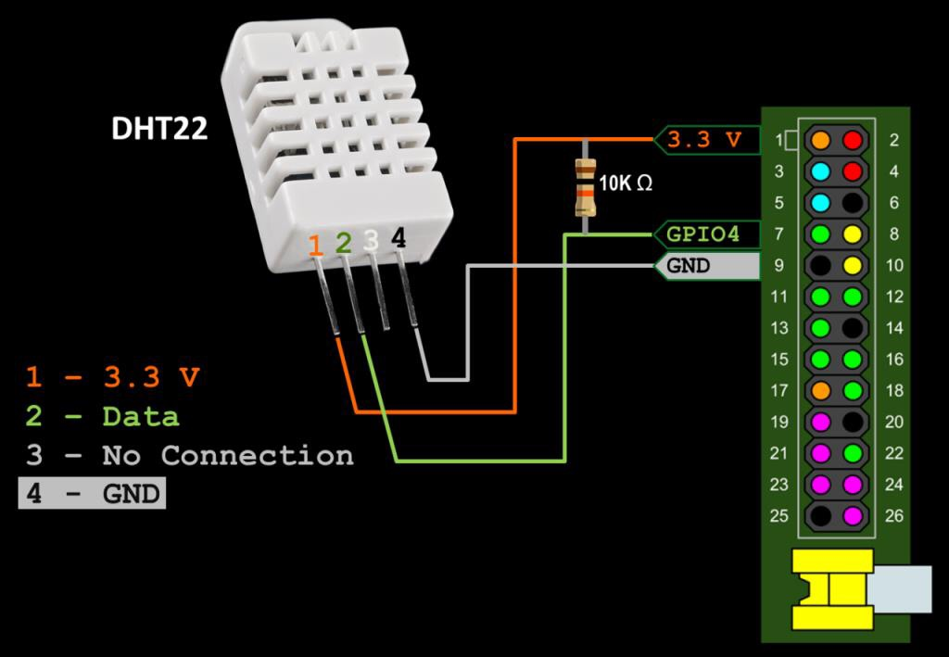

Pin 3 is not used. Follow the above schema.

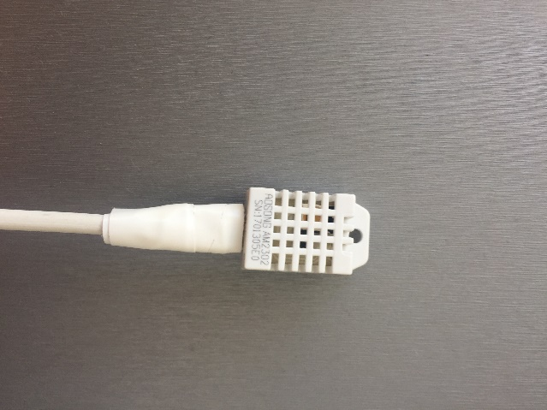 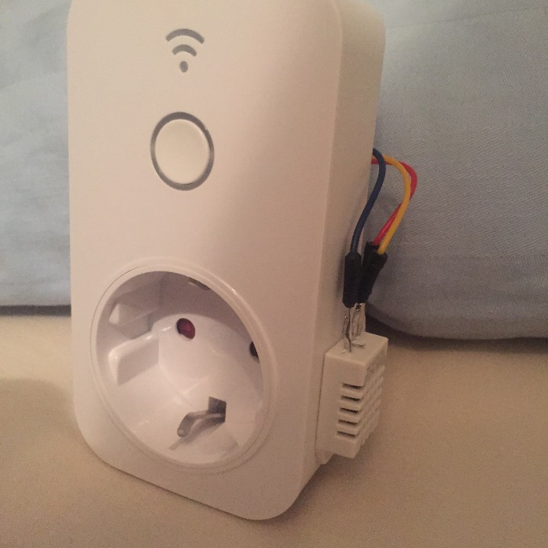

DS18B20 – Temperature sensors

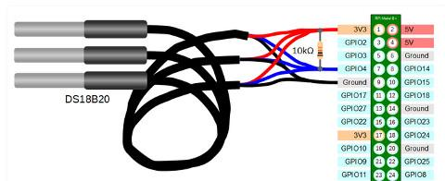

The DS18B20 can be used in a star-setup with several sensors connected. It is not handled in 1.0.8 as per now. It support 1 sensor.

