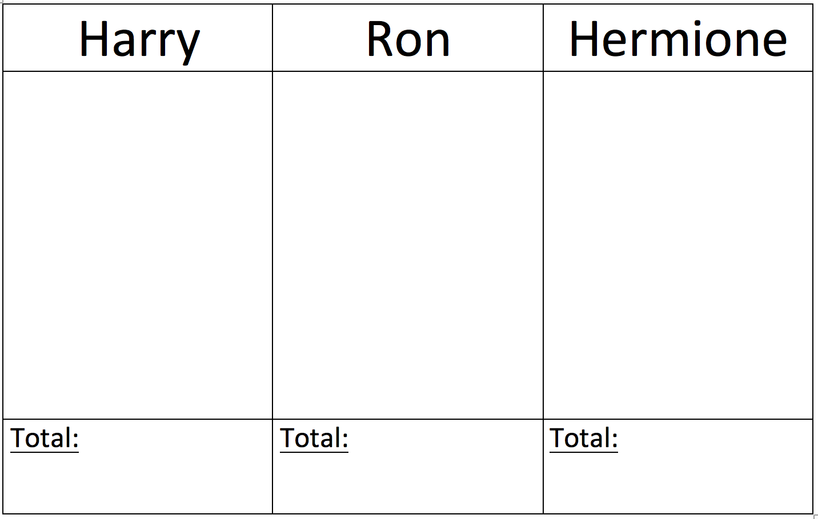

Dormouse

Dormouse

Hatter

Hatter

Alice

Alice