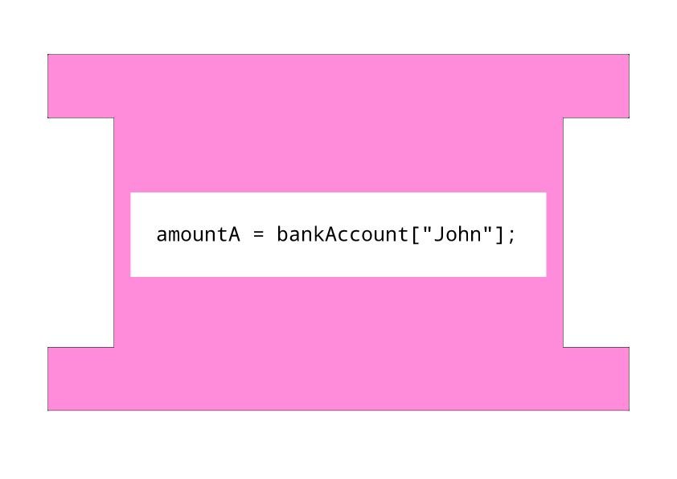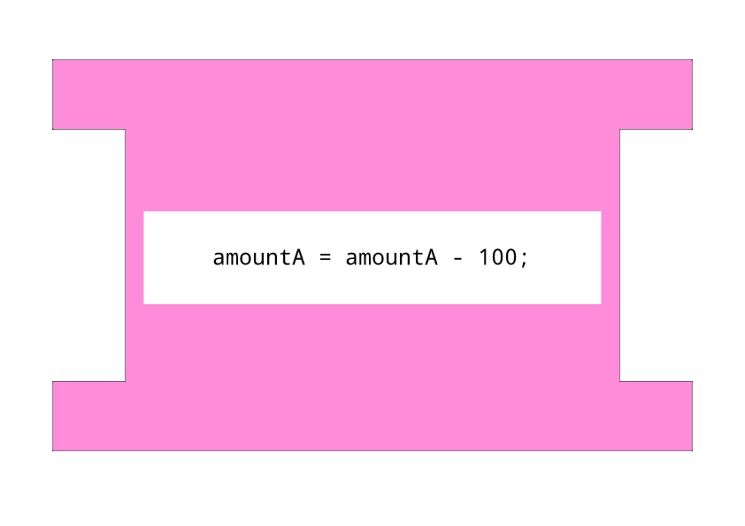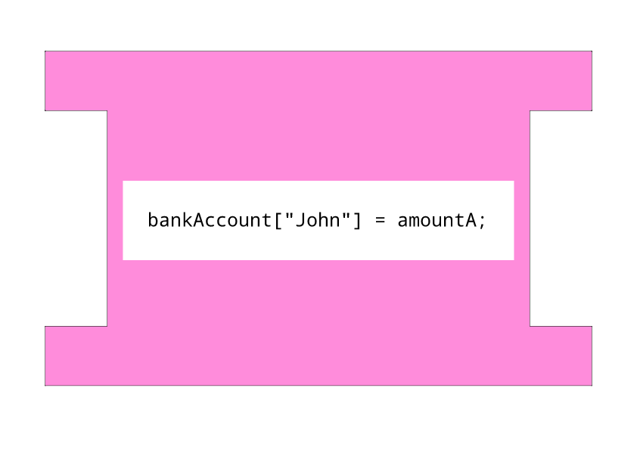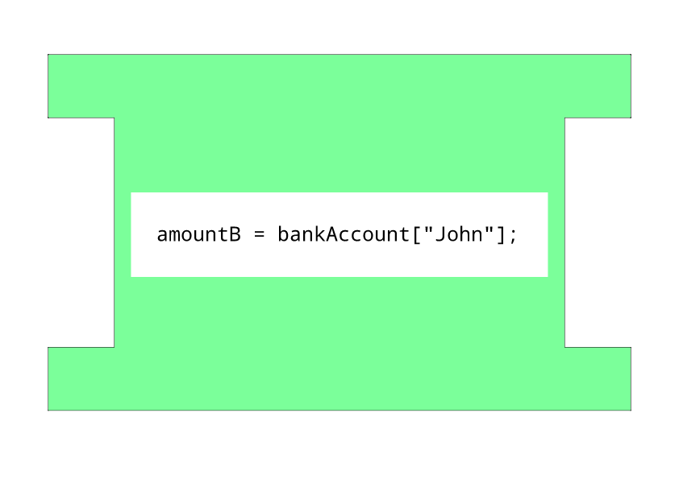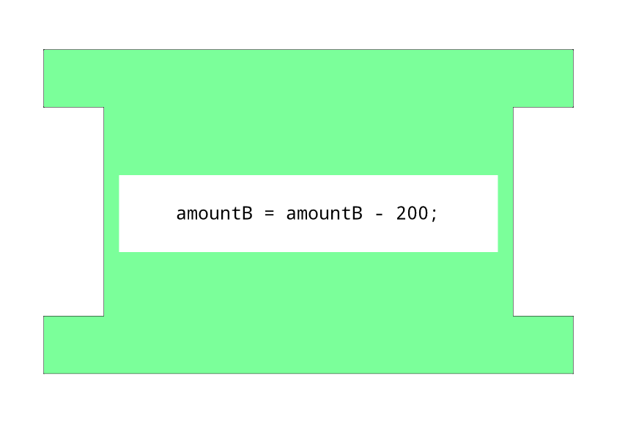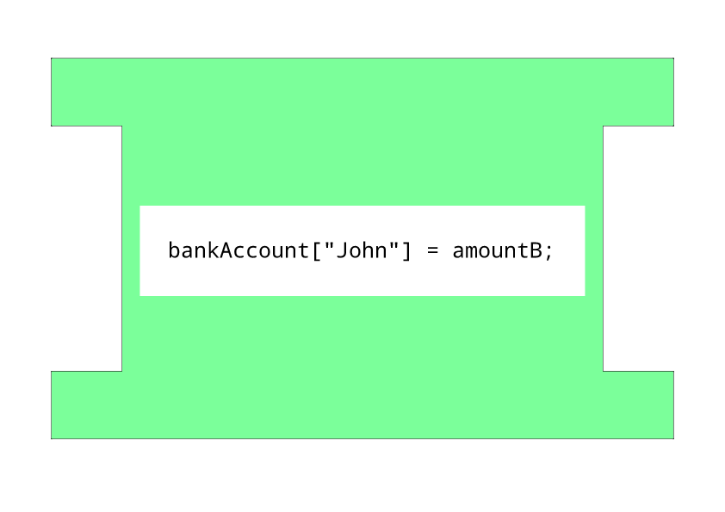

|  |  |  |  |  |  |  |  |
| --- | --- | --- | --- | --- | --- | --- | --- |
| Operation |  |  |  |  |  |  |  |
| Amount |  |  |  |  |  |  |  |

John’s Bank Account:

£5000